**PROGRAMMING II**

CS 1714 MWF,

On-line, Hybrid (asynchronous, synchronous)

**PARTICIPATIONACTIVITY**

1.1.4: Basic input.

1)

Which statement assigns numCars with a number from input?

scanf("%d", "numCars");

scanf("%d" &numCars);

scanf("%d", numCars);

scanf("%d", &numCars);

**Correct**

The statement gets the next decimal integer input value (denoted by the %d, where d is short decimal) and puts that value into the variable numCars.

Feedback?

**PARTICIPATIONACTIVITY**

1.1.5: Basic input.

1)

Type a statement that gets an input value into variable numUsers.

CheckShow answer

**Correct**

scanf("%d", &numUsers);

The input value will be put in numUsers.

1.1 Programming basics

**A first program**

A simple C program appears below.

* A ***program*** starts in main(), executing the statements within main's braces { }, one at a time.
* Each statement typically appears alone on a line and ends with a ***semicolon***, as English sentences end with a period.
* The int wage statement creates an integer variable named wage. The wage = 20statement assigns wage with 20.
* The printf statements output various values.
* The return 0 statement ends the program (the 0 tells the operating system the program ended without error).

The following code (explained later) at the top of a file enables the program to get input and put output:

#include <stdio.h>

**PARTICIPATIONACTIVITY**

1.1.1: Program execution begins with main, then proceeds one statement at a time.

12345

2x speed

#include <stdio.h>

**int** main(**void**) {

**int** wage;

wage = 20;

printf("Salary is ");

printf("%d", wage * 40 * 50);

printf("\n");

**return** 0;

}

20

wage

Salary is

40000

20

'return 0' statement ends the program.

Captions

keyboard_arrow_up

1. A program begins executing statements in main(). 'int wage' declares an integer variable. 'wage = 20' assigns wage with 20.
2. The printf statement outputs 'Salary is ' to the screen at the cursor's present location.
3. This printf statement outputs the result of wage * 40 * 50, so 20 * 40 * 50 or 40000.
4. The printf statement with "\n" moves cursor to next line.
5. 'return 0' statement ends the program.

Feedback?

**PARTICIPATIONACTIVITY**

1.1.2: A first program.

Consider the program above.

1)

Program execution begins at main() and executes statements surrounded by which symbols?

( )

{ }

" "

**Correct**

The statements within main() are contained within { }, called curly braces. The { indicates the start of main's statements, and the } indicates the end of main's statements, here meaning the end of the program.

2)

The statement int wage; creates a variable named wage that is used to _____ the value 20.

input

output

hold

**Correct**

As can be seen in the animation, the variable wage holds the value 20. The variable wage can be assigned with a different value later in the program, so because the value held can *vary*, the item is called a variable. Program variables are different from variables in algebra.

3)

Would the following order of statements work the same as above?

wage = 20;

int wage;

No

Yes

**Correct**

This order doesn't work. Statements are executed one at a time, starting from the first statement after the opening {. The program must *first* create the variable wage to hold a value, and only *then* can assign wage with the value 20. As an analogy, in everyday life, the instructions "Get a teapot. Fill with water." make sense. But the reverse-order "Fill with water. Get a teapot." make no sense, and water will end up on the floor.

4)

Each statement ends with what symbol?

Semicolon ;

Period .

Colon :

**Correct**

Like a period ends an English sentence, a semicolon ends a program statement. Even though each statement is usually written on a unique line, a semicolon is needed as a separator because multiple statements *could*appear on the same line (though that practice is strongly discouraged).

5)

The expression wage * 40 * 50 resulted in what value?

20

40000

20 * 40 * 50

**Correct**

The variable wage holds 20, so wage * 40 * 50 will calculate 20 * 40 * 50, which is 40000. Note that the symbol for multiplication is * (an asterisk).

6)

Each printf() statement outputs items to _____.

a file named output.txt

the keyboard

the screen

**Correct**

In the example, each printf() statement puts an item on the screen, starting at the screen cursor's present location, and moving the cursor after each output item.

Feedback?

zyDE 1.1.1: A first program.

Below is the zyBooks Development Environment (zyDE), a web-based programming practice environment. Click run to compile and execute the program, then observe the output. Change 20 to a different number like 35 and click run again to see the different output.

Load default template...

1

2

3

4

5

6

7

8

9

10

11

12

13

14

#include <stdio.h>

int main(void) {

int wage;

wage = 20;

printf("Salary is ");

printf("%d", wage * 40 * 50);

printf("\n");

return 0;

}

Run

Salary is 40000

Feedback?

**Basic input**

Programs commonly get input values, perform some processing on that input, and put output values to a screen or elsewhere. Input is commonly gotten from a keyboard, a file, fields on a web form or app, etc.

The following statement gets an input value and puts the value into variable x: ***scanf*** ("%d", &x)

The & before x is necessary to indicate where in memory the read value should be stored (described in a section on "pointers").

**PARTICIPATIONACTIVITY**

1.1.3: A program can get an input value from the keyboard.

12

2x speed

#include <stdio.h>

**int** main(**void**) {

**int** wage;

scanf("%d", &wage);

printf("Salary is ");

printf("%d\n", wage * 40 * 50);

**return** 0;

}

20

wage

Salary is

40000

20

Input

20

Output

20

Salary is 40000

wage's value can then be used in subsequent processing and outputs.

Captions

keyboard_arrow_up

1. The scanf statement gets an input value from the keyboard (or file, etc.) and puts that value into the wage variable.
2. wage's value can then be used in subsequent processing and outputs.

Feedback?

**PARTICIPATIONACTIVITY**

1.1.4: Basic input.

1)

Which statement assigns numCars with a number from input?

scanf("%d", "numCars");

scanf("%d" &numCars);

scanf("%d", numCars);

scanf("%d", &numCars);

**Correct**

The statement gets the next decimal integer input value (denoted by the %d, where d is short decimal) and puts that value into the variable numCars.

Feedback?

**PARTICIPATIONACTIVITY**

1.1.5: Basic input.

1)

Type a statement that gets an input value into variable numUsers.

CheckShow answer

**Correct**

scanf("%d", &numUsers);

The input value will be put in numUsers.

Feedback?

zyDE 1.1.2: Basic input.

Run the program and observe the output. Change the input box value from 3 to another number, and then run again. Note: Handling program input in a web-based development environment is surprisingly difficult. *Preentering* the input is a workaround in zyDE. For dynamic output and input interaction, use a traditional development environment.

Load default template...

1

2

3

4

5

6

7

8

9

10

11

12

13

14

15

16

17

18

#include <stdio.h>

int main(void) {

int dogYears;

int humanYears;

scanf("%d", &dogYears);

humanYears = 7 * dogYears;

printf("A ");

printf("%d", dogYears);

printf(" year old dog is about the same age as a ");

printf("%d", humanYears);

printf(" year old human.\n");

return 0;

}

Run

Feedback?

**Basic output: Text**

The ***printf*** construct supports output. Outputting text is achieved via: printf("desired text");. Text in double quotes " " is known as a ***string literal***. Multiple printf statements continue printing on the same output line. A ***newline*** character, \n, in the string literal starts a new output line, called a newline.

Figure 1.1.1: Outputting text and new lines.

|  |  |
| --- | --- |
| #include <stdio.h>  **int** main(**void**) {  printf("Keep calm");  printf("and");  printf("carry on");  **return** 0;  } | Keep calmandcarry on |
| #include <stdio.h>  **int** main(**void**) {  printf("Keep calm\n");  printf("and\n");  printf("carry on\n");  **return** 0;  } | Keep calm  and  carry on |

Feedback?

**PARTICIPATIONACTIVITY**

1.1.6: Basic text output.

1)

Which statement outputs: Welcome!

printf(Welcome!);

printf "Welcome!";

printf("Welcome!");

**Correct**

The string literal is printed to output.

2)

Which statement outputs Hey followed by a new line?

printf(Hey\n);

printf("Hey"\n);

printf("Hey\n");

**Correct**

\n is a special character that starts a new output line.

Feedback?

**PARTICIPATIONACTIVITY**

1.1.7: Basic text output.

End each statement with a semicolon. Do not output a new line unless instructed.

1)

Type a statement that outputs: Hello

CheckShow answer

**Correct**

printf("Hello");

The string literal will be printed.

2)

Type a statement that outputs Hello and then starts a new output line.

CheckShow answer

**Correct**

printf("Hello\n");

\n is a special character that starts a new output line.

Feedback?

**Outputting a variable's value**

Outputting an integer variable's value is achieved via: printf("%d", x). The ***%d*** in the string literal indicates that a decimal number (hence the d) should be printed there, with that number being the value of the variable that follows.

Figure 1.1.2: Outputting a variable's value.

|  |  |
| --- | --- |
| #include <stdio.h>  **int** main(**void**) {  **int** wage;  wage = 20;  printf("Wage is: ");  printf("%d", wage);  printf("\n");  printf("Goodbye.\n");  **return** 0;  } | Wage is: 20  Goodbye. |

Feedback?

Note that the programmer intentionally did *not* start a new output line after outputting "Wage is: " so that the wage variable's value would appear on that same line.

**PARTICIPATIONACTIVITY**

1.1.8: Basic variable output.

1)

Given variable numCars = 9, which statement outputs 9?

printf(numCars);

printf("numCars");

printf("%d", numCars);

**Correct**

The string literal indicates that a decimal number is to be output, whose value follows. numCars' value of 9 is thus output.

Feedback?

**PARTICIPATIONACTIVITY**

1.1.9: Basic output.

1)

Type a statement that outputs the value of numUsers (an integer variable). End statement with a semicolon. Do not output a new line.

CheckShow answer

**Correct**

printf("%d", numUsers);

The value of numUsers will be output.

2)

Type a statement that outputs the value of numPeople (an integer variable; do not output a new line), followed by a statement that gets an input value into numPeople.

CheckShow answer

**Correct**

printf("%d", numPeople); scanf("%d", &numPeople);

printf and scanf are similar, but the & in scanf is commonly forgotten.

Feedback?

**Outputting multiple items with one statement**

Programmers commonly use a single output statement for each line of output by combining the outputting of text, variable values, and a new line. The programmer simply places the items within one string literal and separates the variable names after the string literal with commas. Such combining can improve program readability because the program's code corresponds more closely to the program's output.

Figure 1.1.3: Outputting multiple items using one output statement.

|  |  |
| --- | --- |
| #include <stdio.h>  **int** main(**void**) {  **int** wage;  wage = 20;  printf("Wage is: %d\n", wage);  printf("Goodbye.\n");  **return** 0;  } | Wage is: 20  Goodbye. |

Feedback?

zyDE 1.1.3: Single output statement.

Modify the program to use only two output statements, one for each output sentence.

In 2014, the driving age is 18.

10 states have exceptions.

Do not type numbers directly in the output statements; use the variables. ADVICE: Make incremental changes—Change one code line, run and check, change another code line, run and check, repeat. Don't try to change everything at once.

Load default template...

5

6

7

8

9

10

11

12

13

14

15

16

17

18

19

20

21

22

int drivingAge;

int numStates;

drivingYear = 2014;

drivingAge = 18;

numStates = 10;

printf("In ");

printf("%d", drivingYear);

printf(", the driving age is ");

printf("%d", drivingAge);

printf(".\n");

printf("%d", numStates);

printf(" states have exceptions.\n");

return 0;

}

Run

In 2014, the driving age is 18.

10 states have exceptions.

Feedback?

**PARTICIPATIONACTIVITY**

1.1.10: Basic output.

Indicate the actual output of each statement. Assume userAge is 22.

1)

printf("You are %d years.", userAge);

You are 22 years.

You are userAge years.

No output; an error exists.

**Correct**

userAge's value is printed. Note the spaces before and after %d.

2)

printf("%dyears is good.", userAge);

22 years is good.

22years is good.

No output; an error exists.

**Correct**

"%dyears is good" lacks a space after the %d.

Feedback?

**PARTICIPATIONACTIVITY**

1.1.11: Output simulator.

The following variable has already been declared and assigned: countryPopulation = 1344130000;. Using that variable (do not type the large number) along with text, finish the output statement to output the following:

China's population was 1344130000 in 2011.

Then, try some variations, like:

1344130000 is the population. 1344130000 is a lot.

|  |
| --- |
| printf(); |
| *Keep typing; we're waiting for a valid output statement.* |

Feedback?

**CHALLENGEACTIVITY**

1.1.1: Enter the output.

Jump to level 1

Type the program's output

|  |  |
| --- | --- |
| #include <stdio.h>  **int** main**(void)** {  **int** personAge;  personAge = 21;  printf("Joe is %dyears.", personAge);  **return** 0;  } |  |

1

2

3

4

**5**

Check

Next

**Done**. Click any level to practice more. Completion is preserved.



Different items can be output in one printf statement. First, "Joe is " is printed to output, then the value of personAge, then "years.". Note that "years." lacks a leading space, so the output ends with "21years.". The programmer probably forgot to include that space.

|  |  |
| --- | --- |
| Yours | Joe is 21years. |
| Expected | Joe is 21years. |

1

2

3

4

5

**CHALLENGEACTIVITY**

1.1.2: Output basics.

For activities with output like below, your output's whitespace (newlines or spaces) must match exactly. See this [note.](https://www.zybooks.com/coding-ca-notes/#BasicHighlighting)

Jump to level 1

Write code that outputs variable numMonths. End with a newline.

#include <stdio.h>

int main(void) {

int numMonths;

// Our tests will run your program with input 2, then run again with input 5.

// Your program should work for any input, though.

scanf("%d", &numMonths);

printf("%d\n", numMonths);

return 0;

}

Input

If input is 3, output is:

Birds: 3

#include <stdio.h>

int main(void) {

int numBirds;

// Our tests will run your program with input 3, then run again with input 6.

// Your program should work for any input, though.

scanf("%d", &numBirds);

printf("Birds: %d\n", numBirds);

return 0;

}

Write code that outputs variable numMugs as follows. End with a newline. If input is 4, output is:

We have 4 mugs.

#include <stdio.h>

int main(void) {

int numMugs;

// Our tests will run your program with input 4, then run again with input 7.

// Your program should work for any input, though.

scanf("%d", &numMugs);

printf("We have %d mugs.\n", numMugs);

return 0;

}

**CHALLENGEACTIVITY**

1.1.3: Read multiple user inputs.

Write two ***scanf*** statements to get input values into birthMonth and birthYear. Then write a statement to output the month, a slash, and the year. End with newline.   
  
The program will be tested with inputs 1 2000 and then with inputs 5 1950. Ex: If the input is 1 2000, the output is:   
1/2000   
  
Note: The input values come from user input, so be sure to use scanf statements, as in scanf("%d", &birthMonth), to get those input values (and don't assign values directly, as in birthMonth = 1).

#include <stdio.h>

int main(void) {

int birthMonth;

int birthYear;

scanf("%d", &birthMonth);

scanf("%d", &birthYear);

printf("%d/%d\n", birthMonth, birthYear);

return 0;

}

1.2 Comments and whitespace

info

This section has been set as optional by your instructor.

**Comments**

A ***comment*** is text a programmer adds to code, to be read by humans to better understand the code but ignored by the compiler. Two common kinds of comments exist:

* A ***single-line comment*** starts with // and includes all the following text on that line. Single-line comments commonly appear after a statement on the same line.
* A ***multi-line comment*** starts with /* and ends with */, where all text between /* and */ is part of the comment. A multi-line comment is also known as a ***block comment***.

Figure 1.2.1: Comments example.

#include <stdio.h>

/*

This program calculates the amount of pasta to cook, given the

number of people eating.

Author: Andrea Giada

Date: May 30, 2017

*/

**int** main(**void**) {

**int** numPeople; // Number of people that will be eating

**int** totalOuncesPasta; // Total ounces of pasta to serve numPeople

// Get number of people

printf("Enter number of people: \n");

scanf("%d", &numPeople);

// Calculate and print total ounces of pasta

totalOuncesPasta = numPeople * 3; // Typical ounces per person

printf("Cook %d ounces of pasta.\n", totalOuncesPasta);

**return** 0;

}

Feedback?

**PARTICIPATIONACTIVITY**

1.2.1: Comments.

Indicate which are valid code.

1)

// Get user input

Valid

Invalid

2)

/* Get user input */

Valid

Invalid

3)

/* Determine width and height,

calculate volume,

and return volume squared.

*/

Valid

Invalid

4)

// Print "Hello" to the screen //

Valid

Invalid

5)

// Print "Hello"

Then print "Goodbye"

And finally return.

//

Valid

Invalid

6)

/*

* Author: Michelangelo

* Date: 2014

* Address: 111 Main St, Pacific Ocean

*/

Valid

Invalid

7)

// numKids = 2; // Typical number

Valid

Invalid

8)

/*

numKids = 2; // Typical number

numCars = 5;

*/

Valid

Invalid

9)

/*

numKids = 2; /* Typical number */

numCars = 5;

*/

Valid

Invalid

Feedback?

**Whitespace**

***Whitespace*** refers to blank spaces (space and tab characters) between items within a statement and blank lines between statements (called newlines). A compiler ignores most whitespace.

Good practice is to deliberately and consistently use whitespace to make a program more readable. Programmers usually follow conventions defined by their company, team, instructor, etc., such as:

* Use blank lines to separate conceptually distinct statements.
* Indent lines the same amount.
* Align items to reduce visual clutter.
* Use a single space before and after any operators like =, +, *, or / to make statements more readable.

Figure 1.2.2: Good use of whitespace.

#include <stdio.h>

**int** main(**void**) {

**int** myFirstVar; // Aligned comments yield less

**int** yetAnotherVar; // visual clutter

**int** thirdVar;

// Above blank line separates variable declarations from the rest

printf("Enter a number: ");

scanf("%d", &myFirstVar);

// Above blank line separates user input statements from the rest

yetAnotherVar = myFirstVar; // Aligned = operators

thirdVar = yetAnotherVar + 1;

// Also notice the single-space on left and right of + and =

// (except when aligning the second = with the first =)

printf("Final value is %d\n", thirdVar); // Single-space after the ,

**return** 0; // The above blank line separates the return from the rest

}

Feedback?

Figure 1.2.3: Bad use of whitespace.

#include <stdio.h>

**int** main(**void**) {

**int** numPeople;**int** totalOuncesPasta;

printf("Enter number of people:\n");scanf("%d", &numPeople);

totalOuncesPasta = numPeople * 3;printf("Cook %d ounces of pasta.\n", totalOuncesPasta); **return** 0;}

Feedback?

**PARTICIPATIONACTIVITY**

1.2.2: Whitespace.

Are the specified lines of code good or bad uses of whitespace?

#include <stdio.h>

**int** main() {

**int** userAge;

**int** currentDecade;

**int** nextDecade;

**int** nextMilestone;

printf("Enter your age: \n");

scanf("%d", &userAge);

currentDecade=userAge/10;

nextDecade = currentDecade + 1;

nextMilestone = nextDecade * 10;

printf("Next big birthday is at %d\n", nextMilestone);

**return** 0;

}

1)

int nextDecade;

Bad

2)

currentDecade=userAge/10;

Bad

3)

nextDecade = currentDecade + 1;

Good

4)

nextMilestone = nextDecade * 10;

Good

**Compiling code with comments and whitespace**

The animation below provides a (simplified) demonstration of how a compiler processes code from left-to-right and line by line, finding each statement (and generating machine code using 0s and 1s) and ignoring whitespace and comments.

**PARTICIPATIONACTIVITY**

1.2.3: A compiler scans code line-by-line, left-to-right; whitespace is mostly irrelevant.

Start

2x speed

printf("%d", 20 * 40 * 50);

// 20 dollars/hr * 40 hrs/wk * 50 wks/year.

printf("Enter integer: ");

scanf("%d", &userNum);

Compiler

High-level

program

myfile.c

Executable

program

myfile.exe

1011001101101111

0011101011011101

0000011011010111

1111100011110100

1011011001111000

0110101011101110

Captions

1. The compiler converts a high level program into an executable program using machine code (0s and 1s).
2. Comments do not generate machine code.
3. The compiler recognizes end of statement by semicolon ";"

Feedback?

**PARTICIPATIONACTIVITY**

1.2.4: Compiling code with whitespace and comments.

1)

Spaces are always ignored by the compiler.

False

2)

How many spaces will the compiler ignore in the code below?

numToBuy = numNeeded - numInStock + 2;

6

3)

How many lines of code will the compiler ignore in the code below?

int userAge;

int currentDecade;

int nextDecade;

int nextMilestone;

// FIXME: Get user age

userAge = 29; // Testing with 29

currentDecade = userAge / 10;

nextDecade = currentDecade + 1;

nextMilestone = nextDecade * 10;

3

1.3 Errors and warnings

info

This section has been set as optional by your instructor.

**Syntax errors**

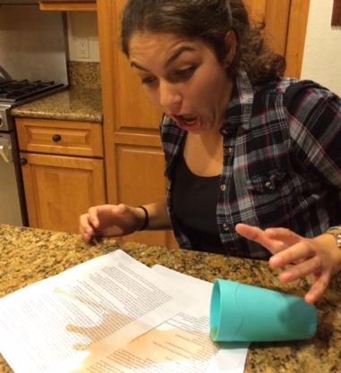

People make mistakes. Programmers thus make mistakes—lots of them. One kind of mistake, known as a ***syntax error***, is to violate a programming language's rules on how symbols can be combined to create a program. An example is forgetting to end a statement with a semicolon.

A compiler generates a message when encountering a syntax error. The following program is missing a semicolon after the first output statement.

Figure 1.3.1: Compiler reporting a syntax error.

|  |  |  |
| --- | --- | --- |
| 1:  2:  3:  4:  5:  6:  7:  8:  9: | #include <stdio.h>  **int** main(**void**) {  printf("Traffic today")  printf(" is very light\n");  **return** 0;  } | main.c:5:27: error: expected ';' after expression  printf("Traffic today")  ^  ;  1 error generated. |

Feedback?

Above, the 5 refers to the 5th line in the code, and the 27 refers to the 27th column in that line.

zyDE 1.3.1: Syntax errors often exist before the reported line.

Complete the program below by typing the following statement as your solution. Note: the statement is intentionally missing an ending semicolon -- don't add the semicolon yet.

printf("Hello")

Press Run, and notice that the error message is for a line that comes AFTER your statement, because that later line is where the compiler got confused.

Add the semicolon, and press Run again. Your program should work correctly now.

#include <stdio.h>

int main(void) {

printf("Hello");

return 0;

}

Run

Hello

Feedback?

**PARTICIPATIONACTIVITY**

1.3.1: Syntax errors.

Find the syntax errors. Assume variable numDogs has been declared.

1)

printf("%d", numDogs).

Error

**Correct**

Statements end with a semicolon, not period.

2)

printf("Dogs: %d" numDogs);

Error

**Correct**

Missing comma before numDogs.

3)

print("Everyone wins.");

Error

**Correct**

Should be printf, not print.

4)

printf("Hello friends!);

Error

No error

**Correct**

Missing the ending ", as in: printf("Hello friends!");

5)

printf("Amy // Michael");

No error

**Correct**

Some might think // creates a problem, but the compiler does not treat // as a comment when within a string literal.

6)

printf("%d", NumDogs);

Error

**Correct**

The declared variable was numDogs, not NumDogs. The compiler will report that NumDogs has not been declared.

7)

int numCats

numCats = 3;

printf("%d", numCats);

Error

**Correct**

Missing a semicolon after int numCats.

8)

printf(%d, numDogs);

Error

**Correct**

Missing quotes: "%d"

9)

printf("%d," numDogs);

Error

**Correct**

The comma should be *outside* the string literal, to separate the string from the numDogs variable.

Feedback?

**Unclear error messages**

Compiler error messages are often unclear or even misleading. The message is like the compiler's "best guess" of what is really wrong.

Figure 1.3.2: Misleading compiler error message.

|  |  |  |
| --- | --- | --- |
| 1:  2:  3:  4:  5:  6:  7:  8:  9: | #include <stdio.h>  **int** main(**void**) {  printf "Traffic today ";  printf("is very light.\n");  **return** 0;  } | main.c:5:9: error: expected ';' after expression  printf "Traffic today ";  ^  ; |

Feedback?

The compiler indicates a missing semicolon ';'. But the real error is the missing parentheses.

Sometimes the compiler error message refers to a line that is actually many lines past where the error actually occurred. Not finding an error at the specified line, the programmer should look to *previous* lines.

**PARTICIPATIONACTIVITY**

1.3.2: The compiler error message's line may be past the line with the actual error.

123

2x speed

1: Stmt

2: Stmt

3: Stmt-with-error

4: Stmt

5: Stmt

6: Stmt

Compiler processing

*Compiler message: Error at line 5*

Programmer should examine line 5

*and earlier lines.*

Upon not finding an error at line 5, the programmer should look at earlier lines.

1. The compiler hasn't yet detected the error.
2. Now the compiler is confused, so it generates a message. But the reported line number is past the actual syntax error.
3. Upon not finding an error at line 5, the programmer should look at earlier lines.

Feedback?

**PARTICIPATIONACTIVITY**

1.3.3: Unclear error messages.

1)

When a compiler says that an error exists on line 5, that line must have an error.

False

**Correct**

The error may actually exist in an earlier line, but the compiler didn't get confused until reaching line 5.

2)

If a compiler says that an error exists on line 90, the actual error may be on line 91, 92, etc.

False

**Correct**

The actual error may be in an earlier line, but the compiler wasn't able to realize the error immediately, so proceeds to subsequent lines, then gets confused and reports an error.

3)

If a compiler generates a specific message like "missing semicolon", then a semicolon must be missing somewhere, though maybe from an earlier line.

True

**Correct**

The actual error could be different, like missing parentheses. If a programmer makes a mistake, the statement and subsequent statements may still be valid code, but eventually the compiler cannot make sense of the code and generates an error message.

Feedback?

**Fixing the first error**

Some errors create an upsettingly long list of error messages. Good practice is to focus on fixing just the first error reported by the compiler and then recompiling. The remaining error messages may be real but are more commonly due to the compiler's confusion caused by the first error and are thus irrelevant.

Figure 1.3.3: Good practice for fixing errors reported by the compiler.

1. Focus on FIRST error message, ignoring the rest.
2. Look at reported line of first error message. If error found, fix. Else, look at previous few lines.
3. Compile, repeat.

Feedback?

zyDE 1.3.2: Fixing syntax errors.

Click run to compile, and note the long error list. Fix only the first error, then recompile. Repeat that process (fix first error, recompile) until the program compiles and runs.  *Expect* to see misleading error messages as well as errors that occur before the reported line number.

18

#include <stdio.h>

int main(void) {

int numBeans;

int numJars;

int totalBeans;

numBeans = 500;

numJars = 3;

printf("%d beans in ", numBeans);

printf("%d jars yields ", numJars);

totalBeans = numBeans * numJars;

printf("%d total\n", totalBeans);

return 0;

}

Run

500 beans in 3 jars yields 1500 total

Feedback?

**PARTICIPATIONACTIVITY**

1.3.4: Fixing the first error.

A compiler generates the following error messages:   
Line 7: Missing semicolon  
Line 9: numItems not defined  
Line 10: Expected '('

1)

The programmer should start by examining line _____.

7

**Correct**

The first error message refers to line 7. The programmer should focus on the first error message.

2)

If the programmer corrects an error on line 7, the programmer should _____.

compile

**Correct**

After finding the first error, the programmer should compile. Examining other errors often wastes time, since those may have stemmed from the first.

3)

If the programmer does NOT find an error on line 7, the programmer should check line _____.

6

**Correct**

Sometimes a compiler doesn't notice an error exists until getting confused on a later line. Thus, the programmer should check the previous line, and if an error isn't found there, check even earlier lines.

**CHALLENGEACTIVITY**

1.3.1: Basic syntax errors.

Type the statements. Then, correct the one syntax error in each statement. Hints: Statements end in semicolons, and string literals use double quotes. 

printf("Predictions are hard.\n";

printf("Especially ');

printf("about the future.\n").

printf("Num is: %d\n", userNum);

Your output

Predictions are hard.

Especially about the future.

Num is: 5

**CHALLENGEACTIVITY**

1.3.2: More syntax errors.

Retype the statements, correcting the syntax errors.

printf("Num: %d\n", songnum);

printf("%d\n", int songNum);

printf("%d songs\n" songNum);

#include <stdio.h>

int main(void) {

int songNum;

songNum = 5;

printf("Num: %d\n", songNum);

printf("%d\n", songNum);

printf("%d songs\n", songNum);

return 0;

}

**Logic errors**

Because a syntax error is detected by the compiler, a syntax error is known as a type of ***compile-time error***.

New programmers commonly complain: "The program compiled perfectly but isn't working." Successfully compiling means the program doesn't have compile-time errors, but the program may have other kinds of errors. A ***logic error***, also called a ***bug***, is an error that occurs while a program runs. For example, a programmer might mean to type numBeans * numJars but accidentally types numBeans + numJars (+ instead of *). The program would compile but would not run as intended.

Figure 1.3.4: Logic errors.

#include <stdio.h>

**int** main(**void**) {

**int** numBeans;

**int** numJars;

**int** totalBeans;

numBeans = 500;

numJars = 3;

printf("%d beans in ", numBeans);

printf("%d jars yields ", numJars);

totalBeans = numBeans + numJars; // Oops, used + instead of *

printf("%d total\n", totalBeans);

**return** 0;

}

Feedback?

zyDE 1.3.3: Fix the bug.

Click run to compile and execute and then note the incorrect program output. Fix the bug in the program.

Load default template...

1

2

3

4

5

6

7

8

9

10

11

12

13

14

15

16

17

18

19

20

#include <stdio.h>

// This program has a bug that causes a logic error.

// Can you find the bug?

int main(void) {

int numBeans;

int numJars;

int totalBeans;

numBeans = 500;

numJars = 3;

printf("%d beans in ", numBeans);

printf("%d jars yields ", numJars);

totalBeans = numBeans * numJars;

printf("%d total\n", totalBeans);

return 0;

}

Run

500 beans in 3 jars yields 1500 total

Feedback?

Bugs

The term *bug* to describe a runtime error was popularized when in 1947 engineers discovered their program on a Harvard University Mark II computer was not working because a moth was stuck in one of the relays (a type of mechanical switch). They taped the bug into their engineering log book, still preserved today ([The moth](http://americanhistory.si.edu/collections/search/object/nmah_334663)).

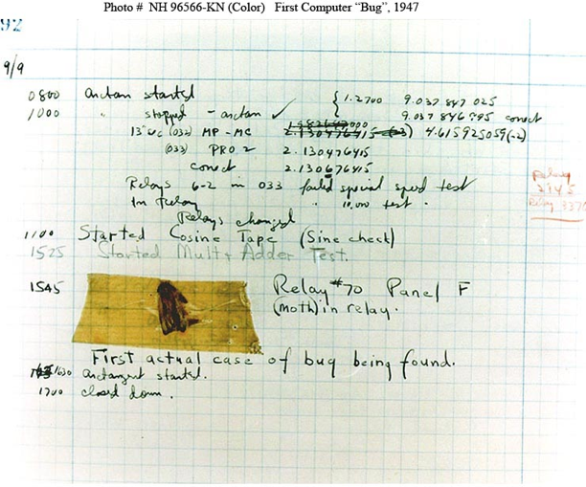

**Compiling frequently**

Good practice, especially for new programmers, is to compile after writing only a few lines of code, rather than writing tens of lines and then compiling. New programmers commonly write tens of lines before compiling, which may result in an overwhelming number of compilation errors and warnings and logic errors that are hard to detect and correct.

**PARTICIPATIONACTIVITY**

1.3.5: Compile and run after writing just a few statements.

12

2x speed

Compile & run

Compile & run

Compile & run

Compile & run

stmt1

stmt2

stmt3

stmt4

stmt5

stmt6

stmt7

stmt1

stmt2

stmt3

stmt4

stmt5

stmt6

stmt7

New programmers should compile and run programs after every few lines. Even experienced programmers compile and run frequently.

Captions

keyboard_arrow_up

1. Writing many lines of code without compiling and running is bad practice.
2. New programmers should compile and run programs after every few lines. Even experienced programmers compile and run frequently.

Feedback?

**PARTICIPATIONACTIVITY**

1.3.6: Compiling and running frequently.

1)

A new programmer writes 5 lines of code, compiles and runs, writes 5 more lines, and compiles and runs again. The programmer is _____ .

following good practice

**Correct**

Though beginning programmers may think such an approach wastes time, in fact the approach saves time. The approach enables faster detection and correction of errors. If multiple errors exist in large code, the errors may interact and be harder to detect and correct.

2)

An experienced programmer writes 80 lines of code and then compiles and runs. The programmer is probably _____ .

programming dangerously

**Correct**

Even experienced programmers tend to compile and run frequently. Errors are common, even for experienced programmers. 80 lines is probably dangerous, since errors may lurk in the code and be hard to find and correct.

Feedback?

**Compiler warnings**

A compiler will sometimes report a ***warning***, which doesn't stop the compiler from creating an executable program but indicates a possible logic error. Ex: Some compilers will report a warning like "Warning, dividing by 0 is not defined" if encountering code like: totalItems = numItems / 0 (running that program does result in a runtime error). Even though the compiler may create an executable program, good practice is to write programs that compile without warnings. In fact, many programmers recommend the good practice of configuring compilers to print even more warnings. For example, gcc can be run as  gcc -Wall yourfile.c.

**PARTICIPATIONACTIVITY**

1.3.7: Compiler warnings.

1)

A compiler warning by default will prevent a program from being created.

False

**Correct**

Unless the programmer specially configures the compiler, warnings will NOT prevent a program from being created; only errors will.

2)

Generally, a programmer should not ignore warnings.

True

**Correct**

Ignoring warnings can cause an important warning to be overlooked in the middle of less-important warnings. Writing code that generates no warnings is better.

3)

A compiler's default settings cause most warnings to be reported during compilation.

False

**Correct**

Default settings commonly do NOT report all important issues. Good practice is to explicitly configure the compiler to report most warnings.

1.4 Computers and programs (general)

info

This section has been set as optional by your instructor.

Figure 1.4.1: Looking under the hood of a car.

  
Source: zyBooks

Feedback?

Just as knowing how a car works "under the hood" has benefits to a car owner, knowing how a computer works under the hood has benefits to a programmer. This section provides a very brief introduction.

**Switches**

When people in the 1800s began using electricity for lights and machines, they created switches to turn objects on and off. A *switch* controls whether or not electricity flows through a wire. In the early 1900s, people created special switches that could be controlled electronically, rather than by a person moving the switch up or down. In an electronically controlled switch, a positive voltage at the control input allows electricity to flow, while a zero voltage prevents the flow. Such switches were useful, for example, in routing telephone calls. Engineers soon realized they could use electronically controlled switches to perform simple calculations. The engineers treated a positive voltage as a "1" and a zero voltage as a "0". 0s and 1s are known as ***bits*** (*b*inary dig*its*). They built connections of switches, known as *circuits*, to perform calculations such as multiplying two numbers.

**PARTICIPATIONACTIVITY**

1.4.1: A bit is either 1 or 0, like a light switch is either on or off (click the switch).

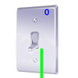

Feedback?

Figure 1.4.2: Early computer made from thousands of switches.

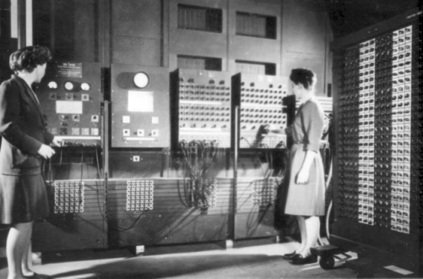  
Source: ENIAC computer ([U. S. Army Photo](http://ftp.arl.army.mil/ftp/historic-computers/)/ Public domain)

Feedback?

These circuits became increasingly complex, leading to the first electronic computers in the 1930s and 1940s, consisting of about ten thousand electronic switches and typically occupying entire rooms as in the above figure. Early computers performed thousands of calculations per second, such as calculating tables of ballistic trajectories.

**Processors and memory**

To support different calculations, circuits called ***processors*** were created to process (aka *execute*) a list of desired calculations, with each calculation called an ***instruction***. The instructions were specified by configuring external switches, as in the figure above. Processors used to take up entire rooms but today fit on a chip about the size of a postage stamp, containing millions or even billions of switches.

Figure 1.4.3: As switches shrunk, so did computers. The computer processor chip on the right has millions of switches.

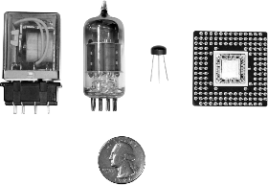  
Source: zyBooks

Feedback?

Instructions are stored in a memory. A ***memory*** is a circuit that can store 0s and 1s in each of a series of thousands of addressed locations, like a series of addressed mailboxes that each can store an envelope (the 0s and 1s). Instructions operate on data, which is also stored in memory locations as 0s and 1s.

Figure 1.4.4: Memory.

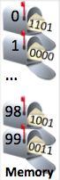

Feedback?

Thus, a computer is basically a processor interacting with a memory, as depicted in the following example. In the example, a computer's processor executes program instructions stored in memory, also using the memory to store temporary results. The example program converts an hourly wage ($20/hr) into an annual salary by multiplying by 40 (hours/week) and then by 50 (weeks/year), outputting the final result to the screen.

**PARTICIPATIONACTIVITY**

1.4.2: Computer processor and memory.

123

2x speed

Multiply 20 by 40

Multiply result by 50

Output result on screen

Memory

Processor

Multiply 20 by 40

800

Multiply result by 50

40000

Output result on screen

40000

Data can be output to the screen.

Captions

keyboard_arrow_up

1. The processor computes data, while the memory stores data (and instructions).
2. Previously computed data can be read from memory.
3. Data can be output to the screen.

Feedback?

The arrangement is akin to a chef (processor) who executes instructions of a recipe (program), each instruction modifying ingredients (data), with the recipe and ingredients kept on a nearby counter (memory).

**Instructions**

Below are some sample types of instructions that a processor might be able to execute, where *X*, *Y*, *Z*, and *num* are each an integer.

Table 1.4.1: Sample processor instructions.

|  |  |
| --- | --- |
| **Add X, #num, Y** | Adds data in memory location *X* to the number *num*, storing result in location *Y*. |
| **Sub X, #num, Y** | Subtracts *num* from data in location *X*, storing result in location *Y*. |
| **Mul X, #num, Y** | Multiplies data in location *X* by *num*, storing result in location *Y*. |
| **Div X, #num, Y** | Divides data in location *X* by *num*, storing result in location *Y*. |
| **Jmp Z** | Tells the processor that the next instruction to execute is in memory location *Z*. |

Feedback?

For example, the instruction "Mul 97, #9, 98" would multiply the data in memory location 97 by the number 9, storing the result into memory location 98. So if the data in location 97 were 20, then the instruction would multiply 20 by 9, storing the result 180 into location 98. That instruction would actually be stored in memory as 0s and 1s, such as "011 1100001 001001 1100010", where 011 specifies a multiply instruction and 1100001, 001001, and 1100010 represent 97, 9, and 98 (as described previously). The following animation illustrates the storage of instructions and data in memory for a program that computes F = (9*C)/5 + 32, where C is memory location 97 and F is memory location 99.

**PARTICIPATIONACTIVITY**

1.4.3: Memory stores instructions and data as 0s and 1s.

12

2x speed

011 1100001 001001 1100010

100 1100010 000101 1100010

001 1100010 100000 1100011

101 00000000000000000000

??

??

00000000000000000010100

??

??

Mul

Div 98, #5, 98

Add 98, #32, 99

Jmp 0

97,

98

#9,

Meaning

20

Location

Memory

0

1

2

3

4

96

97

98

99

011 1100001 001001 1100010

100 1100010 000101 1100010

001 1100010 100000 1100011

101 00000000000000000000

00000000000000000010100

...

0

1

2

3

4

Mul 97, #9, 98

Div 98, #5, 98

Add 98, #32, 99

Jmp 0

20

??

96

97

98

99

??

??

??

??

??

??

??

Location

Memory

The material will commonly draw the memory with the corresponding instructions and data to improve readability.

Captions

keyboard_arrow_up

1. Memory stores instructions and data as 0s and 1s.
2. The material will commonly draw the memory with the corresponding instructions and data to improve readability.

Feedback?

The programmer-created sequence of instructions is called a ***program***, ***application***, or just ***app***.

When powered on, the processor starts by executing the instruction at location 0, then location 1, then location 2, etc. The above program performs the calculation over and over again. If location 97 is connected to external switches and location 99 to external lights, then a computer user (like the women operating the ENIAC computer in the earlier picture) could set the switches to represent a particular Celsius number, and the computer would automatically output the Fahrenheit number using the lights.

**PARTICIPATIONACTIVITY**

1.4.4: Processor executing instructions.

1234

2x speed

Processor

0

1

2

3

4

96

97

98

99

Mul 97, #9, 98

Div 98, #5, 98

Add 98, #32, 99

Jmp 0

...

??

20

??

??

Next:

0

0

Mul 97, #9, 98

20

*

9

-->

180

180

1

1

Div 98, #5, 98

180

/ 5

--> 36

36

2

2

Add 98, #32, 99

36

+ 32

32

--> 68

68

3

3

Jmp 0

0

0

Mul 97, #9, 98

20 * 9

--> 180

180

The processor executes the instruction at location 0, performing the same sequence of instructions over and over again.

Captions

keyboard_arrow_up

1. The processor starts by executing the instruction at location 0.
2. The processor next executes the instruction at location 1, then location 2. 'Next' keeps track of the location of the next instruction.
3. The Jmp instruction indicates that the next instruction to be executed is at location 0, so 0 is assigned to 'Next'.
4. The processor executes the instruction at location 0, performing the same sequence of instructions over and over again.

Feedback?

**PARTICIPATIONACTIVITY**

1.4.5: Computer basics.

1)

A bit can only have the value of 0 or 1.

True

False

**Correct**

The 0 or 1 comes from the fact that computer circuits are built from connections of switches that either allow or block the flow of electricity.

2)

Switches have gotten larger over the years.

True

False

3)

A memory stores bits.

True

False

4)

The computer inside a modern smartphone would have been huge 30 years ago.

True

False

5)

A processor executes instructions like Add 200, #9, 201, represented as 0s and 1s.

True

False

Feedback?

**Writing computer programs**

In the 1940s, programmers originally wrote each instruction using 0s and 1s, such as "001 1100001 001001 1100010". Instructions represented as 0s and 1s are known as ***machine instructions***, and a sequence of machine instructions together form an ***executable program***(sometimes just called an *executable*). Because 0s and 1s are hard to comprehend, programmers soon created programs called *assemblers* to automatically translate human readable instructions, such as "Mul 97, #9, 98", known as ***assembly*** language instructions, into machine instructions. The assembler program thus helped programmers write more complex programs.

In the 1960s and 1970s, programmers created ***high-level languages*** to support programming using formulas or algorithms, so a programmer could write a formula like: F = (9 /5 ) * C + 32. Early high-level languages included *FORTRAN* (for "Formula Translator") or *ALGOL* (for "Algorithmic Language"), which were more closely related to how humans thought than were machine or assembly instructions.

To support high-level languages, programmers created ***compilers***, which are programs that automatically translate high-level language programs into executable programs.

**PARTICIPATIONACTIVITY**

1.4.6: Program compilation and execution.

Start

2x speed

put "Enter wage: "

hourlyWage = Get next input

put "Salary is: "

put (hourlyWage * 40 * 50)

...

011 1100001 001001 1100010

100 1100010 000101 1100010

011 1100010 100000 1100011

011 1100001 001001 1100010

...

High level

program

myfile.txt

Executable

program

myfile.exe

*(Not human readable)*

>

myfile.exe

Enter wage:

20

Salary is: 40000

>

**PARTICIPATIONACTIVITY**

1.4.7: Programs.

**Compiler**

Translates a high-level language program into low-level machine instructions.

A compiler ensures a program is valid according to the language's rules, performs optimizations, then converts to the low-level machine instructions.

**Correct**

**Application**

Another word for program.

The programmer-created sequence of instructions is called a program, application, or just app.

**Correct**

**Machine instruction**

A series of 0s and 1s, stored in memory, that tells a processor to carry out a particular operation like a multiplication.

0s and 1s are hard to comprehend. Most programmers specify the program's functionality in a high-level language, which is then automatically translated to low-level machine instructions.

**Correct**

**Assembly language**

Human-readable processor instructions.

An assembler is a program that translates assembly language instructions into machine instructions.

**Correct**

Note (mostly for instructors): Why introduce machine-level instructions in a high-level language book? Because a basic understanding of how a computer executes programs can help students master high-level language programming. The concept of sequential execution (one instruction at a time) can be clearly made with machine instructions. Even more importantly, the concept of each instruction operating on data in memory can be clearly demonstrated. Knowing these concepts can help students understand the idea of assignment (x = x + 1) as distinct from equality, why x = y; y = x does not perform a swap, what a pointer or variable address is, and much more.

# 1.5 Language history

info

This section has been set as optional by your instructor.

In 1978, Brian Kernighan and Dennis Ritchie at AT&T Bell Labs (which used computers extensively for automatic phone call routing) published a book describing a new high-level language with the simple name ***C***, being named after another language called B (whose name came from a language called BCPL). C became the dominant programming language in the 1980s and 1990s.

In 1985, Bjarne Stroustrup published a book describing a C-based language called ***C++***, adding constructs to support a style of programming known as *object-oriented programming*, along with other improvements. The unusual ++ part of the name comes from ++ being an operator in C that increases a number, so the name C++ suggests an increase or improvement over C.

A June 2019 survey ranking language by their popularity yielded the following:

Table 1.5.1: Top languages ranked by popularity.

|  |  |
| --- | --- |
| Language | Usage by percentage |
| Java | 15% |
| C | 13% |
| Python | 9% |
| C++ | 7% |
| Visual Basic .NET | 5% |
| C# | 4% |
| JavaScript | 3% |
| PHP | 3% |
| SQL | 2% |
| Assembly language | 1% |
| Swift | 1% |

(Source:[https://www.tiobe.com/tiobe-index/](http://www.tiobe.com/tiobe-index/), 2019)

Feedback?

**PARTICIPATIONACTIVITY**

1.5.1: C/C++ history.

1)

In what year was the first C book published?

CheckShow answer

**Correct**

1978

C became the dominant language of the 1980s and 1990s.

2)

In what year was the first C++ book published?

CheckShow answer

**Correct**

1985

C++ added object-oriented constructs to C, among other things.

3)

According to the above table, C, C++, and C# account for what percentage of programming related searches?

CheckShow answer

**Correct**

24%

C++ is a C-based language. C# is more similar to Java

1.6 C example: Salary calculation

This material has a series of sections providing increasingly larger program examples. The examples apply concepts from earlier sections. Each example is in a web-based programming environment so that code may be executed. Each example also suggests modifications, to encourage further understanding of the example. Commonly, the "solution" to those modifications can be found in the series' next example.

This section contains a very basic example for starters; the examples increase in size and complexity in later sections.

zyDE 1.6.1: Modify salary calculation.

The following program calculates yearly and monthly salary given an hourly wage. The program assumes a work-hours-per-week of 40 and work-weeks-per-year of 50.

1. Insert the correct number in the code below to print a monthly salary. Then run the program.

#include <stdio.h>

int main(void) {

int hourlyWage;

hourlyWage = 20;

printf("Annual salary is: ");

printf("%d", hourlyWage * 40 * 50);

printf("\n");

printf("Monthly salary is: ");

printf("%d", ((hourlyWage * 40 * 50) / 1));

// FIXME: The above is wrong. Change the 1 so the statement prints monthly salary.

return 0;

}

Annual salary is: 40000

Monthly salary is: 40000

1.7 zyLab training: Basics

While the zyLab platform can be used without training, a bit of training may help some students avoid common issues.

The assignment is to get an integer from input, and output that integer squared, ending with newline. (Note: This assignment is configured to have students programming directly in the zyBook. Instructors may instead require students to upload a file). Below is a program that's been nearly completed for you.

1. Click "Run program". The output is wrong. Sometimes a program lacking input will produce wrong output (as in this case), or no output. Remember to always pre-enter needed input.
2. Type 2 in the input box, then click "Run program", and note the output is 4.
3. Type 3 in the input box instead, run, and note the output is 6.

When students are done developing their program, they can submit the program for automated grading.

1. Click the "Submit mode" tab
2. Click "Submit for grading".
3. The first test case failed (as did all test cases, but focus on the first test case first). The highlighted arrow symbol means an ending newline was expected but is missing from your program's output.

Matching output exactly, even whitespace, is often required. Change the program to output an ending newline.

1. Click on "Develop mode", and change the output statement to output a newline: printf("%d", userNumSquared);. Type 2 in the input box and run.
2. Click on "Submit mode", click "Submit for grading", and observe that now the first test case passes and 1 point was earned.

The last two test cases failed, due to a bug, yielding only 1 of 3 possible points. Fix that bug.

1. Click on "Develop mode", change the program to use * rather than +, and try running with input 2 (output is 4) and 3 (output is now 9, not 6 as before).
2. Click on "Submit mode" again, and click "Submit for grading". Observe that all test cases are passed, and you've earned 3 of 3 points.

#include <stdio.h>

int main(void) {

int userNum;

int userNumSquared;

scanf("%d", &userNum);

userNumSquared = userNum * userNum; // Bug here; fix it when instructed

printf("%d\n", userNumSquared); // Output formatting issue here; fix it when instructed

return 0;

}

1.8 LAB: Warm up: Basic output with variables

*This zyLab activity prepares a student for a full programming assignment. Warm up exercises are typically simpler and worth fewer points than a full programming assignment, and are well-suited for an in-person scheduled lab meeting or as self-practice.*

A variable like userNum can store a value like an integer. Extend the given program as indicated.

1. Output the user's input. (2 pts)
2. Output the input squared and cubed. *Hint: Compute squared as userNum * userNum.* (2 pts)
3. Get a second user input into userNum2, and output the sum and product. (1 pt)

*Note: This zyLab outputs a newline after each user-input prompt. For convenience in the examples below, the user's input value is shown on the next line, but such values don't actually appear as output when the program runs.*

Enter integer:

4

You entered: 4

4 squared is 16

And 4 cubed is 64!!

Enter another integer:

5

4 + 5 is 9

4 * 5 is 20

**LABACTIVITY**

1.8.1: LAB: Warm up: Basic output with variables

#include <stdio.h>

#include <math.h>

int main(void) {

int userNum;

int userNum2;

printf("Enter integer:\n");

scanf("%d", &userNum);

scanf("%d", &userNum2);

printf("You entered: %d\n", userNum);

printf("%d squared is %d\n", userNum, userNum * userNum);

printf("And %d cubed is %d!!\n", userNum, userNum * userNum * userNum);

printf("Enter another integer:\n");

printf("%d + %d is %d\n", userNum, userNum2, (userNum + userNum2));

printf("%d * %d is %d\n", userNum, userNum2, userNum * userNum2);

return 0;

}

1.9 zyLab training: Interleaved input / output

info

This section has been set as optional by your instructor.

Auto-graded programming assignments have numerous advantages, but have some challenges too. Students commonly struggle with realizing that example input / output provided in an assignment's specification interleaves input and output, but the program *should only output the output parts*. If a program should double its input, an instructor might provide this example:

Enter x:

5

x doubled is: 10

Students often incorrectly create a program that outputs the 5. Instead, the program should only output the output parts:

Enter x:

x doubled is: 10

The instructor's example is showing both the output of the program, AND the user's input to that program, assuming the program is developed in an environment where a user is interacting with a program. But the program itself doesn't output the 5 (or the newline following the 5, which occurs when the user types 5 and presses enter).

Also, if the instructor configured the test cases to observe whitespace, then according to the above example, the program should output a newline after Enter x: (and possibly after the 10, if the instructor's test case expects that).

The program below *incorrectly* echoes the user's input to the output.

1. Try submitting it for grading (click "Submit mode", then "Submit for grading"). Notice that the test cases fail. The first test case's highlighting indicates that output 3 and newline were not expected. In the second test case, the -5 and newline were not expected.
2. Remove the code that echoes the user's input back to the output, and submit again. Now the test cases should all pass.

**LABACTIVITY**

1.9.1: zyLab training: Interleaved input / output

#include <stdio.h>

int main(void) {

int x;

printf("Enter x: \n");

scanf("%d", &x);

//printf("%d\n", x); // Student mistakenly is echo'ing the input to output to match example

printf("x doubled is: %d\n", 2 * x);

return 0;

}

# 1.10 LAB: Formatted output: Hello World!

info

This section has been set as optional by your instructor.

Write a program that outputs "Hello World!" For ALL labs, end with newline (unless otherwise stated).

**LABACTIVITY**

1.10.1: LAB: Formatted output: Hello World!

#include <stdio.h>

int main(void) {

printf("Hello World!\n");

return 0;

}

# 1.11 LAB: Formatted output: No parking sign

info

This section has been set as optional by your instructor.

Write a program that prints a formatted "No parking" sign as shown below. Note the first line has two leading spaces. For ALL labs, end with newline (unless otherwise stated).

NO PARKING

2:00 - 6:00 a.m.

**LABACTIVITY**

1.11.1: LAB: Formatted output: No parking sign

#include <stdio.h>

int main(void) {

printf(" NO PARKING\n2:00 - 6:00 a.m.\n");

return 0;

}

2.1 Variables (int)

**Variable declarations**

A ***variable declaration*** is a statement that declares a new variable, specifying the variable's name and type. Ex: int userAge; declares a new variable named userAge that can hold an integer value. The compiler allocates a memory location for userAge capable of storing an integer. Ex: In the animation below, the compiler allocated userAge to memory location 97, which is known as the variable's address. The choice of 97 is arbitrary and irrelevant to the programmer, but the idea that a variable corresponds to a memory location is important to understand.

When a statement that assigns a variable with a value executes, the processor writes the value into the variable's memory location. Likewise, reading a variable's value reads the value from the variable's memory location. The programmer must declare a variable before any statement that assigns or reads the variable, so that the variable's memory location is known.

**PARTICIPATIONACTIVITY**

2.1.1: A variable refers to a memory location.

1234

2x speed

#include <stdio.h>

**int** main(**void**) {

**int** userAge;

printf("Enter your age: ");

scanf("%d", &userAge);

printf("%d", userAge);

printf(" is a great age.\n");

**return** 0;

}

Memory

96

97

98

99

userAge

Enter your age:

23

23

23

is a great age.

printf() prints userAge's value to screen.

Captions

keyboard_arrow_up

1. Compiler allocates a memory location for userAge, in this case location 97.
2. First printf statement executes.
3. User types 23, scanf() assigns userAge with 23.
4. printf() prints userAge's value to screen.

Feedback?

**PARTICIPATIONACTIVITY**

2.1.2: Declaring integer variables.

Note: Capitalization matters, so MyNumber is not the same as myNumber.

1)

Declare an integer variable named numPeople. (Do not initialize the variable.)

CheckShow answer

**Correct**

int numPeople;

The compiler will allocate a particular memory location for numPeople.

2)

Using two statements on separate lines, declare integer variables named newSales and totalSales. (Do not initialize the variables.)

CheckShow answer

**Correct**

int newSales; int totalSales;

Multiple variables can be declared in the same statement, as in: int newSales, totalSales;, but this material usually avoids that style.

3)

What memory location (address) will a compiler allocate for the variable declaration below? If appropriate, type: Unknown

int numHouses = 99;

CheckShow answer

**Correct**

Unknown

A programmer does not know the specific location, but understanding that a specific location is allocated for a variable is important.

Feedback?

Compiler optimization

*Modern compilers may optimize variables away, allocate variables on the stack, or use registers for variables. However, the conceptual view of a variable in memory helps understand many language aspects.*

**Assignment statements**

An ***assignment statement*** assigns the variable on the left-side of the = with the current value of the right-side expression. Ex: numApples = 8; assigns numApples with the value of the right-side expression (in this case 8). assign

An ***expression*** may be a number like 80, a variable name like numApples, or a simple calculation like numApples + 1. Simple calculations can involve standard math operators like +, -, and *, and parentheses as in 2 * (numApples - 1). An integer like 80 appearing in an expression is known as an ***integer literal***.



In the code below, litterSize is assigned with 3, and yearlyLitters is assigned with 5. Later, annualMice is assigned with the value of litterSize * yearlyLitters (3 * 5, or 15), which is then printed. Next, litterSize is assigned with 14, yearlyLitters is assigned with 10, and annualMice is assigned with their product (14 * 10, or 140), which is printed.

Figure 2.1.1: Assigning a variable.

|  |  |
| --- | --- |
| #include <stdio.h>  **int** main(**void**) {  **int** litterSize;  **int** yearlyLitters;  **int** annualMice;    litterSize = 3; // Low end of litter size range  yearlyLitters = 5; // Low end of litters per year    printf("One female mouse may give birth to ");  annualMice = litterSize * yearlyLitters;  printf("%d mice,\n", annualMice);    litterSize = 14; // High end  yearlyLitters = 10; // High end  printf("and up to ");  annualMice = litterSize * yearlyLitters;  printf("%d mice, in a year.\n", annualMice);    **return** 0;  } | One female mouse may give birth to 15 mice,  and up to 140 mice, in a year. |

Feedback?

**PARTICIPATIONACTIVITY**

2.1.3: Assignment statements.

Be sure to end assignment statements with a semicolon (;).

1)

Write an assignment statement to assign numCars with 99.

CheckShow answer

**Correct**

numCars = 99;

The statement assigns the variable numCars with the value 99.

2)

Assign houseSize with 2300.

CheckShow answer

**Correct**

houseSize = 2300;

The program assigns the variable houseSize with the value 2300.

3)

Assign numFruit with the current value of numApples.

CheckShow answer

**Correct**

numFruit = numApples;

The program evaluates the value of numApples by reading the value held in numApples' memory location, and then assigns numFruit with that value.

4)

The current value in houseRats is 200. What is in houseRats after executing the statement below? Valid answers: 0, 199, 200, or unknown.

numRodents = houseRats;

CheckShow answer

**Correct**

200

The statement evaluates the value of houseRats by reading the value held in houseRats' memory location, and stores a copy of that value into numRodents. houseRats doesn't change.

5)

Assign numItems with the result of ballCount - 3.

CheckShow answer

**Correct**

numItems = ballCount - 3;

The program reads the value of ballCount, subtract 3 from that value, and assigns numItems with the result.

6)

dogCount is 5. What is in animalsTotal after executing the statement below?

animalsTotal = dogCount - 3;

CheckShow answer

**Correct**

2

The statement reads the value of dogCount (5), subtracts 3, and assigns animalsTotal with the result of 2.

7)

dogCount is 5. What is in dogCount after executing the statement below?

animalsTotal = dogCount - 3;

CheckShow answer

**Correct**

5

The statement reads the value of dogCount, but does not change the value of dogCount.

8)

What is in numBooks after both statements execute?

numBooks = 5;

numBooks = 3;

CheckShow answer

**Correct**

3

The first statement assigns numBooks with 5. The second statement assigns numBooks with 3, replacing the previously held value 5.

Feedback?

**CHALLENGEACTIVITY**

2.1.1: Enter the output of the variable assignments.

Jump to level 1

Type the program's output

|  |  |
| --- | --- |
| #include <stdio.h>  **int** main**(void)** {  **int** x;  **int** y;  y = 4;  x = y + 1;  y = 14;    printf("%d %d", x, y);  **return** 0;  } |  |

1

2

3

4

5

**6**

Check

Next

**Done**. Click any level to practice more. Completion is preserved.



x is assigned to the value of a plus a literal, then y is assigned to a literal.

|  |  |
| --- | --- |
| Yours | 5 14 |
| Expected | 5 14 |

1

**CHALLENGEACTIVITY**

2.1.2: Assigning a sum.

Write a statement that assigns numCoins with numNickels + numDimes. Ex: 5 nickels and 6 dimes results in 11 coins.  
  
Note: These activities may test code with different test values. This activity will perform two tests: the first with nickels = 5 and dimes = 6, the second with nickels = 9 and dimes = 0. See [How to Use zyBooks](https://learn.zybooks.com/zybook/HowToUseZyBooks2/chapter/1/section/3).

#include <stdio.h>

int main(void) {

int numCoins;

int numNickels;

int numDimes;

numNickels = 5;

numDimes = 6;

numCoins = numNickels + numDimes;

printf("There are %d coins\n", numCoins);

return 0;

}

### Initializing variables

Although not required, an integer variable is often assigned an initial value when declared. Ex: int maxScore = 100; declares an int variable named maxScore with an initial value of 100.

Figure 2.1.2: Variable initialization: Example program.

#include <stdio.h>

**int** main(**void**) {

**int** avgLifespan = 70;

**int** userAge;

printf("Enter your age: ");

scanf("%d", &userAge);

printf("%d is a great age\n", userAge);

printf("Average lifespan is %d\n", avgLifespan);

**return** 0;

}

Enter your age: 24

24 is a great age

Average lifespan is 70

**PARTICIPATIONACTIVITY**

2.1.4: Declaring and initializing integer variables.

1)

Declare an integer variable named numDogs, initializing the variable to 0 in the declaration.

CheckShow answer

**Correct**

int numDogs = 0;

The compiler will allocate a particular memory location for numDogs, and initially store 0 in that location.

2)

Declare an integer variable named daysCount, initializing the variable to 365 in the declaration.

CheckShow answer

**Correct**

int daysCount = 365;

The compiler will allocate a particular memory location for daysCount, and initially store 365 in that location.

**CHALLENGEACTIVITY**

2.1.3: Declaring and initializing variables.

Write one statement that declares an integer variable numHouses initialized to 25.

#include <stdio.h>

int main(void) {

int numHouses = 25;

printf("%d\n",numHouses);

return 0;

}

### Assignment statement with same variable on both sides

Commonly, a variable appears on both the right and left side of the = operator. Ex: If numItems is 5, after numItems = numItems + 1 executes, numItems will be 6. The statement reads the value of numItems (5), adds 1, and assigns numItems with the result of 6, which replaces the value previously held in numItems.

**PARTICIPATIONACTIVITY**

2.1.5: Variable assignments overwrite a variable's previous values: People-known example.

12345678

2x speed

#include <stdio.h>

**int** main(**void**) {

**int** yourFriends;

**int** totalFriends;

printf("Enter the number of people you know: ");

scanf("%d", &yourFriends);

totalFriends = yourFriends;

printf(" You know %d people.\n", totalFriends);

totalFriends = totalFriends * yourFriends;

printf(" Those people know %d people.\n", totalFriends);

totalFriends = totalFriends * yourFriends;

printf(" And they know %d people.\n\n", totalFriends);

**return** 0;

}

96

97

98

99

??

??

??

??

yourFriends

totalFriends

Enter the number of people you know:

200

200

200

You know

200

people.

200

200

40000

Those people know

40000

people.

40000

200

8000000

And they know

8000000

people.

*

*

Assignment reads totalFriends (now 40000) and yourFriends (200), multiplies those values, and assigns totalFriends with the result of 8000000.

Captions

keyboard_arrow_up

1. The compiler allocated memory for variables.
2. Prompt user with printf.
3. The scanf statement assigns yourFriends with user input.
4. totalFriends is assigned with the value of yourFriends.
5. The printf statement outputs totalFriends.
6. The assignment statement reads totalFriends (200) and yourFriends (200), multiplies those values, and assigns totalFriends with the product of 40000.
7. The printf statement outputs totalFriends.
8. Assignment reads totalFriends (now 40000) and yourFriends (200), multiplies those values, and assigns totalFriends with the result of 8000000.

Six degrees of separation

*The above example relates to the popular idea that any two people on earth are connected by just "six degrees of separation", accounting for overlapping of known-people.*

**PARTICIPATIONACTIVITY**

2.1.6: Assignment statements with same variable on both sides.

1)

numApples is initially 5. What is numApples after:

numApples = numApples + 3;

CheckShow answer

**Correct**

8

The statement reads the current value of numApples (5), adds 3, and assign numApples with the result of 8.

2)

numApples is initially 5. What is numFruit after:

numFruit = numApples;

numFruit = numFruit + 1;

CheckShow answer

**Correct**

6

The first statement assigns numFruit with 5. The second statement reads numFruit (5), adds 1, and assigns numFruit with the result of 6.

3)

Write a statement ending with - 1 that decreases variable flyCount's value by 1.

CheckShow answer

**Correct**

flyCount = flyCount - 1;

The statement reads the value of flyCount, subtracts 1, and assigns flyCount with the result (overwriting the previous value).

**CHALLENGEACTIVITY**

2.1.4: Adding a number to a variable.

Write a statement that increases numPeople by 5. If numPeople is initially 10, then numPeople becomes 15.

#include <stdio.h>

int main(void) {

int numPeople;

scanf("%d", &numPeople);

numPeople = numPeople + 5;

printf("There are %d people.\n", numPeople);

return 0;

}

### Common errors

A common error is to read a variable that has not yet been assigned a value. If a variable is declared but not initialized, the variable's memory location contains some unknown value, commonly but not always 0. A program with an uninitialized variable may thus run correctly on a system that has 0 in the memory location, but then fail on a different system—a very difficult bug to fix. A programmer must ensure that a program assigns a variable with a value before reading.

A common error by new programmers is to write an assignment statement in reverse. Ex: numKids + numAdults = numPeople, or 9 = beansCount. Those statements won't compile, but writing numCats = numDogs in reverse *will* compile, leading to a hard-to-find bug.

**PARTICIPATIONACTIVITY**

2.1.7: Common errors.

Which code segments have an error?

1)

21 = dogCount;

Error

**Correct**

The statement will not compile because the left side must be a variable. The programmer likely meant to write  dogCount = 21;

2)

**int** amountOwed = -999;

No error

**Correct**

A variable can be initialized when declared, and an int variable can hold negative values.

3)

**int** numDays;

**int** numYears;

numDays = numYears * 365;

Error

**Correct**

numYears is used without having been assigned with a value, so the value of numYears is unknown. Most modern compilers check if a variable is used before being assigned with a value, reporting an error or warning.

Feedback?

(*assign) We ask instructors to give us leeway to teach the idea of an "assignment statement," rather than the language's actual "assignment expression," whose use we condone primarily in a simple statement.

**PARTICIPATIONACTIVITY**

2.2.2: Valid identifiers.

Which are valid identifiers?

1)

numCars

Valid

**Correct**

Letters are always valid (upper or lower case).

2)

num_Cars1

Valid

**Correct**

An underscore is treated as a letter.

3)

_numCars

Valid

**Correct**

The underscore can be in the first position just like any other letter.

4)

___numCars

Valid

**Correct**

Two or more underscores may look strange, but the underscore is just like any other letter and can be repeated. However, convention is to not use more than one underscore.

5)

3rdPlace

Invalid

**Correct**

Identifiers must start with a letter.

6)

thirdPlace_

Valid

**Correct**

Ending with an underscore is okay.

7)

thirdPlace!

Invalid

**Correct**

"!" is not allowed.

8)

short

Invalid

**Correct**

"short" is a language keyword so it can't be used as an identifier.

9)

very tall

Invalid

**Correct**

Spaces are not allowed. Instead, an underscore can be used (very_tall) or the words can be abutted (veryTall).

**Style guidelines for identifiers**

While various (crazy-looking) identifiers may be valid, programmers may follow identifier naming conventions (style) defined by their company, team, teacher, etc. Two common conventions for naming variables are:

* Camel case: ***Lower camel case*** abuts multiple words, capitalizing each word except the first, as in numApples or peopleOnBus.
* Underscore separated: Words are lowercase and separated by an underscore, as in num_apples or people_on_bus.

Neither convention is better. The key is to be consistent so code is easier to read and maintain.

Good practice is to create meaningful identifier names that self-describe an item's purpose.Good practice minimizes use of abbreviations in identifiers except for well-known ones like num in numPassengers. Programmers must strive to find a balance. Abbreviations make programs harder to read and can lead to confusion. Long variable names, such as averageAgeOfUclaGraduateStudent may be meaningful, but can make subsequent statements too long and thus hard to read.

**PARTICIPATIONACTIVITY**

2.2.3: Meaningful identifiers.

Choose the "best" identifier for a variable with the stated purpose, given the above discussion.

1)

The number of students attending UCLA.

num

numStdsUcla

numStudentsUcla

numberOfStudentsAttendingUcla

**Correct**

Ucla is likely a well-known abbreviation, so shouldn't cause a problem.

2)

The size of an LCD monitor

size

sizeLcdMonitor

s

sizeLcdMtr

**Correct**

Lcd is abbreviated but may be OK.

3)

The number of jelly beans in a jar.

numberOfJellyBeansInTheJar

jellyBeansInJar

nmJlyBnsInJr

**Correct**

Looks OK. Could start with num, but should be fine as is.

Feedback?

zyBook's naming conventions

*Lower camel case is used for variable naming.  This material strives to follow another good practice of using two or more words per variable such as numStudents rather than just students, to provide meaningfulness, to make variables more recognizable when variable names appear in writing like in this text or in a comment, and to reduce conflicts with reserved words or other already-defined identifiers.*

Table 2.2.1: C reserved words / keywords.

|  |  |  |  |
| --- | --- | --- | --- |
| auto  break  case  char  const  continue  default  do  double  else  enum  extern | float  for  goto  if  inline   (since C99) int  long  register  restrict   (since C99) return  short | signed  sizeof  static  struct  switch  typedef  union  unsigned  void  volatile  while | _Alignas   (since C11) _Alignof   (since C11) _Atomic   (since C11) _Bool   (since C99) _Complex   (since C99) _Generic   (since C11) _Imaginary   (since C99) _Noreturn   (since C11) _Static_assert   (since C11) _Thread_local   (since C11) |

[2.2 Identifiers](https://learn.zybooks.com/zybook/UTSACS1714Fall2020/chapter/2/section/2)

2.3 Arithmetic expressions (general)

info

This section has been set as optional by your instructor.

**Basics**

An ***expression*** is a combination of items, like variables, literals, operators, and parentheses, that evaluates to a value, like 2 * (x + 1). A common place where expressions are used is on the right side of an assignment statement, as in y = 2 * (x + 1).

A ***literal*** is a specific value in code like 2. An ***operator*** is a symbol that performs a built-in calculation, like +, which performs addition. Common programming operators are shown below.

Table 2.3.1: Arithmetic operators.

|  |  |
| --- | --- |
| Arithmetic operator | Description |
| + | The ***addition*** operator is ***+***, as in x + y. |
| - | The ***subtraction*** operator is ***-***, as in x - y. Also, the - operator is for ***negation***, as in -x + y, or x + -y. |
| * | The ***multiplication*** operator is ***\****, as in x * y. |
| / | The ***division*** operator is ***/***, as in x / y. |

Feedback?

**PARTICIPATIONACTIVITY**

2.3.1: Expressions.

Indicate which are valid expressions. x and y are variables, and are the only available variables.

1)

x + 1

Valid

**Correct**

The text consists of a variable (x), operator (+), and literal (1). If x is 5, the expression evaluates to 5 + 1 or 6.

2)

2 * (x - y)

Valid

**Correct**

The text consists of a literal (2), two operators (*, -), and two variables (x, y), properly combined with parentheses. If x is 7 and y is 3, the expression evaluates to 2 * (7 - 3), or 2 * (4), so 8.

3)

x

Valid

**Correct**

An expression can just be a variable.

4)

2

Valid

**Correct**

An expression can just be a literal.

5)

2x

Not valid

**Correct**

In programming, multiplication typically must be indicated explicitly using the * operator. Abutment is allowed in math, but not usually in programming.

6)

2 + (xy)

Not valid

**Correct**

In programming, doing multiplication via abutment, as in xy, is not usually allowed, because xy could be the name of another variable.

7)

x - -2

Valid

**Correct**

The first - represents subtraction, while the second - represents negation. If x were 5, the expression would evaluate to 7.

Feedback?

**PARTICIPATIONACTIVITY**

2.3.2: Capturing behavior with an expression.

Does the expression correctly capture the intended behavior?

1)

6 plus numItems:  
  
6 + numItems

Yes

**Correct**

Straightforward addition.

2)

6 times numItems:  
  
6 x numItems

No

**Correct**

The multiplication operator is *, not x.

3)

totDays divided by 12:   
  
totDays / 12

Yes

**Correct**

Straightforward division.

4)

5 times i:   
  
5i

No

**Correct**

Abutment not allowed. Requires 5 * i.

5)

The negative of userVal:    
  
-userVal

Yes

**Correct**

- serves as subtraction, but also negation.

6)

n factorial   
  
n!

No

**Correct**

Most languages don't use the ! symbol for factorial.

Feedback?

**Evaluation of expressions**

An expression ***evaluates*** to a value, which replaces the expression. Ex: If x is 5, then x + 1 evaluates to 6, and y = x + 1 assigns y with 6.

An expression is evaluated using the order of standard mathematics, such order known in programming as  ***precedence rules***, listed below.

Table 2.3.2: Precedence rules for arithmetic operators.

|  |  |  |
| --- | --- | --- |
| Operator/Convention | Description | Explanation |
| **( )** | Items within parentheses are evaluated first | In 2 * (x + 1), the x + 1 is evaluated first, with the result then multiplied by 2. |
| **unary -** | - used for negation (unary minus) is next | In 2 * -x, the -x is computed first, with the result then multiplied by 2. |
| **\* / %** | Next to be evaluated are *, /, and %, having equal precedence. | (% is discussed elsewhere) |
| **+ -** | Finally come + and - with equal precedence. | In y = 3 + 2 * x, the 2 * x is evaluated first, with the result then added to 3, because * has higher precedence than +. Spacing doesn't matter: y = 3+2 * x would still evaluate 2 * x first. |
| **left-to-right** | If more than one operator of equal precedence could be evaluated, evaluation occurs left to right. | In y = x * 2 / 3, the x * 2 is first evaluated, with the result then divided by 3. |

**PARTICIPATIONACTIVITY**

2.3.3: Evaluating expressions.

2x speed

y =

3 * (x + 10 / w)

x = 4

w = 2

5

3 * (x + 5)

3 * 9

27

10 / 2

4 + 5

9

y =

y = 3 * (x + (10 / w))

*Preferred*

Many programmers prefer to use parentheses to make order of evaluation more clear when such order is not obvious.

1. An expression like 3 * (x + 10 / w) evaluates to a value, using precedence rules. Items within parentheses come first, and / comes before +, yielding 3 * (x + 5).
2. Evaluation finishes inside the parentheses: 3 * (x + 5) becomes 3 * 9.
3. Thus, the original expression evaluates to 3 * 9 or 27. That value replaces the expression. So y = 3 * (x + 10 / w) becomes y = 27, so y is assigned with 27.
4. Many programmers prefer to use parentheses to make order of evaluation more clear when such order is not obvious.

Feedback?

**PARTICIPATIONACTIVITY**

2.3.4: Evaluating expressions and precedence rules.

Select the expression whose parentheses match the evaluation order of the original expression.

1)y + 2 * z

y + (2 * z)

**Correct**

* has precedence over +, so is evaluated first.

2) z / 2-x

(z / 2) - x

**Correct**

/ has precedence over -.

3) x * y * z

(x * y) * z

**Correct**

The two operators have equal precedence, so evaluation occurs left-to-right.

4) x + 1 * y/2

x + ((1 * y) / 2)

**Correct**

* and / have precedence over + so will be evaluated first. * and / have equal precedence so are evaluated left-to-right, despite what the original spacing implied.

5) x / 2 + y / 2

(x / 2) + (y / 2)

**Correct**

/ has precedence over +. The two / are evaluated left-to-right.

6)

What is totCount after executing the following?

numItems = 5;

totCount = 1 + (2 * numItems) * 4;

41

**Correct**

After (2 * 5) is evaluated, * 4 is evaluated because * has precedence over +.

Feedback?

Using parentheses to make the order of evaluation explicit

*A common error is to omit parentheses and assume a different order of evaluation than actually occurs, leading to a bug. Ex: If x is 3, then 5 * x+1 might appear to evaluate as 5 * (3+1) or 20, but actually evaluates as (5 * 3) + 1 or 16 (spacing doesn't matter). Good practice is to use parentheses to make order of evaluation explicit, rather than relying on precedence rules, as in: y = (m * x) + b, unless order doesn't matter as in x + y + z.*

**Example: Calorie expenditure**

A website lists the calories expended by men and women during exercise as follows [(source)](https://web.archive.org/web/20120422154143/http:/fitnowtraining.com/2012/01/formula-for-calories-burned/):

Men: Calories = [(Age × 0.2017) — (Weight × 0.09036) + (Heart Rate × 0.6309) — 55.0969] × Time / 4.184   
  
Women: Calories = [(Age × 0.074) — (Weight × 0.05741) + (Heart Rate × 0.4472) — 20.4022] × Time / 4.184

Below are those expressions written using programming notation:

caloriesMan = ( (ageYears * 0.2017) - (weightPounds * 0.09036) + (heartBPM * 0.6309) - 55.0969 ) * timeSeconds / 4.184    
  
caloriesWoman = ( (ageYears * 0.074) - (weightPounds * 0.05741) + (heartBPM * 0.4472) - 20.4022 )* timeSeconds / 4.184

**PARTICIPATIONACTIVITY**

2.3.5: Converting a formatted expression to a program expression.

Consider the example above. Match the changes that were made.

**[ ]**

Replaced by ( )

In mathematics, subexpressions may be enclosed in parentheses ( ), by brackets [ ] as above, or even by braces { }, to improve readability. In programming, typically only parentheses are allowed. Brackets and braces are typically used for other purposes in programs.

**Correct**

**Multi-word terms with spaces**

Single words

Informally, quantities may be represented with multiple words, as in Heart Rate. In a program, a variable's name must be one word, as in heartRate. Above, the programmer used heartBPM to indicate beats-per-minute for the rate.

**Correct**

**—**

-

In mathematics, minus is often written using a wide segment known as an em dash: —. However, in programming, only the hyphen symbol - may be used, since that character exists on a keyboard.

**Correct**

**×**

*

In mathematics, the symbol for multiplication is usually × or a dot, as in a × y, or a · y. However, in programming, only keyboard characters may be used, so the symbol used is *.

**Correct**

# 2.4 Arithmetic expressions (int)

info

This section has been set as optional by your instructor.

Below is a simple program that includes an expression involving integers.

Figure 2.4.1: Expressions examples: Leasing cost.

|  |  |
| --- | --- |
| #include <stdio.h>  /* Computes the total cost of leasing a car given the down payment,  monthly rate, and number of months  */  **int** main(**void**) {  **int** downPayment;  **int** paymentPerMonth;  **int** numMonths;  **int** totalCost; // Computed total cost to be output  printf("Enter down payment: ");  scanf("%d", &downPayment);  printf("Enter monthly payment: ");  scanf("%d", &paymentPerMonth);  printf("Enter number of months: ");  scanf("%d", &numMonths);  totalCost = downPayment + (paymentPerMonth * numMonths);  printf("Total cost: %d\n", totalCost);  **return** 0;  } | Enter down payment: 500  Enter monthly payment: 300  Enter number of months: 60  Total cost: 18500 |

Feedback?

**PARTICIPATIONACTIVITY**

2.4.1: Simple program with an arithmetic expression.

Consider the example above.

1)

Would removing the parentheses as below have yielded the same result?

downPayment + paymentPerMonth * numMonths

Yes

No

**Correct**

The * would still be evaluated first, because * has higher precedence than +. But using parentheses makes the programmer's intent more clear to people reading the program.

2)

Would using two assignment statements as below have yielded the same result? Assume this declaration exists: int totalMonthly

totalMonthly = paymentPerMonth * numMonths;

totalCost = downPayment + totalMonthly;

Yes

No

**Correct**

The evaluation is ultimately the same, yielding the same result. Breaking larger expressions into multiple assignments with smaller expressions can sometimes improve code readability.

Feedback?

### Style: Single space around operators

A good practice is to include a single space around operators for readability, as in numItems + 2, rather than numItems+2. An exception is minus used as negative, as in: xCoord = -yCoord. Minus (-) used as negative is known as ***unary minus***.

**PARTICIPATIONACTIVITY**

2.4.2: Single space around operators.

Retype each statement to follow the good practice of a single space around operators.

Note: If an answer is marked wrong, something differs in the spacing, spelling, capitalization, etc. This activity emphasizes the importance of such details.

1)

housesCity = housesBlock *10;

CheckShow answer

**Correct**

housesCity = housesBlock * 10;

The spaces ensure the operator is clearly visible. Note that a semicolon (;) is not an operator and should not be preceded by a space.

2)

tot = num1+num2+2;

CheckShow answer

**Correct**

tot = num1 + num2 + 2;

The spaces reduce human reader confusion with num2 and 2.

3)

numBalls=numBalls+1;

CheckShow answer

**Correct**

numBalls = numBalls + 1;

The spaces around the = ensure the assignment is clearly visible.

4)

numEntries = (userVal+1)*2;

CheckShow answer

**Correct**

numEntries = (userVal + 1) * 2;

The spaces may lead to more readable expressions.

Feedback?

### Compound operators

Special operators called ***compound operators*** provide a shorthand way to update a variable, such as userAge ***+=*** 1 being shorthand for userAge = userAge + 1. Other compound operators include ***-=***, ***\*=***, ***/=***, and ***%=***.

**PARTICIPATIONACTIVITY**

2.4.3: Compound operators.

1)

numAtoms is initially 7. What is numAtoms after: numAtoms += 5?

CheckShow answer

**Correct**

12

Same as numAtoms = numAtoms + 5, so 7 + 5 is 12.

2)

numAtoms is initially 7. What is numAtoms after: numAtoms *= 2?

CheckShow answer

**Correct**

14

Same as numAtoms = numAtoms * 2, so 7 * 2 is 14.

3)

Rewrite the statement using a compound operator. If the statement can't be rewritten using a compound operator, type: Not possible  
  
carCount = carCount / 2;

CheckShow answer

**Correct**

carCount /= 2;

carCount /= 2 is same as carCount = carCount / 2.

4)

Rewrite the statement using a compound operator. If the statement can't be rewritten using a compound operator, type: Not possible  
  
numItems = boxCount + 1;

CheckShow answer

**Correct**

Not possible

A compound operator is shorthand for when a variable is being updated, not for a more general assignment. Both sides must thus have the same variable, but here the variables are different (numItems and boxCount).

Feedback?

### No commas allowed

Commas are not allowed in an integer literal. So 1,333,555 is written as 1333555.

**PARTICIPATIONACTIVITY**

2.4.4: Expression in statements.

1)

Is the following an error? Suppose an int's maximum value is 2,147,483,647.

numYears = 1,999,999,999;

Yes

No

**Correct**

Commas aren't allowed in an integer literal.

**CHALLENGEACTIVITY**

2.4.1: Compute an expression.

Write a statement that assigns finalResult with the sum of num1 and num2, divided by 3. Ex: If num1 is 4 and num2 is 5, finalResult is 3.

#include <stdio.h>

int main(void) {

int num1;

int num2;

int finalResult;

scanf("%d", &num1);

scanf("%d", &num2);

finalResult = (num1 + num2) / 3;

printf("Final result: %d\n", finalResult);

return 0;

}

**CHALLENGEACTIVITY**

2.4.2: Total cost.

A drink costs 2 dollars. A taco costs 3 dollars. Given the number of each, compute total cost and assign totalCost with the result. Ex: 4 drinks and 6 tacos yields totalCost of 26.

#include <stdio.h>

int main(void) {

int numDrinks;

int numTacos;

int totalCost;

scanf("%d", &numDrinks);

scanf("%d", &numTacos);

totalCost = (numDrinks * 2) + (numTacos * 3);

printf("Total cost: %d\n", totalCost);

return 0;

}

# 2.5 Example: Health data

info

This section has been set as optional by your instructor.

### Calculating user's age in days

The section presents an example program that computes various health related data based on a user's age using incremental development. ***Incremental development*** is the process of writing, compiling, and testing a small amount of code, then writing, compiling, and testing a small amount more (an incremental amount), and so on.

The initial program below calculates a user's age in days based on the user's age in years. The assignment statement userAgeDays = userAgeYears * 365; assigns userAgeDays with the product of the user's age and 365, which does not take into account leap years.

Figure 2.5.1: Health data: Calculating user's age in days.

#include <stdio.h>

**int** main(**void**) {

**int** userAgeYears;

**int** userAgeDays;

printf("Enter your age in years: ");

scanf("%d", &userAgeYears);

userAgeDays = userAgeYears * 365;

printf("You are %d days old.\n", userAgeDays);

**return** 0;

}

Enter your age in years: 19

You are 6935 days old.

Feedback?

**PARTICIPATIONACTIVITY**

2.5.1: Calculating user age in days.

1)

Which variable is used for the user's age in years?

CheckShow answer

**Correct**

userAgeYears

The variable name userAgeYears clearly indicates the variable will hold the user's age in years. Similarly, userAgeDays is for the user's age in days.

2)

If the user enters 10, what will userAgeYears be assigned?

CheckShow answer

**Correct**

10

userAgeYears is assigned with the user-entered value, or 10.

3)

If the user enters 10, what is userAgeDays assigned?

CheckShow answer

**Correct**

3650

userAgeDays is assigned with userAgeYears * 365, which is 10 * 365, or 3650.

Feedback?

### Considering leap years and calculating age in minutes

The program below extends the previous program by accounting for leap years when calculating the user's age in days. Since each leap year has one extra day, the statement userAgeDays = userAgeDays + (userAgeYears / 4) adds the number of leap years to userAgeDays. Note that the parentheses are not needed but are used to make the statement easier to read.

The program also computes and outputs the user's age in minutes.

Figure 2.5.2: Health data: Calculating user's age in days and minutes.

#include <stdio.h>

**int** main(**void**) {

**int** userAgeYears;

**int** userAgeDays;

**int** userAgeMinutes;

printf("Enter your age in years: ");

scanf("%d", &userAgeYears);

userAgeDays = userAgeYears * 365; // Calculate days without leap years

userAgeDays = userAgeDays + (userAgeYears / 4); // Add days for leap years

printf("You are %d days old.\n", userAgeDays);

userAgeMinutes = userAgeDays * 24 * 60; // 24 hours/day, 60 minutes/hour

printf("You are %d minutes old.\n", userAgeMinutes);

**return** 0;

}

Enter your age in years: 19

You are 6939 days old.

You are 9992160 minutes old.

Feedback?

**PARTICIPATIONACTIVITY**

2.5.2: Calculating user age in days.

1)

The expression (userAgeYears / 4)assumes a leap year occurs every four years?

True

**Correct**

Since the program does not ask what year the user was born, the calculation does not account for the absence of leap years in some years that are multiples of 100.

2)

The statement userAgeDays = userAgeDays + (userAgeYears / 4);requires parentheses to evaluate correctly.

False

**Correct**

Parentheses are not required because / has higher precedence than +. But, the parentheses make the order of evaluation explicit, which makes the programmer's intention clear.

3)

If the user enters 20, what is userAgeDays after the first assignment statement?

7300

**Correct**

The first assignment statement assigns userAgeDays with 20 * 365 or 7300.

4)

If the user enters 20, what is userAgeDays after the second assignment statement?

7305

**Correct**

The second assignment statement assigns userAgeDays with 7300 + (20 / 4), which is 7300 + 5 or 7305.

Feedback?

### Estimating total heartbeats in user's lifetime

The program is incrementally extended again to calculate the approximate number of times the user's heart has beat in his/her lifetime using an average heart rate of 72 beats per minutes.

Figure 2.5.3: Health data: Calculating total heartbeats lifetime.

#include <stdio.h>

**int** main(**void**) {

**int** userAgeYears;

**int** userAgeDays;

**int** userAgeMinutes;

**int** totalHeartbeats;

**int** avgBeatsPerMinute = 72;

printf("Enter your age in years: ");

scanf("%d", &userAgeYears);

userAgeDays = userAgeYears * 365; // Calculate days without leap years

userAgeDays = userAgeDays + (userAgeYears / 4); // Add days for leap years

printf("You are %d days old.\n", userAgeDays);

userAgeMinutes = userAgeDays * 24 * 60; // 24 hours/day, 60 minutes/hour

printf("You are %d minutes old.\n", userAgeMinutes);

totalHeartbeats = userAgeMinutes * avgBeatsPerMinute;

printf("Your heart has beat %d times.\n", totalHeartbeats);

**return** 0;

}

Enter your age in years: 19

You are 6939 days old.

You are 9992160 minutes old.

Your heart has beat 719435520 times.

Feedback?

**PARTICIPATIONACTIVITY**

2.5.3: Calculating user's heartbeats.

1)

Which variable is initialized when declared?

avgBeatsPerMinute

**Correct**

The variable declaration for avgBeatsPerMinute initializes the variable with 72.

2)

If the user enters 10, what value is held in totalHeartbeats after the statement userAgeDays = userAgeYears * 365;

Unknown

**Correct**

totalHeartbeats has not yet been assigned, so the value held in the variable is not known. The later statement totalHeartbeats = userAgeMinutes * avgBeatsPerMinute; assigns totalHeartbeats with 378639360.

Limits on int values

*In the above example, a userAge value of 57 or greater may yield an incorrect output for totalHeartbeats. The reason is that an int variable can typically only hold values up to about 2 billion; trying to store larger values results in "overflow". Other sections discuss overflow as well as other data types that can hold larger values.*

2.6 Floating-point numbers (double)

**Floating-point (double) variables**

A ***floating-point number*** is a real number containing a decimal point that can appear anywhere (or "float") in the number. Ex: 98.6, 0.0001, or -55.667. A ***double*** variable stores a floating-point number. Ex: double milesTravel; declares a double variable.

A ***floating-point literal*** is a number with a fractional part, even if the fraction is 0, as in 1.0, 0.0, or 99.573. Good practice is to always have a digit before the decimal point, as in 0.5, since .5 might mistakenly be viewed as 5.

scanf and printf use ***%lf*** to specify a double type in the string literal, in contrast to %d for an int type. The %lf stands for "long float" is named as such to contrast the double type with a smaller floating-point type discussed elsewhere.

Figure 2.6.1: Variables of type double: Travel time example.

|  |  |
| --- | --- |
| #include <stdio.h>  **int** main(**void**) {  **double** milesTravel; // User input of miles to travel  **double** hoursFly; // Travel hours if flying those miles  **double** hoursDrive; // Travel hours if driving those miles    printf("Enter miles to travel:\n");  scanf("%lf", &milesTravel);    hoursFly = milesTravel / 500.0; // Plane flies 500 mph  hoursDrive = milesTravel / 60.0; // Car drives 60 mph    printf("%lf miles would take:\n", milesTravel);  printf(" %lf hours to fly\n", hoursFly);  printf(" %lf hours to drive\n", hoursDrive);    **return** 0;  } | Enter miles to travel: 1800  1800.000000 miles would take:  3.600000 hours to fly  30.000000 hours to drive  ...  Enter miles to travel: 400.5  400.500000 miles would take:  0.801000 hours to fly  6.675000 hours to drive |

Feedback?

**PARTICIPATIONACTIVITY**

2.6.1: Declaring and assigning double variables.

All variables are of type double and already declared unless otherwise noted.

1)

Declare a double variable named personHeight.

CheckShow answer

**Correct**

double personHeight;

The compiler will allocate a particular memory location for personHeight.

2)

Declare a double variable named packageWeight and initialize the variable to 7.1.

CheckShow answer

**Correct**

double packageWeight = 7.1;

The compiler will allocate a particular memory location for packageWeight and store 7.1 in that memory location.

3)

Assign ballRadius with ballHeight divided by 2.0. Do not use the fraction 1.0 / 2.0; instead, divide ballHeight directly by 2.0.

CheckShow answer

**Correct**

ballRadius = ballHeight / 2.0;

Note that 2.0, not 2, should be used when dealing with floating-point numbers.

4)

Assign ballRadius with ballHeight multiplied by one half, namely (1.0 / 2.0). Use the parentheses around the fraction.

CheckShow answer

**Correct**

ballRadius = ballHeight * (1.0 / 2.0);orballRadius = (1.0 / 2.0) * ballHeight;

The statement first evaluates (1.0 / 2.0), which is 0.5, and then evaluates ballHeight * 0.5. Ex: If ballHeight is 12.0, the expression evaluates to 12.0 * (1.0 / 2.0), which is 12.0 * 0.5, or 6.0.

Feedback?

**PARTICIPATIONACTIVITY**

2.6.2: Floating-point literals.

1)

Which statement best declares and initializes the double variable?

double currHumidity = 99.0;

**Correct**

A floating-point literal should have a fractional part, even if 0.

2)

Which statement best assigns the variable? Both variables are of type double.

cityRainfall = measuredRain - 5.0;

**Correct**

Best to use a floating-point literal like 5.0, rather than an integer literal like 5, when dealing with floating-point variables.

3)

Which statement best assigns the variable? cityRainfall is of type double.

cityRainfall = 0.97;

**Correct**

Best to have the 0 before the decimal point so that the decimal point isn't overlooked. Just .97 might be seen as 97 by a person reading the code.

Feedback?

**PARTICIPATIONACTIVITY**

2.6.3: Input/output of double.

1)

Which statement prints double variable houseHeight?

printf("Height is: %lf", houseHeight);

**Correct**

%lf is used for double, and stands for long float.

2)

Which statement reads user input into double variable cityDistance?

scanf("%lf", &cityDistance);

**Correct**

%lf is used for double, and stands for long float.

Feedback?

**Choosing a variable type (double vs. int)**

A programmer should choose a variable's type based on the type of value held.

* Integer variables are typically used for values that are counted, like 42 cars, 10 pizzas, or -95 days.
* Floating-point variables are typically used for measurements, like 98.6 degrees, 0.00001 meters, or -55.667 degrees.
* Floating-point variables are also used when dealing with fractions of countable items, such as the average number of cars per household.

Floating-point for money

*Some programmers warn against using floating-point for money, as in 14.53 representing 14 dollars and 53 cents, because money is a countable item (reasons are discussed further in another section). int may be used to represent cents or to represent dollars when cents are not included as for an annual salary, as in 40000 dollars, which are countable.*

**PARTICIPATIONACTIVITY**

2.6.4: Floating-point versus integer.

Choose the best type for a variable to represent each item.

1)

The number of cars in a parking lot.

int

**Correct**

Countable: 1 car, 2 cars, 3 cars, etc.

2)

The current temperature in Celsius.

double

**Correct**

A measurement.

3)

A person's height in centimeters.

double

**Correct**

A measurement.

4)

The number of hairs on a person's head.

int

**Correct**

The number of hairs may be large, but is still countable: 1 hair, 2 hairs, etc.

5)

The average number of kids per household.

double

**Correct**

Nobody has exactly 2.2 kids, but the average almost certainly should involve a fraction.

Feedback?

**Floating-point division by zero**

Dividing a nonzero floating-point number by zero results in ***infinity*** or ***-infinity***, depending on the signs of the operands. Printing a floating-point variable that holds infinity or -infinity outputs inf or -inf.

If the dividend and divisor in floating-point division are both 0, the division results in a "not a number". ***Not a number*** (***NaN***) indicates an unrepresentable or undefined value. Printing a floating-point variable that is not a number outputs nan.

Figure 2.6.2: Floating-point division by zero example.

#include <stdio.h>

**int** main(**void**) {

**double** gasVolume;

**double** oilVolume;

**double** mixRatio;

printf("Enter gas volume: ");

scanf("%lf", &gasVolume);

printf("Enter oil volume: ");

scanf("%lf", &oilVolume);

mixRatio = gasVolume / oilVolume;

printf("Gas to oil mix ratio is %lf:1\n", mixRatio);

**return** 0;

}

Enter gas volume: 10.5

Enter oil volume: 0.0

Gas to oil mix ratio is inf:1

Feedback?

**PARTICIPATIONACTIVITY**

2.6.5: Floating-point division.

Determine the result.

1)

13.0 / 3.0

4.333333

Positive infinity

**Correct**

Floating-point division retains the fractional value.

2)

0.0 / 5.0

0.0

**Correct**

0.0 divided by 5.0 is 0.0.

3)

12.0 / 0.0

Positive infinity

**Correct**

Dividing a positive floating-point value by 0.0 results in positive infinity.

4)

0.0 / 0.0

Not a number

**Correct**

Floating-point division of zero by zero is a special case that results in not a number, or NaN.

Feedback?

**Manipulating floating-point output**

Some floating-point numbers have many digits after the decimal point. Ex: Irrational numbers (Ex: 3.14159265359...) and repeating decimals (Ex: 4.33333333...) have an infinite number of digits after the decimal. By default, most programming languages output at least 5 digits after the decimal point. But for many simple programs, this level of detail is not necessary. A common approach is to output floating-point numbers with a specific number of digits after the decimal to reduce complexity or produce a certain numerical type (Ex: Representing currency with two digits after the decimal). The syntax for outputting the double myFloat with two digits after the decimal point is   
printf("%.2lf", myFloat);

When outputting a certain number of digits after the decimal using printf(), C rounds the last output digit, but the floating-point value remains the same. Manipulating how numbers are output is discussed in detail elsewhere.

**PARTICIPATIONACTIVITY**

2.6.6: Reducing the output of Pi.

123

2x speed

printf("Default output of Pi: %lf\n", M_PI);

printf("Pi reduced to 4 digits after the decimal: ");

printf("%.4lf", M_PI);

Pi reduced to 4 digits after the decimal: 3.1416

Default output of Pi: 3.141593

3.141592653589793...

printf("%.4lf", M_PI) outputs Pi to only four digits after the decimal. The last digit is rounded up in the output, but the value of Pi remains the same.

1. The mathematical constant Pi (π) is irrational, a floating-point number whose digits after the decimal point are infinite and non-repeating. The math.h library defines the constant M_PI with the value of Pi.
2. Though C does not attempt to output the full value of Pi, by default, 6 digits after the decimal are output.
3. printf("%.4lf", M_PI) outputs Pi to only four digits after the decimal. The last digit is rounded up in the output, but the value of Pi remains the same.

Feedback?

**PARTICIPATIONACTIVITY**

2.6.7: Reducing floating-point output.

1)

Which of the following arguments completes printf() to output two digits after the decimal point?   
printf(_____, 7.0 / 3.0);

"%.2lf"

**Correct**

printf("%.2lf", 7.0 / 3.0); outputs 2.33.

2)

What is output by printf("%.1lf", 0.125);?

0.1

**Correct**

printf("%.1lf", 0.125); outputs the value with one digit after the decimal point.

3)

What is output by printf("%.3lf", 9.1357);?

9.136

**Correct**

printf("%.3lf", 9.1357); outputs 9.136 because the third digit after the decimal point is rounded.

**CHALLENGEACTIVITY**

2.6.1: Sphere volume.

Given sphereRadius and piVal, compute the volume of a sphere and assign sphereVolume with the result. Use (4.0 / 3.0) to perform floating-point division, instead of (4 / 3) which performs integer division.  
  
Volume of sphere = (4.0 / 3.0) π r3 (Hint: r3 can be computed using *)   
  
[(Notes)](https://www.zybooks.com/coding-ca-notes/#SphereVolume)

#include <stdio.h>

int main(void) {

double piVal = 3.14159;

double sphereVolume;

double sphereRadius;

scanf("%lf", &sphereRadius);

sphereVolume = ((4.0 / 3.0) * piVal * (sphereRadius * sphereRadius * sphereRadius));

printf("%lf\n", sphereVolume);

return 0;

}

**CHALLENGEACTIVITY**

2.7.1: Acceleration of gravity.

Compute the acceleration of gravity for a given distance from the earth's center, distCenter, assigning the result to accelGravity. The expression for the acceleration of gravity is:*(G * M) / (d2)*, where G is the gravitational constant 6.673 x 10-11, M is the mass of the earth 5.98 x 1024 (in kg) and d is the distance in meters from the earth's center (stored in variable distCenter).

#include <stdio.h>

int main(void) {

double G = 6.673e-11;

double M = 5.98e24;

double accelGravity;

double distCenter;

scanf("%lf", &distCenter);

accelGravity = (G * M) / (distCenter * distCenter);

printf("%lf\n", accelGravity);

return 0;

}

2.8 The #define directive

The ***#define*** directive, of the form #define MACROIDENTIFIER replacement, instructs the processor to replace any occurrence of MACROIDENTIFIER in the subsequent program code by the replacement text.

Construct 2.8.1: #define directive.

#define MACROIDENTIFIER replacement

Feedback?

#define is sometimes called a ***macro***. The #define line does *not* end with a semicolon.

*Most uses of #define are strongly discouraged by experienced programmers.*However, for legacy reasons, #define appears in much existing code, so a programmer still benefits from understanding #define.

One (discouraged) use of #define is for a constant. The directive #define MAXNUM 99causes the preprocessor to replace every occurrence of identifier MAXNUM by 99, before continuing with compilation. So if (x < MAXNUM) will be replaced by if (x < 99). In contrast, declaring a constant variable const int MAXNUM = 99 has several advantages over a macro, such as type checking, syntax errors for certain incorrect usages, and more.

Another (discouraged) use of #define is for a type-neutral function. #define may specify arguments, as in #define FCT1(a, b) ((a + b)/(a * b)). A program may then have statements like numInt = FCT1(1,2) or like numFloat = FCT1(1.2, 0.7), which the preprocessor would replace by numInt = ((1 + 2) / (1 * 2)) or numFloat = ((1.2 + 0.7) / (1.2 * 0.7)), respectively. However, defining functions for each type is better practice.

Some advanced techniques make good use of macros, and are mentioned in other sections, such as a section introducing the assert macro.

**PARTICIPATIONACTIVITY**

2.8.1: #define.

Given:

#define PI_CONST 3.14159

**double** CalcCircleArea(**double** radius) {

**return** PI_CONST * radius * radius;

}

1)

The function call CalcCircleArea(1.0) returns 3.14159.

True

**Correct**

The preprocessor replaces PI_CONST by 3.14159, so CalcCircleArea() returns 3.14159 * 1.0 * 1.0, or 3.14159.

2)

Replacing the return expression by PI_CONST * PI_CONST * radiusyields a compiler error since only one replacement is allowed.

False

**Correct**

The preprocessor replaces all occurrences of the PI_CONST identifier.

3)

Replacing the return expression by PI_CONSTPI_CONSTwould yield 3.141593.14159, which would thus yield a compiler error complaining about the two decimal points.

False

**Correct**

The preprocessor recognizes PI_CONSTPI_CONST as its own identifier, and thus would *not*replace that identifier with 3.14159.

4)

The call CalcCircleArea(PI_CONST) would yield a compiler error complaining that the macro cannot be an argument.

False

**Correct**

PI_CONST is a valid identifier in an expression, and thus is a valid argument in a function call.

5)

Placing a semicolon at the end of the #define line will yield a compiler error at that line.

False

**Correct**

Instead, the compiler will replace PI_CONST with 3.14159;, thus creating this line:   return PI_CONST; * radius * radius; That line will then generate a syntax error.

Feedback?

Exploring further:

* Other preprocessor directives include ***#undef***, ***#ifdef***, ***#if***, ***#else***, ***#elif***, ***#pragma***, ***#line***, and ***#error***.
* [Preprocessor tutorial on cplusplus.com](http://www.cplusplus.com/doc/tutorial/preprocessor/)
* [Preprocessor directives on MSDN](http://msdn.microsoft.com/en-us/library/3sxhs2ty(v=vs.110).aspx)

2.9 Using math functions

**Basics**

Some programs require math operations beyond +, -, *, /, like computing a square root. A standard ***math library*** has about 20 math operations, known as functions. A programmer can include the library and then use those math functions.

A ***function*** is a list of statements executed by invoking the function's name, such invoking known as a ***function call***. Any function input values, or ***arguments***, appear within ( ), separated by commas if more than one. Below, function sqrt is called with one argument, areaSquare. The function call evaluates to a value, as in sqrt(areaSquare) below evaluating to 7.0, which is assigned to sideSquare.

**PARTICIPATIONACTIVITY**

2.9.1: Using a math function.

123

2x speed

#include <stdio.h>

#include <math.h>

**int** main(**void**) {

**double** sideSquare;

**double** areaSquare = 49.0;

sideSquare = sqrt(areaSquare);

printf("Square root of %lf", areaSquare);

printf(" is %lf\n", sideSquare);

**return** 0;

}

7.0

49.0

49.0

7.0

sqrt

Thus, sqrt(49.0) evaluates to 7.0.

1. Some calculations require more than the +, -, *, / operators. A programmer can include the math library, and can then use various math functions like sqrt for square root.
2. A function is like a black box. The sqrt function takes an input value, and produces that value's square root.
3. Thus, sqrt(49.0) evaluates to 7.0.

Feedback?

Table 2.9.1: A few common math functions from the math library.

|  |  |  |
| --- | --- | --- |
| Function | Behavior | Example |
| sqrt(x) | Square root of x | sqrt(9.0) evaluates to 3.0. |
| pow(x, y) | Power: xy | pow(6.0, 2.0) evaluates to 36.0. |
| fabs(x) | Absolute value of x | fabs(-99.5) evaluates to 99.5. |

Feedback?

Other available functions are log (natural log), log2 (log base 2), log10 (log base 10), exp (raising e to a power), ceil (rounding up), floor (rounding down), various trigonometric functions like sin, cos, tan, and more. See this [math functions](http://www.cplusplus.com/reference/clibrary/cmath/) link for a comprehensive list of built-in math functions.

**PARTICIPATIONACTIVITY**

2.9.2: Math functions.

1)

sqrt(36.0) evaluates to _____ .

6.0

**Correct**

The function takes argument 36.0 as input, executes some statements to compute the square root 6.0, and evaluates to that value.

2)

What is y?

y = sqrt(81.0);

**Correct**

sqrt(81.0) evaluates to 9.0.   
y is assigned with that value.

3)

What is y?

y = pow(2.0, 8.0);

256.0

**Correct**

28 is 256. Notice that the arguments are separated by a comma: pow(2.0, 8.0).

4)

Is this a valid function call?

y = sqrt(2.0, 8.0);

No

**Correct**

sqrt() only accepts one argument. Trying to pass two arguments is an error.

5)

Is this a valid function call?

y = pow(8.0);

No

**Correct**

pow() requires two arguments. Trying to call pow() with only one argument is an error.

6)

If w and x are double variables, is this a valid function call?

y = pow(w, x);

Yes

**Correct**

The values of w and x will be passed as arguments to pow(). If w is 3.0 and x is 2.0, pow() will evaluate to 3.02or 9.0.

7)

What is y?

w = 3.0;

y = pow(w + 1.0, 2.0);

16.0

**Correct**

pow's first argument is 3.0 + 1.0 or 4.0. Thus, pow() evaluates to 4.02 or 16.0. Arguments may be expressions.

Feedback?

**Example: Mass growth**

The example below computes the growth of a biological mass, such as a tree. If the growth rate is 5% per year, the program computes 1.05 raised to the number of years. A similar program could calculate growth of money given an interest rate.

Figure 2.9.1: Math function example: Mass growth.

#include <stdio.h>

#include <math.h>

**int** main(**void**) {

**double** initMass; // Initial mass of a substance

**double** growthRate; // Annual growth rate

**double** yearsGrow; // Years of growth

**double** finalMass; // Final mass after those years

printf("Enter initial mass: ");

scanf("%lf", &initMass);

printf("Enter growth rate (Ex: 0.05 is 5%%/year): ");

scanf("%lf", &growthRate);

printf("Enter years of growth: ");

scanf("%lf", &yearsGrow);

finalMass = initMass * pow(1.0 + growthRate, yearsGrow);

// Ex: Rate of 0.05 yields initMass * 1.05^yearsGrow

printf("Final mass after %lf years is: %lf\n",

yearsGrow, finalMass);

**return** 0;

}

Enter initial mass: 10000

Enter growth rate (Ex: 0.05 is 5%/year): 0.06

Enter years of growth: 20

Final mass after 20.000000 years is: 32071.354722

...

Enter initial mass: 10000

Enter growth rate (Ex: 0.05 is 5%/year): 0.4

Enter years of growth: 10

Final mass after 10.000000 years is: 289254.654976

Feedback?

**PARTICIPATIONACTIVITY**

2.9.3: Growth rate.

1)

If initMass is 10.0, growthRate is 1.0 (100%), and yearsGrow is 3, what is finalMass?

finalMass = initMass * pow(1.0 + growthRate, yearsGrow);

CheckShow answer

**Correct**

80.0

10.0 * pow(1.0 + 1.0, 3.0)  
10.0 * pow(2.0, 3.0)   
10.0 * 8.0   
80.0

Feedback?

**PARTICIPATIONACTIVITY**

2.9.4: Calculate Pythagorean theorem using math functions.

Select the three statements needed to calculate the value of x in the following:   
x=y2+z2   
For this exercise, calculate y2 before z2.

1)

First statement is:

temp1 = pow(y , 2.0);

**Correct**

Statement assigns y squared to temp1.

2)

Second statement is:

temp2 = pow(z , 2.0);

**Correct**

Statement assigns z squared to temp2.

3)

Third statement is:

x = sqrt(temp1 + temp2);

**Correct**

Statement assigns square root of (temp1 + temp2) to x.

Feedback?

**Calls in arguments**

Commonly a function call's argument itself includes a function call. Below, xy is computed via pow(x, y). The result is used in an expression that is an argument to another call, in this case to pow() again: pow(2.0, pow(x, y) + 1).

**PARTICIPATIONACTIVITY**

2.9.5: Function call in an argument.

123

2x speed

#include <stdio.h>

#include <math.h>

**int** main(**void**) {

**double** x;

**double** y;

**double** z;

x = 3.0;

y = 2.0;

z = pow(2.0, pow(x, y) + 1);

**return** 0;

}

9.0

1024.0

pow(2.0, pow(x, y) + 1)

pow(x, y)

z=2(xy+1)

xy

2(xy+1)

Upon execution, if x = 3.0 and y = 2.0, then pow(x, y) is called and evaluates to 9.0. Next, pow(2.0, 9.0+1) is called, yielding 1024.0.

1. xy can be computed using pow(x, y).
2. A function's argument can be an expression, including a call to another function. 2(xy+1) can be computed as pow(2.0, pow(x, y) + 1).
3. Upon execution, if x = 3.0 and y = 2.0, then pow(x, y) is called and evaluates to 9.0. Next, pow(2.0, 9.0+1) is called, yielding 1024.0.

Feedback?

**PARTICIPATIONACTIVITY**

2.9.6: Function calls in arguments.

Type the ending value of z.

1)

z = pow(2.0, pow(2.0, 3.0));

CheckShow answer

**Correct**

256.0

The innermost expression is evaluated first, namely pow(2.0, 3.0) yielding 23 or 8. Then pow(2.0, 8.0) is called, evaluating to  28 or 256.0.

2)

x = 9.0;

z = pow(sqrt(x) + sqrt(x), 2.0);

CheckShow answer

**Correct**

36.0

First, sqrt(x) is called, so sqrt(9.0) evaluated to 3.0. Then, the second sqrt(x) is called, also yielding 3.0. Next, 3.0 + 3.0 is evaluated, yielding 6.0. Finally, pow(6.0, 2.0) is evaluated, yielding 36.0.

3)

x = -9.0;

z = sqrt(fabs(x));

CheckShow answer

**Correct**

3.0

First, fabs(x) is evaluated, so fabs(-9.0) evaluates to 9.0. Then, sqrt(9.0) is called, evaluating to 3.0.

Feedback?

stdlib

*Some math functions for integers are in a library named stdlib, requiring: #include <stdlib.h>. Ex: abs() computes the absolute value of an integer.*

**CHALLENGEACTIVITY**

2.9.1: Using math functions.

Jump to level 1

Type the program's output

|  |  |
| --- | --- |
| #include <stdio.h>  #include <math.h>  **int** main**(void)** {  **double** x;  x = pow(2.0, sqrt(9.0));  // This will output 1 decimal place  printf("%.1lf\n", x);  **return** 0;  } |  |

Next

**Done**. Click any level to practice more. Completion is preserved.



The innermost expression, sqrt(9.0), is evaluated first, producing 3.0. Then pow(2.0, 3.0) is evaluated.

|  |  |
| --- | --- |
| Yours | 8.0 |
| Expected | 8.0 |

**CHALLENGE ACTIVITY**

2.9.2: Math functions.

#include <stdio.h>

#include <math.h>

int main(void) {

double x;

double y;

double z;

scanf("%lf", &x);

scanf("%lf", &y);

z = sqrt(x / y);

printf("%.2lf\n", z);

return 0;

}

Compute: z=|y−x|^5

#include <stdio.h>

#include <math.h>

int main(void) {

double x;

double y;

double z;

scanf("%lf", &x);

scanf("%lf", &y);

z = fabs((y - x) * (y - x) * (y - x) * (y - x) * (y - x));

printf("%.2lf\n", z);

return 0;

}

Compute: z = sqrt (|x * y|^3)

#include <stdio.h>

#include <math.h>

int main(void) {

double x;

double y;

double z;

scanf("%lf", &x);

scanf("%lf", &y);

z = sqrt (fabs((x * y) * (x * y) * (x * y)));

printf("%.2lf", z);

return 0;**CHALLENGEACTIVITY**

2.9.3: Using math functions to calculate the distance between two points

Determine the distance between point (x1, y1) and point (x2, y2), and assign the result to pointsDistance. The calculation is:   
  
Distance=(x2−x1)2+(y2−y1)2  
  
  
Ex: For points (1.0, 2.0) and (1.0, 5.0), pointsDistance is 3.0.

#include <stdio.h>

#include <math.h>

int main(void) {

double x1;

double y1;

double x2;

double y2;

double xDist;

double yDist;

double pointsDistance;

xDist = 0.0;

yDist = 0.0;

pointsDistance = 0.0;

scanf("%lf", &x1);

scanf("%lf", &y1);

scanf("%lf", &x2);

scanf("%lf", &y2);

pointsDistance = sqrt(((x2 - x1) * (x2 -x1)) + ((y2 - y1) * (y2 - y1)));

printf("%lf\n", pointsDistance);

return 0;

}

2.10 Integer division and modulo

info

This section has been set as optional by your instructor.

**Division: Integer rounding**

When the operands of / are integers, the operator performs integer division, which does not generate any fraction.

**PARTICIPATIONACTIVITY**

2.10.1: Integer division does not generate any fraction.

1234

2x speed

y = 10 / 4;

2

.5

x

2

y = 3 / 4;

0

.75

x

0

a = (1 / 2) * b * h

0

...

0

f = c * (9/5) + 32

1

*Always 0*

*Always c*1 + 32*

int w = 10;

int x = 4;

y = w / x;

2

int w = 10;

double x = 4.0;

y = w / x;

2.5

If at least one operand of / is a floating-point type, then floating-point division occurs. So if int w = 10 and double x = 4.0, then w / x is 2.5.

1. If both operands of / are integers, the operator performs integer division: No fractional part is generated. Thus 10 / 4 is 2, not 2.5. And 3 / 4 is 0, not 0.75.
2. Programmers may forget, causing strange logic errors. (1/2) * b * h is always (0) * b * h or 0. And c * (9/5) + 32 is always c * (1) + 32.
3. The same applies for integer variables. No fraction is generated for y = w / x if w and x are int type, even if y is a floating-point type.
4. If at least one operand of / is a floating-point type, then floating-point division occurs. So if int w = 10 and double x = 4.0, then w / x is 2.5.

Feedback?

The / operator performs floating-point division if at least one operand is a floating-point type.

**PARTICIPATIONACTIVITY**

2.10.2: Integer division modulo.

Determine the result. Some expressions only use literals to focus attention on the operator, but most practical expressions include variables.

1)

13 / 3

CheckShow answer

**Correct**

4

3 divides into 13 four times, yielding 12 with remainder 1 thrown away.

2)

4 / 9

CheckShow answer

**Correct**

0

9 does not divide into 4, so the answer is 0. No fraction is generated.

3)

(5 + 10 + 15) * (1 / 3)

CheckShow answer

**Correct**

0

1 / 3 performs integer division, evaluating to 0. Thus the entire expression evaluates to 0. A better expression would be (5 + 10 + 15) / 3.

4)

x / y  where int x = 10 and int y = 4.

CheckShow answer

**Answer**

2

Both operands of /, x and y, are integers, so integer division is applied: 10 / 4 is 2.

5)

10 / 4.0

CheckShow answer

**Correct**

2.5

At least one operand of /, namely 4.0, is a floating-point type, so floating-point division is applied: 10 / 4.0 is 2.5.

6)

x / y  where int x = 10 and double y = 4.0.

CheckShow answer

**Correct**

2.5

At least one operand of /, namely y, is a floating-point type, so floating-point division is applied: 10 / 4.0 is 2.5.

Feedback?

**Division: Divide by 0**

For integer division, the second operand of / or % must never be 0, because division by 0 is mathematically undefined. A ***divide-by-zero error*** occurs at runtime if a divisor is 0, causing a program to terminate. A divide-by-zero error is an example of a ***runtime error***, a severe error that occurs at runtime and causes a program to terminate early. In the example below, the program terminates and outputs the error message "Floating point exception" when the program attempts to divide by daysPerYear, which is 0.

Figure 2.10.1: Divide-by-zero example: Compute salary per day.

|  |  |
| --- | --- |
| #include <stdio.h>  **int** main(**void**) {  **int** salaryPerYear; // User input: Yearly salary  **int** daysPerYear; // User input: Days worked per year  **int** salaryPerDay; // Output: Salary per day  printf("Enter yearly salary: ");  scanf("%d", &salaryPerYear);  printf("Enter days worked per year: ");  scanf("%d", &daysPerYear);  // If daysPerYear is 0, then divide-by-zero causes program termination.  salaryPerDay = salaryPerYear / daysPerYear;  printf("Salary per day is: %d\n", salaryPerDay);  **return** 0;  } | Enter yearly salary: 60000  Enter days worked per year: 0  Floating point exception |

Feedback?

**PARTICIPATIONACTIVITY**

2.10.3: More integer division.

Determine the result. Type "Error" if the program would terminate due to divide-by-zero. Only literals appear in these expressions to focus attention on the operators; most practical expressions include variables.

1)

100 / 2

CheckShow answer

**Correct**

50

100 / 2 is just 50.

2)

100 * (1 / 2)

CheckShow answer

**Correct**

0

The expression in the parentheses is evaluated first, yielding 0 due to integer division. Then 100 * 0 is 0.

3)

100 * 1 / 2

CheckShow answer

**Correct**

50

Because * and / have the same precedence, evaluation is left-to-right. Thus 100 * 1 / 2 is 100 / 2, which is 50.

4)

100 / (1 / 2)

CheckShow answer

**Correct**

Error

The expression in the parentheses is evaluated first, yielding 0 due to integer division. Then 100 / 0 is undefined and causes the program to terminate.

5)

x = 2;  
y = 5;  
z = 1 / (y - x - 3);

CheckShow answer

**Correct**

Error

The expression in the parentheses is evaluated first: 5 - 2 - 3 is 0. Then 1 / 0 is undefined and causes the program to terminate.

Feedback?

**Modulo (%)**

The basic arithmetic operators include not just +, -, *, /, but also %. The ***modulo operator*** (***%***) evaluates the remainder of the division of two integer operands. Ex: 23 % 10 is 3.

Examples:

* 24 % 10 is 4. Reason: 24 / 10 is 2 with remainder 4.
* 50 % 50 is 0. Reason: 50 / 50 is 1 with remainder 0.
* 1 % 2 is 1. Reason: 1 / 2 is 0 with remainder 1.
* 10 % 4.0 is not valid. "Remainder" only makes sense for integer operands.

Figure 2.10.2: Division and modulo example: Minutes to hours/minutes.

|  |  |
| --- | --- |
| #include <stdio.h>  **int** main(**void**) {  **int** userMinutes; // User input: Minutes  **int** outHours; // Output hours  **int** outMinutes; // Output minutes (remaining)  printf("Enter minutes: ");  scanf("%d", &userMinutes);  outHours = userMinutes / 60;  outMinutes = userMinutes % 60;  printf("%d minutes is ", userMinutes);  printf("%d hours and ", outHours);  printf("%d minutes.\n", outMinutes);  **return** 0;  } | Enter minutes: 367  367 minutes is 6 hours and 7 minutes.  ...  Enter minutes: 189  189 minutes is 3 hours and 9 minutes. |

Feedback?

**PARTICIPATIONACTIVITY**

2.10.4: Modulo.

Determine the result. Type "Error" if appropriate. Only literals appear in these expressions to focus attention on the operators; most practical expressions include variables.

1)

50 % 2

CheckShow answer

**Correct**

0

50 / 2 is 25 with remainder 0.

2)

51 % 2

CheckShow answer

**Correct**

1

Note that any odd number % 2 is 1, while any even number % 2 is 0.

3)

78 % 10

CheckShow answer

**Correct**

8

78 / 10 is 7 with remainder 8.

4)

596 % 10

CheckShow answer

**Correct**

6

Note that any number % 10 yields the digit in the rightmost (1s) place, in this case 6.

5)

100 % (1 / 2)

CheckShow answer

**Correct**

Error

1 / 2 is 0. 100 % 0 is undefined (as 100 / 0 is undefined) and causes the program to terminate.

6)

100.0 % 40

CheckShow answer

**Correct**

Error

% is only defined for integer operands; "remainder" makes no sense if floating-point division is performed. 100.0 / 40 is 2.5; no remainder exists because a fraction was generated. In contrast, 100 % 40 is 20 (100 / 40 is 2 remainder 20).

Feedback?

**PARTICIPATIONACTIVITY**

2.10.5: Integer division and modulo.

A florist wants to create as many bunches of 12 flowers as possible. totalFlowers holds the total number of flowers available.

1)

Complete the statement to assign numBunches with the maximum number of bunches that can be made.

numBunches = ;

CheckShow answer

**Correct**

totalFlowers / 12

totalFlowers / 12 calculates the number of bunches that can be made with exactly 12 flowers. If totalFlowers is 45, 45 / 12 or 3 bunches can be made.

2)

Using only the variable totalFlowers, complete the statement to assign remainingFlowers with the number of remaining flowers after creating as many bunches of 12 as possible.

remainingFlowers = ;

CheckShow answer

**Correct**

totalFlowers % 12

totalFlowers % 12 calculates the remainder of totalFlowers divided by 12, which is the number of remaining flowers. If totalFlowers is 45, 3 bunches of 12 can be made, with 45 % 12 or 9 remaining flowers.

Feedback?

Why parentheses matter

The following summary of a dialog on a popular programmer discussion forum shows the importance of using parentheses, in this case in an expression involving modulo.

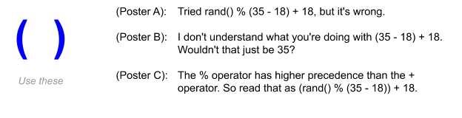

**CHALLENGEACTIVITY**

2.10.1: Enter the output of the integer expressions.

Jump to level 1

Type the program's output

|  |  |
| --- | --- |
| #include <stdio.h>  **int** main**(void)** {  **int** a;  **int** x;  **int** y;  a = 2;  x = 4;  y = a * x;  y = y + 5;    printf("%d %d", x, y);  **return** 0;  } |  |

1

2

3

4

**5**

Check

Next

**Done**. Click any level to practice more. Completion is preserved.



|  |  |
| --- | --- |
| Yours | 4 13 |
| Expected | 4 13 |

1

2

3

4

5

Feedback?

**Modulo examples**

Modulo has several useful applications. Below are just a few.

Example 2.10.1: Random number in range.

Given a random number randNum, % can generate a random number within a range:

* randNum % 10   
  Yields 0 - 9: Possible remainders are 0, 1, ..., 8, 9. Remainder 10 is not possible: Ex: 19 % 10 is 9, but 20 % 10 is 0.
* randNum % 51   
  Yields 0 - 50: Note that % 50 would yield 0 - 49.
* (randNum % 9) + 1   
  Yields 1 - 9: The % 9 yields 9 possible values 0 - 8, so the + 1 yields 1 - 9.
* (randNum % 11) + 20   
  Yields 20 - 30: The % 11 yields 11 possible values 0 - 10, so the + 20 yields 20 - 30.

Feedback?

Example 2.10.2: Getting digits.

Given a number, % and / can be used to get each digit. For a 3-digit number userVal like 927:

onesDigit = userVal % 10; // Ex: 927 % 10 is 7.

tmpVal = userVal / 10;

tensDigit = tmpVal % 10; // Ex: tmpVal = 927 / 10 is 92. Then 92 % 10 is 2.

tmpVal = tmpVal / 10;

hundredsDigit = tmpVal % 10; // Ex: tmpVal = 92 / 10 = 9. Then 9 % 10 is 9.

Feedback?

Example 2.10.3: Get prefix of a phone number.

Given a 10-digit phone number stored as an integer, % and / can be used to get any part, such as the prefix. For phoneNum = 9365551212 (whose prefix is 555):

tmpVal = phoneNum / 10000; // / 10000 shifts right by 4, so 936555.

prefixNum = tmpVal % 1000; // % 1000 gets the right 3 digits, so 555.

Dividing by a power of 10 shifts a value right. 321 / 10 is 32. 321 / 100 is 3.

% by a power of 10 gets the rightmost digits. 321 % 10 is 1. 321 % 100 is 21.

Feedback?

**PARTICIPATIONACTIVITY**

2.10.6: Modulo examples.

1)

Given a non-negative number x, which yields a number in the range 5 - 10?

(x % 6) + 5

**Correct**

% 6 yields 0 - 5. Then + 5 yields 5 - 10.

2)

Given a non-negative number x, which expression has the range -10 to 10?

(x % 21) - 10

**Correct**

x % 21 yields 0 to 20. Then - 10 yields -10 to 10.

3)

Which gets the tens digit of x. Ex: If x = 693, which yields 9?

(x / 10) % 10

**Correct**

x / 10 shifts right one place, putting the tens digit in the ones place. Then % 10 gets the (new) ones digit. Ex: 693 / 10 is 69, then 69 % 10 is 9.

4)

Given a 16-digit credit card number stored in x, which gets the last (rightmost) four digits? (Assume the fourth digit from the right is non-zero).

x % 10000

**Correct**

x % 10000 yields 0 - 9999, being the rightmost four digits. To get other digits like the next four digits, divide first to shift the desired digits to the rightmost digits, then use % to get just those digits.

**CHALLENGEACTIVITY**

2.10.2: Compute change.

A cashier distributes change using the maximum number of five dollar bills, followed by one dollar bills. For example, 19 yields 3 fives and 4 ones. Write a single statement that assigns the number of one dollar bills to variable numOnes, given amountToChange. Hint: Use the % operator.

#include <stdio.h>

int main(void) {

int amountToChange;

int numFives;

int numOnes;

scanf("%d", &amountToChange);

numFives = amountToChange / 5;

numOnes = amountToChange % 5;

printf("numFives: %d\n", numFives);

printf("numOnes: %d\n", numOnes);

return 0;

}

2.11 Type conversions

**Type conversions**

A calculation sometimes must mix integer and floating-point numbers. For example, given that about 50.4% of human births are males, then 0.504 * numBirths calculates the number of expected males in numBirths births. If numBirths is an int variable (int because the number of births is countable), then the expression combines a floating-point and integer.

A ***type conversion*** is a conversion of one data type to another, such as an int to a double. The compiler automatically performs several common conversions between int and double types, such automatic conversion known as ***implicit conversion***.

* For an arithmetic operator like + or *, if either operand is a double, the other is automatically converted to double, and then a floating-point operation is performed.
* For assignments, the right side type is converted to the left side type.

*int-to-double* conversion is straightforward: 25 becomes 25.0.

*double-to-int* conversion just drops the fraction: 4.9 becomes 4.

**PARTICIPATIONACTIVITY**

2.11.1: Implicit type conversion: int-to-double.

123

2x speed

expectedMales = 0.504 * numBirths;

0.504

316

159.264

*

0.504

*Compiler automatically performs*

*int-to-double conversion*

*double*

*int*

*double*

*double*

*

*double*

*double*

*int*

*

*316 becomes 316.0*

*expectedMales is assigned with 159.264*

*double*

316.0

Then, the program computes 0.504 * 316.0 yielding 159.264. expectedMales is a double variable and is assigned with that result.

Captions

keyboard_arrow_up

1. 0.504 is a floating-point literal. numBirths is an int variable. The compiler sees "double * int", and performs an implicit int-to-double type conversion.
2. If numBirths is 316, 316 is first converted 316.0.
3. Then, the program computes 0.504 * 316.0 yielding 159.264. expectedMales is a double variable and is assigned with that result.

Feedback?

**PARTICIPATIONACTIVITY**

2.11.2: Implicit conversions among double and int.

Type the value of the expression given int numItems = 5. For any floating-point answer, type answer to tenths. Ex: 8.0, 6.5, or 0.1.

1)

3.0 / 1.5

CheckShow answer

**Correct**

2.0

Normal floating-point division.

2)

3.0 / 2

CheckShow answer

**Correct**

1.5

2 is first converted to 2.0, then 3.0 / 2.0 yields 1.5.

3)

(numItems + 10) / 2

CheckShow answer

**Correct**

7

5 + 10 is 15. 15 / 2 yields 7 (remainder of 1 is ignored).

4)

(numItems + 10) / 2.0

CheckShow answer

**Correct**

7.5

5 + 10 is 15. That int is converted to double 15.0. Then 15.0 / 2.0 yields 7.5.

Feedback?

**PARTICIPATIONACTIVITY**

2.11.3: Implicit conversions among double and int with variables.

Type the value held in the variable after the assignment statement, given int numItems = 5, and double itemWeight = 0.5. For any floating-point answer, type answer to tenths. Ex: 8.0, 6.5, or 0.1

1)

// someDoubleVar is type double

someDoubleVar = itemWeight * numItems;

CheckShow answer

**Correct**

2.5

5 is converted to 5.0. Then 0.5 * 5.0 yields 2.5, which is assigned to someDoubleVar.

2)

// someIntVar is type int

someIntVar = itemWeight * numItems;

CheckShow answer

**Correct**

2

5 is converted to 5.0. Then 0.5 * 5.0 yields 2.5. The compiler sees "int = double" so converts the double to int by truncating the fraction, yielding 2.

Feedback?

Assigning doubles with integer literals

*Because of implicit conversion, statements like double someDoubleVar = 0; or someDoubleVar = 5; are allowed, but discouraged. Using 0.0 or 5.0 is preferable.*

**Type casting**

A programmer sometimes needs to explicitly convert an item's type. Ex: If a program needs a floating-point result from dividing two integers, then at least one of the integers needs to be converted to double so floating-point division is performed. Otherwise, integer division is performed, evaluating to only the quotient and ignoring the remainder. A ***type cast*** explicitly converts a value of one type to another type.

A programmer can precede an expression with (type) to convert the expression's value to the indicated type. Ex: If myIntVar is 7, then (double)myIntVar converts int 7 to double 7.0.

The program below casts the numerator and denominator each to double so floating-point division is performed (actually, converting only one would have worked).

Figure 2.11.1: Using type casting to obtain floating-point division.

|  |  |
| --- | --- |
| #include <stdio.h>  **int** main(**void**) {  **int** kidsInFamily1; // Should be int, not double  **int** kidsInFamily2; // (know anyone with 2.3 kids?)  **int** numFamilies;  **double** avgKidsPerFamily; // Expect fraction, so double  kidsInFamily1 = 3;  kidsInFamily2 = 4;  numFamilies = 2;  avgKidsPerFamily = (**double**)(kidsInFamily1 + kidsInFamily2)  / (**double**)numFamilies;  printf("Average kids per family: %lf\n", avgKidsPerFamily);  **return** 0;  } | Average kids per family: 3.500000 |

Feedback?

**PARTICIPATIONACTIVITY**

2.11.4: Type casting.

Determine the resulting type for each expression. Assume numSales1, numSales2, and totalSales are int variables.

1)

(numSales1 + numSales2) / 2

int

**Correct**

numSales1 + numSales2 yields an int. Dividing the int sum by the integer literal 2 yields an int value.

2)

(double)(numSales1 + numSales2) / 2

double

**Correct**

numSales1 + numSales2 yields an int. The int sum is then cast to a double value. Dividing a double by an int causes the int to be implicitly converted to a double, resulting in a double value.

3)

(numSales1 + numSales2) / totalSales

int

**Correct**

numSales1 + numSales2 yields an int. Dividing the int sum by totalSales (an integer variable) yields an int value.

4)

(numSales1 + numSales2) / (double)totalSales

double

**Correct**

numSales1 + numSales2 yields an int. Then, totalSales is cast to a double. Dividing the int sum by a double causes the int sum to be implicitly converted to a double, resulting in a double value.

Feedback?

**Common errors**

A common error is to accidentally perform integer division when floating-point division was intended. The program below undesirably performs integer division rather than floating-point division.

Figure 2.11.2: Common error: Forgetting cast results in integer division.

|  |  |
| --- | --- |
| #include <stdio.h>  **int** main(**void**) {  **int** kidsInFamily1; // Should be int, not double  **int** kidsInFamily2; // (know anyone with 2.3 kids?)  **int** numFamilies;  **double** avgKidsPerFamily; // Expect fraction, so double  kidsInFamily1 = 3;  kidsInFamily2 = 4;  numFamilies = 2;  avgKidsPerFamily = (kidsInFamily1 + kidsInFamily2) / numFamilies;  // Should be 3.5, but is 3 instead  printf("Average kids per family: %lf\n", avgKidsPerFamily);  **return** 0;  } | Average kids per family: 3.000000 |

Feedback?

A common error is to cast the entire result of integer division, rather than the operands, thus not obtaining the desired floating-point division.

**PARTICIPATIONACTIVITY**

2.11.5: Common error: Casting final result instead of operands.

1234

2x speed

examAvg = (**double**)((midtermScore + finalScore) / 2);

*double*

*int*

*int*

*int*

90

85

+

175

*int*

*int*

*int*

2

/

*int*

87

*int*

(double)( )

87.0

*double*

*Common error: Casting the result of*

*integer division does not perform the*

*desired floating-point division*

The type cast converts 87 to 87.0. Casting the result of integer division does not perform the desired floating-point division.

Captions

keyboard_arrow_up

1. The programmer wants to use floating-point division to compute the average of midtermScore (an int) and finalScore (an int).
2. (midtermScore + finalScore) is evaluated first. If midtermScore is 90 and finalScore is 85, the expression evaluates to (90 + 85) or 175.
3. Next, 175 / 2 is evaluated. Both operands are integers, so integer divisions is performed, yielding 87.
4. The type cast converts 87 to 87.0. Casting the result of integer division does not perform the desired floating-point division.

Feedback?

**PARTICIPATIONACTIVITY**

2.11.6: Type casting.

1)

Which yields 2.5?

(double)(10) / (double)(4)

**Correct**

The casts yield 10.0 / 4.0, which is 2.5.

2)

Which does NOT yield 3.75?

(double)(15 / 4)

**Correct**

This common error first does integer division of 15 / 4 which is 3, then converts to 3.0.

3)

Given aCount, bCount, and cCount are integer variables, which variable must be cast to a double for the expression (aCount * bCount) / cCount to evaluate to a double value?

Only one variable

**Correct**

Casting any one of the three variables results in floating-point division that yields a double value.

Feedback?

**CHALLENGEACTIVITY**

2.11.1: Type conversions.

Jump to level 1

Type the program's output

|  |  |
| --- | --- |
| #include <stdio.h>  **int** main**(void)** {  **int** kidsInClass1;  **int** kidsInClass2;  **int** numClasses;  **double** kidsAvgMethod1;  **double** kidsAvgMethod2;    kidsInClass1 = 2;  kidsInClass2 = 3;  numClasses = 2;    kidsAvgMethod1 = (**double**)(kidsInClass1 + kidsInClass2)  / (**double**)(numClasses);  kidsAvgMethod2 = (kidsInClass1 + kidsInClass2) / numClasses;    printf("%.1lf\n", kidsAvgMethod1); // These will output 1 decimal place.  printf("%.1lf\n", kidsAvgMethod2);    **return** 0;  } |  |

1

2

3

4

**5**

Check

Next

**Done**. Click any level to practice more. Completion is preserved.



kidsAvgMethod1 is calculated using type casting to convert from int to double. So, (double)(kidsInClass1 + kidsInCass2) returns the sum of kidsInClass1 + kidsInClass2 as a floating-point number, and (double)(numClasses)converts numClasses into a floating-point number. kidsAvgMethod2 is calculated using integer division.

|  |  |
| --- | --- |
| Yours | 2.5  2.0 |
| Expected | 2.5  2.0 |

1

2

3

4

5

Feedback?

**CHALLENGEACTIVITY**

2.11.2: Type casting: Computing average kids per family

Compute the average kids per family. Note that the integers should be type cast to doubles.  

#include <stdio.h>

int main(void) {

int numKidsA;

int numKidsB;

int numKidsC;

int numFamilies;

double avgKids;

scanf("%d", &numKidsA);

scanf("%d", &numKidsB);

scanf("%d", &numKidsC);

scanf("%d", &numFamilies);

avgKids =((double)(numKidsA + numKidsB + numKidsC)) / numFamilies;

printf("%lf\n", avgKids);

# 2.12 Binary

info

This section has been set as optional by your instructor.

Normally, a programmer can think in terms of base ten numbers. However, a compiler must allocate some finite quantity of bits (e.g., 32 bits) for a variable, and that quantity of bits limits the range of numbers that the variable can represent. Thus, some background on how the quantity of bits influences a variable's number range is helpful.

Because each memory location is composed of bits (0s and 1s), a processor stores a number using base 2, known as a ***binary number***.

For a number in the more familiar base 10, known as a ***decimal number***, each digit must be 0-9 and each digit's place is weighed by increasing powers of 10.

Table 2.12.1: Decimal numbers use weighed powers of 10.

|  |  |
| --- | --- |
| Decimal number with 3 digits | Representation |
| 212 | =2⋅102+1⋅101+2⋅100=2⋅100+1⋅10+2⋅1=200+10+2=212 |

Feedback?

In ***base 2***, each digit must be 0-1 and each digit's place is weighed by increasing powers of 2.

Table 2.12.2: Binary numbers use weighed powers of 2.

|  |  |
| --- | --- |
| Binary number with 4 bits | Representation |
| 1101 | =1⋅23+1⋅22+0⋅21+1⋅20=1⋅8+1⋅4+0⋅2+1⋅1=8+4+0+1=13 |

Feedback?

The compiler translates decimal numbers into binary numbers before storing the number into a memory location. The compiler would convert the decimal number 212 to the binary number 11010100, meaning 1*128 + 1*64 + 0*32 + 1*16 + 0*8 + 1*4 + 0*2 + 0*1 = 212, and then store that binary number in memory.

**PARTICIPATIONACTIVITY**

2.12.1: Understanding binary numbers.

Set each binary digit for the unsigned binary number below to 1 or 0 to obtain the decimal equivalents of 9, then 50, then 212, then 255. Note also that 255 is the largest integer that the 8 bits can represent.

**0**

**128**

**27**

**0**

**64**

**26**

**1**

**32**

**25**

**1**

**16**

**24**

**0**

**8**

**23**

**0**

**4**

**22**

**1**

**2**

**21**

**1**

**1**

**20**

**51**

(decimal value)

Feedback?

**PARTICIPATIONACTIVITY**

2.12.2: Binary numbers.

1)

Convert the binary number 00001111 to a decimal number.

CheckShow answer

**Correct**

15

8 + 4 + 2 + 1 is 15

2)

Convert the binary number 10001000 to a decimal number.

CheckShow answer

**Correct**

136

128 + 8 is 136

3)

Convert the decimal number 17 to an 8-bit binary number.

CheckShow answer

**Correct**

00010001

16 + 1 is 17

4)

Convert the decimal number 51 to an 8-bit binary number.

CheckShow answer

**Correct**

00110011

32 + 16 + 2 + 1 is 51

### Common errors

A common error is to use double quotes rather than single quotes around a character literal, as in myChar = "x", yielding a compiler error.

Similarly, a common error is to forget the quotes around a character literal, as in myChar = x, usually yielding a compiler error (unless x is also a declared variable, then perhaps yielding a logic error).

**CHALLENGEACTIVITY**

2.13.1: Printing a message with ints and chars.

Print a message telling a user to press the letterToQuit key numPresses times to quit. End with newline. Ex: If letterToQuit = 'q' and numPresses = 2, print: 

Press the q key 2 times to quit.

Feedback?

#include <stdio.h>

int main(void) {

char letterToQuit;

int numPresses;

scanf(" %c ", &letterToQuit);

scanf("%d", &numPresses);

printf("Press the %c key %d times to quit.\n",letterToQuit, numPresses);

return 0;

}

**CHALLENGEACTIVITY**

2.13.2: Outputting all combinations.

Output all combinations of character variables a, b, and c, in the order shown below. If a = 'x', b = 'y', and c = 'z', then the output is: 

xyz xzy yxz yzx zxy zyx

Your code will be tested in three different programs, with a, b, c assigned with 'x', 'y', 'z', then with '#', '$', '%', then with '1', '2', '3'.

#include <stdio.h>

int main(void) {

char a;

char b;

char c;

scanf(" %c ", &a);

scanf(" %c ", &b);

scanf(" %c ", &c);

printf("%c%c%c %c%c%c %c%c%c %c%c%c %c%c%c %c%c%c",a,b,c,a,c,b,b,a,c,b,c,a,c,a,b,c,b,a);

printf("\n");

return 0;

}

**CHALLENGEACTIVITY**

2.13.3: Successive letters.

Declare a character variable letterStart. Write a statement to read a letter from the user into letterStart, followed by statements that output that letter and the next letter in the alphabet. End with a newline. Hint: A letter is stored as its ASCII number, so adding 1 yields the next letter. Sample output assuming the user enters 'd': de

#include <stdio.h>

int main(void) {

char letterStart;

scanf("%c", &letterStart);

printf("%c%c\n",letterStart,letterStart + 1);

return 0;

}

[2.13 Characters](https://learn.zybooks.com/zybook/UTSACS1714Fall2020/chapter/2/section/13)

# 2.14 Strings

### Strings and string literals

A ***string*** is a sequence of characters. A ***string literal*** surrounds a character sequence with double quotes, as in "Hello", "52 Main St.", or "42", vs. an integer literal like 42 or character literal like 'a'. Various characters may be in a string, such as letters, numbers, spaces, or symbols like $ or %, as in "$100 for Julia!!". Earlier sections showed string literals being output, as in: printf("Hello");.

**PARTICIPATIONACTIVITY**

2.14.1: A string is stored as a sequence of characters in memory.

Type a string to see how a string is stored as a sequence of characters in memory. In this case, the string happens to be in memory locations 501 to 506. Try typing Hello! or 627.

|  |  |  |  |  |  |  |  |  |  |  |  |  |  |
| --- | --- | --- | --- | --- | --- | --- | --- | --- | --- | --- | --- | --- | --- |
| Type a string (up to 6 characters): | Memory   |  |  | | --- | --- | | 501 |  | | 502 |  | | 503 |  | | 504 |  | | 505 |  | | 506 |  | |

Feedback?

**PARTICIPATIONACTIVITY**

2.14.2: String literals.

Indicate which items are string literals.

1)

"Hey"

Yes

No

**Correct**

Consists of characters: H, e, y

2)

"Hey there."

Yes

No

**Correct**

A string literal may contain spaces, periods, and other non-letter characters.

3)

674

Yes

No

**Correct**

A string literal must be surrounded by double quotes.

4)

"674"

Yes

No

**Correct**

While looking like a number, the double quotes make this a string literal consisting of characters: 6, 7, 4.

5)

'ok'

Yes

No

**Correct**

A string literal requires double quotes as in "ok", not single quotes as in 'ok'.

6)

"a"

Yes

No

**Correct**

A string literal may have just one character, but is still considered a string (and not a character).

Feedback?

### String variables and assignments

Some variables should hold a string. A string data type isn't built into C like char, int, or double, but can be stored in a character array. A ***character array*** is a sequence of items, introduced in a later section. A programmer can declare a string as char firstName[50];, which can store 50 characters. Note the use of brackets [ ] to indicate the string size, not parentheses. This material may refer to a character array as a string or a ***C string***.

A programmer can *not* assign a string with a value like for other types. Ex: str1 = "Hello" or str1 = str2 will cause a compiler error. Instead, a programmer sets a string with a value using the function ***strcpy***(str1, str2), which copies each character in str2 into corresponding locations of str1. str1 must be at least as large as str2, else a runtime error may occur. A programmer must add #include <string.h> to use strcpy.

Initializing a string is an exception: char firstMonth[8] = "January"; is allowed. The reason is because the compiler can fill in each character when first creating the variable. But the compiler is not involved once a program starts running so a subsequent assignment statement is not allowed. The literal's number of characters should be less than the array size. Strings are always terminated with a special character called the ***null character***, '\0'. To hold the string "January", 8 characters are needed, 'J', 'a', 'n', 'u', 'a', 'r', 'y', '\0'. A programmer can omit the size as in char firstMonth[] = "January";, in which case the compiler creates an array of the necessary size.

Figure 2.14.1: Declaring and assigning a string.

#include <stdio.h>

#include <string.h>

**int** main(**void**) {

**char** sentenceSubject[20];

**char** sentenceVerb[20];

**char** sentenceObject[20] = "an apple";

strcpy(sentenceSubject, "boy");

strcpy(sentenceVerb, "ate");

printf("A ");

printf("%s ", sentenceSubject);

printf("%s ", sentenceVerb);

printf("%s.\n", sentenceObject);

**return** 0;

}

A boy ate an apple.

Feedback?

**PARTICIPATIONACTIVITY**

2.14.3: Declaring and assigning a string variable.

1)

Declare a C string variable userName having 8 characters (uninitialized).

CheckShow answer

**Correct**

char userName[8];

Variable userName can now hold 8 characters.

2)

Write a statement that assigns userName with "Sarah".

CheckShow answer

**Correct**

strcpy(userName, "Sarah");

The function strcpy will copy the characters S, a, r, a, h into userName's memory locations.

3)

Suppose string str1 is initially "Hello" and str2 is "Hi".   
After strcpy(str1,str2);, what is str1?   
Omit the quotes.

CheckShow answer

**Correct**

Hi

str2's contents are copied to str1. str1's previous contents "Hello" are irrelevant.

4)

Suppose string str1 is initially "Hello" and str2 is "Hi".   
After strcpy(str1, str2); and then strcpy(str2, "Bye");, what is str1?   
Omit the quotes.

CheckShow answer

**Correct**

Hi

str2's contents are copied to str1. A later change to str2 doesn't impact str1.

5)

Type one statement that declares a string named smallestPlanet initialized to "Mercury". Let the compiler determine the string's size.

CheckShow answer

**Correct**

char smallestPlanet[] = "Mercury";

The compiler creates a string capable of storing 8 letters and fills the string's memory locations with M, e, r, c, u, r, y, and a null character.

6)

Given char homePlanet[] ="Earth";, what size array is created by the compiler?

CheckShow answer

**Correct**

6

homePlanet needs to hold 6 characters: 'E', 'a', 'r', 't', 'h', '\0'.

Feedback?

### Getting a string without whitespaces from input

A ***whitespace character*** is a character used to represent horizontal and vertical spaces in text, and includes spaces, tabs, and newline characters. Ex: "Oh my goodness!" has two whitespace characters, one between h and m, the other between y and g.

Below shows the basic approach to get a string from input into variable userString. The approach automatically skips initial whitespace, then gets characters until the next whitespace is seen (leaving that whitespace in the input).

scanf("%s", userString);

When using scanf for a string (in contrast to int, double, or char), the subsequent string variable is *not* preceded by a & symbol. A later section explains why; briefly, a char array variable is already an address, namely the address of the first character in the character sequence.

**PARTICIPATIONACTIVITY**

2.14.4: Getting a string without whitespace from input.

For the given input, indicate what string will be put into userString by:

scanf("%s", userString);

1)

abc

CheckShow answer

2)

Hi there.

CheckShow answer

3)

Hello! I'm tired.

CheckShow answer

4)

      Very fun.

CheckShow answer

Feedback?

**PARTICIPATIONACTIVITY**

2.14.5: Getting a string without whitespace from input (continued).

For the given input, indicate what string will be put into secondString by:

scanf("%s", firstString);

scanf("%s", secondString);

1)

Oh my!

CheckShow answer

**Correct**

my!

firstString will get "Oh". The secondString will get the next non-whitespace characters "my!".

2)

Frank  
Sinatra

CheckShow answer

**Correct**

Sinatra

firstString will get "Frank", ending at the newline, which is whitespace. The next get first skips that newline, putting "Sinatra" into secondString.

3)

Oh...  
  
  
...no!

CheckShow answer

**Correct**

...no!

firstString will get "Oh...". The next get first skips the multiple newlines, putting "...no!" into secondString.

4)

We all  
know

CheckShow answer

**Correct**

all

firstString will get "We". The next get skips the space after e, putting "all" into secondString.

Feedback?

### Example: Word game

The following example illustrates getting strings from input and putting strings to output.

Figure 2.14.2: Strings example: Word game.

|  |  |
| --- | --- |
| #include <stdio.h>  **int** main(**void**) {  **char** wordRelative[50];  **char** wordFood[50];  **char** wordAdjective[50];  **char** wordTimePeriod[50];  // Get user's words  printf("Type input (< 50 char) w/o spaces.\n");  printf("Enter a kind of relative:\n");  scanf("%s", wordRelative);  printf("Enter a kind of food:\n");  scanf("%s", wordFood);  printf("Enter an adjective:\n");  scanf("%s", wordAdjective);  printf("Enter a time period:\n");  scanf("%s", wordTimePeriod);  // Tell the story  printf("\n");  printf("My %s", wordRelative);  printf(" says eating %s \n", wordFood);  printf("will make me more %s, \n", wordAdjective);  printf("so now I eat it every %s.\n", wordTimePeriod);  **return** 0;  } | Type input (< 50 chars) w/o spaces.  Enter a kind of relative:  mother  Enter a kind of food:  apples  Enter an adjective:  loud  Enter a time period:  week  My mother says eating apples  will make me more loud,  so now I eat it every week. |

Feedback?

### Getting a string with whitespace from input

Sometimes a programmer wishes to get whitespace characters into a string, such as getting a user's input of the name "Franklin D. Roosevelt" into a string variable presidentName.

But, scanf("%s", stringVar) will only read characters up to the next whitespace. In C, getting an input string containing spaces is non-trivial, and left for another section.

**PARTICIPATIONACTIVITY**

2.14.6: Getting a string with whitespace from input.

1)

What does scanf("%s", firstString) store into the variable firstString for input:   
Frank Sinatra

Frank

Frank Sinatra

Feedback?

### Example: Getting multi-word names

Figure 2.14.3: Reading an input string containing spaces using scanf stops at the first space.

|  |  |
| --- | --- |
| #include <stdio.h>  **int** main(**void**) {  **char** firstName[50];  **char** lastName[50];  printf("Enter first name:\n");  scanf("%s", firstName); // Gets up to first space or ENTER  printf("Enter last name:\n");  scanf("%s", lastName); // Gets up to first space or ENTER  printf("\n");  printf("Welcome %s %s!\n", firstName, lastName);  printf("May I call you %s?\n", firstName);  **return** 0;  } | Enter first name:  Betty  Enter last name:  Sue  Welcome Betty Sue!  May I call you Betty? |

Feedback?

The user never got a chance to enter her last name of McKay; scanf read Sue as the last name.

**CHALLENGEACTIVITY**

2.14.1: Reading and outputting strings.

Write a program that reads a person's first and last names, separated by a space. Then the program outputs last name, comma, first name. End with newline.   
  
Example output if the input is: Maya Jones 

Jones, Maya

#include <stdio.h>

int main(void) {

char firstName[20];

char lastName[20];

scanf("%s",&firstName);

scanf("%s",&lastName);

printf("%s, %s\n",lastName,firstName);

return 0;

}

2.15 Integer overflow

info

This section has been set as optional by your instructor.

An integer variable cannot store a number larger than the maximum supported by the variable's data type. An ***overflow*** occurs when the value being assigned to a variable is greater than the maximum value the variable can store.

A common error is to try to store a value greater than about 2 billion into an int variable. For example, the decimal number 4,294,967,297 requires 33 bits in binary, namely 100000000000000000000000000000001 (we chose the decimal number for easy binary viewing). Trying to assign that number into an int results in overflow. The 33rd bit is lost and only the lower 32 bits are stored, namely 00000000000000000000000000000001, which is decimal number 1.

**PARTICIPATIONACTIVITY**

2.15.1: Overflow error.

12

2x speed

...

**int** hrsUploadedTotal;

hrsUploadedTotal = 4294967297;

Overflow occurs

00000000000000000000000000000001

1

hrsUploadedTotal

(32 bits)

hrsUploadedTotal is a variable of type int.

Captions

keyboard_arrow_up

1. hrsUploadedTotal is a variable of type int.
2. Assigning a value greater than the maximum value the variable can store results in overflow. The leftmost bit is lost, so hrsUploadedTotal actually stores a value of 1.

Feedback?

Declaring the variable of type *long long*, (described in another section) which uses at least 64 bits, would solve the above problem. But even that variable could overflow if assigned a large enough value.

Most compilers detect when a statement assigns to a variable a literal constant so large as to cause overflow. The compiler may not report a syntax error (the syntax is correct), but may output a ***compiler warning*** message that indicates a potential problem. A GNU compiler outputs the message "warning: overflow in implicit constant conversion", and a Microsoft compiler outputs "warning: '=': truncation of constant value". Generally, good practice is for a programmer to not ignore compiler warnings.

A common source of overflow involves intermediate calculations. Given int variables num1, num2, num3 each with values near 1 billion, (num1 + num2 + num3) / 3 will encounter overflow in the numerator, which will reach about 3 billion (max int is around 2 billion), even though the final result after dividing by 3 would have been only 1 billion. Dividing earlier can sometimes solve the problem, as in (num1 / 3) + (num2 / 3) + (num3 / 3), but programmers should pay careful attention to possible implicit type conversions.

zyDE 2.15.1: long long variables.

Run the program and observe the output is as expected. Replicate the multiplication and printing three more times, and observe incorrect output due to overflow. Change num's type to *long long*, and observe the corrected output. Note: %lld is the specifier to print a long long variable.

Load default template...

1

2

3

4

5

6

7

8

9

10

11

12

13

14

15

16

17

18

#include <stdio.h>

int main(void) {

int num;

num = 1000;

num = num * 1000;

printf("num: %d\n", num);

num = num * 1000;

printf("num: %d\n", num);

num = num * 1000;

printf("num: %d\n", num);

return 0;

}

Run

num: 1000000

num: 1000000000

num: -727379968

Feedback?

**PARTICIPATIONACTIVITY**

2.15.2: Overflow.

Assume all variables below are declared as int, which uses 32 bits.

1)

Overflow can occur at any point in the program, and not only at a variable's initialization.

Yes

**Correct**

Overflow will occur whenever the data type of a variable has insufficient space to store the value assigned.

2)

Will x = 1234567890 cause overflow?

No

**Correct**

The value of about 1 billion assigned to x is within the range of about ±2 billion, so will not cause overflow.

3)

Will x = 9999999999 cause overflow?

Yes

**Correct**

This number is greater than about 2 billion, so cannot be assigned to a 32-bit int variable without causing overflow.

4)

Will x = 4000000000 cause overflow?

Yes

**Correct**

The number is outside the range of a 32-bit int, which is about ±2 billion.

5)

Will these assignments cause overflow?  
x = 1000;   
y = 1000;   
z = x * y;

No

**Correct**

z is 1,000,000, which is less than 2 billion.

6)

Will these assignments cause overflow?  
x = 1000;   
y = 1000;   
z = x * x;   
z = z * y * y;

Yes

**Correct**

z is 1,000,000,000,000, which is much larger than 2 billion. Compilers may not detect overflow in calculations and thus not generate a warning; the program simply runs incorrectly.

Feedback?

# 2.16 Numeric data types

int and double are the most common numeric data types. However, several other numeric types exist. The following table summarizes available integer numeric data types.

The size of integer numeric data types can vary between compilers, for reasons beyond our scope. The following table lists the sizes for numeric integer data types used in this material along with the minimum size for those data types defined by the language standard.

Table 2.16.1: Integer numeric data types.

|  |  |  |  |
| --- | --- | --- | --- |
| Declaration | Size | Supported number range | Standard-defined minimum size |
| char myVar; | 8 bits | -128 to 127 | 8 bits |
| short myVar; | 16 bits | -32,768 to 32,767 | 16 bits |
| long myVar; | 32 bits | -2,147,483,648 to 2,147,483,647 | 32 bits |
| long long myVar; | 64 bits | -9,223,372,036,854,775,808 to 9,223,372,036,854,775,807 | 64 bits |
| int myVar; | 32 bits | -2,147,483,648 to 2,147,483,647 | *16 bits* |

Feedback?

int is the most commonly used integer type. int

***long long*** is used for integers expected to exceed about 2 billion. That is not a typo; the word appears twice. printf() and scanf() use %lld to specify a long long item.

In case the reader is wondering, the language does not have a simple way to print numbers with commas. So if x is 8000000, printing 8,000,000 is not trivial.

A common error made by a program's user is to enter the wrong type, such as entering a string when the input statement was scanf("%d", &myInt); , which can cause strange program behavior.

short is rarely used. One situation is to save memory when storing many (e.g., tens of thousands) of smaller numbers, which might occur for arrays (another section). Another situation is in *embedded*computing systems having a tiny processor with little memory, as in a hearing aid or TV remote control. Similarly, char, while technically a number, is rarely used to directly store a number, except as noted for short.

**PARTICIPATIONACTIVITY**

2.16.1: Integer types.

Indicate whether each is a good variable declaration for the stated purpose, assuming int is usually used for integers, and long long is only used when absolutely necessary.

1)

The number of days of school per year:  
int numDaysSchoolYear;

True

**Correct**

Although the max is 366, int is typically used rather than short.

2)

The number of days in a human's lifetime.   
int numDaysLife;

True

**Correct**

The number might be as big as about 100 yrs * 365 days/year or 36,500. int can hold up to about 2 billion, so is large enough.

3)

The number of cells in the average human body.   
int numCells;

False

**Correct**

The human body contains approximately 37.2 trillion cells, exceeding the roughly 2 billion limit of an int. A long long is needed.

4)

The number of human heartbeats in one year, assuming 100 beats/minute.   
long long numHeartBeats;

False

**Correct**

100 beats/min * 60 min/hr * 24 hr/day * 365 days/yr yields 52,560,000 beats/yr. 52 million is much less than an int's 2 billion max. A long long is not necessary.

Feedback?

The following table summarizes available floating-point numeric types.

Table 2.16.2: Floating-point numeric data types.

|  |  |  |
| --- | --- | --- |
| Declaration | Size | Supported number range |
| float x; | 32 bits | -3.4x1038 to 3.4*1038 |
| double x; | 64 bits | -1.7x10308 to 1.7*10308 |

Feedback?

The compiler uses one bit for sign, some bits for the mantissa, and some for the exponent. Details are beyond our scope. The language (unfortunately) does not actually define the number of bits for float and double types, but the above sizes are very common.

float is typically only used in memory-saving situations, as discussed above for short.

Due to the fixed sizes of the internal representations, the mantissa (e.g, the 6.02 in 6.02e23) is limited to about 7 significant digits for float and about 16 significant digits for double. So for a variable declared as double pi, the assignment pi = 3.14159265 is OK, but pi = 3.14159265358979323846 will be truncated.

A variable cannot store a value larger than the maximum supported by the variable's data type. An ***overflow*** occurs when the value being assigned to a variable is greater than the maximum value the variable can store. Overflow with floating-point results in infinity. Overflow with integer is discussed elsewhere.

**PARTICIPATIONACTIVITY**

2.16.2: Representation of 32-bit floating-point values.

Enter a decimal value:Convert*22000 in a 32-bit floating-point representation (IEEE):*

|  |  |  |
| --- | --- | --- |
| **Sign** | **Exponent** | **Mantissa** |
| 0 | 1    0    0    0    1    1    0    1 | 1.    0    1    0    1    0    1    1    1    1    1    0    0    0    0    0    0    0    0    0    0    0    0    0 |
| +1 | 2(141 - 127) = 214 | 1.3427734375 |

*Representation's value: 22000*

Feedback?

On some processors, especially low-cost processors intended for "embedded" computing, like systems in an automobile or medical device, floating-point calculations may run slower than integer calculations, such as 100 times slower. Floating-point types are typically only used when really necessary. On more powerful processors like those in desktops, servers, smartphones, etc., special floating-point hardware nearly or entirely eliminates the speed difference.

Floating-point numbers are sometimes used when an integer exceeds the range of the largest integer type.

**PARTICIPATIONACTIVITY**

2.16.3: Floating-point numeric types.

1)

float is the most commonly-used floating-point type.

False

**Correct**

Today, double is. Decades ago, float was, but then larger computer memories allowed programmers to use a floating-point type that was "double" the size of float, hence the name.

2)

int and double types are limited to about 16 digits.

False

**Correct**

A double's mantissa is limited to 16 digits (due to the number of bits that represent the mantissa), but an int's range is about +/- 2 billion which means 10 digits.

# 2.17 Unsigned

Sometimes a programmer knows that a variable's numbers will always be positive (0 or greater), such as when the variable stores a person's age or weight. The programmer can prepend the word "unsigned" to inform the compiler that the integers will always be positive. Because the integer's sign needs not be stored, the integer range reaches slightly higher numbers, as follows:

Table 2.17.1: Unsigned integer data types.

|  |  |  |  |
| --- | --- | --- | --- |
| Declaration | Size | Supported number range | Standard-defined minimum size |
| unsigned char myVar; | 8 bits | 0 to 255 | 8 bits |
| unsigned short myVar; | 16 bits | 0 to 65,535 | 16 bits |
| unsigned long myVar; | 32 bits | 0 to 4,294,967,295 | 32 bits |
| unsigned long long myVar; | 64 bits | 0 to 184,467,440,737,095,551,615 | 64 bits |
| unsigned int myVar; | 32 bits | 0 to 4,294,967,295 | *16 bits* |

Feedback?

Signed numbers use the leftmost bit to store a number's sign, and thus the largest magnitude of a positive or negative integer is half the magnitude for an unsigned integer. Signed numbers actually use a more complicated representation called two's complement, but that's beyond our scope.

The following example demonstrates the use of unsigned long and unsigned long long variables to convert memory size.

Figure 2.17.1: Unsigned variables example: Memory size converter.

|  |  |
| --- | --- |
| #include <stdio.h>  **int** main(**void**) {  **unsigned** **long** memSizeGiB;  **unsigned** **long** **long** memSizeBytes;  **unsigned** **long** **long** memSizeBits;    printf("Enter memory size in GiBs: ");  scanf("%lu", &memSizeGiB);    // 1 GiB = 1024 MiB, 1 MiB = 1024 KiB, 1 KiB = 1024 bytes  memSizeBytes = memSizeGiB * (1024 * 1024 * 1024);  // 1 byte = 8 bits  memSizeBits = memSizeBytes * 8;    printf("Memory size in bytes: %llu\n", memSizeBytes);  printf("Memory size in bits: %llu\n", memSizeBits);    **return** 0;  } | Enter memory size in GiBs: 1  Memory size in bytes: 1073741824  Memory size in bits: 8589934592  ...  Enter memory size in GiBs: 4  Memory size in bytes: 4294967296  Memory size in bits: 34359738368 |

Feedback?

Note that printf and scanf use %u to specify an unsigned int, %lu to specify an unsigned int or unsigned long, and %llu to specify an unsigned long long.

A common error is for a programmer to mismatch types in a printf and scanf, such as scanf("%d", &numCells); where numCells is an unsigned integer.

**PARTICIPATIONACTIVITY**

2.17.1: Unsigned variables.

1)

Declare a 64-bit unsigned integer variable numMolecules.

CheckShow answer

**Correct**

unsigned long long numMolecules;

An unsigned long is 32 bits. An unsigned long long is 64 bits.

2)

Declare a 16-bit unsigned integer variable named numAtoms.

CheckShow answer

**Correct**

unsigned short numAtoms;

An unsigned short is 16 bits.

3)

Initialize numAtoms to the smallest valid unsigned value.

**unsigned** **short** numAtoms = ;

CheckShow answer

**Correct**

0

The smallest value an unsigned variable can be assigned is 0.

**CHALLENGEACTIVITY**

2.18.1: Enumerations: Grocery items.

Print either "Fruit", "Drink", or "Unknown" (followed by a newline) depending on the value of userItem. Print "Unknown" (followed by a newline) if the value of userItem does not match any of the defined options. For example, if userItem is GR_APPLES, output should be:

Fruit

#include <stdio.h>

int main(void) {

enum GroceryItem {GR_APPLES, GR_BANANAS, GR_JUICE, GR_WATER};

enum GroceryItem userItem;

userItem = GR_APPLES;

if (userItem == GR_APPLES){

printf("Fruit\n");

}

else if (userItem == GR_BANANAS){

printf("Fruit\n");

}

else if (userItem == GR_JUICE){

printf("Drink\n");

}

else if (userItem == GR_WATER){

printf("Drink\n");

}

else {

printf("Unknown\n");

}

return 0;

**CHALLENGEACTIVITY**

2.18.2: Soda machine with enums.

Complete the code provided to add the appropriate amount to totalDeposit.

{ #include <stdio.h>

int main(void) {

enum AcceptedCoins {ADD_QUARTER, ADD_DIME, ADD_NICKEL, ADD_UNKNOWN};

int totalDeposit = 0;

int userInput;

printf("Add coin: 0 (add 25), 1 (add 10), 2 (add 5). ");

scanf("%d", &userInput);

if (userInput == ADD_QUARTER) {

totalDeposit = totalDeposit + 25;

}

else if (userInput == ADD_DIME){

totalDeposit = totalDeposit + 10;

}

else if (userInput == ADD_NICKEL){

totalDeposit = totalDeposit + 5;

}

else {

printf("Invalid coin selection.\n");

}

printf("totalDeposit: %d\n", totalDeposit);

return 0;

}}

2.19 Random numbers

**Generating a random number**

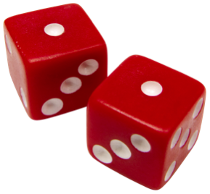

Some programs need to use a random number. Ex: A game program may need to roll dice, or a website program may generate a random initial password.

The ***rand()*** function, in the C standard library, returns a random integer each time the function is called, in the range 0 to RAND_MAX.

Figure 2.19.1: Outputting three random integers.

|  |  |
| --- | --- |
| #include <stdio.h>  #include <stdlib.h> // Enables use of rand()  **int** main(**void**) {  printf("%d\n", rand());  printf("%d\n", rand());  printf("%d\n", rand());  printf("RAND_MAX: %d\n", RAND_MAX);  **return** 0;  } | 16807  282475249  1622650073  RAND_MAX: 2147483647 |

Feedback?

Line 2 includes the C standard library, which defines the rand() function and RAND_MAX.

RAND_MAX is a machine-dependent value, but is at least 32,767. Above, RAND_MAX is about 2 billion.

Usually, a programmer wants a random integer restricted to a specific number of possible values. The modulo operator % can be used. Ex: integer % 10 has 10 possible remainders: 0, 1, 2, ..., 8, 9.

**PARTICIPATIONACTIVITY**

2.19.1: Restricting random integers to a specific number of possible values.

123

2x speed

rand()

22457

% 3

% 3

Possible remainders are

0 % 3 = 0

1 % 3 = 1

2 % 3 = 2

3 % 3 = 0

4 % 3 = 1

5 % 3 = 2

6 % 3 = 0

...

24

0

% 3

2

rand() % N yields N possible values, from 0 to N-1

0, 1, 2

Thus, rand() % 3 yields 3 possible values: 0, 1, and 2. Generally, rand() % N yields N possible values, from 0 to N-1.

Captions

keyboard_arrow_up

1. Each call to rand() returns a random integer between 0 and a large number RAND_MAX.
2. A programmer usually wants a smaller number of possible values, for which % can be used. % (modulo) means remainder. rand() % 3 has possible remainders of 0, 1, and 2.
3. Thus, rand() % 3 yields 3 possible values: 0, 1, and 2. Generally, rand() % N yields N possible values, from 0 to N-1.

Feedback?

**PARTICIPATIONACTIVITY**

2.19.2: Random number basics.

1)

What library must be included to use the rand() function?

The C standard library

**Correct**

The C standard library contains useful functions for various purposes, like generating random integers, converting among strings and numbers, and more.

2)

The random integer returned by rand() will be in what range?

0 to RAND_MAX

**Correct**

The range is quite large, starting from 0. RAND_MAX is at least 32,767, but on some machines may be larger (such as about 2 billion on a 32-bit machine).

3)

Which expression's range is restricted to 0 to 7?

rand() % 8

**Correct**

% computes the modulo, meaning remainder. Possible remainders when dividing by 8 are 0, 1, 2, 3, 4, 5, 6, and 7.

4)

Which expression yields one of 5 possible values?

rand() % 5

**Correct**

Possible values are 0, 1, 2, 3, and 4, which is 5 possible values.

5)

Which expression yields one of 100 possible values?

rand() % 100

**Correct**

Yields 0 to 99, which is 100 possible values (counting the 0).

6)

Which expression would best mimic the random outcome of flipping a coin?

rand() % 2

**Correct**

Yields 2 possible values, 0 and 1. Those values can represent the two possible outcomes of a coin flip, heads and tails.

7)

What is the smallest *possible* value returned by rand() % 10?

0

**Correct**

The range of rand() starts with 0, and 0 % 10 is 0.

8)

What is the largest *possible* value returned by rand() % 10?

9

**Correct**

num % 10 can range from 0 to 9.

Feedback?

**Specific ranges**

The technique above generates random integers with N possible values ranging from 0 to N-1, like 6 values from 0 to 5. Commonly, a programmer wants a specific range that starts with some value x that isn't 0, like 10 to 15, or -20 to 20. The programmer should first determine the number of values in the range, generate a random integer with that number of possible values, and then add x to adjust the range to start with x.

**PARTICIPATIONACTIVITY**

2.19.3: Generating random integers in a specific range not starting from 0.

123

2x speed

15 - 10

+ 1

6 possible values

rand() % 6

0

1

2

3

4

5

10

11

12

13

14

15

(rand() % 6)

+ 10

10

11

12

13

14

15

Adding 10 still generates 6 values, but now those values start at 10. The range thus becomes 10 to 15.

Captions

keyboard_arrow_up

1. A programmer wants random integers in the range 10 to 15. The number of possible values is 15 − 10 + 1. (People often forget the + 1.)
2. rand() % 6 generates 6 possible values as desired, but with range 0 to 5.
3. Adding 10 still generates 6 values, but now those values start at 10. The range thus becomes 10 to 15.

Feedback?

**PARTICIPATIONACTIVITY**

2.19.4: Generating random integers in a specific range.

1)

Goal: Random integer from the 6 possible values 0 to 5.   
rand() % ___

CheckShow answer

**Correct**

6

% by 6 has 6 possible remainders: 0, 1, 2, 3, 4, 5.

2)

Goal: Random integer from 0 to 4.   
rand() % ___

CheckShow answer

**Correct**

5

0 to 4 has 5 possible values: 0, 1, 2, 3, 4.   
A common mistake is to assume 0 to 4 has 4 possible values because 4 − 0 = 4. But 1 more value exists in that range.

3)

How many values exist in the range 10 to 15?

CheckShow answer

**Correct**

6

15 − 10 + 1 = 6. A common mistake is to forget the + 1. But one can verify the 6 values by listing: 10, 11, 12, 13, 14, 15.

4)

How many values exist in the range 10 to 100?

CheckShow answer

**Correct**

91

100 − 10 + 1 = 91. A common mistake is to forget the + 1.

5)

Goal: Random integer in the range 10 to 15.   
(rand() % 6) + ___

CheckShow answer

**Correct**

10

rand() % 6 yields 6 values from 0 to 5. Adding 10 thus yields 6 values from 0 + 10 = 10 to 5 + 10 = 15.

6)

Goal: Random integer in the range 16 to 25.   
(rand() % ___) + 16

CheckShow answer

**Correct**

10

25 − 16 + 1 = 10. rand() % 10 generates values from 0 to 9. Adding 16 yields 0 + 16 = 16 to 9 + 16 = 25.

7)

How many values are in the range -5 to 5?

CheckShow answer

**Correct**

11

5 − (-5) + 1 = 11. Ranges involving negatives are treated the same as ranges with only positives. The 11 values are -5, -4, -3, -2, -1, 0, 1, 2, 3, 4, 5.

8)

Goal: Random integer in the range -20 to 20.   
(rand() % 41) + ___

CheckShow answer

**Correct**

-20

-20 to 20 has 41 values in the range (20 - (-20) + 1 = 41).   
(rand() % 41)'s range is 0 to 40.   
Adding -20 yields a range of -20 to 20.

Feedback?

**PARTICIPATIONACTIVITY**

2.19.5: Specific range.

1)

Which generates a random integer in the range 18 ... 30?

(rand() % (30 - 18 + 1)) + 18

**Correct**

rand() % 13 yields a range of 0 to 12. Adding 18 yields a range of 18 ... 30.

Feedback?

The following program randomly moves a student from one seat to another seat in a lecture hall, perhaps to randomly move students before an exam. The seats are in 20 rows numbered 1 to 20. Each row has 30 seats (columns) numbered 1 to 30. The student should be moved from the left side (columns 1 to 15) to the right side (columns 16 to 30).

Figure 2.19.2: Randomly moving a student from one seat to another.

|  |  |
| --- | --- |
| #include <stdio.h>  #include <stdlib.h> // Enables use of rand()  // Switch a student  // from a random seat on the left (cols 1 to 15)  // to a random seat on the right (cols 16 to 30)  // Seat rows are 1 to 20  **int** main(**void**) {  **int** rowNumL;  **int** colNumL;  **int** rowNumR;  **int** colNumR;  rowNumL = (rand() % 20) + 1; // 1 to 20  colNumL = (rand() % 15) + 1; // 1 to 15  rowNumR = (rand() % 20) + 1; // 1 to 20  colNumR = (rand() % 15) + 16; // 16 to 30  printf("Move from ");  printf("row %d col %d", rowNumL, colNumL);  printf(" to ");  printf("row %d col %d\n", rowNumR, colNumR);  **return** 0;  } | Move from row 8 col 5 to row 14 col 24 |

Feedback?

**PARTICIPATIONACTIVITY**

2.19.6: Random integer example: Moving seats.

Consider the above example.

1)

The row is chosen using (rand() % 20) + 1. The 20 is because 20 rows exist. The + 1 is _____ .

necessary

**Correct**

The + 1 is necessary because (rand() % 20)'s range is 0 to 19, but the rows are numbered 1 to 20. Thus, adjustment by + 1 is needed.

2)

The column for the left is chosen using (rand() % 15) + 1. The 15 is used because the left half of the hall has _____ columns.

15

**Correct**

The seats are in 30 columns numbered 1 to 30. The left half is numbered 1 to 15, and the right half 16 to 30. For 1 to 15, there are 15 − 1 + 1 = 15 values.

3)

The column for the right could have been chosen using (rand() % 15) + 15.

False

**Correct**

The right columns are numbered 16 to 30. (rand() % 15)'s range is 0 to 14. Adding 15 would have yielded 15 to 29, which is wrong. The starting value of the desired range should be added, in this case 16.

Feedback?

**Pseudo-random**

The integers generated by rand() are known as pseudo-random. "Pseudo" means "not actually, but having the appearance of". The integers are pseudo-random because each time a program runs, calls to rand() yield the same sequence of values. Earlier in this section, a program called rand() three times and output 16807, 282475249, 1622650073. Every time the program is run, those same three integers will be printed. Such reproducibility is important for testing some programs. (Players of classic arcade games like Pac-man may notice that the seemingly-random actions of objects actually follow the same pattern every time the game is played, allowing players to master the game by repeating the same winning actions).

Internally, the rand() function has an equation to compute the next "random" integer from the previous one, (invisibly) keeping track of the previous one. For the first call to rand(), no previous random integer exists, so the function uses a built-in integer known as the ***seed***. By default, the seed is 1. A programmer can change the seed using the function srand(), as in srand(2) or srand(99).

If the seed is different for each program run, the program will get a unique sequence. One way to get a different seed for each program run is to use the current time as the seed. The function ***time()*** returns the number of seconds since Jan 1, 1970.

Note that the seeding should only be done once in a program, before the first call to rand().

Figure 2.19.3: Using a unique seed for each program run.

|  |  |
| --- | --- |
| #include <stdio.h>  #include <stdlib.h>  #include <time.h> // Enables use of time()  **int** main(**void**) {  srand((**int**)time(0)); // Unique seed  printf("%d\n", rand());  printf("%d\n", rand());  printf("%d\n", rand());  **return** 0;  } | 636952311  51510682  304122633  (next run)  637053153  1746362176  1450088483 |

Feedback?

**PARTICIPATIONACTIVITY**

2.19.7: Using a unique seed for each program run.

1)

The s in srand() most likely stands for _____ .

seed

**Correct**

srand() sets the seed value that will be used by rand() to generate the first "random" integer in the sequence that rand() generates.

2)

By starting a program with srand(15), calls to rand() will yield a different integer sequence for each program run.

False

**Correct**

The sequence will differ than if srand() was not called (which is the same as srand(1)), but that sequence will be the same for every program run. Ex: The sequence following srand(2) may be 33614, 564950498, and 1097816499. Every program run will yield that same sequence.

3)

By starting a program with srand(time(0)), calls to rand() will yield a different integer sequence for each successive program run.

True

**Correct**

time(0) returns the number of seconds since Jan 1, 1970. Thus, each successive program run will be seeded with a higher value than the previous run, yielding a different sequence.

4)

rand() is known as generating a "pseudo-random" sequence of values because the sequence begins repeating itself after about 20 numbers.

False

**Correct**

The "pseudo" is because the sequence is the same for the given seed, with the next "random" number computed from the previous one. But the sequence does not repeat itself; millions of numbers can be generated without reaching a repeating pattern within the sequence.

Feedback?

**CHALLENGEACTIVITY**

2.19.1: Generate a random integer.

Jump to level 1

Generate a random integer between -5 and 6 (inclusive)

( rand() %

) +

Check

Next

**Done**. Click any level to practice more. Completion is preserved.



Expected: (rand() % 12) + -5. The divisor is the range size, so 6 - -5 + 1 = 12, which yields 0 to 11. That range is shifted by -5 to yield -5 to 6.

**CHALLENGEACTIVITY**

2.19.2: rand function: Seed and then get random numbers.

Type a statement using srand() to seed random number generation using variable seedVal. Then type **two statements** using rand() to print two random integers between (and including) 0 and 9. End with a newline. Ex: 

5

7

Note: For this activity, using one statement may yield different output (due to the compiler calling rand() in a different order). Use two statements for this activity. Also, after calling srand() once, do not call srand() again. [(Notes)](https://www.zybooks.com/coding-ca-notes/#RandFunction)

#include <stdio.h>

#include <stdlib.h> // Enables use of rand()

int main(void) {

int seedVal;

scanf("%d", &seedVal);

srand(seedVal);

printf("%d\n",(rand() % 10));

printf("%d\n",(rand() % 10));

return 0;

}

**CHALLENGEACTIVITY**

2.19.3: Fixed range of random numbers.

Type **two statements** that use rand() to print 2 random integers between (and including) 100 and 149. End with a newline. Ex: 

101

133

Note: For this activity, using one statement may yield different output (due to the compiler calling rand() in a different order). Use two statements for this activity. Also, srand() has already been called; do not call srand() again.

#include <stdio.h>

#include <stdlib.h> // Enables use of rand()

#include <time.h> // Enables use of time()

int main(void) {

int seedVal;

scanf("%d", &seedVal);

srand(seedVal);

printf("%d\n", (rand() % 50) + 100);

printf("%d\n", (rand() % 50) + 100);

return 0;

}

2.20 The printf and scanf functions

The printf() function is used to print output from a program.

printf() allows a program to print text along with formatted numbers and text. To use the printf() function, a program must include the stdio library using the statement #include <stdio.h>. The first argument to the printf() function is a format string. The ***format string*** defines the format of the text that will be printed along with any number of placeholders, known as format specifiers, for printing numeric values and text stored in variables. A ***format specifier*** is a placeholder that defines the type of value that will be printed in its place. A format specifier begins with the % character followed by a sequence of characters that indicate the type of value to be printed, summarized in the table below. For each format specifier included within the format string, the value to be printed must be provided in the call to the printf() function as arguments following the format strings. These arguments are additional input to the printf() function, with each argument separated by a comma within the parentheses.

Table 2.20.1: Format specifiers for printf() and scanf() statements.

|  |  |  |
| --- | --- | --- |
| Format specifier | Data type | Notes |
| %c | char | Prints or reads a single ASCII character |
| %d | int | Prints or reads a decimal integer value. |
| %hd | short | Prints or reads a short signed integer. |
| %ld | long | Prints or reads a long signed integer. |
| %lld | long long | Prints or reads a long long signed integer. |
| %u | unsigned int | Prints or reads an unsigned integer. |
| %hu | unsigned short | Prints or reads an unsigned short integer. |
| %lu | unsigned long | Prints or reads an unsigned long integer. |
| %llu | unsigned long long | Prints or reads an unsigned long long integer. |
| %f | float | Prints or reads a float floating-point value. |
| %lf | double | Prints or reads a double floating-point value (lf stands for long float). |
| %s | string | printf() will print the contents of a string (string literal or character array) up to the null character. scanf() will read a string of characters from the user input until a whitespace character (a space, tab, or newline) is reached. |
| %% |  | Prints the % character. |

Feedback?

Thus, printf("You know %d people.\n", totalPeopleKnown); prints a sentence having a decimal integer value. The %d format specifier indicates that the printf() statement should output a decimal integer value. printf() will print the value in variable totalPeopleKnown in place of the %d. Other common specifiers are %c for a single character, and %s for a character array (a string).

Multiple format specifiers can appear in the format string. Thus, printf("Daily rainfall in past %d days was %lf inches.\n", numDays, avgRainfall);prints a sentence with two numbers. The value in numDays will be printed in place of %d, and the value in avgRainfall in place of %lf.

The % character is special character in the format string, because all format specifiers begin with %. The sequence %% prints an actual % character. So printf("Rate is 9%%");prints: Rate is 9%.

**PARTICIPATIONACTIVITY**

2.20.1: printf() format specifiers.

Complete the printf() to print the given item.

1)

int numExecs = 99;

printf("", numExecs);

CheckShow answer

**Correct**

%d

%d is the format specifier for a decimal integer.

2)

double pointVal = 1.0;

printf("", pointVal);

CheckShow answer

**Correct**

%lf

%lf is the format specifier for a double (can be remembered as: long float).

3)

char studentNickname[50];

printf("", studentNickname);

CheckShow answer

**Correct**

%s

%s is the format specifier for a string, which is a char array.

4)

char userKey = 'q';

printf("", userKey);

CheckShow answer

**Correct**

%c

%c is for a single character (whereas %s is for a char array / string).

5)

Print the text: 40#

printf("40");

CheckShow answer

**Correct**

#

The characters in the string literal are printed. # is just another character.

6)

Print the text: 40%

printf("40) ");

CheckShow answer

**Correct**

%%

% is normally part of a specifier like %d. %% indicates that an actual % character should be printed.

7)

What does this print?

**int** numItems = 3;

printf("I owe %d!", numItems);

CheckShow answer

**Correct**

I owe 3!

3 replaces %d, immediately followed by !. No space need follow the %d.

8)

What does this print?

**int** numItems = 6;

**char** fruitName[] = "apple";

printf("I ate %d %ss.", numItems, fruitName);

CheckShow answer

**Correct**

I ate 6 apples.

6 replaces %d. apple replaces %s. Immediately after %s, an s and period are printed. No space is needed after the %s.

Feedback?

The scanf() function can be used to read a user-entered value into a variable. Similar to printf(), the first argument to scanf() is a format string that specifies the type of value to read. Thus, scanf("%d", &numFriends); will read a decimal integer from the user input. For each format specifier in the format string, scanf() must include a corresponding argument. The & before the variable name numFriends indicates the location in memory of the variable, where scanf() will store the read value.

Figure 2.20.1: Using scanf() to read an int.

**int** numFriends;

scanf("%d", &numFriends); // & before variable indicates memory location

Feedback?

scanf() can also read a string into a character array, using %s. However, no & precedes the character array argument. The example below illustrates. & must not be used when reading a string. A common error when trying to read a user-entered string (a character array) using scanf is to place an & before the string variable. Similarly, a common error when using scanf to read a numeric or character data type is to forget the & before the variable name.

Figure 2.20.2: Using scanf() to read a string.

**char** bookTitle[50];

scanf("%s", bookTitle); // & is not used when reading a string

Feedback?

scanf() may read more characters than the string buffer can hold

*Using %s with the scanf() function can be unsafe, since scanf() may read more characters than the buffer can hold. Ex: In the code above, scanf() is unaware of the 50 character limit for bookTitle and will attempt to write 100 characters if the input string has 100 characters. In such a case, the program's memory may become corrupted.*

**PARTICIPATIONACTIVITY**

2.20.2: scanf() format specifiers.

1)

Read a decimal integer from the user, storing the value read in the variable filmSpeed.

scanf("%d", );

CheckShow answer

**Correct**

&filmSpeed

scanf() will read a decimal integer and store the value read in the variable filmSpeed.

2)

Read a floating point value from the user and store the result in a double variable exposureTimeSec.

scanf("%lf", );

CheckShow answer

**Correct**

&exposureTimeSec

%lf is the format specifier for a double.

3)

Read a string from the user input and store the string read in a character array named filmType.

scanf("%s", );

CheckShow answer

**Correct**

filmType

The & should not precede the variable name when reading a string from user input using scanf().

Feedback?

Exploring further:

* [printf() reference](http://www.cplusplus.com/reference/cstdio/printf/)at cplusplus.com
* [scanf() reference](http://www.cplusplus.com/reference/cstdio/scanf/)at cplusplus.com

2.21 Debugging

info

This section has been set as optional by your instructor.

***Debugging*** is the process of determining and fixing the cause of a problem in a computer program.  ***Troubleshooting*** is another word for debugging. Far from being an occasional nuisance, debugging is a core programmer task, like diagnosing is a core medical doctor task. Skill in carrying out a methodical debugging process can improve a programmer's productivity.

Figure 2.21.1: A methodical debugging process.

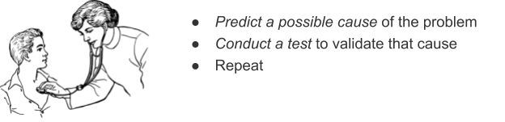

Feedback?

A common error among new programmers is to try to debug without a methodical process, instead staring at the program, or making random changes to see if the output is improved.

Consider a program that, given a circle's circumference, computes the circle's area. Below, the output area is clearly too large. In particular, if circumference is 10, then radius is 10 / (2 * PI_VAL), so about 1.6. The area is then PI_VAL * 1.6 * 1.6, or about 8, but the program outputs about 775.

Figure 2.21.2: Circle area program: Problem detected.

|  |  |
| --- | --- |
| #include <stdio.h>  **int** main(**void**) {  **const** **double** PI_VAL = 3.14159265;  **double** circleRadius;  **double** circleCircumference;  **double** circleArea;  printf("Enter circumference: ");  scanf("%lf", &circleCircumference);    circleRadius = circleCircumference / 2 * PI_VAL;  circleArea = PI_VAL * circleRadius * circleRadius;    printf("Circle area is: %lf\n", circleArea);    **return** 0;  } | Enter circumference: 10  Circle area is: 775.156914 |

Feedback?

First, a programmer may predict that the problem is a bad output statement. This prediction can be tested by adding the statement circleArea = 999;. The output statement is OK, and the predicted problem is invalidated. Note that a temporary statement commonly has a "FIXME" comment to remind the programmer to delete this statement.

Figure 2.21.3: Circle area program: Predict problem is bad output.

|  |  |
| --- | --- |
| #include <stdio.h>  **int** main(**void**) {  **const** **double** PI_VAL = 3.14159265;  **double** circleRadius;  **double** circleCircumference;  **double** circleArea;    printf("Enter circumference: ");  scanf("%lf", &circleCircumference);    circleRadius = circleCircumference / 2 * PI_VAL;  circleArea = PI_VAL * circleRadius * circleRadius;    circleArea = 999; // FIXME delete  printf("Circle area is: %lf\n", circleArea);    **return** 0;  } | Enter circumference: 0  Circle area is: 999.000000 |

Feedback?

Next, the programmer predicts the problem is a bad area computation. This prediction is tested by assigning the value 0.5 to radius and checking to see if the output is 0.7855 (which was computed by hand). The area computation is OK, and the predicted problem is invalidated. Note that a temporary statement is commonly left-aligned to make clear it is temporary.

Figure 2.21.4: Circle area program: Predict problem is bad area computation.

|  |  |
| --- | --- |
| #include <stdio.h>  **int** main(**void**) {  **const** **double** PI_VAL = 3.14159265;  **double** circleRadius;  **double** circleCircumference;  **double** circleArea;    printf("Enter circumference: ");  scanf("%lf", &circleCircumference);    circleRadius = circleCircumference / 2 * PI_VAL;    circleRadius = 0.5; // FIXME delete  circleArea = PI_VAL * circleRadius * circleRadius;    printf("Circle area is: %lf\n", circleArea);    **return** 0;  } | Enter circumference: 0  Circle area is: 0.785398 |

Feedback?

The programmer then predicts the problem is a bad radius computation. This prediction is tested by assigning PI_VAL to the circumference, and checking to see if the radius is 0.5. The radius computation fails, and the prediction is likely validated. Note that unused code was temporarily commented out.

Figure 2.21.5: Circle area program: Predict problem is bad radius computation.

|  |  |
| --- | --- |
| #include <stdio.h>  **int** main(**void**) {  **const** **double** PI_VAL = 3.14159265;  **double** circleRadius;  **double** circleCircumference;  **double** circleArea;    printf("Enter circumference: ");  scanf("%lf", &circleCircumference);    circleCircumference = PI_VAL; // FIXME delete  circleRadius = circleCircumference / 2 * PI_VAL;  printf("Radius: %lf\n", circleRadius); // FIXME delete    /*  circleArea = PI_VAL * circleRadius * circleRadius;    printf("Circle area is: %lf\n", circleArea);  */    **return** 0;  } | Enter circumference: 0  Radius: 4.934802 |

Feedback?

The last test seems to validate that the problem is a bad radius computation. The programmer visually examines the expression for a circle's radius given the circumference, which looks fine at first glance. However, the programmer notices that radius = circumference / 2 * PI_VAL; should have been radius = circumference / (2 * PI_VAL);. The parentheses around the product in the denominator are necessary and represent the desired order of operations. Changing to radius = circumference / (2 * PI_VAL); solves the problem.

The above example illustrates several common techniques used while testing to validate a predicted problem:

* Manually set a variable to a value.
* Insert print statements to observe variable values.
* Comment out unused code.
* Visually inspect the code (not every test requires modifying/running the code).

Statements inserted for debugging must be created and removed with care. A common erroris to forget to remove a debug statement, such as a temporary statement that manually sets a variable to a value. Left-aligning such a statement and/or including a FIXME comment can help the programmer remember. Another common error is to use /* */ to comment out code that itself contains /* */ characters. The first */ ends the comment before intended, which usually yields a syntax error when the second */ is reached or sooner.

The predicted problem is commonly vague, such as "Something is wrong with the input values." Conducting a general test (like printing all input values) may give the programmer new ideas as to a more-specific predicted problems. The process is highly iterative—new tests may lead to new predicted problems. A programmer typically has a few initial predictions, and tests the most likely ones first.

zyDE 2.21.1: Debugging using a repeated two-step process.

Use the above repeating two-step process (predict problem, test to validate) to find the problem in the following code for the provided input.

#include <stdio.h>

int main(void) {

int sideLength;

int cubeVolume;

printf("Enter cube's side length: \n");

scanf("%d", &sideLength);

cubeVolume = sideLength * sideLength * sideLength;

printf("Cube's volume is: %d\n", cubeVolume);

return 0;

}

Run

Enter cube's side length:

Cube's volume is: -727379968

Feedback?

**PARTICIPATIONACTIVITY**

2.21.1: Debugging.

Answer based on the above discussion.

1)

The first step in debugging is to make random changes to the code and see what happens.

False

**Correct**

While a common first step among beginners, a methodical process starts with predicting a problem (or at least a problem area).

2)

A common predicted-problem testing approach is to insert printf statements.

True

**Correct**

This is perhaps the most common predicted-problem testing approach.

3)

Variables in temporary statements can be written in uppercase, as in MYVAR = 999, to remind the programmer to remove them.

False

**Correct**

The language is case sensitive, so using uppercase refers to a different variable.

4)

A programmer lists all possible predicted problems first, then runs tests to validate each.

False

**Correct**

The list of all possible problems is typically huge. A programmer thinks of a few possible problems, then tests the most likely first. Testing may lead to new predictions.

5)

Most beginning programmers naturally follow a methodical process.

False

**Correct**

In contrast, beginning programmers commonly stare at the code or make random changes. A good skill to develop is to think methodically. Predict likely problems, then carefully test to validate each prediction.

6)

A program's output should be positive and usually is, but in some instances the output becomes negative. Overflow is a good prediction of the problem.

True

**Correct**

A reasonable test is to try small and large numbers and see if the large numbers consistently exhibit the problem. Hand calculation of the expected output and determination of whether the output value fits in the variable's size is also a good test.

2.22 Style guidelines

info

This section has been set as optional by your instructor.

Each programming team, whether a company, open source project, or a classroom, may have ***style guidelines*** for writing code. Below are the style guidelines followed by most code in this material. That style is not necessarily better than any other style. The key is to be consistent in style so that code within a team is easily understandable and maintainable.

You may not have learned all of the constructs discussed below; you may wish to revisit this section after covering new constructs.

Table 2.22.1: Sample style guide.

|  |  |  |
| --- | --- | --- |
| Sample guidelines used in this material | Yes | No (for our sample style) |
| Whitespace | | |
| Each statement usually appears on its own line. | x = 25;  y = x + 1; | x = 25; y = x + 1; // No  **if** (x == 5) { y = 14; } // No |
| A blank line can separate conceptually distinct groups of statements, but related statements usually have no blank lines between them. | x = 25;  y = x + 1; | x = 25;  // No  y = x + 1; |
| Most items are separated by one space (and not less or more). No space precedes an ending semicolon. | C = 25;  F = ((9 * C) / 5) + 32;  F = F / 2; | C=25; // No  F = ((9*C)/5) + 32; // No  F = F / 2 ; // No |
| Sub-statements are indented 3 spaces from parent statement. Tabs are not used as tabs may behave inconsistently if code is copied to different editors.  (Auto-tabbing may need to be disabled in some source code editors). | **if** (a < b) {  x = 25;  y = x + 1;  } | **if** (a < b) {  x = 25; // No  y = x + 1; // No  }  **if** (a < b) {  x = 25; // No  } |
| Braces | | |
| For branches, loops, functions, or structs, opening brace appears at end of the item's line. Closing brace appears under item's start. | **if** (a < b) {  // Called K&R style  }  **while** (x < y) {  // K&R style  } | **if** (a < b)  {  // Also popular, but we use K&R  } |
| For if-else, the else appears on its own line | **if** (a < b) {  ...  }  **else** {  // Called Stroustrup style  // (modified K&R)  } | **if** (a < b) {  ...  } **else** {  // Original K&R style  } |
| Braces always used even if only one sub-statement | **if** (a < b) {  x = 25;  } | **if** (a < b)  x = 25; // No, can lead to error later |
| Naming | | |
| Variable/parameter names are camelCase, starting with lowercase | **int** numItems; | **int** NumItems; // No  **int** num_items; // Common, but we don't use |
| Variable/parameter names are descriptive, use at least two words (if possible, to reduce conflicts), and avoid abbreviations unless widely-known like "num". Single-letter variables are rare; exceptions for loop indices (i, j), or math items like point coordinates (x, y). | **int** numBoxes;  **char** userKey; | **int** boxes; // No  **int** b; // No  **char** k; // No  **char** usrKey; // No |
| Constants use upper case and underscores (and at least two words) | **const** **int** MAXIMUM_WEIGHT = 300; | **const** **int** MAXIMUMWEIGHT = 300; // No  **const** **int** maximumWeight = 300; // No  **const** **int** MAXIMUM = 300; // No |
| Variables usually declared early (not within code), and initialized where appropriate and practical. | **int** i;  **char** userKey = '-'; | **int** i;  **char** userKey;  userKey = 'c';  **int** j; // No |
| Function names are CamelCase with uppercase first. | PrintHello() | printHello() // No  print_hello() // No |
| Miscellaneous | | |
| Lines of code are typically less than 100 characters wide. | Code is more easily readable when lines are kept short. One long line can usually be broken up into several smaller ones. |  |

Feedback?

***K&R style*** for braces and indents is named after C language creators Kernighan and Ritchie. ***Stroustrup style*** for braces and indents is named after C++ language creator Bjarne Stroustrup. The above are merely example guidelines.

Exploring further:

* [Google's C++ Style Guide](https://google.github.io/styleguide/cppguide.html)

2.23 C example: Salary calculation with variables

Using variables in expressions, rather than numbers like 40, makes a program more general and makes expressions more meaningful when read too.

zyDE 2.23.1: Calculate salary: Generalize a program with variables and input.

The following program uses a variable workHoursPerWeek rather than directly using 40 in the salary calculation expression.

1. Run the program, observe the output. Change 40 to 35 (France's work week), and run again.
2. Generalize the program further by using a variable workWeeksPerYear. Run the program. Change 50 to 52, and run again.
3. Introduce a variable monthlySalary, used similarly to annualSalary, to further improve program readability.

Load default template...

4

5

6

7

8

9

10

11

12

13

14

15

16

17

18

19

20

21

int hourlyWage;

int workHoursPerWeek;

int annualSalary;

// FIXME: Declare and initialize variable workWeeksPerYear, then replace the 50's below

hourlyWage = 20;

workHoursPerWeek = 40;

annualSalary = hourlyWage * workHoursPerWeek * 50;

printf("Annual salary is: ");

printf("%d\n", annualSalary);

printf("Monthly salary is: ");

printf("%d\n", ((hourlyWage * workHoursPerWeek * 50) / 12));

return 0;

}

Run

Annual salary is: 40000

Monthly salary is: 3333

Feedback?

When values are stored in variables as above, the program can read user inputs for those values. If a value will never change, the variable can be declared as const.

zyDE 2.23.2: Calculate salary: Generalize a program with variables and input.

The program below has been generalized to read a user's input value for hourlyWage.

1. Run the program. Notice the user's input value of 10 is used. Modify that input value, and run again.
2. Generalize the program to get user input values for workHoursPerWeek and workWeeksPerYear (change those variables' initializations to 0). Run the program.
3. monthsPerYear will never change, so declare that variable as const. Use the standard for naming constant variables. Ex: const int MAX_LENGTH = 99. Run the program.
4. Change the values in the input area below the program, and run the program again.

Load default template...

1

2

3

4

5

6

7

8

9

10

11

12

13

14

15

16

17

18

19

20

#include <stdio.h>

int main (void) {

int hourlyWage;

int workHoursPerWeek;

int workWeeksPerYear;

int monthsPerYear; // FIXME: Declare as const and use standard naming

int annualSalary;

int monthlySalary;

printf("Enter hourly wage: \n");

scanf("%d", &hourlyWage);

// FIXME: Get user input values for workHoursPerWeek and workWeeksPerYear

workHoursPerWeek = 40;

workWeeksPerYear = 50;

annualSalary = hourlyWage * workHoursPerWeek * workWeeksPerYear;

printf("Annual Salary is: ");

printf("%d\n", annualSalary);

Run

Enter hourly wage:

Annual Salary is: 20000

Monthly salary is: 32767

Feedback?

2.24 C example: Married-couple names with variables

info

This section has been set as optional by your instructor.

zyDE 2.24.1: Married-couple names with variables.

Pat Smith and Kelly Jones are engaged. What are possible last name combinations for the married couple (listing Pat first)?

1. Run the program below to see three possible married-couple names. Note the use of variable firstNames to hold both first names of the couple.
2. Extend the program to declare and use a variable lastName similarly. Note that the print statements are neater. Run the program again.
3. Extend the program to print two more options that abut the last names, as in SmithJones and JonesSmith. Run the program again.

#include <stdio.h>

#include <string.h>

int main(void) {

char firstName1[50];

char lastName1[50];

char firstName2[50];

char lastName2[50];

char firstNames[50];

// FIXME: Declare lastName

printf("What is the first person's first name?\n");

scanf("%s", firstName1);

printf("What is the first person's last name?\n");

scanf("%s", lastName1);

printf("What is the second person's first name?\n");

scanf("%s", firstName2);

printf("What is the second person's last name?\n");

scanf("%s", lastName2);

Run

What is the first person's first name?

What is the first person's last name?

What is the second person's first name?

What is the second person's last name?

Here are some common married-couple names:

Pat Smith and Kelly Jones

Pat and Kelly Smith

Pat and Kelly Jones

Pat and Kelly Smith-Jones

Pat and Kelly Jones-Smith

Feedback?

zyDE 2.24.2: Married-couple names with variables (solution).

A solution to the above problem follows:

#include <stdio.h>

#include <string.h>

int main(void) {

char firstName1[50];

char lastName1[50];

char firstName2[50];

char lastName2[50];

char firstNames[50];

char lastName[50];

printf("What is the first person's first name?\n");

scanf("%s", firstName1);

printf("What is the first person's last name?\n");

scanf("%s", lastName1);

printf("What is the second person's first name?\n");

scanf("%s", firstName2);

printf("What is the second person's last name?\n");

scanf("%s", lastName2);

Run

What is the first person's first name?

What is the first person's last name?

What is the second person's first name?

What is the second person's last name?

Here are some common married-couple names:

Pat Smith and Kelly Jones

Pat and Kelly Smith

Pat and Kelly Jones

Pat and Kelly Smith-Jones

Pat and Kelly Jones-Smith

Pat and Kelly SmithJones

Pat and Kelly JonesSmith

# 2.25 LAB: Input and formatted output: House real estate summary

Sites like Zillow get input about house prices from a database and provide nice summaries for readers. Write a program with two inputs, current price and last month's price (both integers). Then, output a summary listing the price, the change since last month, and the estimated monthly mortgage computed as (currentPrice * 0.051) / 12 (Note: Output directly as a floating-point value. Do not store in a variable.).

Ex: If the input is:

200000 210000

the output is:

This house is $200000. The change is $-10000 since last month.

The estimated monthly mortgage is $850.000000.

Note: Getting the precise spacing, punctuation, and newlines exactly right is a key point of this assignment. Such precision is an important part of programming.

**LABACTIVITY**

2.25.1: LAB: Input and formatted output: House real estate summary

#include <stdio.h>

int main(void) {

int currentPrice;

int lastMonthsPrice;

scanf("%d", &currentPrice);

scanf("%d", &lastMonthsPrice);

printf("This house is $%d. The change is $%d since last month.\n", currentPrice, (currentPrice - lastMonthsPrice));

printf("The estimated monthly mortgage is $%lf.\n", (currentPrice * 0.051) / 12);

return 0;

}

# 2.26 LAB: Using math functions

Given three floating-point numbers x, y, and z, output x to the power of z, x to the power of (y to the power of 2), the absolute value of y, and the square root of (xy to the power of z).

Output each floating-point value with two digits after the decimal point, which can be achieved as follows:  
printf("%0.2lf", yourValue);

Ex: If the input is:

5.0 6.5 3.2

the output is:

172.47 340002948455826440449068892160.00 6.50 262.43

**LABACTIVITY**

2.26.1: LAB: Using math functions

#include <stdio.h>

#include <math.h>

int main(void) {

double x;

double y;

double z;

scanf("%lf", &x);

scanf("%lf", &y);

scanf("%lf", &z);

printf("%0.2lf ", pow(x, z));

printf("%0.2lf ", pow(x, pow(y, 2)));

printf("%0.2lf ", fabs(y));

printf("%0.2lf\n", sqrt(pow(x * y, z)));

return 0;

}

# 3.1 If-else branches (general)

### Branch concept

People familiar with restaurants may be familiar with steering people to different-sized tables based on group size.

**PARTICIPATION ACTIVITY**

3.1.1: Branching concept.

123

2x speed

Counter

2

1

4

1

3

If party of 1:

Else If party of 2:

Else:

Host



Party of:

The host mentally executes the algorithm: If party of 1, seat at counter; Else If party of 2, seat at small table; Else seat at large table.

##### Captions

keyboard_arrow_up

1. A restaurant host seats patrons. The host seats a party of 1 at the counter.
2. A party of 2 is seated at a small table. Other size parties are seated at a large table.
3. The host mentally executes the algorithm: If party of 1, seat at counter; Else If party of 2, seat at small table; Else seat at large table.

Feedback?

**PARTICIPATION ACTIVITY**

3.1.2: Branch concept.

Consider the example above.

1)

A party of 1 is sat at _____ .

the counter

a small table

**Correct**

The host's algorithm starts with: If party of 1, seat at counter.

2)

A party of 2 is sat at _____ .

the counter

a small table

**Correct**

The host's algorithm is: If not a party of 1, but a party of 2, seat at a small table.

3)

A party of 5 is sat _____ .

at a large table

nowhere

**Correct**

In the host's algorithm, if not a party of 1, and not a party of 2, then seat at a large table. Thus, any party that is not of size 1 or 2 gets a large table, so parties of 3, 4, 5, 6, etc. (The algorithm doesn't do anything special for very large parties).

Feedback?

### Branch basics (If)

A ***branch*** is a program path taken only if an expression's value is true. Ex: A hotel may discount a price only for people over age 60.

**PARTICIPATION ACTIVITY**

3.1.3: A simple branch: Hotel discount.

123

2x speed

age = Get next input

price = 155

Put price to output

price = price - 20

If age > 60

Output

Input: 72

Input: 45

135

Put "Cost: " to output

Cost:

Cost:

155

72

45

135

But, if the input age were 45, then age > 60 is false. The branch is not taken, so the output is 155.

##### Captions

keyboard_arrow_up

1. A branch is a program path taken if an expression is true. This program assigns price = 155, and gets input age. If age > 60, the branch with price = price - 20 should be taken.
2. When executing, if the input age is 72, then age > 60 is true. The branch is taken, so price = price - 20 executes. The output is thus 135.
3. But, if the input age were 45, then age > 60 is false. The branch is not taken, so the output is 155.

Feedback?

Such a branch is commonly known as an ***If*** branch: A branch taken only if an expression is true.

**PARTICIPATION ACTIVITY**

3.1.4: Branches.

Consider the example above.

1)

If the input is 25, the output is Cost: _____ .

135

155

**Correct**

Initially, price = 155 executes. Next, the age is assigned with the input 25. Next, because 25 > 60 is false, the branch is not taken, so the output statements execute, thus outputting 155.

2)

If the input is 80, the output is Cost: _____ .

135

155

**Correct**

Initially, price = 155 executes. Next, the age is assigned with the input 80. Next, because 80 > 60 is true, the branch is taken, and price = price - 20 executes, making price 135. Next, the output statements execute, thus outputting 135.

3)

If the input is 60, will the branch be taken?

Yes

No

**Correct**

The expression will be 60 > 60, which is false (60 equals 60, but 60 is not greater than 60). Thus, the branch will not execute, and price will remain 155.

Feedback?

### If branch example: Absolute value

The following shows how an if branch can be used to compute an absolute value of a number.

**PARTICIPATION ACTIVITY**

3.1.5: Example if branch: Computing absolute value.

123

2x speed

val = Get next input

Put val to output

val = -val

If val < 0

Output

Input: -9

Input: 45

9

45

-9

45

9

But, if the input val were 45, then val < 0 is false. The branch is not taken, so the output is 45.

##### Captions

keyboard_arrow_up

1. This program outputs the absolute value of the input. After getting input val, if val < 0, the branch val = -val executes. Finally, val is output.
2. When executing, if the input val is -9, then val < 0 is true. The branch is taken, so val = -val executes, assigning val with 9. So 9 is output.
3. But, if the input val were 45, then val < 0 is false. The branch is not taken, so the output is 45.

Feedback?

**PARTICIPATION ACTIVITY**

3.1.6: Example if branch: Absolute value.

Consider the example above.

1)

If the input is -6, does the branch execute?

Yes

No

**Correct**

-6 < 0 is true, so the branch executes. val = -val executes, assigning val with -(-6) or 6, which is then output.

2)

If the input is 0, does the branch execute?

Yes

No

**Correct**

0 < 0 is false, so the branch does not execute.

Feedback?

### If-else branches

An ***if-else*** structure has two branches: The first branch is taken if an expression is true, else the other branch is taken.

**PARTICIPATION ACTIVITY**

3.1.7: If-else branches.

1234

2x speed

weight = Get next input

Put "Done." to output

Put "Can ride." to output

If weight < 150

Output

Input: 128

Input: 175

Can't ride.

128

175

Else

Put "Can't ride." to output

Can ride.

Done.

Done.

But, if the input is 175, weight < 150 is false, so the else branch executes. "Can't ride" is output.

##### Captions

keyboard_arrow_up

1. An if-else has two branches. The if branch is taken if the expression is true. Otherwise, the else branch is taken.
2. This program should output "Can ride. Done." if the input weight < 150, else should output "Can't ride. Done."
3. If the input weight is 128, weight < 150 is true, so the if branch executes. "Can ride" is output.
4. But, if the input is 175, weight < 150 is false, so the else branch executes. "Can't ride" is output.

Feedback?

**PARTICIPATION ACTIVITY**

3.1.8: If-else branches.

Consider the example above.

1)

What is output when the input is 90?

Can ride. Done.

Can't ride. Done.

**Correct**

90 < 150 is true, so the if branch is taken, which outputs "Can ride." Finally, "Done." is output.

2)

What is output when the input is 200?

Can ride. Done.

Can't ride. Done.

**Correct**

200 < 150 is false, so the else branch is taken, which outputs "Can't ride." Finally, "Done." is output.

3)

What is output when the input is exactly 150?

Can ride. Done. Can't ride. Done.

Can ride. Can't ride. Done.

Can't ride. Done.

**Correct**

150 < 150 is false, so the else branch executes.

4)

What input value causes both the if branch to execute (outputting "Can ride") and the else branch to execute (outputting "Can't ride")?

149

150

151

No such value

**Correct**

No value can cause both branches to execute. Either the expression is true (so the if branch executes), or false (so the else branch executes).

5)

What value causes "Done." to NOT be output?

130

160

No such value.

**Correct**

The if branch and the else branch join and lead to the statement that follows the if-else, which outputs "Done." Any value will cause either the if branch or the else branch to execute, either of which is followed by outputting "Done."

Feedback?

### If-else example: Max

The following example shows how an if-else can be used to get the maximum of two values.

**PARTICIPATION ACTIVITY**

3.1.9: If-else example: Max.

123

2x speed

x = Get next input

Put max to output

max = x

If x > y

Output

Input: 7 3

Input: 3 7

7

3

7

7

3

Else

max = y

7

7

7

y = Get next input

If the input instead is 3 7, x > y is false, so the else executes. max is assigned with y, which is 7. Thus, whether the input is 7 3 or is 3 7, max gets the larger value.

##### Captions

keyboard_arrow_up

1. This program should output the maximum of two input values.
2. If x is 7 and y is 3, x > y is true, so the if branch executes, which assigns max with x, so 7.
3. If the input instead is 3 7, x > y is false, so the else executes. max is assigned with y, which is 7. Thus, whether the input is 7 3 or is 3 7, max gets the larger value.

Feedback?

**PARTICIPATION ACTIVITY**

3.1.10: If-else example: Max.

Consider the example above.

1)

When the input is -3 0, which branch executes?

If

Else

**Correct**

-3 > 0 is false, so the else branch executes, assigning max with 0.

2)

When the input is 99 98, which branch executes?

If

Else

**Correct**

99 > 98 is true, so the if branch executes, assigning max with 99.

3)

The if branch assigns max = x. The else branch assigns max = ?

x

y

**Correct**

If x > y, the if branch assigns max = x. Otherwise, the else branch assigns max = y.

4)

If the inputs are 5 5, does max get assigned with x or y?

x

y

**Correct**

Because 5 > 5 is false, the else branch executes, thus assigning max = y. However, note that when x and y are equal, the code could have been written to assign max = x, as in: If x ≥ y.

Feedback?

### If-elseif-else branches

Commonly a programmer wishes to take one of multiple (three or more) branches. An if-else can be extended to an if-elseif-else structure. Each branch's expression is checked in sequence; as soon as one branch's expression is found to be true, that branch is taken. If no expression is found true, execution will reach the else branch, which then executes.

**PARTICIPATION ACTIVITY**

3.1.11: If-elseif-else branch.

1234

2x speed

year = Get next input

(more statements)

Put "Orwell!" to output

If year equals 1984

Output

Input: 1984

Input: 2001

Space Odyssey!

1984

2001

Else If year equals 2001

Put "Space Odyssey!" to output

Orwell!

Else

Put "Nothing special" to output

Input: 1997

1997

Nothing special

If year equals anything else, like 1997, the if branch is not taken, and else-if branch is not taken, so the else branch is taken. "Nothing special" is output.

##### Captions

keyboard_arrow_up

1. This program gets a year, then if 1984 outputs "Orwell!", else if 2001 outputs "Space Odyssey!", else outputs "Nothing special", thus indicating if a year was featured in a famous book/movie.
2. If year equals 1984, the if branch is taken, outputting "Orwell!".
3. If the input is 2001, year equals 1984 is false. So the next branch is checked: year equals 2001 is true, so that branch is taken, thus outputting "Space Odyssey!".
4. If year equals anything else, like 1997, the if branch is not taken, and else-if branch is not taken, so the else branch is taken. "Nothing special" is output.

Feedback?

Note: The else part is optional. If omitted, then if none of the previous expressions are true, no branch executes.

**PARTICIPATION ACTIVITY**

3.1.12: If-elseif-else.

Consider the if-elseif-else structure below:

If x equals -1

Put "Disagrees" to output

Else If x equals 0

Put "Neutral" to output

Else If x equals 1

Put "Agrees" to output

Else

Put "Invalid entry" to output

1)

If x is 1, what is output?

Disagrees

Neutral

Agrees

Invalid entry

**Correct**

When executing, the program first checks if x equals -1, which is false. So the program next checks if x equals 0, which is false. So the program next checks if x equals 1, which is true, so the branch is taken.

2)

If x is -2, what is output?

Disagrees

Invalid entry

(Nothing is output)

**Correct**

x equals -1 is false, so the first branch is skipped. x equals 0 is false, so the second branch is skipped. x equals 1 is false, so the third branch is skipped. Thus, the else branch is reached, which executes regardless of x's value.

3)

Could the programmer have written the three branches in the order x equals 1, x equals 0, and x equals -1, and achieved the same results?

No

Yes

**Correct**

For those particular expressions, the order doesn't matter; only one branch can have a true expression, so that one branch whose expression is true will execute, or the else branch will execute.

4)

In the code above, suppose a programmer, after the third branch (x equals 1), inserts a new branch: Else If x equals -1 ... When might that new branch execute?

When x is -1

When x is 1

Never

**Correct**

That branch could never execute, because if x is -1, the first branch will execute, and the latter branches will not be considered. The programmer is making a logic error by inserting such a branch.

5)

In the code above, suppose a programmer removed the Else part entirely. If x is 2, which is correct?

The last branch, meaning the Else If x equals 1 branch, will execute.

No branch will execute.

The program is not legal.

**Correct**

A branch only executes if the branch's expression is reached and is true. Each expression is reached, but none is true, so none will execute. Execution will simply proceed to the next statement following the if-elseif structure.

# 3.2 If-else

### If statements

An ***if*** statement executes a group of statements if an expression is true. Braces surround the if branch's statements. ***Braces*** { }, sometimes redundantly called curly braces, represent a grouping, such as a grouping of statements. Note: { } are braces, [ ] are brackets.

Good practice is to indent a branch's statements, using a consistent number of spaces. This material indents 3 spaces.

**PARTICIPATION ACTIVITY**

3.2.1: if statement: Hotel discount.

12345

2x speed

printf("Enter age: ");

scanf("%d", &userAge);

hotelRate = 155;

**if** (userAge > 65) {

printf("Your Hotel rate: ");

printf("%d\n", hotelRate);

68

}

#include <stdio.h>

**int** main(**void**) {

**int** hotelRate;

**int** userAge;

hotelRate = 155;

printf("Enter age: ");

scanf("%d", &userAge);

**if** (userAge > 65) {

hotelRate = hotelRate - 20;

}

printf("Your hotel rate: ");

printf("%d\n", hotelRate);

**return** 0;

}

hotelRate = hotelRate - 20;

hotelRate

userAge

Memory

95

96

97

98

155

Enter age:

68

68

155

- 20

135

> 65

*(true)*

Your hotel rate:

135

The program completes by printing the hotel rate.

##### Captions

keyboard_arrow_up

1. An if statement executes a group of statements if an expression is true. The program assigns hotelRate with 155 and then gets the user's age from input.
2. userAge is 68, so the expression 68 > 65 is true, and the if's statement will execute. Thus, the statement following the opening brace { will execute next.
3. hotelRate is decreased by 20, which is the discount for guests older than 65.
4. The closing brace } indicates the end of the group of statements.
5. The program completes by printing the hotel rate.

Feedback?

**PARTICIPATION ACTIVITY**

3.2.2: If statement.

What is the final value of numItems?

1)

bonusVal = 19;

numItems = 1;

**if** (bonusVal > 10) {

numItems = numItems + 3;

}

CheckShow answer

**Correct**

4

numItems starts with 1. 19 > 10 is true, so the branch executes, assigning numItems with 1 + 3, or 4.

2)

bonusVal = 0;

numItems = 1;

**if** (bonusVal > 10) {

numItems = numItems + 3;

}

CheckShow answer

**Correct**

1

numItems starts with 1. 0 > 10 is false, so the branch does not execute, and thus numItems remains 1.

Feedback?

### If-else statement

An ***if-else*** statement executes one group of statements when an expression is true, and another group of statements when the expression is false.

Construct 3.2.1: If-else statement.

// Statements that execute before the branches

**if** (expression) {

// Statements that execute when expression is true (first branch)

}

**else** {

// Statements that execute when expression is false (second branch)

}

// Statements that execute after the branches

Feedback?

In the example below, if a user inputs an age less than 25, the statement insurancePrice = 4800 executes. Otherwise, insurancePrice = 2200 executes.

**PARTICIPATION ACTIVITY**

3.2.3: if-else statement: Car insurance.

123

2x speed

22

#include <stdio.h>

**int** main(**void**) {

**int** userAge;

**int** insurancePrice;

printf("Enter age: ");

scanf("%d", &userAge);

**if** (userAge < 25) {

insurancePrice = 4800;

}

**else** {

insurancePrice = 2200;

}

printf("Annual price: $");

printf("%d\n", insurancePrice);

**return** 0;

}

insurancePrice

userAge

Memory

95

96

97

98

Enter age:

155

- 20

135

< 25

*(true)*

Your hotel rate:

135

22

22

4800

Annual price: $

4800

Enter age:

40

40

40

*(false)*

2200

Annual price: $

2200

user's age is 40, so the expression 40 < 25 is false, and the else's statements will execute.

##### Captions

keyboard_arrow_up

1. An if-else statement executes a group of statements if an expression is true, and executes another group of statements otherwise.
2. userAge is 22, so the expression 22 < 25 is true, and the if's statements will execute.
3. user's age is 40, so the expression 40 < 25 is false, and the else's statements will execute.

Feedback?

Car insurance prices

*(*[*Car insurance prices*](http://www.carsdirect.com/car-insurance/the-average-car-insurance-rates-by-age#b)*for drivers under 25 are higher because 1 in 6 such drivers are involved in an accident each year, vs. 1 in 15 for older drivers. Source:*[*www.census.gov*](http://www.census.gov/)*, 2009).*

**PARTICIPATION ACTIVITY**

3.2.4: If-else statements.

1)

What is the final value of numItems?

bonusVal = 5;

**if** (bonusVal < 12) {

numItems = 100;

}

**else** {

numItems = 200;

}

CheckShow answer

**Correct**

100

5 < 12 is true, so the first branch executes, namely numItems = 100.

2)

What is the final value of numItems?

bonusVal = 12;

**if** (bonusVal < 12) {

numItems = 100;

}

**else** {

numItems = 200;

}

CheckShow answer

**Correct**

200

12 < 12 is false, so the second branch executes, namely numItems = 200.

3)

What is the final value of numItems?

bonusVal = 15;

numItems = 44;

**if** (bonusVal < 12) {

numItems = numItems + 3;

}

**else** {

numItems = numItems + 6;

}

numItems = numItems + 1;

CheckShow answer

**Correct**

51

numItems is first assigned with 44. 15 < 12 is false, so the second branch executes, which adds 6, so numItems becomes 50. The statement after the branch adds 1 more, so the final value is 51.

4)

What is the final value of bonusVal?

bonusVal = 11;

**if** (bonusVal < 12) {

bonusVal = bonusVal + 2;

}

**else** {

bonusVal = bonusVal + 10;

}

CheckShow answer

**Correct**

13

11 < 12 is true, so the first branch executes, assigning bonusVal with 13. Note that the second branch does not execute even though bonusVal is now larger; only one of the two branches can execute.

5)

What is the final value of bonusVal?

bonusVal = 11;

**if** (bonusVal < 12) {

bonusVal = bonusVal + 2;

bonusVal = 3 * bonusVal;

}

**else** {

bonusVal = bonusVal + 10;

}

CheckShow answer

**Correct**

39

11 < 12 is true, so the first branch executes, which has two statements. The first assigns bonusVal with 13. The second assigns bonusVal with 3 * 13, or 39.

Feedback?

**PARTICIPATION ACTIVITY**

3.2.5: Writing an if-else statement.

Translate each description to an if-else statement as directly as possible. Use { }. (Not checked, but please indent a branch's statements some consistent number of spaces, such as 3 spaces).

1)

If userAge is greater than 62, assign itemDiscount with 15. Else, assign itemDiscount with 0.

CheckShow answer

**Correct**

if (userAge > 62) { itemDiscount = 15; } else { itemDiscount = 0; }

New programmers commonly forget the parentheses, braces, or semicolons.

2)

If numPeople is greater than 10, execute groupSize = 2 * groupSize. Otherwise, execute groupSize = 3 * groupSize and numPeople = numPeople - 1.

CheckShow answer

**Correct**

if (numPeople > 10) { groupSize = 2 * groupSize; } else { groupSize = 3 * groupSize; numPeople = numPeople - 1; }

Note that both statements in the second branch must be within that branch's braces.

3)

If numPlayers is greater than 11, execute teamSize = 11. Otherwise, execute teamSize = numPlayers. Then, no matter the value of numPlayers, execute teamSize = 2 * teamSize.

CheckShow answer

**Correct**

if (numPlayers > 11) { teamSize = 11; } else { teamSize = numPlayers; } teamSize = 2 * teamSize;

The teamSize = 2 * teamSize; statement executes regardless of numPlayers' initial value.

Feedback?

**CHALLENGE ACTIVITY**

3.2.1: Enter the output for the if-else branches.

Jump to level 1

Type the program's output

|  |  |
| --- | --- |
| #include <stdio.h>  **int** main**(void)** {  **int** numApples;    numApples = 9;  **if** (numApples < 9) {  printf("a\n");  }  **else** {  printf("f\n");  }    printf("k\n");  **return** 0;  } |  |

1

2

**3**

Check

Next

**Done**. Click any level to practice more. Completion is preserved.



numApples is assigned with 9. Since numApples is equal to 9 the expression evaluates to false, the program outputs "f" and then "k".

|  |  |
| --- | --- |
| Yours | f  k |
| Expected | f  k |

1

2

3

Feedback?

**CHALLENGE ACTIVITY**

3.2.2: Basic if-else expression.

Jump to level 1

Write an expression that will cause the following code to print "I am a teenager" if the value of userAge is less than 20.

1

2

3

4

5

6

7

8

9

10

11

12

13

14

15

16

#include <stdio.h>

int main(void) {

int userAge;

scanf("%d", &userAge); // Program will be tested with values: 18, 19, 20, 21.

if (userAge > 19) {

printf("I am an adult\n");

}

else {

printf("I am a teenager\n");

}

return 0;

}

1

2

**3**

Check

Try again

**Done**. Click any level to practice more. Completion is preserved.



An expression may use > to evaluate if userAge is greater than 19. If the expression evaluates to false, then the second branch executes.

1: Compare output

keyboard_arrow_up

Input

18

 Your output

I am a teenager

2: Compare output

keyboard_arrow_up

Input

19

 Your output

I am a teenager

3: Compare output

keyboard_arrow_up

Input

20

 Your output

I am an adult

4: Compare output

keyboard_arrow_up

Input

21

 Your output

I am an adult

1

2

3

Feedback?

**CHALLENGE ACTIVITY**

3.2.3: Basic if-else.

Jump to level 1

Write an if-else statement for the following: If numDifference is less than -15, execute totalDifference = -25. Else, execute totalDifference = numDifference.

1

2

3

4

5

6

7

8

9

10

11

12

13

14

15

16

17

18

19

#include <stdio.h>

int main(void) {

int totalDifference;

int numDifference;

scanf("%d", &numDifference); // Program will be tested with values: -14, -15, -16, -17.

if(numDifference < -15){

totalDifference = -25;

}

else{

totalDifference = numDifference;

}

printf("%d", totalDifference);

return 0;

}

1

**2**

Check

Try again

**Done**. Click any level to practice more. Completion is preserved.



If numDifference is less than -15, totalDifference is assigned with -25. Else, totalDifference is assigned with numDifference.

1: Compare output

keyboard_arrow_up

Input

-14

 Your output

-14

2: Compare output

keyboard_arrow_up

Input

-15

 Your output

-15

3: Compare output

keyboard_arrow_up

Input

-16

 Your output

-25

4: Compare output

keyboard_arrow_up

Input

-17

 Your output

-25

1

2

Feedback?

### Multi-branch if-else statements

An If-else statement can be extended to have three (or more) branches. Each branch's expression is checked in sequence. As soon as one branch's expression is found to be true, that branch's statement execute (and no subsequent branch is considered). If no expression is true, the else branch executes.

Construct 3.2.2: Multi-branch if-else statement. Only 1 branch will execute.

**if** (expression1) {

// Statements that execute when expression1 is true

// (first branch)

}

**else** **if** (expression2) {

// Statements that execute when expression1 is false and expression2 is true

// (second branch)

}

**else** {

// Statements that execute when expression1 is false and expression2 is false

// (third branch)

}

Feedback?

The ***equality operator*** ***==*** evaluates to true if the left side and right side are equal. Ex: If numYears holds the value 10, then the expression numYears == 10 evaluates to true.

Note that the equality operator is ==, not =.

Figure 3.2.1: Multi-branch if-else example: Anniversaries.

|  |  |
| --- | --- |
| #include <stdio.h>  **int** main(**void**) {  **int** numYears;    printf("Enter number years married: ");  scanf("%d", &numYears);    **if** (numYears == 1) {  printf("Your first year -- great!\n");  }  **else** **if** (numYears == 10) {  printf("A whole decade -- impressive.\n");  }  **else** **if** (numYears == 25) {  printf("Your silver anniversary -- enjoy.\n");  }  **else** **if** (numYears == 50) {  printf("Your golden anniversary -- amazing.\n");  }  **else** {  printf("Nothing special.\n");  }    **return** 0;  } | Enter number years married: 10  A whole decade -- impressive.  ...  Enter number years married: 25  Your silver anniversary -- enjoy.  ...  Enter number years married: 30  Nothing special.  ...  Enter number years married: 1  Your first year -- great! |

Feedback?

**PARTICIPATION ACTIVITY**

3.2.6: Multi-branch if-else statements.

What is the final value of employeeBonus for each given value of numSales?

**if** (numSales == 0) {

employeeBonus = 0;

}

**else** **if** (numSales == 1) {

employeeBonus = 2;

}

**else** **if** (numSales == 2) {

employeeBonus = 5;

}

**else** {

employeeBonus = 10;

}

1)

numSales is 2

CheckShow answer

**Correct**

5

The first branch is skipped because 2 == 0 is false. The second branch is skipped because 2 == 1 is false. The third branch executes because 2 == 2 is true, so employeeBonus = 5. The fourth branch is never considered.

2)

numSales is 0

CheckShow answer

**Correct**

0

The first branch executes because 0 == 0 is true, so employeeBonus = 0. The remaining branches are never considered.

3)

numSales is 7

CheckShow answer

**Correct**

10

The first branch is skipped because 7 == 0 is false. Likewise, the second and third branches are skipped. The else branch is thus executed, so employeeBonus = 10.

Feedback?

### Common errors

When a branch has a single statement, the braces are optional, but good practice  *always* uses the braces. Always using braces even when a branch only has one statement prevents the common error of mistakenly thinking a statement is part of a branch.

**PARTICIPATION ACTIVITY**

3.2.7: Common error when omitting braces.

12

2x speed

**if** (numSales < 20)

salesBonus = 0;

**else**

totBonus = totBonus + 1;

salesBonus = 20;

numSales

salesBonus

Memory

95

96

97

98

**else**

totBonus = totBonus + 1;

salesBonus = 20;

*Indentation is irrelevant.*

*salesBonus = 20; is not part of else,*

*so always executes.*

totBonus

*Always using braces avoids*

*the above common error.*

15

numSales

salesBonus

Memory

95

96

97

98

totBonus

15

0

2

2

20

15 < 20

0

**if** (numSales < 20)

salesBonus = 0;

{

}

{

}

15 < 20

Always using braces avoids the common error of not including all statements within an if or else branch.

##### Captions

keyboard_arrow_up

1. Braces aren't used, so the else branch's only statement is totBonus = totBonus + 1. But, salesBonus = 20; should also be part of the else branch.
2. Always using braces avoids the common error of not including all statements within an if or else branch.

Feedback?

**PARTICIPATION ACTIVITY**

3.2.8: Braces are important.

Omitting braces is a common source of errors. What is the final value of numItems?

1)

numItems = 0;

bonusVal = 19;

**if** (bonusVal > 10)

numItems = bonusVal;

numItems = numItems + 1;

CheckShow answer

**Correct**

20

The branch executes, numItems = 19. Last statement adds 1, so 20.

2)

numItems = 0;

bonusVal = 5;

**if** (bonusVal > 10)

// Need to update bonusVal

numItems = bonusVal;

numItems = numItems + 1;

CheckShow answer

**Correct**

1

numItems = bonusVal is part of the branch, which does not execute. The comment is irrelevant. So numItems = numItems + 1 computes 0 + 1, yielding 1.

3)

numItems = 0;

bonusVal = 5;

**if** (bonusVal > 10)

// Update bonusVal

bonusVal = bonusVal - 1;

numItems = bonusVal;

numItems = numItems + 1;

CheckShow answer

**Correct**

6

bonusVal = bonusVal - 1 is part of the branch, which does not execute. numItems = bonusVal is NOT part of the branch (indentation doesn't matter), and thus executes, assigning numItems with 5. The last statement assigns numItems with 5 + 1, or 6. Always using braces prevents this *very common error*.

**CHALLENGE ACTIVITY**

3.2.4: If-else statement: Fix errors.

Re-type the code and fix any errors. The code should convert non-positive numbers to 1.

**if** (userNum > 0)

printf("Positive.\n");

**else**

printf("Non-positive, converting to 1.\n");

userNum = 1;

printf("Final: %d\n", userNum);

#include <stdio.h>

int main(void) {

int userNum;

scanf("%d", &userNum);

if (userNum > 0){

printf("Positive.\n");

}

else{

printf("Non-positive, converting to 1.\n");

userNum = 1;

}

printf("Final: %d\n", userNum);

return 0;

}

[3.2 If-else](https://learn.zybooks.com/zybook/UTSACS1714Fall2020/chapter/3/section/2)

3.3 More if-else

**Nested if-else statements**

A branch's statements can include any valid statements, including another if-else statement, which are known as ***nested if-else*** statements.

Figure 3.3.1: Nested if-else.

**if** (userChoice == 1) { // userChoice is 1

...

}

**else** **if** (userChoice == 2) {

**if** (numItems < 0) { // userChoice is 2 and numItems < 0

...

}

**else** { // userChoice is 2 and numItems >= 0

...

}

}

**else** { // userChoice is not 1 or 2

...

}

Feedback?

**PARTICIPATION ACTIVITY**

3.3.1: Nested if-else statements.

Determine the final value of salesBonus given the initial values specified below.

**if** (salesType == 2) {

**if** (salesBonus < 5) {

salesBonus = 10;

}

**else** {

salesBonus = salesBonus + 2;

}

}

**else** {

salesBonus = salesBonus + 1;

}

1)

salesType = 1; salesBonus = 0;

0

1

10

**Correct**

salesType is 1, so the first if's expression is false. The else branch executes and increases salesBonus by 1, yielding 0 + 1, or 1.

2)

salesType = 2; salesBonus = 4;

5

6

10

**Correct**

The first if's expression is true, so nest if-else statement executes. The nested if's expression is true, so salesBonus is assigned with 10.

3)

salesType = 2; salesBonus = 7;

8

9

10

**Correct**

The first if's expression is true and the nested if's expression is false. So, the nested else branch executes, assigning salesBonus with 7 + 2, or 9.

Feedback?

**Multiple distinct if statements**

Sometimes the programmer has multiple if statements in sequence, which looks similar to a multi-branch if-else statement but has a very different meaning. Each if-statement is independent, and thus more than one branch can execute, in contrast to the multi-branch if-else arrangement.

Figure 3.3.2: Multiple distinct if statements.

|  |  |
| --- | --- |
| #include <stdio.h>  **int** main(**void**) {  **int** userAge;    printf("Enter age: ");  scanf("%d", &userAge);    // Note that more than one "if" statement can execute  **if** (userAge < 16) {  printf("Enjoy your early years.\n");  }    **if** (userAge > 15) {  printf("You are old enough to drive.\n");  }    **if** (userAge > 17) {  printf("You are old enough to vote.\n");  }    **if** (userAge > 24) {  printf("Most car rental companies will rent to you.\n");  }    **if** (userAge > 34) {  printf("You can run for president.\n");  }    **return** 0;  } | Enter age: 12  Enjoy your early years.  ...  Enter age: 27  You are old enough to drive.  You are old enough to vote.  Most car rental companies will rent to you.  ...  Enter age: 99  You are old enough to drive.  You are old enough to vote.  Most car rental companies will rent to you.  You can run for president. |

Feedback?

**PARTICIPATION ACTIVITY**

3.3.2: If statements.

Determine the final value of numBoxes.

1)

numBoxes = 0;

numApples = 9;

**if** (numApples < 10) {

numBoxes = 2;

}

**if** (numApples < 20) {

numBoxes = numBoxes + 1;

}

CheckShow answer

**Correct**

3

The first if statement executes, assigning 2 to numBoxes. The second if statement also executes, assigning 2 + 1 or 3 to numBoxes.

2)

numBoxes = 0;

numApples = 9;

**if** (numApples < 10) {

**if** (numApples < 5) {

numBoxes = 1;

}

**else** {

numBoxes = 2;

}

}

**else** **if** (numApples < 20) {

numBoxes = numBoxes + 1;

}

CheckShow answer

**Correct**

2

The first branch executes, which is a nested if-else. The second nested branch executes, assigning 2 to numBoxes. The numApples < 20 branch is skipped because it is part of the if-else for which the if branch was taken.

**CHALLENGE ACTIVITY**

3.3.2: If-else statements.

Jump to level 1

Write multiple if statements: If carYear is before 1968, print "Probably has few safety features." (without quotes). If after 1969, print "Probably has head rests.". If after 1990, print "Probably has electronic stability control.". If after 2001, print "Probably has tire-pressure monitor.". End each phrase with period and newline. Ex: carYear = 1995 prints:

Probably has head rests.

Probably has electronic stability control.

#include <stdio.h>

int main(void) {

int carYear;

scanf("%d", &carYear);

if (carYear < 1968){

printf("Probably has few safety features.\n");

}

if (carYear > 1969){

printf ("Probably has head rests.\n");

}

if (carYear > 1990){

printf("Probably has electronic stability control.\n");

}

if (carYear > 2001){

printf("Probably has tire-pressure monitor.\n");

}

return 0;

}

Print "userNum1 is negative." if userNum1 is less than 0. End with newline. Assign userNum2 with 3 if userNum2 is greater than 14. Otherwise, print "userNum2 is less or equal 14.". End with newline.

#include <stdio.h>

int main(void) {

int userNum1;

int userNum2;

scanf("%d", &userNum1);

scanf("%d", &userNum2);

if (userNum1 < 0){

printf ("userNum1 is negative.\n");

}

if (userNum2 <= 14){

printf("userNum2 is less or equal 14.\n");

}

else if (userNum2 > 14){

userNum2 = 3;

}

printf("userNum2 is %d.\n", userNum2);

return 0;

}

3.4 Equality and relational operators

**Equality operators**

An ***equality operator*** checks whether two operands' values are the same (==) or different (!=). Note that equality is ==, not just =.

An expression involving an equality operator evaluates to a Boolean value. A ***Boolean*** is a type that has just two values: true or false.

Table 3.4.1: Equality operators.

|  |  |  |
| --- | --- | --- |
| Equality operators | Description | Example (assume x is 3) |
| == | a ***==*** b means a is equal to b | x == 3 is true x == 4 is false |
| != | a ***!=*** b means a is not equal to b | x != 3 is false x != 4 is true |

Feedback?

**PARTICIPATION ACTIVITY**

3.4.1: Evaluating expressions that have equality operators.

Indicate whether the expression evaluates to true or false.  
x is 5, y is 7.

1)

x == 5

True

**Correct**

x is 5, so 5 == 5 is true.

2)

x == y

False

**Correct**

x is 5 and y is 7, so 5 == 7 is false.

3)

y != 7

False

**Correct**

y is 7, so 7 != 7 is false: "7 is not equal to 7" is false, because 7 is indeed equal to 7.

4)

y != 99

True

**Correct**

y is 7, so 7 != 99 is true: "7 is not equal to 99" is true, because 7 is indeed not equal to 99.

5)

x != y

True

**Correct**

x is 5 and y is 7, so 5 != 7 is true.

6)

Is x = = y a valid expression?

No

**Correct**

For operators that use multiple characters, spaces are not allowed between the characters.

Feedback?

**PARTICIPATION ACTIVITY**

3.4.2: Creating expressions with equality operators.

Type the equality operator to complete the desired expression.

1)

numDogs is 0

numDogs 0

CheckShow answer

**Correct**

==

Saying numDogs is 0 is the same as saying numDogs equals 0, so the equality operator == is used. Note: Using = instead of ==, as in numDogs = 0, is a common error. The = operator is for assignment (thus assigning numDogs with 0), not for checking for equality.

2)

numDogs and numCats are the same

numDogs numCats

CheckShow answer

**Correct**

==

Many English phrases can mean "equal", such as "same", "identical", "don't differ", etc.

3)

numDogs and numCats differ

numDogs numCats

CheckShow answer

4)

numDogs is either less than or greater than numCats

numDogs numCats

CheckShow answer

**Correct**

!=

If numDogs is either less than or greater than numCats, then numDogs is not-equal to numCats. <> is not a valid operator, but that's no problem because != has the same meaning.

5)

userChar is the character 'x'.

userChar 'x'

CheckShow answer

**Correct**

==

Chars are commonly compared for equality. Note the single quotes around the x; omitting those is a common error.

Feedback?

**Relational operators**

A ***relational operator*** checks how one operand's value relates to another, like being greater than.

Some operators like >= involve two characters. A programmer cannot arbitrarily combine the >, =, and < symbols; only the shown two-character sequences represent valid operators.

Table 3.4.2: Relational operators.

|  |  |  |
| --- | --- | --- |
| Relational operators | Description | Example (assume x is 3) |
| < | a ***<*** b means a is less than b | x < 4 is true x < 3 is false |
| > | a ***>*** b means a is greater than b | x > 2 is true x > 3 is false |
| <= | a ***<=*** b means a is less than or equal to b | x <= 4 is true x <= 3 is true x <= 2 is false |
| >= | a ***>=*** b means a is greater than or equal to b | x >= 2 is true x >= 3 is true x >= 4 is false |

Feedback?

**PARTICIPATION ACTIVITY**

3.4.3: Evaluating equations having relational operators.

Indicate whether the expression evaluates to true or false.  
x is 5, y is 7.

1)

x <= 7

True

**Correct**

5 <= 7 is true, because 5 is less than 7.

2)

y >= 7

True

**Correct**

y is 7, so 7 >= 7 is true. The operator means greater than or equal, and in this case the two operands are equal.

3)

Is x <> y a valid expression?

No

**Correct**

Although intuitive, <> is not a built-in operator in the language. Fortunately, != has the same meaning.

4)

Is x =< y a valid expression?

No

**Correct**

<= is the operator for less than or equal, not =<.

Feedback?

**PARTICIPATION ACTIVITY**

3.4.4: Creating expressions with relational operators.

Type the operator to complete the desired expression.

1)

numDogs is greater than 10

numDogs 10

CheckShow answer

**Correct**

>

Straightforward.

2)

numCars is greater than or equal to 5

numCars 5

CheckShow answer

**Correct**

>=

>= means greater than or equal to. => is *not* a valid operator.

3)

numCars is 5 or greater

numCars 5

CheckShow answer

**Correct**

>=

Each operator captures various English descriptions.

4)

centsLost is a negative number

centsLost 0

CheckShow answer

**Correct**

<

< 0 is the common way to detect a negative number.

Feedback?

**Example: Golf scores**

In golf and miniature golf, each hole has a "par" indicating the normal number of strokes to get the ball in the hole. The following program outputs special names for numbers below par. The program uses one relational operator, and several equality operators, in a multi-branch if-else statement.

zyDE 3.4.1: Golf scores.

This program outputs special names for different numbers of strokes for a par 4 hole. Press Run to see the name for the input strokes of 2. Try changing the input strokes to different values, and press Run again to see the name.

If desired, try extending the program to print "Bogey" for 5, and "Double bogey" for 6. Remember that equals is ==, not =.

Try typing "= 1" instead of "== 1" and see what happens. Try typing an unsupported operator, like =>, and see what happens.

30

else if (numStrokes == 1) {

printf("Hole in 1!!!\n");

}

else if (numStrokes == 2) {

printf("Eagle!\n");

}

else if (numStrokes == 3) {

printf("Birdie.\n");

}

else if (numStrokes == 4) {

printf("Par.\n");

}

else {

printf("Better luck next time.\n");

}

return 0;

}

Run

Better luck next time.

Feedback?

**CHALLENGE ACTIVITY**

3.4.1: Enter the output for the branches with relational and equality operators.

Jump to level 1

Type the program's output

|  |  |
| --- | --- |
| #include <stdio.h>  **int** main**(void)** {  **int** numApples;  numApples = 6;    **if** (numApples != 4) {  printf("c\n");  }  **else** {  printf("e\n");  }    printf("g\n");  **return** 0;  } |  |

1

2

3

**4**

Check

Next

**Done**. Click any level to practice more. Completion is preserved.



If numApples is not equal to 4, then the program outputs "c", else the program outputs "e". "g" is outputted in either case.

|  |  |
| --- | --- |
| Yours | c  g |
| Expected | c  g |

1

2

3

4

Feedback?

**CHALLENGE**

**CHALLENGE ACTIVITY**

3.4.2: Equality and relational expressions.

Jump to level 1

Write an expression that will cause "Dollar or less" to print if the value of numCents is less than or equal to 100.

#include <stdio.h>

int main(void) {

int numCents;

scanf("%d", &numCents); // Program will be tested with values: 99, 100, 101, 102.

if (numCents <= 100) {

printf("Dollar or less\n");

}

else {

printf("More than a dollar\n");

}

return 0;

}

Write an expression that will cause "greater or equal to -10" to print if the value of userNum is greater than or equal to -10.

#include <stdio.h>

int main(void) {

int userNum;

scanf("%d", &userNum); // Program will be tested with values: -9, -10, -11, -12.

if (userNum >= -10) {

printf("greater or equal to -10\n");

}

else {

printf("less than -10\n");

}

return 0;

}

Complete the expression so that userPoints is assigned with 0 if userStreak is greater than 20 (second branch). Otherwise, userPoints is assigned with 10 (first branch).

#include <stdio.h>

int main(void) {

int userStreak;

int userPoints;

scanf("%d", &userStreak); // Program will be tested with values: 18, 19, 20, 21.

userPoints = 0;

if (userStreak < 21) {

userPoints = 10;

}

else {

userPoints = 0;

}

printf("%d\n", userPoints);

return 0;

}

**Comparing characters, strings, and floating-point types**

The relational and equality operators work for integer, character, and floating-point built-in types.

Comparing characters compares their ASCII numerical encoding.

Floating-point types should not be compared using the equality operators, due to the imprecise representation of floating-point numbers, as discussed in a later section.

The operators should not be used with strings; unexpected results will occur. See another section discussing the string comparison function strcmp().

**PARTICIPATION ACTIVITY**

3.4.5: Comparing various types.

Which comparison will compile AND consistently yield expected results? Variables have types denoted by their names.

1)

myInt == 42

OK

Not OK

**Correct**

Integer types are commonly compared.

2)

myChar == 'q'

OK

Not OK

**Correct**

The characters' numerical encodings will be compared.

3)

myDouble == 3.26

OK

Not OK

**Correct**

Compiles, but due to imprecision of floating-point representations, such comparisons may yield unexpected results. More later; for now, just don't compare floating-point types.

4)

myString == "Hello"

OK

Not OK

**Correct**

Compiles, but does not behave as expected. String comparisons are discussed later.

Feedback?

**Common errors**

Perhaps the most common error in C and C++ is to use = rather than == in an if-else expression, as in: if (numDogs = 9) { ... }. That code is not a syntax error. The statement assigns numDogs with 9, and then because that value is non-zero, the expression is considered true. C's designers allowed assignment in expressions to allow compact code, and use = for assignment rather than := or similar to save typing. Many people believe those language design decisions were mistakes, leading to many bugs. Some modern compilers provide a warning when = appears in an if-else expression.

Another common error is to use invalid character sequences like =>, !<, or <>, which are *not*valid operators.

**PARTICIPATION ACTIVITY**

3.4.6: Watch out for assignment in an if-else expression.

What is the final value of numItems?

1)

numItems = 3;

**if** (numItems == 3) {

numItems = numItems + 1;

}

CheckShow answer

**Correct**

4

numItems is originally 3. 3 == 3, so the branch executes, adding 1 more, so 4.

2)

numItems = 3;

**if** (numItems = 10) {

numItems = numItems + 1;

}

CheckShow answer

**Correct**

11

The if expression is numItems = 10. So numItems is assigned with 10. 10 is non-zero so treated as true, so the branch executes, adding 1 more, yielding 11. Bizarre, right?

Feedback?

**CHALLENGE ACTIVITY**

3.4.3: If-else statement: Fix errors.

Jump to level 1

Find and fix the error in the if-else statement.

1

2

3

4

5

6

7

8

9

10

11

12

13

14

15

16

#include <stdio.h>

int main(void) {

int userNum;

scanf("%d", &userNum); // Program will be tested with values: 1, 2, 3, 4.

if (userNum != 2) {

printf("Num is not two\n");

}

else {

printf("Num is equal to two\n");

}

return 0;

}

**1**

Check

Try again

**Done**. Click any level to practice more. Completion is preserved.



The if statement has to check if userNum is not 2.

1: Compare output

keyboard_arrow_up

Input

1

 Your output

Num is not two

2: Compare output

keyboard_arrow_up

Input

2

 Your output

Num is equal to two

3: Compare output

keyboard_arrow_up

Input

3

 Your output

Num is not two

4: Compare output

keyboard_arrow_up

Input

4

 Your output

Num is not two

Feedback?

**CHALLENGE ACTIVITY**

3.4.4: If-else statement: Print senior citizen.

Write an if-else statement that checks patronAge. If 55 or greater, print "Senior citizen", otherwise print "Not senior citizen" (without quotes). End with newline.

1

2

3

4

5

6

7

8

9

10

11

12

13

14

15

16

#include <stdio.h>

int main(void) {

int patronAge;

scanf("%d", &patronAge);

if (patronAge >= 55){

printf ("Senior citizen\n");

}

else{

printf ("Not senior citizen\n");

}

return 0;

}

# 3.5 Detecting ranges (general)

info

This section has been set as optional by your instructor.

### Range detection using if-elseif-else

An if-elseif-else structure can elegantly detect number ranges, such as under 6, 6 - 7, 8 - 9, 10 - 11, and 12 and up, with each branch performing a different action for each range. Each expression only needs to indicate the upper range part; if execution reaches an expression, the lower range part is implicit from the previous expressions being false.

**PARTICIPATION ACTIVITY**

3.5.1: An if-elseif-else structure can elegantly detect ranges.

1234

2x speed

13

12

11

10

9

8

7

6

5

4

3

2

1

No teams

12 or over

10, 11

Under 12

8, 9

Under 10

6, 7

Under 8

No teams

5 or under

No teams

Else:

Play on U12 team

Else If age < 12:

Play on U10 team

Else If age < 10:

Play on U8 team

Else If Age < 8:

No teams

If Age < 6:

An if-elseif-else structure can elegantly capture such ranges. When an expression is checked, one knows that all the previous expressions were false, thus defining the low range end.

##### Captions

keyboard_arrow_up

1. Kids of various ages may wish to play soccer. A soccer club may not have teams for kids 5 and under.
2. One level of teams is listed as "Under 8" (or just U8), which is understood to mean just 7 or 6, but not 5 or younger.
3. Likewise, U10 means 9 and 8, and U12 means 11 and 10. No teams exist for ages 12 and over.
4. An if-elseif-else structure can elegantly capture such ranges. When an expression is checked, one knows that all the previous expressions were false, thus defining the low range end.

Feedback?

**PARTICIPATION ACTIVITY**

3.5.2: Using if-elseif-else to detect increasing ranges.

Indicate the range corresponding to each branch. x is a non-negative integer.

**0 - 9**

If x < 10 : Branch 1

x is non-negative so may be 0 or greater. x being non-negative, coupled with x < 10, specifies range 0 - 9. 10 is not included due to x having to be less than 10.

**Correct**

**10 - 19**

Else If x < 20 : Branch 2

If execution reaches here, the previous expression of x < 10 must have been false, meaning x is 10 or greater, which coupled with x < 20 specifies range 10 - 19.

**Correct**

**20 - 29**

Else If x < 30 : Branch 3

If execution reaches here, the previous expression of x < 20 must have been false, meaning x is 20 or greater, which coupled with x < 30 specifies range 20 - 29.

**Correct**

**30+**

Else : Branch 4

If execution reaches here, the previous expression of x < 30 must have been false, meaning x is 30 or greater. No upper limit is specified.

**Correct**

Reset

Feedback?

**PARTICIPATION ACTIVITY**

3.5.3: More ranges with if-elseif-else.

Indicate the range detected by the expression, assuming each question continues a single if-elseif-else structure. x is an integer. Type ranges as: 25 - 29

1)

If x > 100 : Branch 1

- infinity

CheckShow answer

**Correct**

101

The expression detects x greater than 100, so the next larger integer is 101.

2)

Else If x > 50 : Branch 2

CheckShow answer

**Correct**

51 - 100

If execution reaches here, the previous expression x > 100 must be false, meaning x is 100 or less. Coupled with x > 50 (meaning x is at least 51), then the range is 51 - 100.

3)

Else

-infinity -

CheckShow answer

**Correct**

50

The previous expression of x > 50 evaluated to false, meaning x is 50 or less. Because x is any integer, the low range end is -infinity, and the high range end is 50. Note that an if-elseif-else structure can be used not just for increasing ranges, but also for decreasing ranges as for this structure.

4)

Is this a reasonable if-elseif-else structure? Type yes or no.  
  
If x < 100: Branch 1  
Else If x < 200: Branch 2  
Else If x < 150: Branch 3  
Else: Branch 4

CheckShow answer

**Correct**

No

If execution reaches the expression x < 150, the previous expression of x < 200 must have been false, meaning x is 200 or greater. Thus, x < 150 could never be true at that point in the if-elseif-else structure, so writing such code is not reasonable.

3.6 Detecting ranges with if-else statements

info

This section has been set as optional by your instructor.

Programmers commonly use the sequential nature of the multi-branch if-else arrangement to detect ranges of numbers. In the following example, the second branch expression is only reached if the first expression is false. So the second branch is taken if userAge < 16 *is false* (so 16 or greater) AND userAge is < 25, meaning userAge is between 16 - 24 (inclusive).

Figure 3.6.1: Using sequential nature of multi-branch if-else for ranges: Insurance prices.

#include <stdio.h>

**int** main(**void**) {

**int** userAge;

**int** insurancePrice;

printf("Enter your age: ");

scanf("%d", &userAge);

**if** (userAge < 16) { // Age 15 and under

printf("Too young.\n");

insurancePrice = 0;

}

**else** **if** (userAge < 25) { // Age 16..24

insurancePrice = 4800;

}

**else** **if** (userAge < 40) { // Age 25..39

insurancePrice = 2350;

}

**else** { // Age 40 and up

insurancePrice = 2100;

}

printf("Annual price: $%d\n", insurancePrice);

**return** 0;

}

Enter your age: 19

Annual price: $4800

...

Enter your age: 27

Annual price: $2350

...

Enter your age: 15

Too young.

Annual price: $0

...

Enter your age: 129

Annual price: $2100

Source:[carsdirect.com](http://www.carsdirect.com/car-insurance/the-average-car-insurance-rates-by-age#b), 2017

Feedback?

**PARTICIPATION ACTIVITY**

3.6.1: Ranges and multi-branch if-else.

Type the range for each branch. Type ranges as: 25 - 29, or type 30+ for all numbers 30 and larger.

**if** (numSales < 10) {

...

}

**else** **if** (numSales < 20) { // 2nd branch range: _____

...

}

**else** **if** (numSales < 30) { // 3rd branch range: _____

...

}

**else** { // 4th branch range: _____

...

}

1)

2nd branch range:

CheckShow answer

**Correct**

10 - 19

If execution reaches here, the previous expression of numSales < 10 must have been false, meaning numSales is 10 or greater, which coupled with numSales < 20 specifies range 10 - 19.

2)

3rd branch range:

CheckShow answer

**Correct**

20 - 29

If execution reaches here, the previous expression of numSales < 20 must have been false, meaning numSales is 20 or greater, which coupled with numSales < 30 specifies range 20 - 29.

3)

4th branch range:

CheckShow answer

**Correct**

30+

If execution reaches here, the previous expression of numSales < 30 must have been false, meaning numSales is 30 or greater. No upper limit is specified.

4)

What is the range for the last branch below?

**if** (numItems < 0) {

...

}

**else** **if** (numItems > 100) {

...

}

**else** { // Range: ______

...

}

CheckShow answer

**Correct**

0 - 100

The first expression of numItems < 0 must have been false, meaning numItems is 0 or greater. The second expression of numItems > 100 must have been false, meaning numItems is 100 or less. To reach the last else branch, numItems must be 0 - 100.

Feedback?

**PARTICIPATION ACTIVITY**

3.6.2: Complete the multi-branch if-else.

1)

Second branch: userNum is less than 200

if (userNum < 100 ) {

   ...

}

else if () {

   ...

}

else { // userNum >= 200

   ...

}

CheckShow answer

**Correct**

userNum < 200oruserNum <= 199

Second branch executes if userNum >= 100 but < 200.

2)

Second branch: userNum is positive (non-zero)

if (userNum < 0 ) {

   ...

}

{

   ...

}

else { // userNum is 0

   ...

}

CheckShow answer

**Correct**

else if (userNum > 0)

Note that if third branch executes, userNum must be 0.

3)

Second branch: userNum is greater than 105

if (userNum < 100 ) {

   ...

}

{

   ...

}

else { // userNum is between

      // 100 and 105

   ...

}

CheckShow answer

**Correct**

else if (userNum > 105)

Second branch executes if userNum > 105.

4)

If the final else branch executes, what must userNum have been? Type "unknown" if appropriate.

**if** (userNum <= 9) {

...

}

**else** **if** (userNum >= 11) {

...

}

**else** {

... // userNum if this executes?

}

CheckShow answer

**Correct**

10

If userNum is less than or equal to 9, the first branch executes. If greater than or equal to 11, the second branch executes. The only value that causes execution to reach the third branch is 10.

5)

Which branch will execute? Valid answers: 1, 2, 3, or none.

userNum = 555;

**if** (userNum < 0) {

... // Branch 1

}

**else** **if** (userNum == 0) {

... // Branch 2

}

**else** **if** (userNum < 100) {

... // Branch 3

}

CheckShow answer

**Correct**

None

None of the three branches have a true expression for userNum = 555. The last branch is not just "else" but has an expression.

Feedback?

**CHALLENGE ACTIVITY**

3.6.1: Multi-branch if-else statement: Print century.

Write an if-else statement with multiple branches. If givenYear is 2101 or greater, print "Distant future" (without quotes). Else, if givenYear is 2001 or greater (2001-2100), print "21st century". Else, if givenYear is 1901 or greater (1901-2000), print "20th century". Else (1900 or earlier), print "Long ago". Do NOT end with newline.

#include <stdio.h>

int main(void) {

int givenYear;

scanf("%d", &givenYear);

if (givenYear >= 2101){

printf("Distant future");

}

else if (givenYear >= 2001){

printf("21st century");

}

else if (givenYear >= 1901){

printf("20th century");

}

else{

printf("Long ago");

}

return 0;

}

# 3.7 Logical operators

info

This section has been set as optional by your instructor.

### Logical AND, OR, and NOT (general)

A ***logical operator*** treats operands as being true or false, and evaluates to true or false. Logical operators include AND, OR, and NOT. Programming languages typically use various symbols for those operators, but below the words AND, OR, and NOT are used for introductory purposes.

**PARTICIPATION ACTIVITY**

3.7.1: Logical operators: AND, OR, and NOT.

1234

2x speed

a AND b

NOT a

false

false

false

true

a

b

false

false

true

true

false

true

false

true

a OR b

false

true

true

true

a

b

false

false

true

true

false

true

false

true

false

true

true

false

a

*Let x = 7, y = 9*

(x > 0) AND (y < 10)

true

true

true

(x > 0) AND (y < 5)

true

false

false

(x < 0) OR (y > 10)

false

false

false

(x < 0) OR (y > 5)

false

true

true

NOT (x < 0)

false

true

NOT (x > 0)

true

false

Each operand is commonly an expression itself. If x = 7, y = 9, then (x > 0) AND (y < 10) is true AND true, so evaluates to true (both operands are true).

##### Captions

keyboard_arrow_up

1. AND evaluates to true only if BOTH operands are true.
2. OR evaluates to true if ANY operand is true (one, the other, or both).
3. NOT evaluates to the opposite of the operand.
4. Each operand is commonly an expression itself. If x = 7, y = 9, then (x > 0) AND (y < 10) is true AND true, so evaluates to true (both operands are true).

Feedback?

Table 3.7.1: Logical operators.

|  |  |
| --- | --- |
| Logical operator | Description |
| a AND b | ***Logical AND***: true when both of its operands are true |
| a OR b | ***Logical OR***: true when at least one of its two operands are true |
| NOT a | ***Logical NOT***: true when its one operand is false, and vice-versa. |

Feedback?

**PARTICIPATION ACTIVITY**

3.7.2: Evaluating expressions with logical operators.

Indicate whether the expression evaluates to true or false.  
x is 7, y is 9.

1)

x > 5

true

**Correct**

Relational operators evaluate to true or false. Because 7 > 5, the expression evaluates to true.

2)

(x > 5) AND (y < 20)

true

**Correct**

x > 5 is true. y < 20 is also true. If both operands of AND are true, AND evaluates to true.

3)

(x > 10) AND (y < 20)

false

**Correct**

x > 10 is false. Both operands of AND must be true for AND to evaluate to true. Since one is false, AND evaluates to false.

4)

(x > 10) OR (y < 20)

true

5)

(x > 10) OR (y > 20)

false

**Correct**

x > 10 is false. y > 20 is also false. Neither operand of OR is true, so OR evaluates to false.

6)

NOT (x > 10)

true

**Correct**

x > 10 is false. NOT evaluates to the opposite of the operand. So NOT(false) is true.

7)

NOT ( (x > 5) AND (y < 20) )

false

**Correct**

(x > 5) AND (y < 20) evaluates to true. NOT(true) evaluates to false.

Feedback?

### Detecting ranges with logical operators (general)

A common use of logical operators is to detect if a value is within a range.

**PARTICIPATION ACTIVITY**

3.7.3: Using AND to detect if a value is within a range.

123

2x speed

10

15

11

12

13

14

10 < x < 15

10 < x

AND

x < 15

x < 15 defines the range 14 and lower. ANDing yields the overlapping range. Only when x is 11, 12, 13, or 14 will both expressions be true.

##### Captions

keyboard_arrow_up

1. The range 10 < x < 15 means that x may be 11, 12, 13, 14.
2. Specifying that range in a program can be done using two < operators along with an AND operator. 10 < x defines the range 11 and higher.
3. x < 15 defines the range 14 and lower. ANDing yields the overlapping range. Only when x is 11, 12, 13, or 14 will both expressions be true.

Feedback?

**PARTICIPATION ACTIVITY**

3.7.4: Using AND to detect if a value is within a range.

1)

Which approach uses a logical operator to detect if x is in the range 1 to 99.

(0 < x) AND (x < 100)

**Correct**

The first expression checks if x is 1 or greater. The second checks if x is 99 or less. ANDing those checks if x is 1 or greater AND is 99 or less, so checks if x is 1 to 99.

2)

Which detects if x is in the range -4 to +4?

(x > -5) AND (x < 5)

**Correct**

The first expression checks that x is -4 or greater. The second checks that x is 4 or less. ANDing yields -4 to 4.

3)

Which detects if x is either less than -5, or greater than 10?

(x < -5) OR (x > 10)

**Correct**

Notice that this question asks to detect if x is in one of two ranges, one range being less than -5 (to negative infinity), and the other greater than 10 (to positive infinity). Because two ranges are being checked for, OR is used.

Feedback?

### Logical operators

Special symbols are used to represent the AND, OR, and NOT logical operators.

Table 3.7.2: Logical operators.

|  |  |
| --- | --- |
| Logical operator | Description |
| a && b | ***Logical AND*** (&&): true when both of its operands are true |
| a || b | ***Logical OR*** (||): true when at least one of its two operands are true |
| !a | ***Logical NOT*** (!): true when its one operand is false, and vice-versa. |

Feedback?

**PARTICIPATION ACTIVITY**

3.7.5: Logical operators.

Match the symbol with the logical operator.

**&&**

AND

Two ampersand symbols mean logical AND. Note: A single ampersand, &, is a valid operator but is different than logical AND. Using a single ampersand is a common beginner's error.

**Correct**

**||**

OR

Two vertical pipe symbols mean logical OR. Note: A single vertical pipe, |, is a valid operator but is different than logical OR. Using a single vertical pipe is a common beginner error.

**Correct**

**!**

NOT

An exclamation point means NOT. The exclamation point comes before the operand as in !a, rather than after as in a!

**Correct**

**!!**

No such operator

Two exclamation points do not represent a valid operator (but instead represent two NOT operators in sequence, which cancel each other out).

**Correct**

Reset

Feedback?

**PARTICIPATION ACTIVITY**

3.7.6: Evaluating expressions with logical operators.

Given numPeople = 10, userKey = 'q'. Indicate whether the expression evaluates to true or false.

1)

(numPeople >= 10) && (userKey == 'x')

false

**Correct**

AND requires both operands to be true; though the first is true, the second is false.

2)

(numPeople >= 20) || (userKey == 'q')

true

**Correct**

OR only requires that at least one operand is true; here, the second operand is true.

3)

!(userKey == 'a')

true

**Correct**

'q' == 'a' is false. Then !(false) yields true. Note that (userKey != 'a') would yield the same value.

4)

!( (numPeople == 5) || (numPeople == 6) )

true

**Correct**

The OR evaluates to false, since numPeople is neither 5 nor 6. Then, !(false) yields true.

Feedback?

Logical operators are commonly used in expressions found in if-else statements.

**PARTICIPATION ACTIVITY**

3.7.7: Logical operators: Complete the expressions to detect the desired range.

1)

daysLogged is greater than 30 and less than 90

**if** ( (daysLogged > 30) (daysLogged < 90) ) {

...

}

CheckShow answer

**Correct**

&&

The expression evaluates to true if daysLogged is between 30 and 90, such as 41.

2)

0 < maxCars < 100

**if** ( (maxCars > 0) (maxCars < 100) ) {

...

}

CheckShow answer

**Correct**

&&

Note that the mathematical inequality must be rewritten as two sub-expressions, each involving two operands.

3)

numStores is between 10 and 20, inclusive.

**if** ( (numStores >= 10) (numStores <= 20) ) {

...

}

CheckShow answer

**Correct**

&&

Expressions that detect ranges using logical AND are common.

4)

notValid is either less than 15, or greater than 79.

**if** ( (notValid < 15) (notValid > 79) ) {

...

}

CheckShow answer

**Correct**

||

Expressions that detect two ranges use logical OR.

Feedback?

**PARTICIPATION ACTIVITY**

3.7.8: Creating expressions with logical operators.

1)

numDogs is 3 or more and numCats is 3 or more.

**if** ( (numDogs >= 3) ) {

...

}

CheckShow answer

**Correct**

&& (numCats >= 3) or && (numCats > 2) or && numCats >= 3 or && numCats > 2

Such expressions require attention to details like parentheses and correct operator selection. The parentheses are optional but are good practice.

2)

Either wage is greater than 10 or age is less than 18. Use ||. Use > and < (not >= and <=). Use parentheses around sub-expressions.

**if** ( ) {

...

}

CheckShow answer

**Correct**

(wage > 10) || (age < 18)

If either sub-expression is true, the expression evaluates to true.

3)

num is a 3-digit positive integer. Ex: 100, 989, and 523, are 3-digit positive integers, but 55, 1000, and -4 are not.  
  
For most direct readability, your expression should compare directly with the smallest and largest 3-digit number.

**if** ( (num >= 100) ) {

...

}

CheckShow answer

**Correct**

&& (num <= 999) or && (num < 1000) or && num <= 999 or && num < 1000

Comparing with 100 and 999 is preferred because they themselves are the limits of 3-digit numbers.

Feedback?

**PARTICIPATION ACTIVITY**

3.7.9: Logical expression simulator.

Try typing different expressions involving x, y and observe whether the expression evaluates to true.

**int** x = ;

**int** y = ;

**if** () {

...

}

 Run code

**Output is:**

|  |
| --- |
| *Syntax error.* |

Feedback?

### Example: TV channels

A cable TV provider may have regular channels numbered 2-499, and high-definition channels numbered 1002-1499. A program may set a character variable to 's' for standard, 'h' for high-definition, and 'e' for error.

Figure 3.7.1: Detecting ranges: Cable TV channels.

**if** ( (userChannel >= 2) && (userChannel <= 499) ) {

channelType = 's';

}

**else** **if** ((userChannel >= 1002) && (userChannel <= 1499) ) {

channelType = 'h';

}

**else** {

channelType = 'e';

}

Feedback?

zyDE 3.7.1: Detecting ranges: Cable TV channels.

Run the program and observe the output. Change the input box value from 3 to another number, and run again.

scanf("%d", &userChannel);

if ( (userChannel >= 2) && (userChannel <= 499) ) {

channelType = 's';

}

else if ((userChannel >= 1002) && (userChannel <= 1499) ) {

channelType = 'h';

}

else {

channelType = 'e';

}

printf("Channel type: %c\n", channelType);

return 0;

}

Run

Channel type: s

Feedback?

**PARTICIPATION ACTIVITY**

3.7.10: TV channel example: Detecting ranges.

Consider the above example.

1)

If userChannel is 300, to what does the if statement's expression, (userChannel >= 2) && (userChannel <= 499), evaluate?

true

**Correct**

300 >= 2 is true, and 300 <= 499 is also true, so the AND evaluates to true.

2)

If userChannel is 300, does the else if's expression (userChannel >= 1002) && (userChannel <= 1499) get checked?

No

**Correct**

Because the code uses an if-else, 300 will cause the first branch to execute, and then jump to after the if-else statement. The second branch's expression won't be checked.

3)

Did the expressions use logical AND or logical OR?

AND

**Correct**

To detect a value within a range, logical AND is required to find the overlapping region of the ranges of the two expressions. Using OR is a common mistake among beginner programmers.

4)

Channels 500-599 are pay channels. Does this expression detect that range? (userChannel >= 500) || (userChannel <= 599)

No

**Correct**

The left and right expressions are correct, but logical OR is used instead of logical AND. Using OR is a common beginner mistake. Using OR, the expression will always evaluate to true, because any number is either at least 500 OR no more than 599. Ex: 2000 is at least 500, -677 is no more than 599, and 550 is both. Any number satisfies at least one of the left or right expressions.

Feedback?

### Detecting ranges implicitly vs. explicitly

If a program should detect increasing ranges without gaps, a multi-branch if-else statement can be used without logical operators; the low-end of the range is implicitly known upon reaching an expression. Likewise, a decreasing range without gaps has implicitly-known high-ends. In contrast, when gaps exist, the range's low and high ends must both be explicitly detected, using a logical operator.

**PARTICIPATION ACTIVITY**

3.7.11: Detecting ranges implicitly vs. explicitly.

123

2x speed

**if** (x < 0) {

// Negative

}

**else** **if** (x <= 10) {

// 0..10

}

**else** **if** (x <= 20) {

// 11..20

}

**else** {

// 21+

}

**if** (x < 0) {

// Negative

}

**else** **if** ( (x >= 0) && (x <= 10) ) {

// 0..10

}

**else** **if** ( (x >= 11) && (x <= 20) {

// 11..20

}

**else** {

// 21+

}

**if** (x < 0) {

// Negative

}

**else** **if** ( (x >= 16) && (x <= 25) ) {

// 16..25

}

**else** **if** ( (x >= 50) && (x <= 62) ) {

// 50..62

}

**else** {

// 0..15, 26..49, 63+

If the range has gaps, the range's ends must be explicitly indicated, using AND. So if the if expression is x < 0, and then next range is 16..25, an explicit range is needed.

##### Captions

keyboard_arrow_up

1. This code detects ranges explicitly using the AND operator. The first branch executes when x < 0, the second when (x >=0) && (x <= 10).
2. But, if the first branch doesn't execute, x must be >= 0, so the second branch's expression can just be x <= 10. The x >= 0 is implicit.
3. If the range has gaps, the range's ends must be explicitly indicated, using AND. So if the if expression is x < 0, and then next range is 16..25, an explicit range is needed.

Feedback?

**PARTICIPATION ACTIVITY**

3.7.12: Detecting ranges implicitly vs. explicitly.

Using a multi-branch if-else statement, indicate whether one end of each range can be detected implicitly, or whether both ends must be detected explicitly.

1)

<= 10  
11..20  
21..50  
51+

Implicit

**Correct**

No gaps exist in this increasing series of ranges, so the low-end of each range is implicit.

**if** (x <= 10)...

**else** **if** (x <= 20)... // x must be 11 or more

**else** **if** (x <= 50)... // x must be 21 or more

**else**... // x must be 51 or more

Detecting each range is NOT wrong, but just unnecessary.

2)

<=10  
50..100  
150..200

Explicit

**Correct**

While the ranges are increasing, gaps exist. Ex: 11..49 is not present. So the ranges must be detected explicitly.

**if** (x <= 10)...

**else** **if** ( (x >= 50) && (x <= 100) )...

**else** **if** ( (x >= 150) && (x <= 200) )...

3)

>= 100  
90..99  
80..89

Implicit

**Correct**

No gaps exist in this decreasing series of ranges, so the upper-end of each range is implicit.

**if** (x >= 100)...

**else** **if** (x >= 90)...

**else** **if** (x >= 80)...

Feedback?

**CHALLENGE ACTIVITY**

3.7.1: Enter the output of the Boolean expressions.

Jump to level 1

Type the program's output

|  |  |
| --- | --- |
| #include <stdio.h>  **int** main**(void)** {  **int** x;  x = 5;  **if** ( !((x > 6) || (x < 3)) ) {  printf("a\n");  }  **if** ( (x > 6) && (x < 2) ) {  printf("b\n");  }  printf("c\n");    **return** 0;  } |  |

1

2

3

4

**5**

Check

Next

**Done**. Click any level to practice more. Completion is preserved.



If x is neither greater than 6 nor less than 3, a is printed. If x is greater than 6 and less than 2, b is printed. c is always printed.

|  |  |
| --- | --- |
| Yours | a  c |
| Expected | a  c |

# 3.8 Order of evaluation

### Precedence rules

The order in which operators are evaluated in an expression are known as ***precedence rules***. Arithmetic, logical, and relational operators are evaluated in the order shown below.

Table 3.8.1: Precedence rules for arithmetic, logical, and relational operators.

|  |  |  |
| --- | --- | --- |
| Operator/Convention | Description | Explanation |
| ( ) | Items within parentheses are evaluated first | In (a * (b + c)) - d, the + is evaluated first, then *, then -. |
| ! | ! (logical NOT) is next | ! x || y is evaluated as (!x) || y |
| * / % + - | Arithmetic operators (using their precedence rules; see earlier section) | z - 45 * y < 53 evaluates * first, then -, then <. |
| <   <=   >   >= | Relational operators | x < 2 || x >= 10 is evaluated as (x < 2) || (x >= 10) because < and >= have precedence over ||. |
| ==   != | Equality and inequality operators | x == 0 && x >= 10 is evaluated as (x == 0) && (x >= 10) because < and >= have precedence over &&. == and != have the same precedence and are evaluated left to right. |
| && | Logical AND | x == 5 || y == 10 && z != 10 is evaluated as (x == 5) || ((y == 10) && (z != 10)) because && has precedence over ||. |
| || | Logical OR | || has the lowest precedence of the listed arithmetic, logical, and relational operators. |

Feedback?

**PARTICIPATION ACTIVITY**

3.8.1: Applying the precedence rules to an expression can be thought of as a 'tree'.

1234

2x speed

x + 1 > y * z || z == 3

x

1

||

y

z

*

/

\

+

/

\

>

z

==

3

/

\

/

\

\

/

\

6

3

18

7

8

false

3

true

true

If x is 7, y is 6, and z is 3, then y * z is 18. Next, x + 1 is 8. Next, 8 > 18 is false. Next, z == 3 is true. Finally, false || true is true.

##### Captions

keyboard_arrow_up

1. Expressions like x + 1 > y * z || z == 3 are evaluated using precedence rules. Among +, >, *, ||, and ==, the * comes first.
2. Next comes +, then >, then ==, and finally ||.
3. The expression is actually treated like a "tree", evaluated from the bottom upwards.
4. If x is 7, y is 6, and z is 3, then y * z is 18. Next, x + 1 is 8. Next, 8 > 18 is false. Next, z == 3 is true. Finally, false || true is true.

Feedback?

**PARTICIPATION ACTIVITY**

3.8.2: Order of evaluation.

To teach precedence rules, these questions intentionally omit parentheses; good style would use parentheses to make order of evaluation explicit.

1)

Which operator is evaluated first?  
! y && x

!

**Correct**

! has one of the highest precedences, higher than &&, so !y is evaluated first. If y is false and x is true, the expression evaluates as (!false) && true, which is true && true, which is true.

2)

Which operator has precedence?  
w + 3 > x - y * z

*

**Correct**

Arithmetic operators (+, -, *) have precedence over relational operators. Among +, -, *, the * has higher precedence and thus y * z is evaluated first.

3)

In what order are the operators evaluated?  
w + 3 != y - 1 && x

+, -, !=, &&

**Correct**

Arithmetic operators have higher precedence than equality or logical AND operators. Among + and -, evaluation is left-to-right, so + is first, then - is second. Next, the equality operators have precedence over logical AND, so != is third. && is thus fourth.

4)

To what does this expression evaluate, given int x = 4, int y = 7.  
x == 3 || x + 1 > y

false

**Correct**

The arithmetic operator has highest precedence, yielding x == 3 || 5 > y. Next is the relational operator >, yielding x == 3 || false (because 5 > 7 is false). Next is ==, yielding false || false. Finally, the || is evaluated, yielding false.

Feedback?

### Common error: Missing parentheses

A common error is to write an expression that is evaluated in a different order than expected. Good practice is to use parentheses in expressions to make the intended order of evaluation explicit. Several examples are below.

**PARTICIPATION ACTIVITY**

3.8.3: Common errors in expressions.

1)

Does ! x == 3 evaluate as !(x == 3)?

No

**Correct**

! has precedence over ==, so the expression evaluates as (!x) == 3. Using parentheses ensures an expression evaluates as a programmer desires, as in !(x == 3)

2)

Does w + x == y + z evaluate as (w + x) == (y + z)?

Yes

**Correct**

+ has precedence over ==, so w + x and y + x are each evaluated before the ==. However, good practice is to write (w + x) == (y + z) to make the intended order explicit.

3)

Does w && x == y && z evaluate as (w && x) == (y && z)?

No

**Correct**

== has precedence over &&. Thus, perhaps surprisingly, the expression evaluates as (w && (x == y)) && z, which almost certainly was not the programmer's intent. This example illustrates why consistently using parentheses can reduce bugs.

Feedback?

**PARTICIPATION ACTIVITY**

3.8.4: Order of evaluation.

Which illustrates the actual order of evaluation via parentheses?

1)

! green == red

(!green) == red

**Correct**

Spacing doesn't matter; ! has precedence. Lack of parentheses causes common errors.

2)

bats < birds || birds < insects

(bats < birds) || (birds < insects)

**Correct**

The comparisons occur first. The parentheses make that clear.

3)

! (bats < birds) || (birds < insects)

(! (bats < birds)) || (birds < insects)

**Correct**

The items within parentheses are evaluated first. Then, ! has precedence over || so is evaluated next.

4)

(num1 == 9) || (num2 == 0) && (num3 == 0)

(num1 == 9) || ((num2 == 0) && (num3 == 0))

**Correct**

Items within parentheses are evaluated first. && has precedence over ||.

Feedback?

### Common error: Math expression for range

A common error often made by new programmers is to write expressions like (16 < age < 25), as one might see in mathematics.

The meaning, however, almost certainly is not what the programmer intended. Suppose age is presently 28. The expression is evaluated left-to-right, so evaluation of 16 < age yields true. Next, the expression true < 25 is evaluated; clearly not the programmer's intent. However, true is actually 1, and evaluating 1 < 25 will yield true. Thus, the above expression evaluates to true, even for ages greater than 25.

Thus, 16 < age < 25 is actually the same as (16 < age) < 25, which evaluates to (true) < 25 for any age over 16, which is the same as (1) < 25, which evaluates to true. The correct way to do such a comparison is: (age > 16) && (age < 25).

**PARTICIPATION ACTIVITY**

3.8.5: Expression for detecting a range.

1)

A programmer erroneously wrote an expression as: 0 < x < 10. Rewrite the expression using logical AND. Use parentheses.

(0 < x)

CheckShow answer

**Correct**

&& (x < 10)

If 0 < x AND x < 10, then x must be between 0 and 10, as intended by the math expression 0 < x < 10.

Feedback?

### Common error: Bitwise rather than logical operators

Logical AND is && and not just &, and logical OR is || and not just |. & and | represent ***bitwise operators***, which perform AND or OR on corresponding individual bits of the operands.

A common error is to use a bitwise operator instead of a logical operator, typing & instead of &&, or typing | instead of ||. A bitwise operator may yield different behavior than expected.

**PARTICIPATION ACTIVITY**

3.8.6: Bitwise vs. logical operators.

Indicate if the expression correctly uses logical operators.

1)

(x > 5) & (y > 3) & (z != 0)

No

**Correct**

A single & is not logical AND, but rather bitwise AND, which has different behavior.

2)

(x == 0) || (y == 0) | (z == 0)

No

**Correct**

The second operator uses just one | rather than ||.

3)

((x == y) && (y == z)) || (w == 0)

Yes

**Correct**

Logical AND was used, and logical OR was also used.

# 3.9 Example: Toll calculation

info

This section has been set as optional by your instructor.

### Calculating toll based on time of day

The section presents an example program that calculates the toll amount for travel along a toll road or toll lane. The toll amount is based on the time of day, day of the week, and number of persons in the vehicle.

The initial version of the program calculates the toll amount for travel on a weekday based upon the toll schedule below. The table lists times in both am/pm format and 24-hour format.

Table 3.9.1: Weekday toll schedule.

|  |  |  |
| --- | --- | --- |
| Time (am/pm) | Time (24 hour) | Toll amount |
| Before 6:00 am | Before 6:00 | 1.55 |
| 6:00 am to 9:59 am | 6:00 to 9:59 | 4.65 |
| 10:00 am to 5:59 pm | 10:00 to 17:59 | 2.35 |
| 6:00 pm and after | 18:00 and after | 1.55 |

Feedback?

The program gets the time of travel from the user using 24 hours format, and uses the hour to determine the toll amount. A multi-branch if-else statement is used to determine in which range the hour belongs and assigns tollAmount with the toll based on the table above, and outputs the toll.

Figure 3.9.1: Calculating toll based on time of day.

#include <stdio.h>

**int** main(**void**) {

**int** timeHour; // Time of travel hour (24 hour format)

**int** timeMinute; // Time of travel minute

**char** inputColon; // Used to read time format

**double** tollAmount;

printf("Enter time of travel (HH:MM in 24 hour format): ");

// Read an integer (hour), colon (char), and integer (minute)

scanf("%d%c%d", &timeHour, &inputColon, &timeMinute);

// Determine toll based on hour of travel

**if** (timeHour < 6) { // Before 6:00 am

tollAmount = 1.55;

}

**else** **if** (timeHour < 10) { // 6 am to 9:59 am

tollAmount = 4.65;

}

**else** **if** (timeHour < 18) { // 10 am to 5:59 pm

tollAmount = 2.35;

}

**else** { // 6 pm and after

tollAmount = 1.55;

}

// Output time and toll amount

printf("Toll at %d:", timeHour);

// Output minute with formatting (discussed elsewhere) to

// print two digits for minutes.

printf("%02d is %lf", timeMinute, tollAmount);

**return** 0;

}

Enter time of travel (HH:MM in 24 hour format): 9:30

Toll at 9:30 is 4.650000

Feedback?

**PARTICIPATION ACTIVITY**

3.9.1: Toll calculation.

For the given input, what is the final value of tollAmount?

1)5:45

1.55

**Correct**

timeHour is assigned with 5. 5 < 6 is true, so the first branch executes, and tollAmount is assigned with 1.55.

2)9:45

4.65

**Correct**

timeHour is assigned with 9. 9 < 6 is false, so the first branch does not execute. Then, 9 < 10 is evaluated, which is true. The second branch executes, and tollAmount is assigned with 4.65.

3)10:00

2.35

**Correct**

timeHour is assigned with 10. 10 < 6 is false, and 10 < 10 is false, so the first two branches do not execute. Then, 10 < 18 is evaluated, which is true. Thus, the third branch executes, and tollAmount is assigned with 2.35.

4)22:15

1.55

**Correct**

timeHour is assigned with 22, which is not less than 6, 10, or 18. Thus, the else branch executes and assigns tollAmount with 1.55.

Feedback?

### Calculating toll based on time of day and day of week

A toll road often has a different toll schedule for weekends and holidays than for weekdays. The table below lists the toll schedule for weekends and holidays.

Table 3.9.2: Toll schedule for weekends and holidays.

|  |  |  |
| --- | --- | --- |
| Time (am/pm) | Time (24 hour) | Toll amount |
| Before 8:00 am | Before 8:00 | 1.55 |
| 8:00 am to 11:59 am | 8:00 to 11:59 | 3.05 |
| 12:00 pm to 3:59 pm | 12:00 to 15:59 | 3.45 |
| 4:00 pm to 6:59 pm | 16:00 to 18:59 | 3.60 |
| 7:00 pm to 9:59 pm | 19:00 to 21:59 | 3.05 |
| 10:00 pm and after | 22:00 and after | 1.55 |

Feedback?

The revised program below additionally gets the type of day from the user (0 for weekdays, and 1 for weekends or holidays). The program uses nested if-else statements to calculate the toll amount. The outer if-else checks if the today is a weekday or weekend/holiday. The nested if-else statements implement the respective toll schedules by determining the appropriate toll based on the hour of travel.

The program also uses if-else statements to output the time of travel using am/pm format instead of 24-hour format.

Figure 3.9.2: Calculating toll based on time of day and day of week.

#include <stdio.h>

**int** main(**void**) {

**int** timeHour; // Time of travel hour (24 hour format)

**int** timeMinute; // Time of travel minute

**int** typeOfDay; // 0 - weekday, 1 - weekend/holiday

**char** inputColon; // Used to read time format

**double** tollAmount;

printf("Enter time of travel (HH:MM in 24 hour format): ");

// Read an integer (hour), colon (char), and integer (minute)

scanf("%d%c%d", &timeHour, &inputColon, &timeMinute);

printf("Enter type of day (0 - weekday, 1 - weekend/holiday): ");

scanf("%d", &typeOfDay);

**if** (typeOfDay == 0) { // Weekday time and rates

// Determine toll based on hour of travel

**if** (timeHour < 6) { // Before 6:00 am

tollAmount = 1.55;

}

**else** **if** (timeHour < 10) { // 6 am to 9:59 am

tollAmount = 4.65;

}

**else** **if** (timeHour < 18) { // 10 am to 5:59 pm

tollAmount = 2.35;

}

**else** { // 6 pm and after

tollAmount = 1.55;

}

}

**else** { // Weekend/holiday time and rates

// Determine toll based on hour of travel

**if** (timeHour < 8) { // Before 8:00 am

tollAmount = 1.55;

}

**else** **if** (timeHour < 12) { // 8 am to 11:59 am

tollAmount = 3.05;

}

**else** **if** (timeHour < 16) { // 12 pm to 3:59 pm

tollAmount = 3.45;

}

**else** **if** (timeHour < 19) { // 4 pm to 6:5 9pm

tollAmount = 3.60;

}

**else** **if** (timeHour < 22) { // 7 pm to 9:59 pm

tollAmount = 3.05;

}

**else** { // 10 pm and after

tollAmount = 1.55;

}

}

// Output toll using am/pm format

printf("Toll at ");

// Output hour adjusting for am/pm format

**if** (timeHour == 0) {

printf("12:");

}

**else** **if** (timeHour <= 12) {

printf("%d:", timeHour);

}

**else** {

printf("%d:", timeHour - 12);

}

// Output minute with formatting (discussed elsewhere) to

// print two digits for minutes.

printf("%02d", timeMinute);

// Output am/pm

**if**( timeHour < 12 ) {

printf(" am");

}

**else** {

printf(" pm");

}

printf(" is %lf\n", tollAmount);

**return** 0;

}

Enter time of travel (HH:MM in 24 hour format): 10:45

Enter type of day (0 - weekday, 1 - weekend/holiday): 1

Toll at 10:45 am is 3.050000

Feedback?

**PARTICIPATION ACTIVITY**

3.9.2: If-else statements for calculating toll amount and formatting time.

1)

The outer if-else statement checks the type of day, and the nested if-else statements check the hour of travel.

True

**Correct**

The outer if-else statements checks if typeOfDay is 0, in which case the nested if-else statements implement the weekday toll schedules. If typeDay is not 0, the else part's nested if-else statement implements the toll schedule for weekends and holidays.

2)

An alternative implementation that checks the hour of travel in an outer if-else statements and checks the type of day using nested if-else statements would have the same number of if statements.

False

**Correct**

Because the two toll schedules are not the same, this approach would have 10 branches in the outer if-else statement, and 2 branches in each nest if-else statement, for a total of 30 branches. The current implementations has 2 branches in the outer if-else statement, 4 branches in one of the nested if-else statements, and 6 branches in the other nested if-else statement, for a total of only 12 branches.

3)

If timeHour is 0 and timeMinute is 30, the time will be output as: 0:30.

False

**Correct**

The if-else statements at the end of the program display the time using am/pm format. timeHours is 0, so the program prints 12 for the hour and 30 for the minutes, yielding 12:30.

Feedback?

### Calculating toll with carpool discount

A toll road may have a discount for carpools, sometimes called high-occupancy vehicles (HOV). The following program uses if-else statement to adjust the toll amount based on the number of person in the vehicle. The carpool discount rules are:

* A carpool is 3 or more person per vehicle.
* The toll for carpools on weekdays between 6:00 am and 10:00 am is half the normal toll.
* Otherwise, the toll for carpools is 0 (as in free).

Figure 3.9.3: Calculating toll with carpool discount.

#include <stdio.h>

**int** main(**void**) {

**int** timeHour; // Time of travel hour (24 hour format)

**int** timeMinute; // Time of travel minute

**int** typeOfDay; // 0 - weekday, 1 - weekend/holiday

**int** numPersons; // Persons in vehicle

**char** inputColon; // Used to read time format

**double** tollAmount;

printf("Enter time of travel (HH:MM in 24 hour format): ");

// Read an integer (hour), colon (char), and integer (minute)

scanf("%d%c%d", &timeHour, &inputColon, &timeMinute);

printf("Enter type of day (0 - weekday, 1 - weekend/holiday): ");

scanf("%d", &typeOfDay);

printf("Enter number of persons in vehicle: ");

scanf("%d", &numPersons);

**if** (typeOfDay == 0) { // Weekday time and rates

// Determine toll based on hour of travel

**if** (timeHour < 6) { // Before 6:00 am

tollAmount = 1.55;

}

**else** **if** (timeHour < 10) { // 6 am to 9:59 am

tollAmount = 4.65;

}

**else** **if** (timeHour < 18) { // 10 am to 5:59 pm

tollAmount = 2.35;

}

**else** { // 6 pm and after

tollAmount = 1.55;

}

}

**else** { // Weekend/holiday time and rates

// Determine toll based on hour of travel

**if** (timeHour < 8) { // Before 8:00 am

tollAmount = 1.55;

}

**else** **if** (timeHour < 12) { // 8 am to 11:59 am

tollAmount = 3.05;

}

**else** **if** (timeHour < 16) { // 12 pm to 3:59 pm

tollAmount = 3.45;

}

**else** **if** (timeHour < 19) { // 4 pm to 6:59 pm

tollAmount = 3.60;

}

**else** **if** (timeHour < 22) { // 7 pm to 9:59 pm

tollAmount = 3.05;

}

**else** { // 10 pm and after

tollAmount = 1.55;

}

}

// Check for carpool rate (3 or more persons) and update toll

**if** (numPersons >= 3) {

// If on a weekday between 6:00 am and 9:59 am, toll is half off

**if** ((typeOfDay == 0) && (timeHour >= 6) && (timeHour < 10)) {

tollAmount = tollAmount * 0.5;

}

// Otherwise, the toll is free

**else** {

tollAmount = 0.0;

}

}

// Output toll using am/pm format

printf("Toll at ");

// Output hour adjusting for am/pm format

**if** (timeHour == 0) {

printf("12:");

}

**else** **if** (timeHour <= 12) {

printf("%d:", timeHour);

}

**else** {

printf("%d:", timeHour - 12);

}

// Output minute with formatting (discussed elsewhere) to

// print two digits for minutes.

printf("%02d", timeMinute);

// Output am/pm

**if**( timeHour < 12 ) {

printf(" am");

}

**else** {

printf(" pm");

}

printf(" is %lf\n", tollAmount);

**return** 0;

}

Enter time of travel (HH:MM in 24 hour format): 17:15

Enter type of day (0 - weekday, 1 - weekend/holiday): 0

Enter number of persons in vehicle: 3

Toll at 5:15 pm is 0.000000

Feedback?

**PARTICIPATION ACTIVITY**

3.9.3: Toll calculation.

Match the final value of tollAmount to the timeHour, typeOfDay, and numPersons.

**4.65**

timeHour is 7, typeOfDay is 0, numPersons is 1

Based on the time and day, tollAmount is assigned with 4.65. numPersons is not greater than or equal to 3, so the if statement to adjust the toll for carpools does not executes.

**Correct**

**2.325**

timeHour is 8, typeOfDay is 0, numPersons is 4

Based on the hour and type of day, tollAmount is first assigned with 4.65. numPersons is >= 3, so the if statement to adjust the toll for carpools executes. typeOfDay is 0 and timeHour is both greater than 6 and less than 10, so tollAmount is assigned with 4.65 * 0.5, or 2.325.

**Correct**

**0.0**

timeHour is 18, typeOfDay is 1, numPersons is 3

Based on the hour and type of day, tollAmount is first assigned with 3.60. numPersons is >= 3, so the if statement to adjust the toll for carpools executes. typeOfDay is 1, so the else breach executes and assigns tollAmount with 0.0.

**Correct**

**1.55**

timeHour is 20, typeOfDay is 0, numPersons is 2

Based on the hour and type of day, tollAmount is assigned with 1.55. numPersons is not greater than or equal to 3, so the if statement to adjust the toll for carpools does not executes.

**CHALLENGE ACTIVITY**

3.10.1: Rock-paper-scissors.

Write a switch statement that checks nextChoice. If 0, print "Rock". If 1, print "Paper". If 2, print "Scissors". For any other value, print "Unknown". End with newline.

#include <stdio.h>

int main(void) {

int nextChoice;

scanf("%d", &nextChoice);

if(nextChoice == 0){

printf("Rock\n");

}

else if (nextChoice == 1){

printf("Paper\n");

}

else if (nextChoice == 2){

printf("Scissors\n");

}

else{

printf("Unknown\n");

}

return 0;

}

**CHALLENGE ACTIVITY**

3.10.2: Switch statement to convert letters to Greek letters.

Write a switch statement that checks origLetter. If 'a' or 'A', print "Alpha". If 'b' or 'B', print "Beta". For any other character, print "Unknown". Use fall-through as appropriate. End with newline.

#include <stdio.h>

int main(void) {

char origLetter;

scanf(" %c", &origLetter);

if ((origLetter == 'a') || (origLetter == 'A')){

printf("Alpha\n");

}

else if ((origLetter == 'b') || (origLetter == 'B')){

printf("Beta\n");

}

else{

printf("Unknown\n");

}

return 0;

}

# 3.11 Boolean data type

### Boolean data type

***Boolean*** refers to a quantity that has only two possible values, true or false. C has the data type ***bool*** for representing Boolean quantities. The programmer must add #include <stdbool.h> to use bool.

A Boolean variable may be set using true or false keywords. Ex: isMale = true; assigns isMale with the Boolean value true. A Boolean variable may also be set to the result of a logical expression. Ex: isOverweight = (userBmi >= 25); assigns isOverweight with the result of the expression userBmi >= 25.

bool data in C89

*The stdbool.h library was added to the C programming language in 1999, known as C99. When using an older version of C, such as C89, the bool data type is commonly defined using the following:*

**typedef** **int** bool;

#define false 0

#define true 1

*The first statement defines a new type named bool that is equivalent to the int type. The next two statements define false as the value 0 and true as the value 1.*

Figure 3.11.1: Variables of bool data type: Life expectancy calculator.

#include <stdio.h>

#include <stdbool.h>

**int** main(**void**) {

**double** lifeExpectancy;

**double** userBmi;

**char** userChoice;

bool isOverweight;

bool isMale;

// Get user's sex

printf("Female (f) or male (m): ");

scanf("%c", &userChoice);

**if** (userChoice == 'm') {

isMale = true;

}

**else** {

isMale = false;

}

// Get user's BMI

printf("Enter body mass index (BMI): ");

scanf("%lf", &userBmi);

isOverweight = (userBmi >= 25);

// Determine life expectancy based on sex and BMI

**if** (isMale && !isOverweight ) {

lifeExpectancy = 79.4;

}

**else** **if** (!isMale && !isOverweight ) {

lifeExpectancy = 83.5;

}

**else** **if** (isMale && isOverweight) {

lifeExpectancy = 77.3;

}

**else** {

lifeExpectancy = 81.4;

}

printf("Life expectancy is %lf years.\n", lifeExpectancy);

**return** 0;

}

Female (f) or male (m): f

Enter body mass index (BMI): 24.1

Life expectancy is 83.500000 years.

...

Female (f) or male (m): m

Enter body mass index (BMI): 28.2

Life expectancy is 77.300000 years.

Source:[Life expectancy calculator (Bankrate.com, 2017)](http://www.bankrate.com/calculators/retirement/life-age-expectancy-calculator.aspx)

Feedback?

Representing true and false

*The bool data type is not strictly Boolean. false is stored as 0, and true is stored as 1. Printing a boolean value requires printing the value as a decimal integer, as in printf("%d", isWinner)*

*Good practice is to avoid assigning bool variables with or comparing bool variables with 0 or 1 values.*

**PARTICIPATIONACTIVITY**

3.11.1: Boolean variables.

1)

Write a statement that declares a Boolean variable named hasHighBP.

CheckShow answer

2)

Write a statement that assigns hasHighBP with false.

CheckShow answer

3)

isTall, isRich, and isFamous are Boolean variables. What is isFamous after executing the following statements? Type true or false.

isTall = false;

isRich = true;

isFamous = false;

**if** (isTall && isRich) {

isFamous = true;

}

CheckShow answer

Feedback?

### Uses of Boolean data types

A programmer can use a Boolean variable to simplify a complex expression. An expression that combines logical and relational operators can be simplified by assigning bool variables with the result of the expression using relational operators. The if-else expression can then consist of only logical operations using those variables.

The following program assigns bool variables isHot, isReallyHot, and isHumid with the results of expressions comparing currentTemp, desiredTemp, and currentHumidity. The if-else statement then uses isHot and isHumid in the if-else's expressions.

Figure 3.11.2: Using Boolean variables to simplify expressions.

isHot = (currentTemp > desiredTemp);

isReallyHot = (currentTemp > (desiredTemp + 5.0));

isHumid = (currentHumidity > 0.50);

**if** (isReallyHot) {

// Use A/C and evaporative cooler

acOn = **true**;

evapCoolerOn = **true**;

}

**if** (isHot && isHumid) {

// Use A/C

acOn = **true**;

evapCoolerOn = **false**;

}

**else** **if** (isHot && !isHumid) {

// Use evaporative cooler

acOn = **false**;

evapCoolerOn = **true**;

}

**else** {

acOn = **false**;

evapCoolerOn = **false**;

}

Feedback?

**PARTICIPATIONACTIVITY**

3.11.2: Simplifying expressions.

Given the following if-else statement:

**if** ( (userAge > 13) && (userAge < 21) && studentGpa >= 3.5 ) {

studentDiscount = 7.5;

}

**else** **if** ( (userAge > 13) && (userAge < 21) && studentGpa >= 2.75 ) {

studentDiscount = 5.0;

}

**else** {

studentDiscount = 0.0;

}

1)

Write a statement that assigns the variable veryGoodGpa with an expression that evaluates to true if studentGpa is greater than or equal to 3.5.

veryGoodGpa = ( );

CheckShow answer

2)

Write a statement that assigns the variable goodGpa with an expression that evaluates to true if studentGpa is greater than 2.75.

goodGpa = ( );

CheckShow answer

3)

Write a statement that assigns the variable isInAgeRange with an expression that evaluates to true if userAge is greater than 13 and less than 21.

isInAgeRange = ( );

CheckShow answer

4)

Revise the if expression above to use the variables isInAgeRange and veryGoodGpa.

**if** ( ) {

studentDiscount = 7.5;

}

**CHALLENGEACTIVITY**

3.11.1: Using bool.

Assign isTeenager with true if kidAge is 13 to 19 inclusive. Otherwise, assign isTeenager with false.

#include <stdio.h>

#include <stdbool.h>

int main(void) {

bool isTeenager;

int kidAge;

scanf("%d", &kidAge);

/* Your solution goes here */

if (isTeenager) {

printf("Teen\n");

}

else {

printf("Not teen\n");

}

return 0;

}

**CHALLENGEACTIVITY**

3.11.2: Bool in branching statements.

Write an if-else statement to describe an integer. Print "Positive even number" if isEven and isPositive are both true. Print "Positive number" if isEven is false and isPositive is true. Print "Not a positive number" otherwise. End with newline.

#include <stdio.h>

#include <stdbool.h>

int main(void) {

int userNum;

bool isPositive;

bool isEven;

scanf("%d", &userNum);

isPositive = (userNum > 0);

isEven = ((userNum % 2) == 0);

if ((isEven == true) && (isPositive == true)){

printf("Positive even number\n");

}

else if ((isEven == false) && (isPositive == true)){

printf("Positive number\n");

}

else{

printf("Not a positive number\n");

}

return 0;

}

3.12 String access operations

**String character indices**

A string is a sequence of characters in memory. Each string character has a position number called an ***index***, starting with 0 (not 1).

**PARTICIPATIONACTIVITY**

3.12.1: A string's characters each has an index, starting with 0.

Start

2x speed

Index

0

1

2

3

M

a

r

y

"Mary"

Captions

keyboard_arrow_up

1. A string is a sequence of characters. So "Mary" is a sequence of characters M, a, r, y.
2. Each character has an index, starting with 0 (not 1). For a four-character string like "Mary", M is at index 0, a at 1, r at 2, and y at 3. A 4-character string's last index is 3, not 4.

Feedback?

**PARTICIPATIONACTIVITY**

3.12.2: String indices.

1)

For string "Light", what is L's index?

0

1

2)

For string "Light", what is i's index?

0

1

2

3)

For string "Light", what is t's index?

4

5

4)

For string "Oh my", which character is at index 2?

h

(space)

m

5)

For string "You wish!", which character is at index 4?

(space)

w

6)

For string "You wish!", which character is at index 9?

h

!

"

No such character

Feedback?

**Accessing string characters**

The notation someString[x] accesses the character at index x of a string.

Figure 3.12.1: String character access.

|  |  |
| --- | --- |
| #include <stdio.h>  **int** main(**void**) {  **char** userWord[6];  printf("Enter a 5-letter word: ");  scanf("%s", userWord);  printf("Scrambled: ");  printf("%c", userWord[3]);  printf("%c", userWord[1]);  printf("%c", userWord[4]);  printf("%c", userWord[0]);  printf("%c", userWord[2]);  printf("\n");  **return** 0;  } | Enter a 5-letter word: water  Scrambled: earwt  ...  Enter a 5-letter word: Quick  Scrambled: cukQi  ...  Enter a 5-letter word: 98765  Scrambled: 68597 |

Feedback?

**PARTICIPATIONACTIVITY**

3.12.3: Accessing string characters.

Given string userString is "Run!". Indicate char x's value.

1)

x = userString[0];

R

u

2)

x = userString[3];

n

!

3)

x = userString[8];

(blank)

(error)

Feedback?

**Null character**

So that code can detect where a string ends, the compiler ends a string with a ***null character***, written as '\0'. The string's char array must be large enough to include the null character; "Hi" requires a char array of size at least 3 for the 'H', 'i', and the null character.

**PARTICIPATIONACTIVITY**

3.12.4: A char array declaration and initialization with null-terminated string.

Start

2x speed

**char** name[4] = "Amy";

80

79

78

77

76

75

k

\0

y

m

A

...

name

3

2

1

0

otherVar

strlen(): 3

4th element for \0

Captions

keyboard_arrow_up

1. The character array must be large enough to include the null character. The compiler automatically inserts the null character to indicate the end of a string.

Feedback?

**PARTICIPATIONACTIVITY**

3.12.5: Null character.

Given userString is "Run!". Indicate the value of char x.

1)

x = userString[3];

n

!

2)

x = userString[4];

null character

(error)

3)

x = userString[4];

'\0'

(error)

4)

x = userString[5];

'\0'

(error)

Feedback?

**Changing a character in a string**

A character in a string can be assigned. If userString is "abcde", then userString[3] = 'X' yields "abcXe".

Figure 3.12.2: Example: Changing a character.

|  |  |
| --- | --- |
| #include <stdio.h>  #include <ctype.h>  **int** main(**void**) {  **char** userWord[21] = "Caterpillar";  **int** replaceIndex;  printf("Enter an index (0-10): ");  scanf("%d", &replaceIndex);  userWord[replaceIndex] = '*';  printf("Updated string: ");  printf("%s\n", userWord);  **return** 0;  } | Enter an index (0-10): 0  Updated string: *aterpillar  ...  Enter an index (0-10): 3  Updated string: Cat*rpillar  ...  Enter an index (0-10): 10  Updated string: Caterpilla* |

Feedback?

**PARTICIPATIONACTIVITY**

3.12.6: Assigning a string character.

Given string firstName is "Ron".

1)

What is firstName after:   
firstName[1] = '@';

@on

R@n

2)

What is firstName after:   
firstName[3] = '!';

Ron!

(error)

3)

What is firstName after:   
firstName[0] = "XX";

XXn

(error)

Feedback?

**Working with the end of a string**

Determining the last character in a string is often useful. If a string's length is known, the last character is at index length - 1. Ex: "Hey" has length 3, with y at index 2.  ***strlen***(s1) returns s1's length. Ex: If s1 is "Hey", strlen(s1) returns 3. Note that strlen() does *not* count a string's ending null character. strlen() requires  #include <string.h>.

A common task is to append (add to the end) a string to an existing string. ***strcat***(s1, s2) appends string s2 to string s1. Ex: If s1 is "Hey", strcat(s1, "!!!") makes s1 "Hey!!!. s1 must have been large enough, else an error occurs. strcat() requires #include <string.h>.

The example program below might be part of a "caption contest" for a website where a user enters a string below an image. The program automatically adds a period if the user did not include any punctuation at the caption's end. Because reading a string having spaces is non-trivial in C, the program expects the user to separate words with underscores.

Figure 3.12.3: Example: Adding a period to a caption if no punctuation.

|  |  |
| --- | --- |
| #include <stdio.h>  #include <string.h>  **int** main(**void**) {  **char** userCaption[22]; // 20 user char, +1 for period, +1 for null char  **int** lastIndex;  **char** lastChar;  printf("Enter a caption (20 char max): ");  scanf("%s", userCaption);  lastIndex = strlen(userCaption) - 1;  lastChar = userCaption[lastIndex];  **if** ( (lastChar != '.') && (lastChar != '!') && (lastChar != '?') ) {  // User's caption lacked ending punctuation, so add a period  strcat(userCaption, ".");  }  printf("New: %s\n", userCaption);  **return** 0;  } | Enter a caption (20 char max): Hello_world  New: Hello_world.  ...  Enter a caption (20 char max): Anyone_home?  New: Anyone_home?  ...  Enter a caption (20 char max): TGIF!  New: TGIF!  ...  Enter a caption (20 char max): Another_day.  New: Another_day.  ...  Enter a caption (20 char max): Life_is_sweet  New: Life_is_sweet. |

Feedback?

**PARTICIPATIONACTIVITY**

3.12.7: Working with the end of a string.

1)

What is the index of the last letter in "Hey"?

2

3

2)

What is the length of string "Hey"?

2

3

3)

Is a string's length the same as a string's last index?

Yes

No, the length is 1 greater.

No, the length is 1 less.

Feedback?

**PARTICIPATIONACTIVITY**

3.12.8: String length.

userText is "March 17, 2034".

1)

What does strlen(userText) return?

CheckShow answer

2)

What is the index of the last character in userText?

CheckShow answer

3)

To what character does userText[strlen(userText) - 1] evaluate?

CheckShow answer

Feedback?

**PARTICIPATIONACTIVITY**

3.12.9: Working with the end of a string.

For each question userString is initially "Done" and has enough characters for the concatenation. Indicate userString's value after the statement provided.

Do not type quotes in your answer, so type Done rather than "Done". If appropriate, type: Error

1)

strcat(userString, "!");

CheckShow answer

2)

strcat(userString, '?');

CheckShow answer

3)

strcat(userString, " now");

CheckShow answer

4)

Assume anotherString is "yet..."  
  
strcat(userString, anotherString);

CheckShow answer

5)

userString[strlen(userString)] = 't';

CheckShow answer

6)

userString[strlen(userString) - 1] = 't';

CheckShow answer

Feedback?

**Common errors**

A common error is to access an invalid array index, especially one larger than the largest array index or one larger than the string length. Ex: Given char userText[10] = "Hello", reading userText[10] reads a memory location that may belong to another variable, thus yielding a strange value. Likewise, assigning userText[10] with a value may overwrite the value in some other variable, yielding bizarre program behavior. Similarly, assigning userText[strlen(userText)] overwrites the null character, so the program no longer knows where the string ends. Such errors can be extremely difficult to debug.

**PARTICIPATIONACTIVITY**

3.12.10: Common error: Overwriting the null character.

Start

2x speed

#include <stdio.h>

**int** main(**void**) {

**char** userName[4] = "Cat";

userName[0] = 'B';

userName[1] = 'i';

userName[2] = 'l';

userName[3] = 'l';

printf("%s\n", userName);

**return** 0;

}

75

76

77

78

...

userName

\0

79

0

1

2

e

y

H

C

a

t

strlen(): 3

*// Error*

80

t

81

S

3

anotherVar

0

1

2

\0

82

83

...

l

B

i

l

B

i

l

l

S

t

Captions

keyboard_arrow_up

1. String variable userName has 4 characters, including the null character. Those 4 items happen to be in memory locations 76 to79. Location 80 has some other variable's value.
2. Accesses to indices 0, 1, 2 are fine. But assigning the character at index 3 overwrites the null character, so the program no longer knows where the string ends.
3. Printing userName may result in strange behavior. The compiler views userName starting at userName[0] and continues until a null character is reached.

Feedback?

**PARTICIPATIONACTIVITY**

3.12.11: Out-of-range string access.

Given: char userText[7] = "Monday";

1)

userText[7] = '!' may write to another variable's location and cause bizarre program behavior.

True

False

2)

userText[strlen(userText)] yields 'y'.

True

False

Feedback?

**CHALLENGEACTIVITY**

3.12.1: String library functions.

Assign the size of userInput to stringSize. Ex: if userInput is "Hello ", output is: 

Size of userInput: 5

#include <stdio.h>

#include <string.h>

int main(void) {

char userInput[50];

int stringSize;

scanf("%s", userInput);

stringSize = strlen(userInput);

printf("Size of userInput: %d\n", stringSize);

return 0;

}

**CHALLENGEACTIVITY**

3.12.2: Looking for characters.

Write an expression to detect that the first character of userInput matches firstLetter.

#include <stdio.h>

#include <string.h>

int main(void) {

char userInput[50];

char firstLetter;

scanf("%s", userInput);

scanf(" %c", &firstLetter);

if (userInput[0] == firstLetter) {

printf("Found match: %c\n", firstLetter);

}

else {

printf("No match: %c\n", firstLetter);

}

return 0;

}

# 3.13 Character operations

Including the  ***ctype.h library*** via  #include <ctype.h> provides access to several functions for working with characters. ctype stands for character type.

Table 3.13.1: Character functions return values.

|  |  |  |  |  |  |  |
| --- | --- | --- | --- | --- | --- | --- |
| ***isalpha***(c) | true if alphabetic:  a-z or A-Z | isalpha('x') // true  isalpha('6') // false  isalpha('!') // false |  | ***toupper***(c) | Uppercase version | toupper('a') // A  toupper('A') // A  toupper('3') // 3 |
| ***isdigit***(c) | true if digit: 0-9. | isdigit('x') // false  isdigit('6') // true |  | ***tolower***(c) | Lowercase version | tolower('A') // a  tolower('a') // a  tolower('3') // 3 |
| ***isspace***(c) | true if whitespace. | isspace(' ') // true  isspace('\n') // true  isspace('x') // false |  |  |  |  |

Note: Above, false is zero, and true is non-zero.

See <http://www.cplusplus.com/reference/cctype/>for a more complete list (applies to both C and C++).

Feedback?

Figure 3.13.1: State abbreviation capitalization.

|  |  |
| --- | --- |
| #include <stdio.h>  #include <ctype.h>  **int** main(**void**) {  **char** let0;  **char** let1;  printf("Enter a two-letter state abbreviation: ");  scanf("%c", &let0);  scanf("%c", &let1);  **if** ( ! (isalpha(let0) && isalpha(let1)) ) {  printf("Error: Both are not letters.\n");  }  **else** {  let0 = toupper(let0);  let1 = toupper(let1);  printf("Capitalized: %c%c\n", let0, let1);  }  **return** 0;  } | Enter a two-letter state abbreviation: az  Capitalized: AZ  ...  Enter a two-letter state abbreviation: AZ  Capitalized: AZ  ...  Enter a two-letter state abbreviation: Mn  Capitalized: MN  ...  Enter a two-letter state abbreviation: 5x  Error: Both are not letters.  ...  Enter a two-letter state abbreviation: A@  Error: Both are not letters. |

Feedback?

**PARTICIPATIONACTIVITY**

3.13.1: Character functions.

To what value does each evaluate? userStr is "Hey #1?".

1)

isalpha('7')

True

False

**Correct**

'7' is not alphabetic (a-z or A-Z.)

2)

isalpha(userStr[0])

True

False

**Correct**

'H' is alphabetic.

3)

isspace(userStr[3])

True

False

**Correct**

That character is a space ' ' between the y and #.

4)

isdigit(userStr[6])

True

False

**Correct**

That character is '?'.

5)

toupper(userStr[1]) returns 'E'.

True

False

**Correct**

'e' becomes 'E'.

6)

tolower(userStr[2]) yields an error because 'y' is already lower case .

True

False

**Correct**

No error, just returns 'y'.

7)

tolower(userStr[6]) yields an error because '?' is not alphabetic.

True

False

**Correct**

No error, just returns '?'.

8)

After tolower(userStr[0]), userStr becomes "hey #1?"

True

False

**Correct**

tolower does not modify its string argument, but rather returns a value.

Feedback?

**CHALLENGEACTIVITY**

3.13.1: String with digit.

Set hasDigit to true if the 3-character passCode contains a digit.

#include <stdio.h>

#include <string.h>

#include <stdbool.h>

#include <ctype.h>

int main(void) {

bool hasDigit;

char passCode[50];

hasDigit = false;

scanf("%s", passCode);

if (isdigit(passCode[0])){

hasDigit = true;

}

if (isdigit(passCode[1])){

hasDigit = true;

}

if (isdigit(passCode[2])){

hasDigit = true;

}

// if ((isDigit(passCode[0})) || (isDigit(passCode[1])) || (isDigit(passCode[2])))

if (hasDigit) {

printf("Has a digit.\n");

}

else {

printf("Has no digit.\n");

}

return 0;

}

**CHALLENGEACTIVITY**

3.13.2: Alphabetic replace.

Replace any alphabetic character with '_' in 2-character string passCode. Ex: If passCode is "9a", output is:

9_

Hint: Use two if statements to check each of the two characters in the string, using isalpha().

#include <stdio.h>

#include <string.h>

#include <ctype.h>

int main(void) {

char passCode[3];

scanf("%s", passCode);

if (isalpha(passCode[0])){

passCode[0] = '_';

}

if (isalpha(passCode[1])){

passCode[1] = '_';

}

printf("%s\n", passCode);

return 0;

}

3.14 Conditional expressions

If-else statements with the form shown below are so common that the language supports the shorthand notation shown.

**PARTICIPATIONACTIVITY**

3.14.1: Conditional expression.

2x speed

**if** (condition) {

myVar = expr1;

}

**else** {

myVar = expr2;

}

myVar =

myVar =

(condition)

expr1

expr2

?

:

An if-else statement can be written as a conditional expression.

Captions

keyboard_arrow_up

1. An if-else statement can be written as a conditional expression.

Feedback?

A ***conditional expression*** has the form condition ? exprWhenTrue : exprWhenFalse.

All three operands are expressions. If the condition evaluates to true, then exprWhenTrueis evaluated. If the condition evaluates to false, then exprWhenFalse is evaluated. The conditional expression evaluates to whichever of those two expressions was evaluated. For example, if x is 2, then the conditional expression (x == 2) ? 5 : 9 * x evaluates to 5.

A conditional expression has three operands and thus the "?" and ":" together are sometimes referred to as a ***ternary operator***.

Good practice is to restrict usage of conditional expressions to an assignment statement, as in: y = (x == 2) ? 5 : 9 * x;. Common practice is to put parentheses around the first expression of the conditional expression, to enhance readability.

**PARTICIPATIONACTIVITY**

3.14.2: Conditional expressions.

Convert each if-else statement to a single assignment statement using a conditional expression, using parentheses around the condition. Enter "Not possible" if appropriate. ..

1)

**if** (x > 50) {

y = 50;

}

**else** {

y = x;

}

y = () ? 50 : x;

CheckShow answer

**Correct**

x > 50

In the code provided (x > 50) is the condition evaluated to determine what value is assigned to y.

2)

**if** (x < 20) {

y = x;

}

**else** {

y = 20;

}

y = (x < 20)

CheckShow answer

**Correct**

? x : 20;

x is evaluated and assigned to y when (x < 20) is true. 20 is evaluated and assigned to y when (x < 20) is false.

3)

**if** (x < 100) {

y = 0;

}

**else** {

y = x;

}

CheckShow answer

**Correct**

y = (x < 100) ? 0 : x;

0 is evaluated and assigned to y when (x < 100) is true. x is evaluated and assigned to y when (x < 100) is false.

4)

**if** (x < 0) {

x = -x;

}

**else** {

x = x;

}

CheckShow answer

**Correct**

x = (x < 0) ? -x : x;

-x is evaluated and assigned to x when (x < 0) is true. x is evaluated and assigned to x when (x < 0) is false.

5)

**if** (x < 0) {

y = -x;

}

**else** {

z = x;

}

CheckShow answer

**Correct**

Not possible

The if branch assigns y, while the else branch assigns z, so this cannot be converted to a conditional expression.

Feedback?

**CHALLENGEACTIVITY**

3.14.1: Conditional expressions: Enter the output of the code.

Jump to level 1

Type the program's output

|  |  |
| --- | --- |
| #include <stdio.h>  **int** main**(void)** {  **int** myNumber;  **int** yourNumber;    myNumber = 1;  yourNumber = (myNumber == 6) ? myNumber - 3 : myNumber + 8;  printf("%d\n", yourNumber);  **return** 0;  } |  |

1

2

**3**

Check

Next

**Done**. Click any level to practice more. Completion is preserved.



yourNumber = (myNumber == 6) ? myNumber - 3 : myNumber + 8 assigns yourNumber with myNumber - 3 if myNumber is equal to 6 and assigns yourNumber with myNumber + 8 otherwise. Since myNumber is less than 6, yourNumber is assigned with myNumber + 8.

|  |  |
| --- | --- |
| Yours | 9 |
| Expected | 9 |

1

2

3

Feedback?

**CHALLENGEACTIVITY**

3.14.2: Conditional expression: Print negative or positive.

Create a conditional expression that evaluates to string "negative" if userVal is less than 0, and "non-negative" otherwise. Ex: If userVal is -9, output is:

-9 is negative.

#include <stdio.h>

#include <string.h>

int main(void) {

char condStr[50];

int userVal;

scanf("%d", &userVal);

strcpy(condStr, (userVal < 0) ? "negative" : "non-negative");

printf("%d is %s.\n", userVal, condStr);

return 0;

}

**CHALLENGEACTIVITY**

3.14.3: Conditional assignment.

Using a conditional expression, write a statement that increments numUsers if updateDirection is 1, otherwise decrements numUsers. Ex: if numUsers is 8 and updateDirection is 1, numUsers becomes 9; if updateDirection is 0, numUsers becomes 7.   
  
Hint: Start with "numUsers = ...".

#include <stdio.h>

int main(void) {

int numUsers;

int updateDirection;

scanf("%d", &numUsers);

scanf("%d", &updateDirection);

if (updateDirection == 1){

numUsers = numUsers + 1;

}

else if (updateDirection == 0){

numUsers = numUsers - 1;

}

printf("New value is: %d\n", numUsers);

return 0;

}

3.15 Floating-point comparison

Floating-point numbers should not be compared using ==. Ex: Avoid float1 == float2. Reason: Some floating-point numbers cannot be exactly represented in the limited available memory bits like 64 bits. Floating-point numbers expected to be equal may be close but not exactly equal.

**PARTICIPATIONACTIVITY**

3.15.1: Floating-point comparisons.

123

2x speed

numMeters = 0.7;

numMeters = numMeters - 0.4;

numMeters = numMeters - 0.3;

// numMeters expected to be 0,

// but is actually 0.0000000000000000555112

if (numMeters == 0.0) {

// Equals 0.

}

else {

// Does not equal 0.

}

Bug

if (fabs(numMeters - 0.0) < 0.001) {

// Equals 0.

}

else {

// Does not equal 0.

}

numMeters

Expected

Actual

0.7

0.6999999999999999555910790

0.3

0.2999999999999999333866185

0

-0.0000000000000000555111512

0.7

0.4

0.3

0.6999999999999999555910790

0.4000000000000000222044605

0.2999999999999999888977697

Compare floats for 'close enough'.

Captions

keyboard_arrow_up

1. Floating-point numbers can't always be exactly represented in limited memory bits.
2. Thus, floats should not be compared with ==.
3. Compare floats for 'close enough'.

Feedback?

Floating-point numbers should be compared for "close enough" rather than exact equality. Ex: If (x - y) < 0.0001, x and y are deemed equal. Because the difference may be negative, the absolute value is used: fabs(x - y) < 0.0001. fabs() is a function in the math library. The difference threshold indicating that floating-point numbers are equal is often called the ***epsilon***. Epsilon's value depends on the program's expected values, but 0.0001 is common.

**PARTICIPATIONACTIVITY**

3.15.2: Using == with floating-point numbers.

1)

Given: float x, y  
x == y is OK.

True

False

**Correct**

Floating-point numbers should not use == for comparison, due to inexact representation.

2)

Given: double x, y  
x == y is OK.

True

False

**Correct**

Variables of type double are floating-point numbers, which should not use ==.

3)

Given: double x  
x == 32.0 is OK.

True

False

**Correct**

x and 32.0 are floating-point numbers, which should not use ==.

4)

Given: int x, y  
x == y is OK.

True

False

**Correct**

Integer values are represented exactly, so == is OK to use.

5)

Given: double x  
x == 32 is OK.

True

False

**Correct**

Comparing a floating-point with an integer is very bad practice. The comparison should be with 32.0. And floating-point comparisons should not use ==.

Feedback?

**PARTICIPATIONACTIVITY**

3.15.3: Floating-point comparisons.

Each comparison has a problem. Click on the problem.

1)

fabs(x - y)== 0.0001

**Correct**

Comparison should be <, not ==. If difference is less than 0.0001, the values are deemed "close enough."

2)

abs(x - y)<0.0001

**Correct**

Floating-point absolute value is needed. abs() is for integers.

3)

fabs(x - y) < 1.0

**Correct**

While difference thresholds may vary per program, 1.0 is far too large for floating-point inexactness.

Feedback?

**PARTICIPATIONACTIVITY**

3.15.4: Floating point statements.

Complete the comparison for floating-point numbers.

1)

Determine if double variable x is 98.6.

(x - 98.6) < 0.0001

CheckShow answer

**Correct**

fabs

fabs() computes floating-point absolute value.

2)

Determine if double variables x and y are equal. Threshold is 0.0001.

fabs(x - y)

CheckShow answer

**Correct**

< 0.0001

If difference is less than 0.0001, values are close enough.

3)

Determine if double variable x is 1.0

fabs() < 0.0001

CheckShow answer

**Correct**

x - 1.0

The subtraction order doesn't matter, because the absolute value is taken.

Feedback?

Figure 3.15.1: Example of comparing floating-point numbers for equality: Body temperature.

|  |  |
| --- | --- |
| #include <stdio.h>  #include <math.h>  **int** main(**void**) {  **double** bodyTemp;    printf("Enter body temperature in Fahrenheit: ");  scanf("%lf", &bodyTemp);    **if** (fabs(bodyTemp - 98.6) < 0.0001) {  printf("Temperature is exactly normal.\n");  }  **else** **if** (bodyTemp > 98.6) {  printf("Temperature is above normal.\n");  }  **else** {  printf("Temperature is below normal.\n");  }    **return** 0;  } | Enter body temperature in Fahrenheit: 98.6  Temperature is exactly normal.  ...  Enter body temperature in Fahrenheit: 90  Temperature is below normal.  ...  Enter body temperature in Fahrenheit: 99  Temperature is above normal. |

Feedback?

**PARTICIPATIONACTIVITY**

3.15.5: Body temperature in Fahrenheit.

Refer to the body temperature code provided in the previous figure.

1)

What is output if the user enters 98.6?

Exactly normal

Above normal

Below normal

**Correct**

98.6 - 98.6 will be less than 0.0001, despite any rounding.

2)

What is output if the user enters 97.0?

Exactly normal

Above normal

Below normal

**Correct**

The equals branch won't execute because the difference is not less than 0.0001, and the second branch won't either, leaving the third branch to execute.

3)

What is output if the user enters 98.6000001?

Exactly normal

Above normal

Below normal

**Correct**

98.6000001 - 98.6 is 0.0000001, which is less than 0.0001. The comparison for "close enough" isn't a perfect approach. If the programmer really wants to detect such small differences, the programmer would use a smaller epsilon, like 0.000000001.

Feedback?

To see the inexact value stored in a floating-point variable, a format sub-specifier can be used in an output statement. Such output formatting is discussed in another section.

Figure 3.15.2: Observing the inexact values stored in floating-point variables.

|  |  |
| --- | --- |
| #include <stdio.h>  **int** main(**void**) {  **double** sampleValue1 = 0.2;  **double** sampleValue2 = 0.3;  **double** sampleValue3 = 0.7;  **double** sampleValue4 = 0.0;  **double** sampleValue5 = 0.25;    printf("samplevalue1 using just %%lf: %lf\n",  sampleValue1);  printf("sampleValue1 is %.25lf\n", sampleValue1);  printf("sampleValue2 is %.25lf\n", sampleValue2);  printf("sampleValue3 is %.25lf\n", sampleValue3);  printf("sampleValue4 is %.25lf\n", sampleValue4);  printf("sampleValue5 is %.25lf\n", sampleValue5);    **return** 0;  } | samplevalue1 using just %lf: 0.200000  sampleValue1 is 0.2000000000000000111022302  sampleValue2 is 0.2999999999999999888977698  sampleValue3 is 0.6999999999999999555910790  sampleValue4 is 0.0000000000000000000000000  sampleValue5 is 0.2500000000000000000000000 |

Feedback?

**PARTICIPATIONACTIVITY**

3.15.6: Inexact representation of floating-point values.

Enter a decimal value:Convert*1.29 in a 32-bit floating-point representation (IEEE):*

|  |  |  |
| --- | --- | --- |
| **Sign** | **Exponent** | **Mantissa** |
| 0 | 0    1    1    1    1    1    1    1 | 1.    0    1    0    0    1    0    1    0    0    0    1    1    1    1    0    1    0    1    1    1    0    0    0 |
| +1 | 2(127 - 127) = 20 | 1.2899999618530273 |

*Representation's value: 1.2899999618530273*

Feedback?

**PARTICIPATIONACTIVITY**

3.15.7: Representing floating-point numbers.

1)

Floating-point values are always stored with some inaccuracy.

True

False

**Correct**

Sometimes a floating-point number can be represented exactly in the finite number of bits, like 0.0, 2.0, or 0.25. Thus, sometimes == will work, but other times will fail, so still should not be used.

2)

If a floating-point variable is assigned with 0.2, and prints as 0.2, the value must have been represented exactly.

True

False

**Correct**

Although the value is printed as 0.2, 0.2 is not exactly represented when using a floating-point variable. When using type double, the nearest floating-point value is 0.200000000000000011102230246251565404236316680908203125. Rounding occurs when variables are printed due to the limited number of printed digits.

Feedback?

**CHALLENGEACTIVITY**

3.15.1: Floating-point comparison: Print Equal or Not equal.

Write an expression that will cause the following code to print "Equal" if the value of sensorReading is "close enough" to targetValue. Otherwise, print "Not equal". Ex: If targetValue is 0.3333 and sensorReading is (1.0/3.0), output is:

Equal

#include <stdio.h>

#include <math.h>

int main(void) {

double targetValue;

double sensorReading;

scanf("%lf", &targetValue);

scanf("%lf", &sensorReading);

if ((fabs(targetValue - sensorReading)) < .0001) {

printf("Equal\n");

}

else {

printf("Not equal\n");

}

return 0;

}

120000

[3.17 C example: Salary calculation with branches](https://learn.zybooks.com/zybook/UTSACS1714Fall2020/chapter/3/section/17)

3.18 C example: Search for name using branches

zyDE 3.18.1: Search for name using branches.

A ***core generic top-level domain (core gTLD)*** name is one of the following Internet domains: .com, .net, .org, and .info ([ICANN: gTLDs](https://archive.icann.org/en/tlds/)). The following program asks the user to input a name and prints whether that name is a gTLD. The program uses the strcmp() function, which returns zero if the two compared strings are identical.

1. Run the program, noting that the .info input name is not currently recognized as a gTLD.
2. Extend the if-else statement to detect the .info domain name as a gTLD. Run the program again.
3. Extend the program to output a message if the user entered the name without a leading dot. Ex:"com" does not start with a dot.

Load default template...

1

2

3

4

5

6

7

8

9

10

11

12

13

14

15

16

17

18

19

20

#include <stdio.h>

#include <string.h>

#include <stdbool.h>

int main(void) {

char inputName[50];

char searchName[50];

char coreGtld1[50];

char coreGtld2[50];

char coreGtld3[50];

// FIXME: Add a fourth core gTLD: .info

bool isCoreGtld;

strcpy(coreGtld1, ".com");

strcpy(coreGtld2, ".net");

strcpy(coreGtld3, ".org");

isCoreGtld = false;

printf("\nEnter a top-level domain name: \n");

scanf("%s", inputName);

Run

Enter a top-level domain name:

The name ".info" is not a core gTLD.

Feedback?

Below is a solution to the above problem.

zyDE 3.18.2: Search for name using branches (solution).

Load default template...

1

2

3

4

5

6

7

8

9

10

11

12

13

14

15

16

17

18

19

20

#include <stdio.h>

#include <string.h>

#include <stdbool.h>

int main(void) {

char inputName[50];

char searchName[50];

char coreGtld1[50];

char coreGtld2[50];

char coreGtld3[50];

char coreGtld4[50];

bool isCoreGtld;

strcpy(coreGtld1, ".com");

strcpy(coreGtld2, ".net");

strcpy(coreGtld3, ".org");

strcpy(coreGtld4, ".info");

isCoreGtld = false;

printf("\nEnter a top-level domain name: \n");

Run

Enter a top-level domain name:

The name ".info" is a core gTLD.

# 3.19 LAB: Smallest number

Write a program whose inputs are three integers, and whose output is the smallest of the three values.

Ex: If the input is:

7 15 3

the output is:

3

**LABACTIVITY**

3.19.1: LAB: Smallest number

10 / 10

#include <stdio.h>

int main(void) {

int inputA;

int inputB;

int inputC;

int smallest = 0;

scanf("%d", &inputA);

scanf("%d", &inputB);

scanf("%d", &inputC);

if (inputA > inputB){

smallest = inputB;

}

else{

smallest = inputA;

}

if (smallest > inputC){

smallest = inputC;

}

printf("%d\n",smallest);

return 0;

}

26 August 20

**C Programming Basics and GCC (compiler)**

1. Mid level language created in 1972 by Dennis Ritchie/Bell Laboratories
2. Foundation of C++ and Java
3. Portable
4. Widely used for systems and applications
5. Allows for more control in terms of memory management
6. Free and widely supported
7. Ansi C is known as standard C (predecessor of all newer versions)
   1. Easy to transition to newer versions later
8. The basic C program (<name>.c file extension)
   1. #include<stdio.h>//preprocessor directive starts with # and include stdio header file
   2. Int main(int argc, char* argv[])//main function..entry point to prgm execution…return type for main() is int..typically return 0.. main has two parameters…int argc, char* argv
   3. {
      1. Printf(“Insert string here\n”);//for standard output formatted text
      2. Return 0;
      3. }

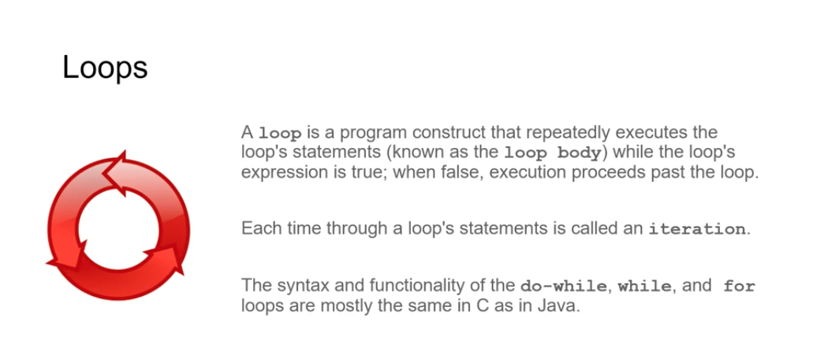

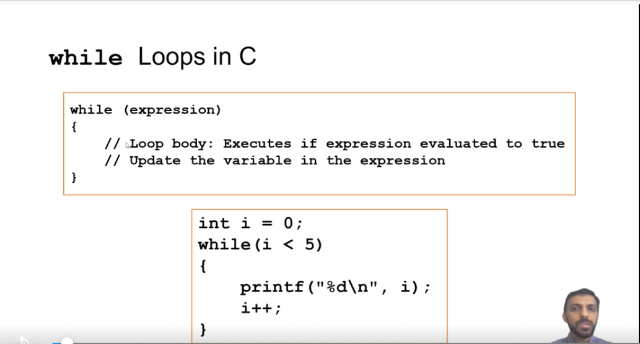

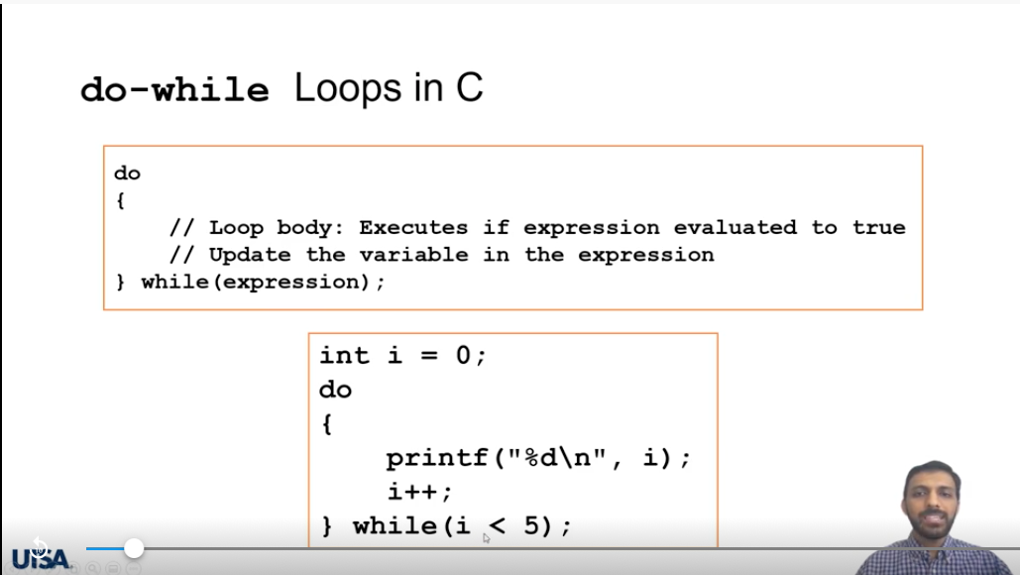

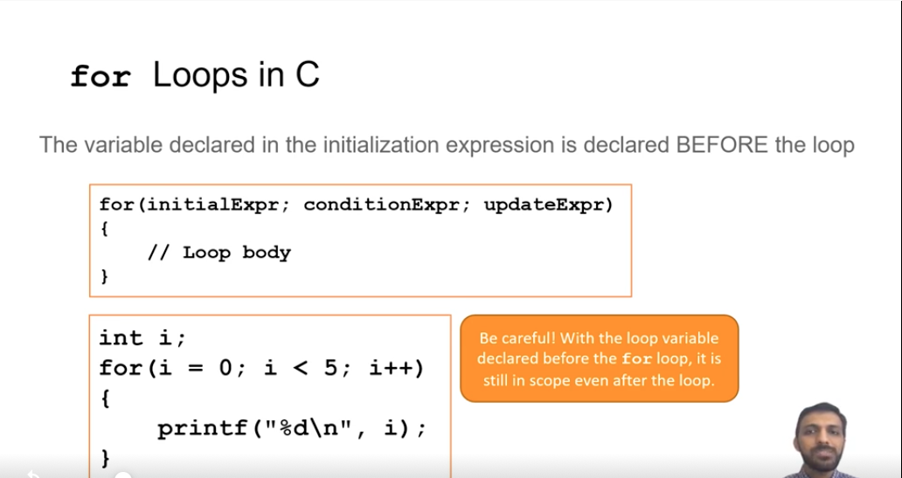

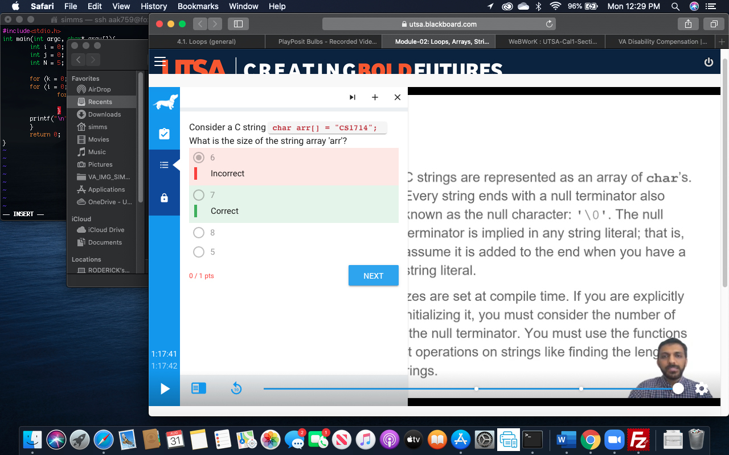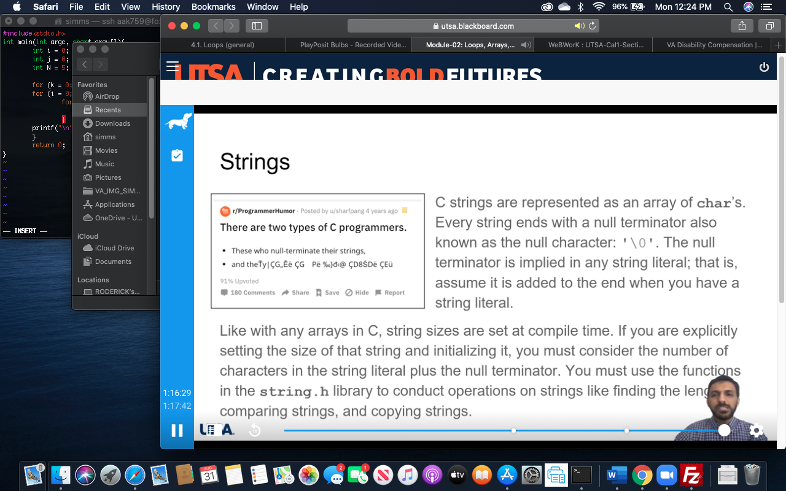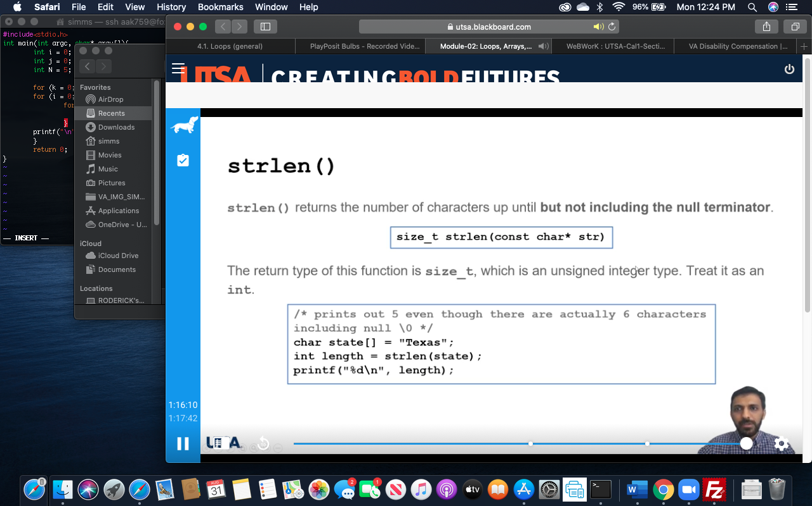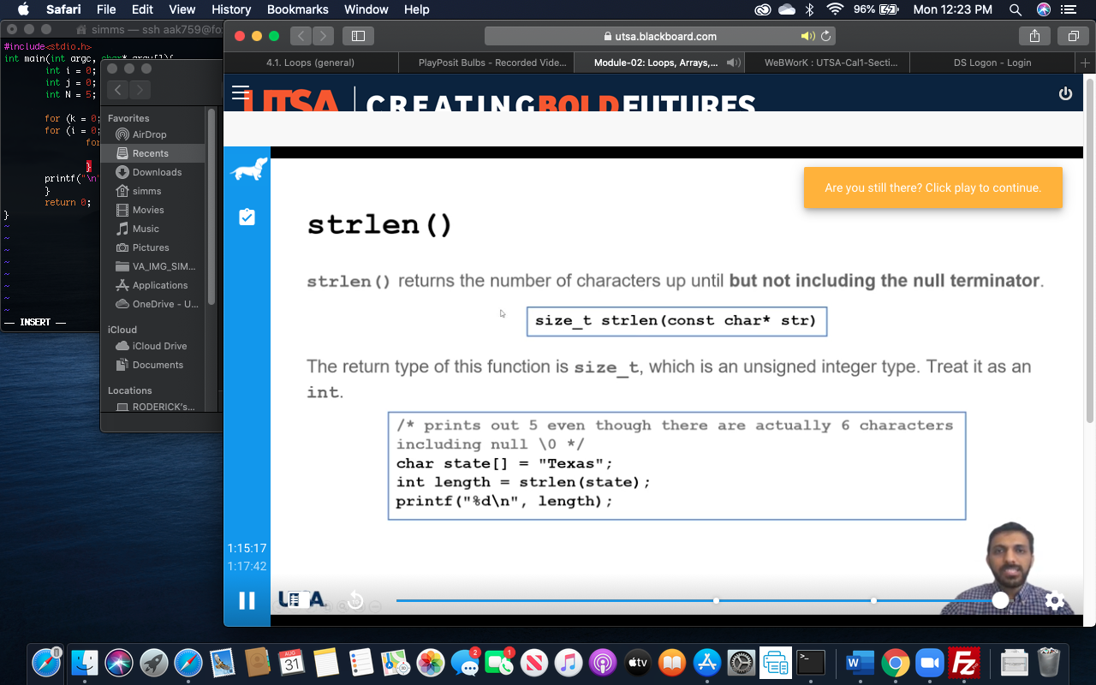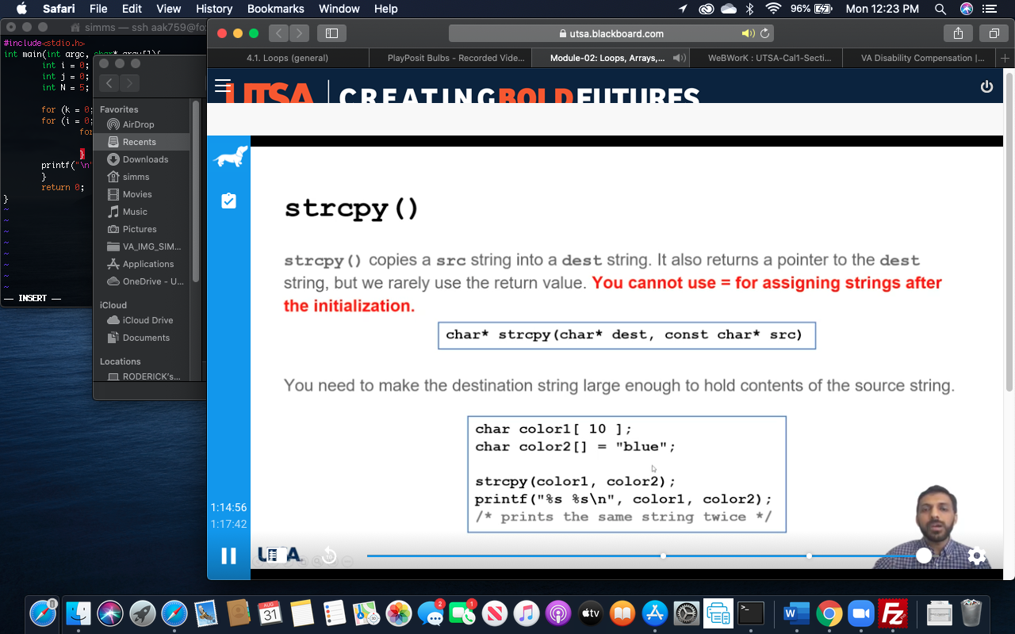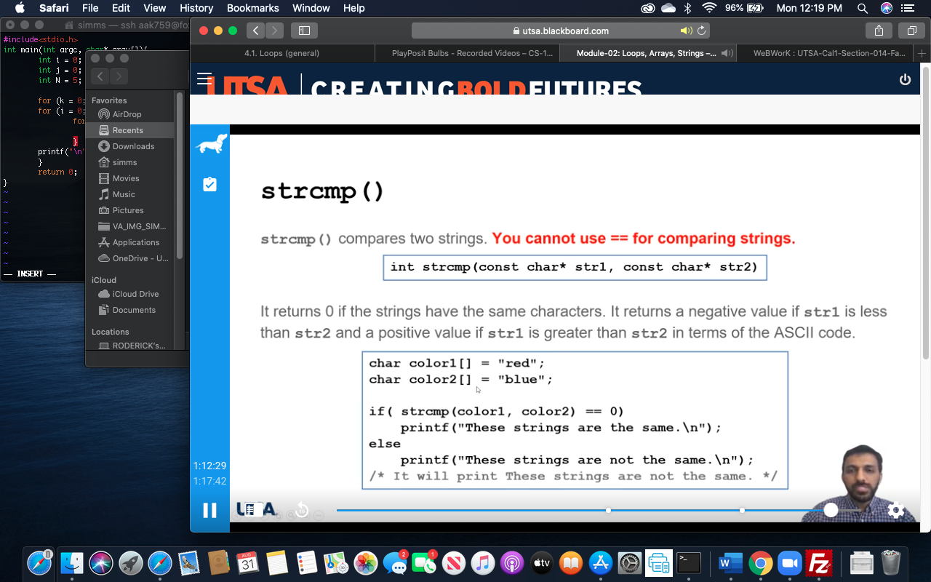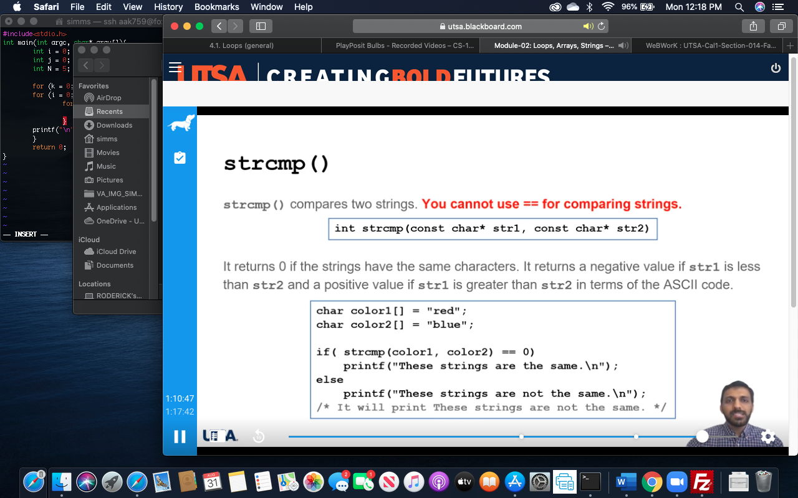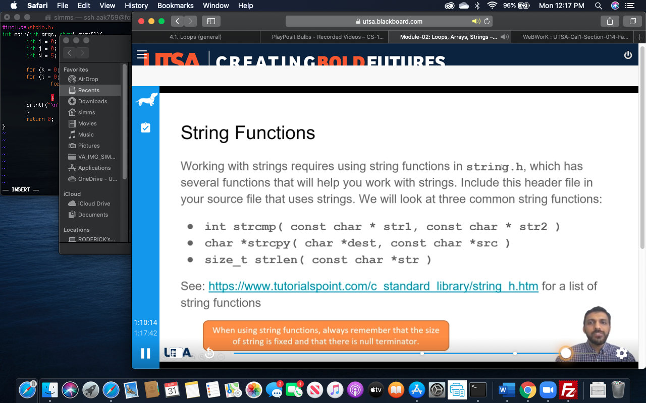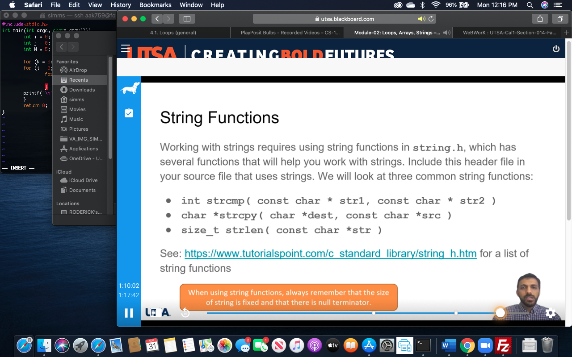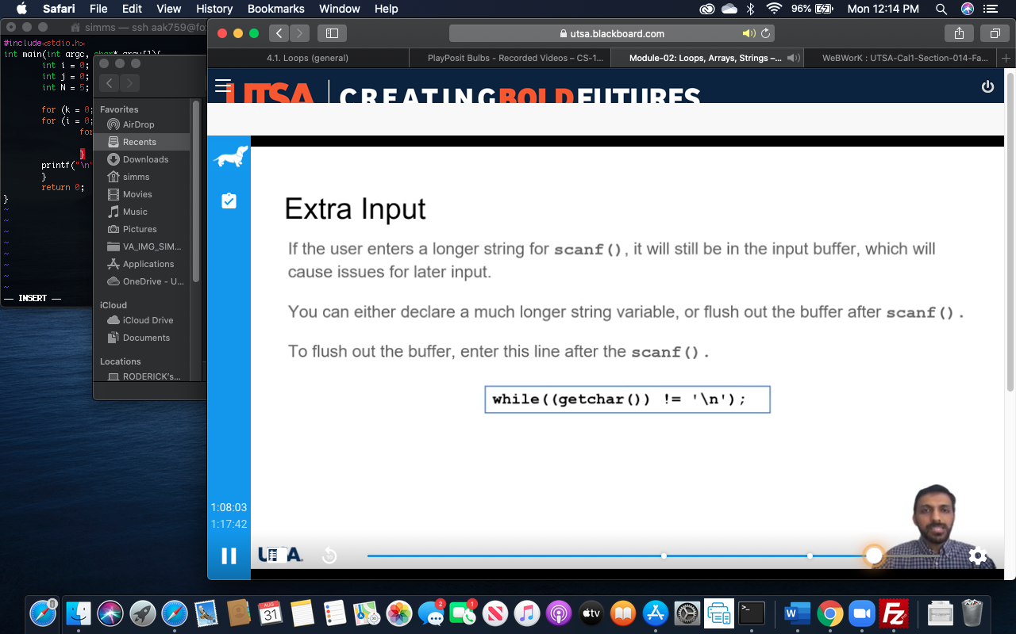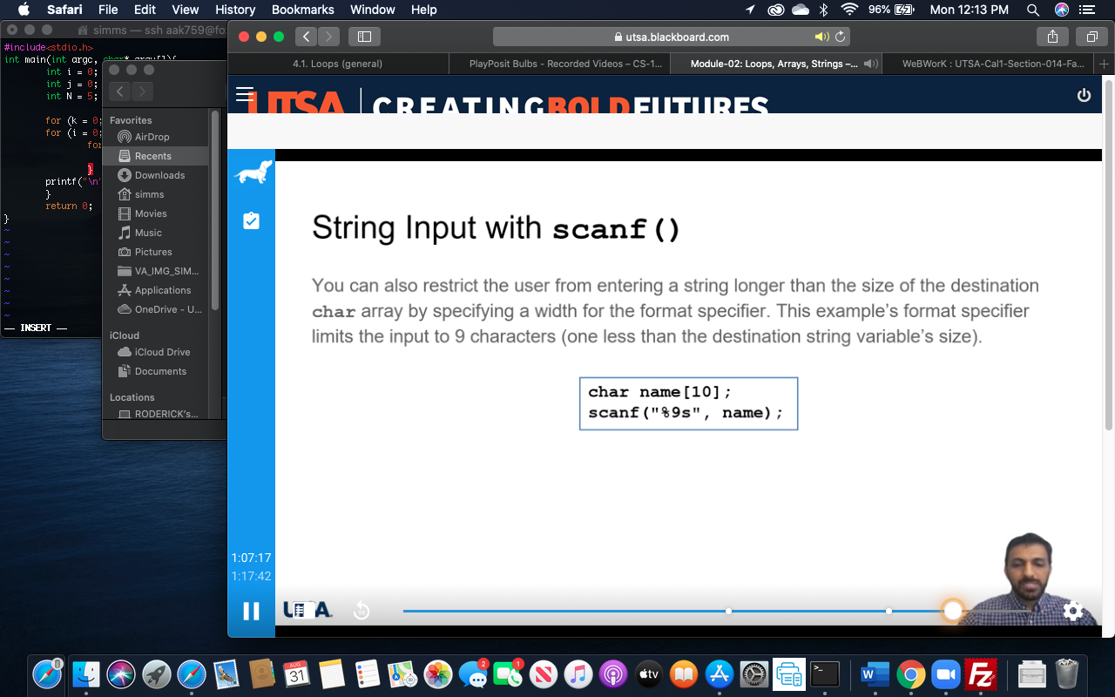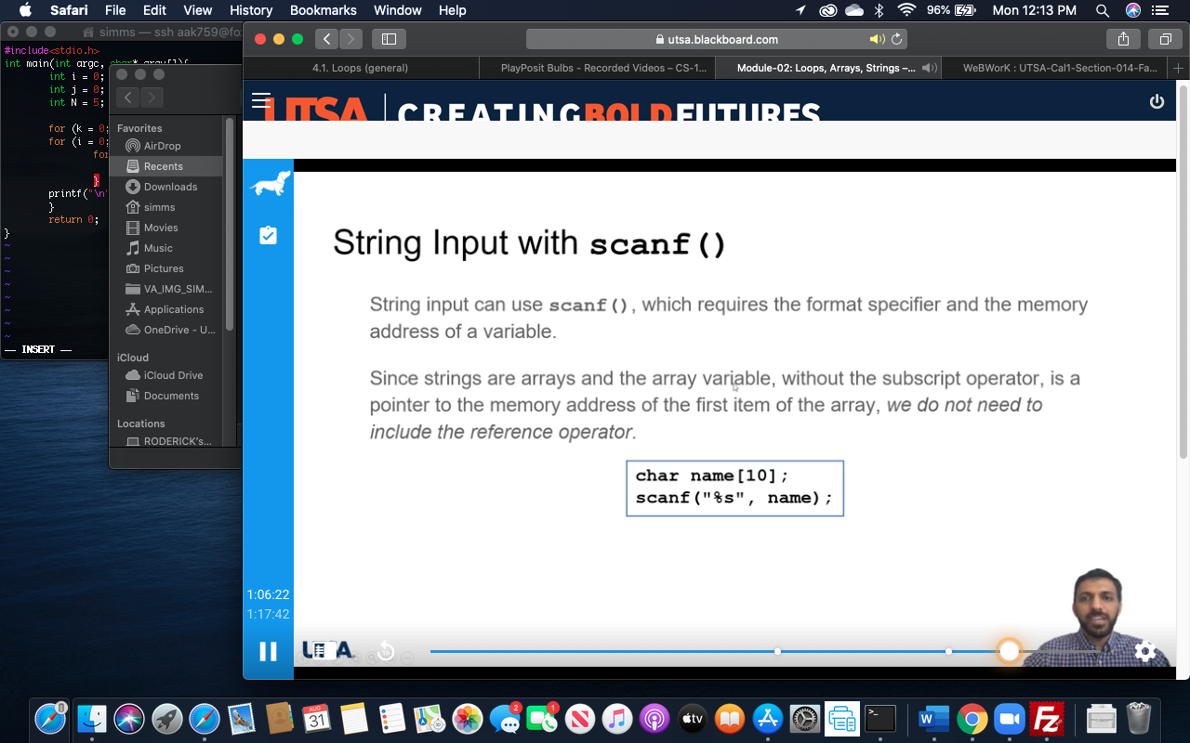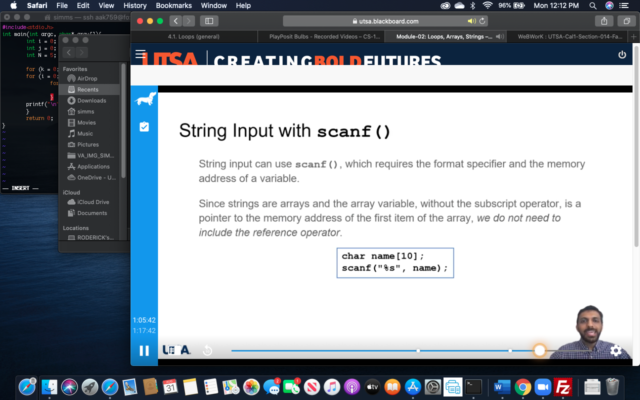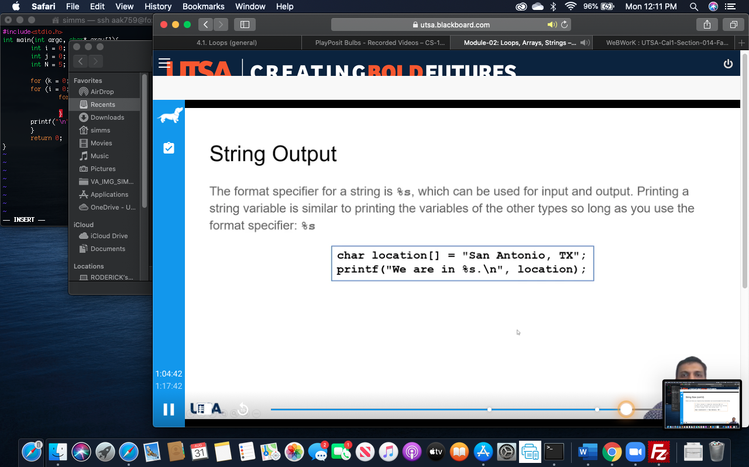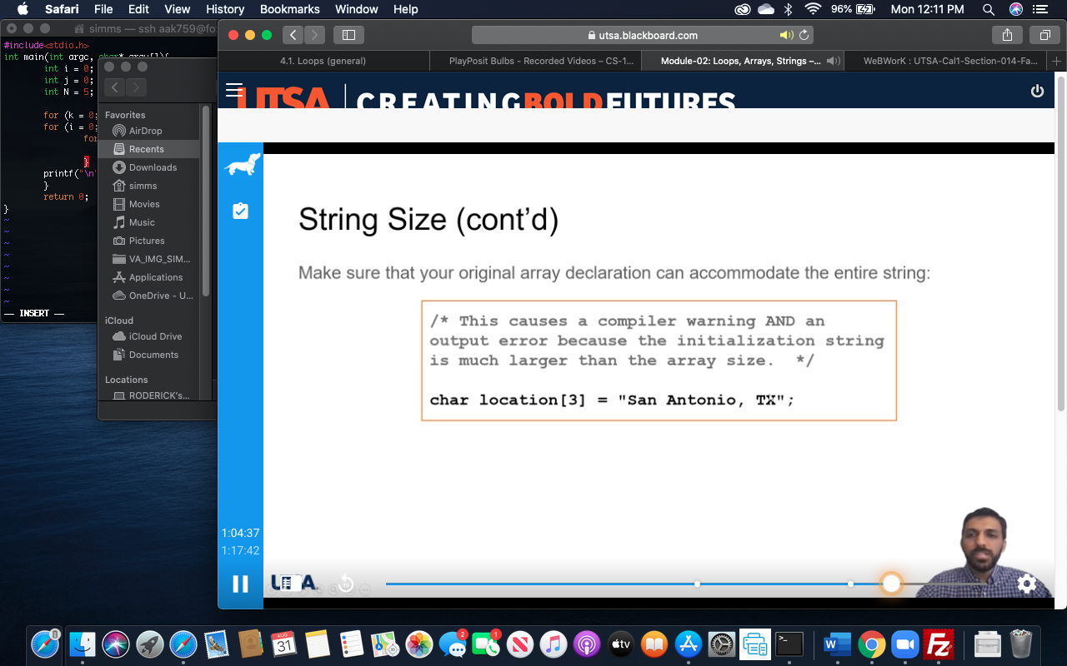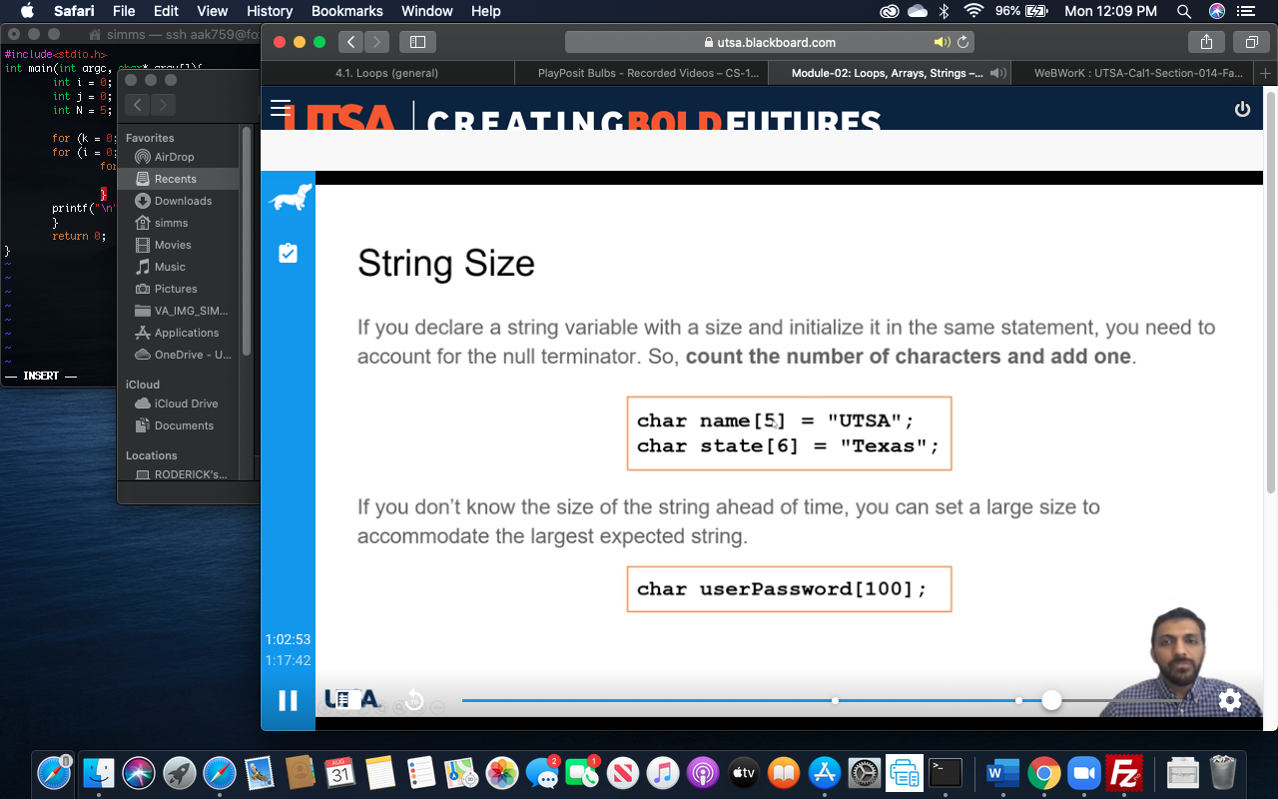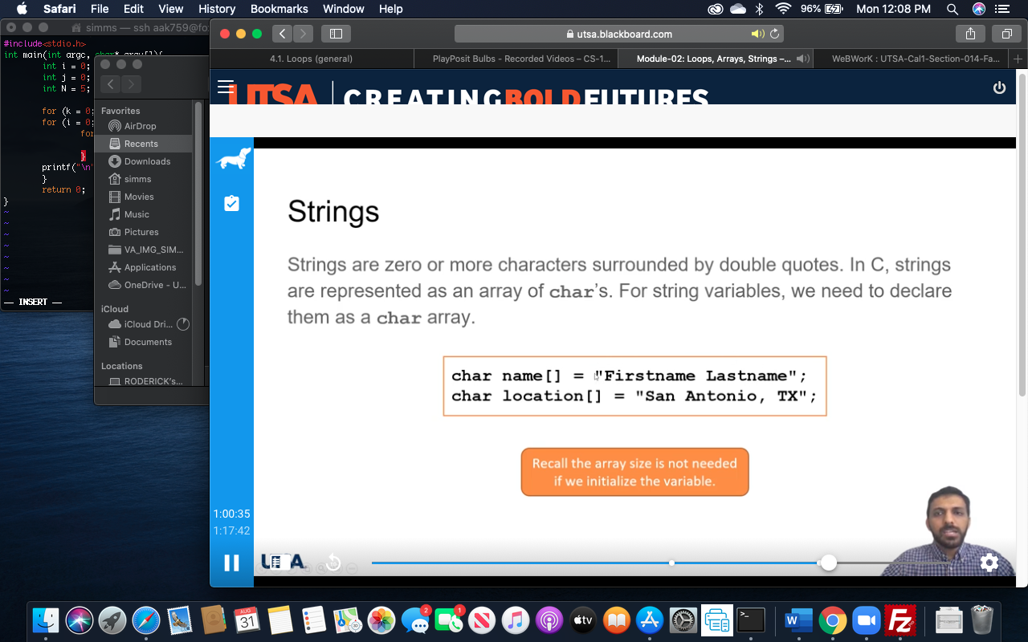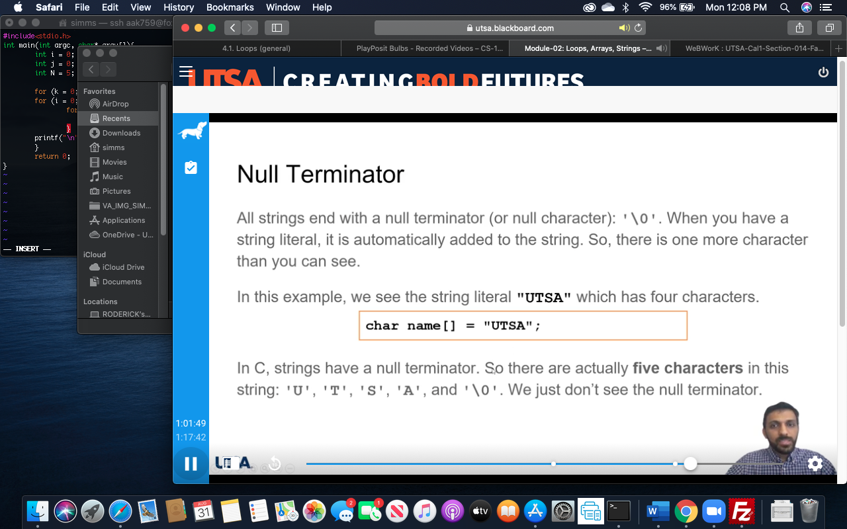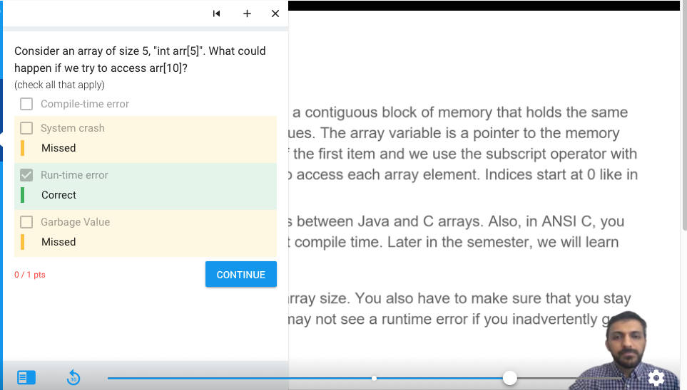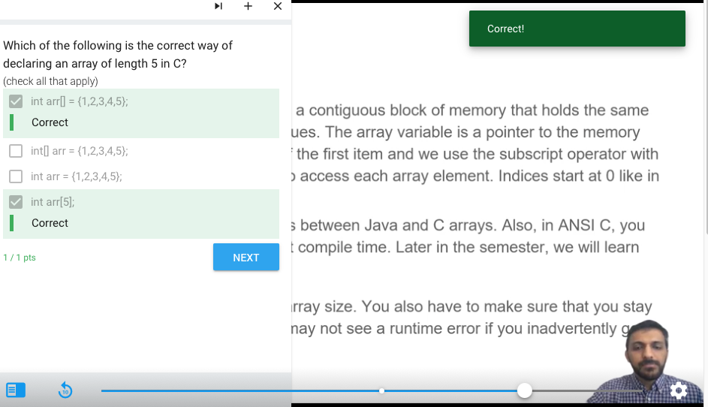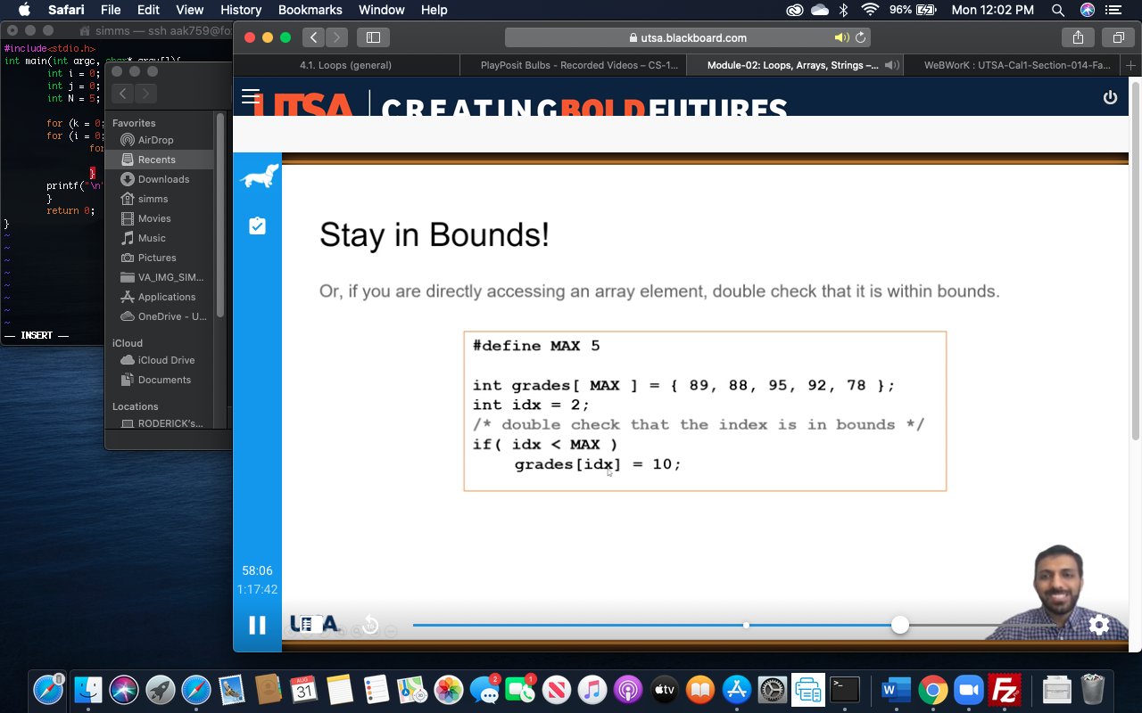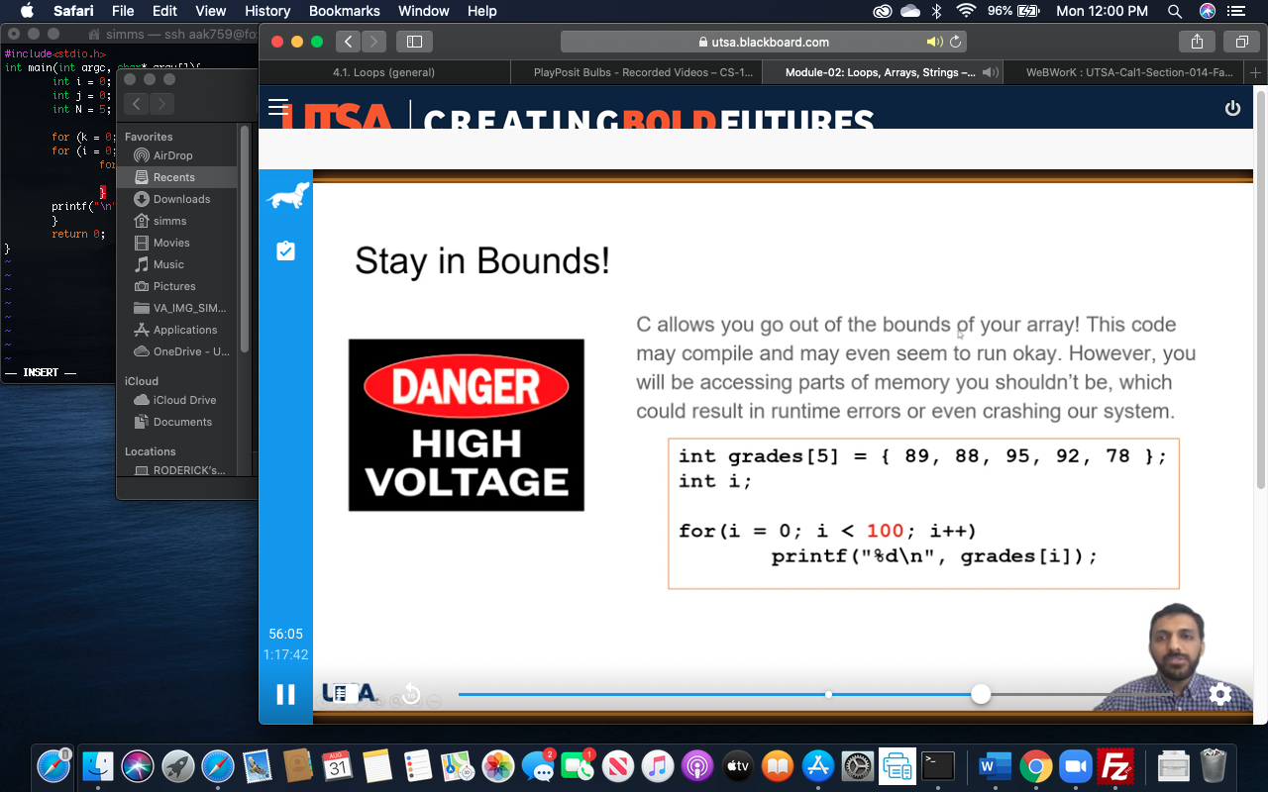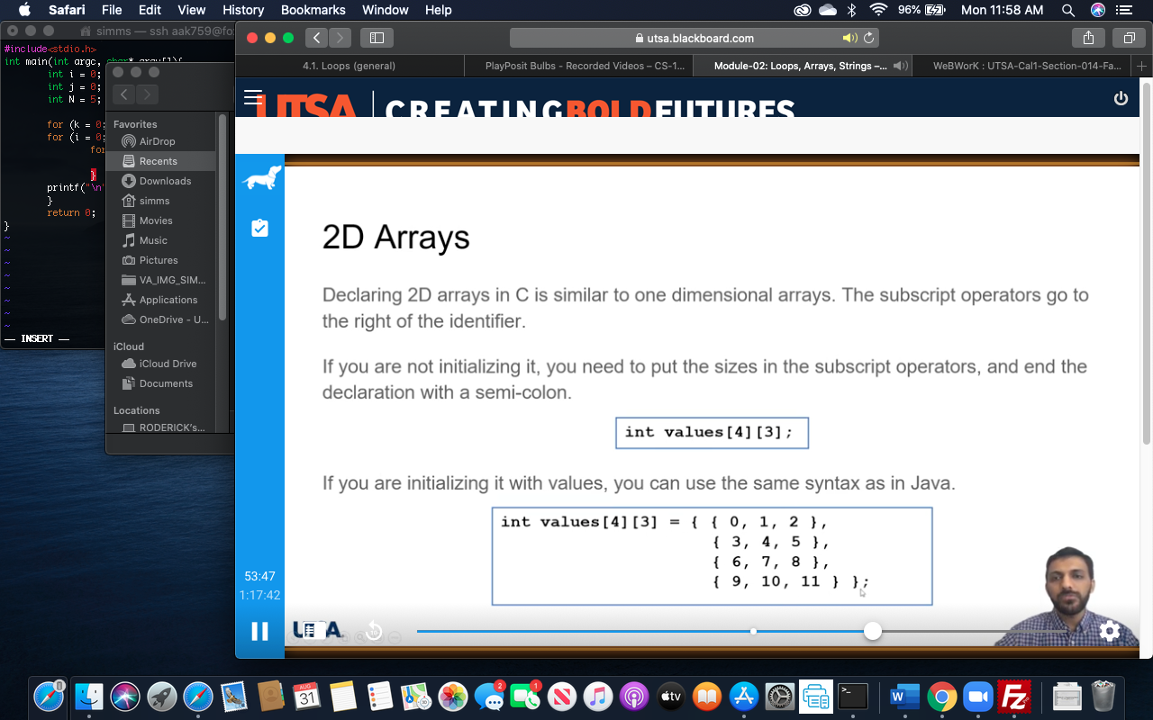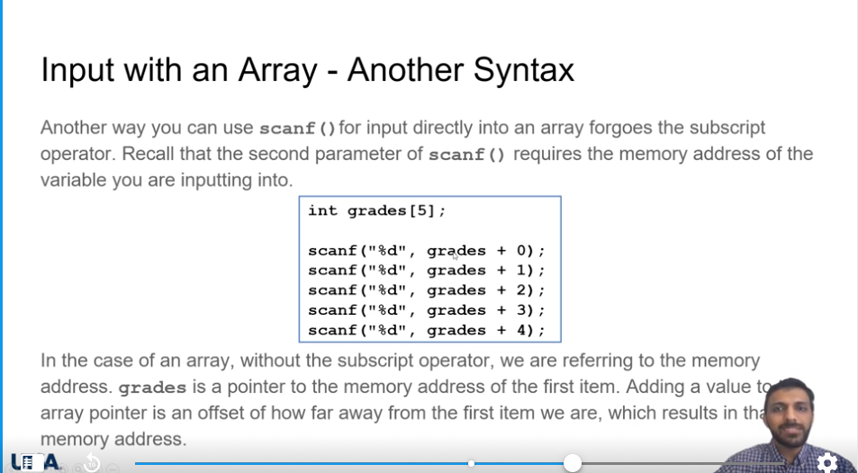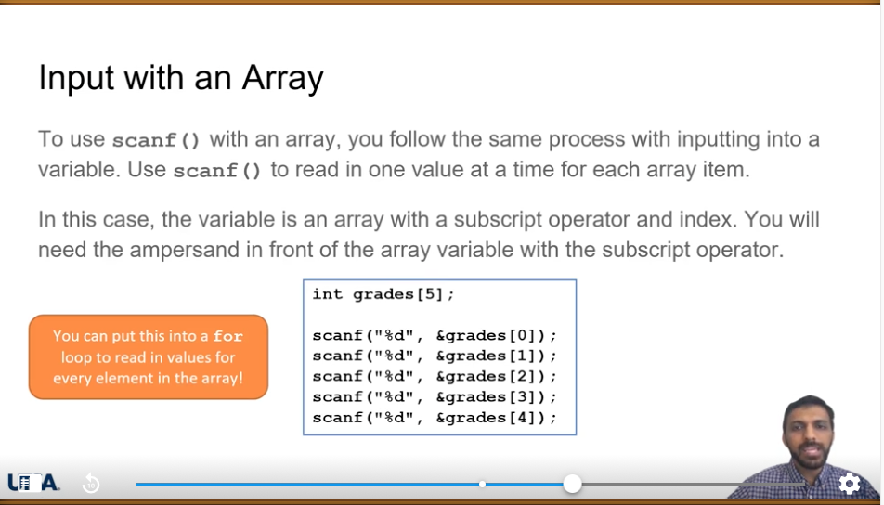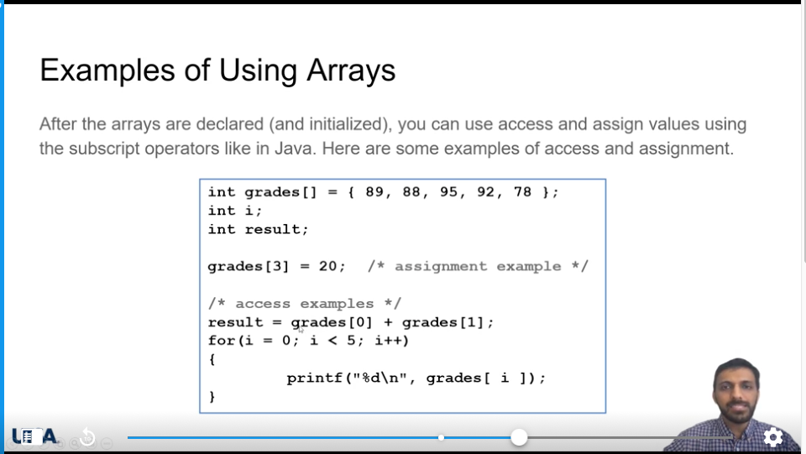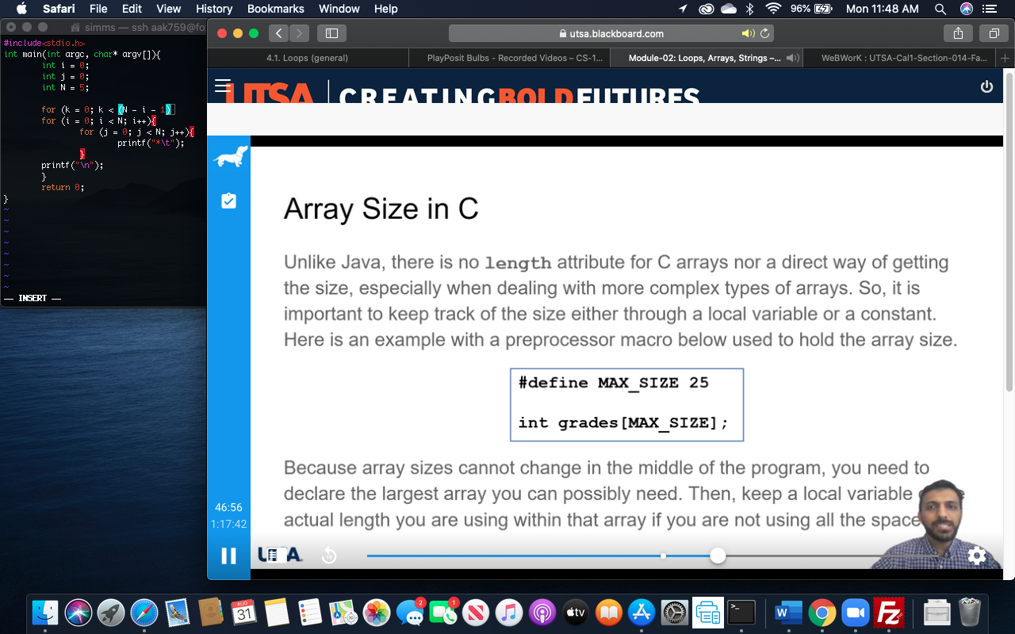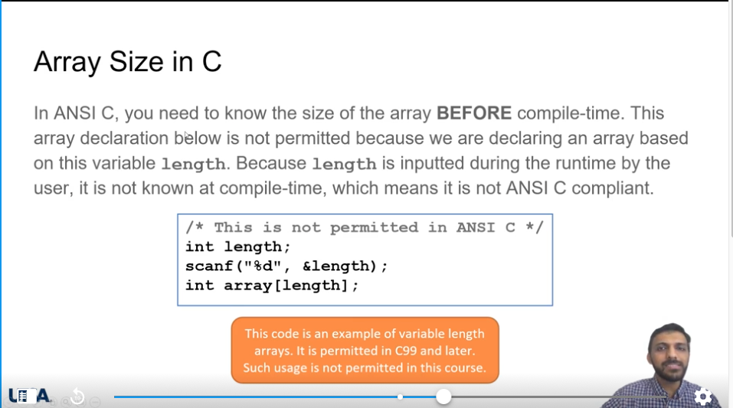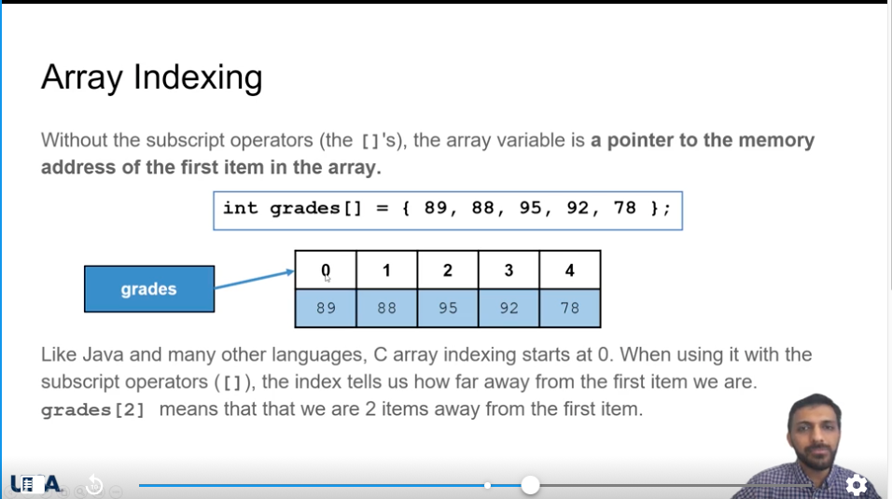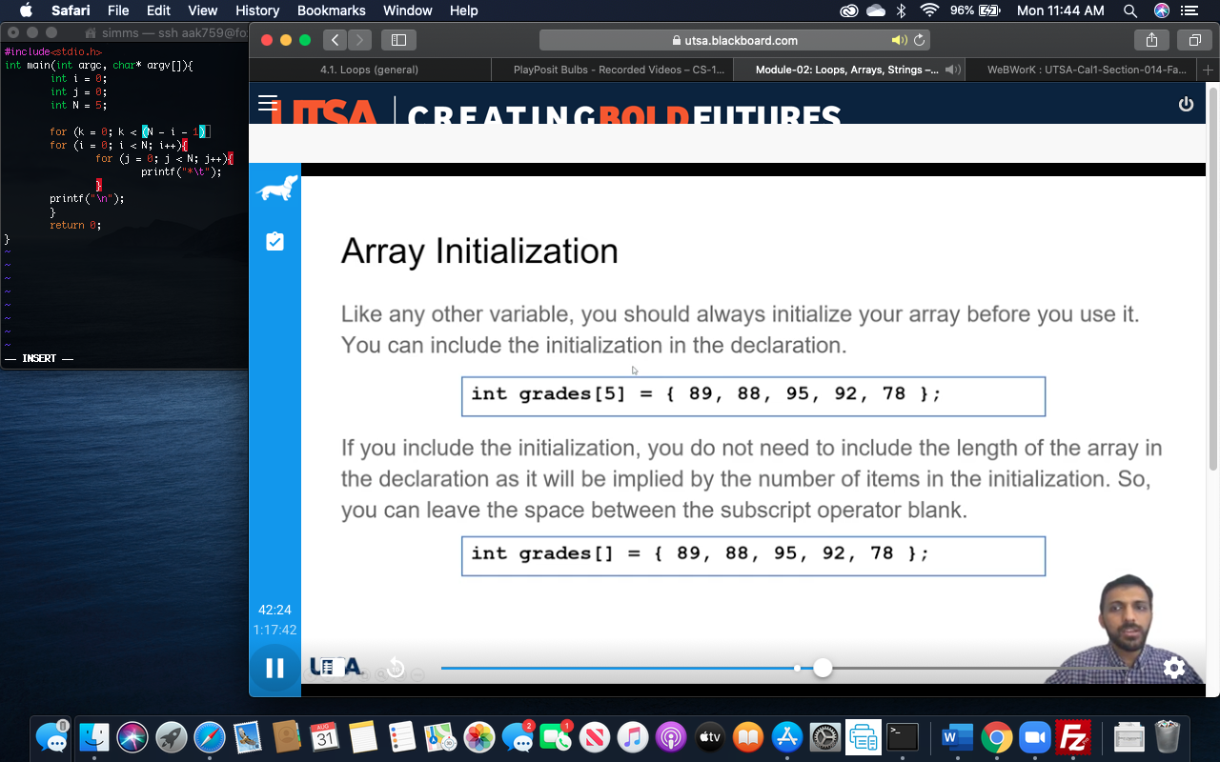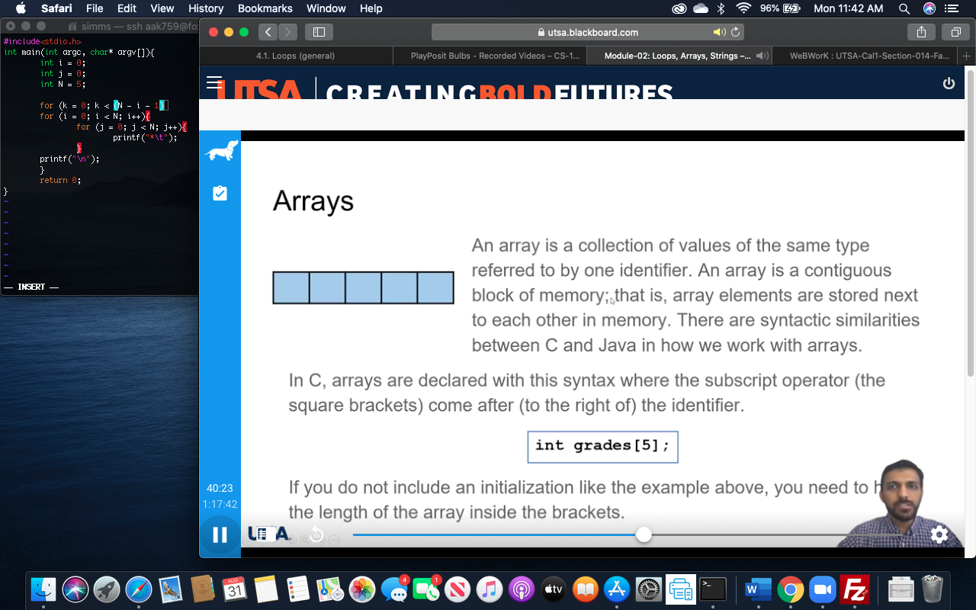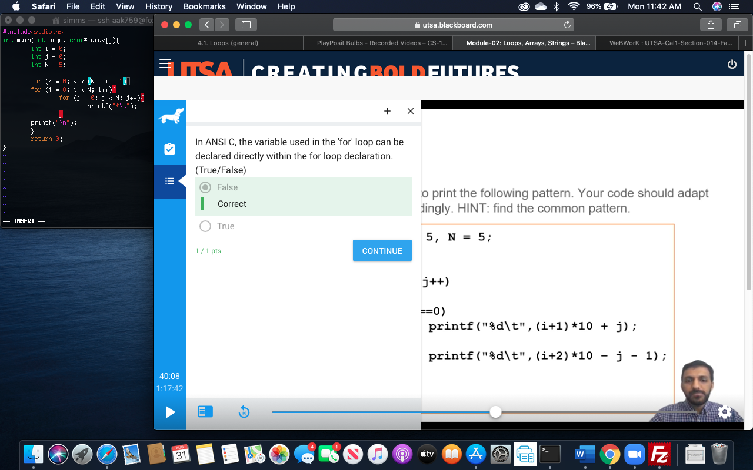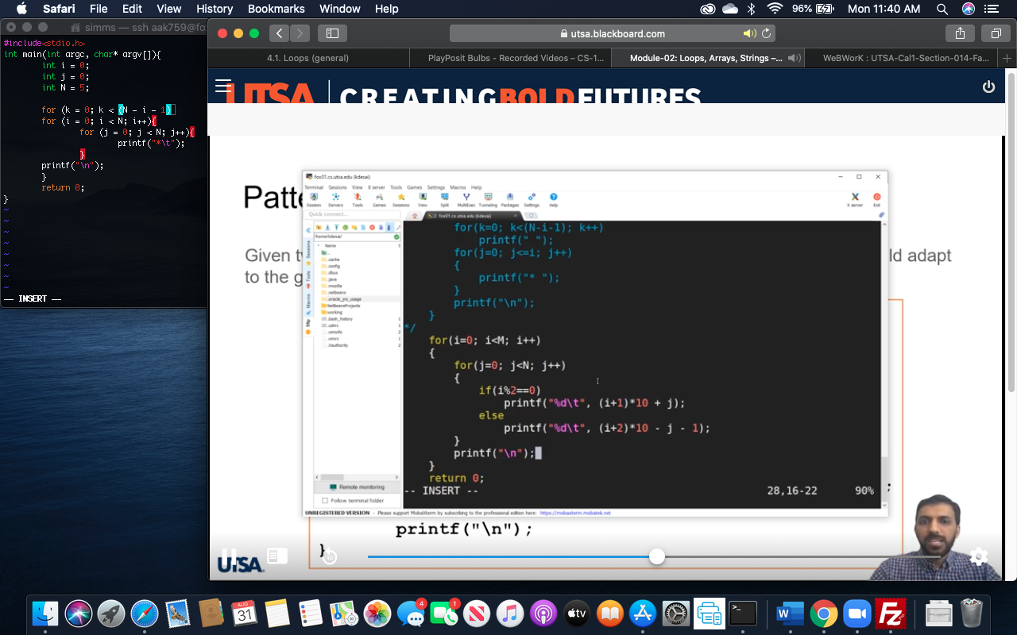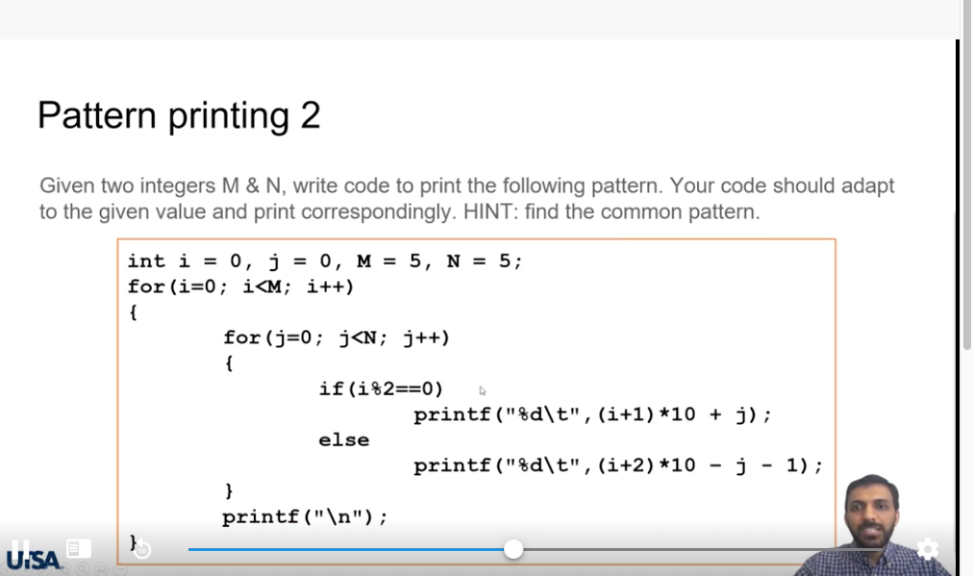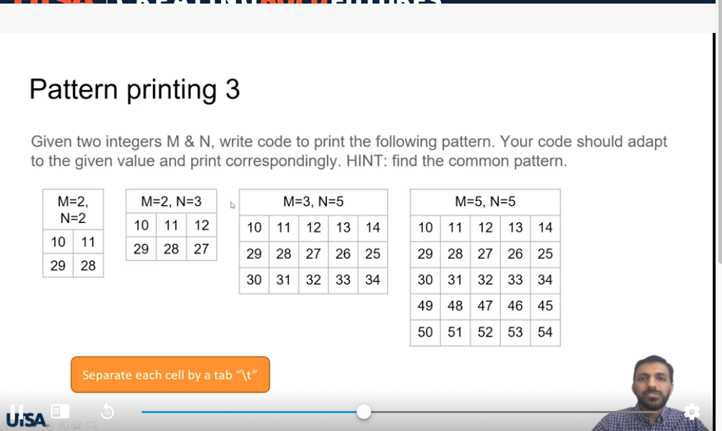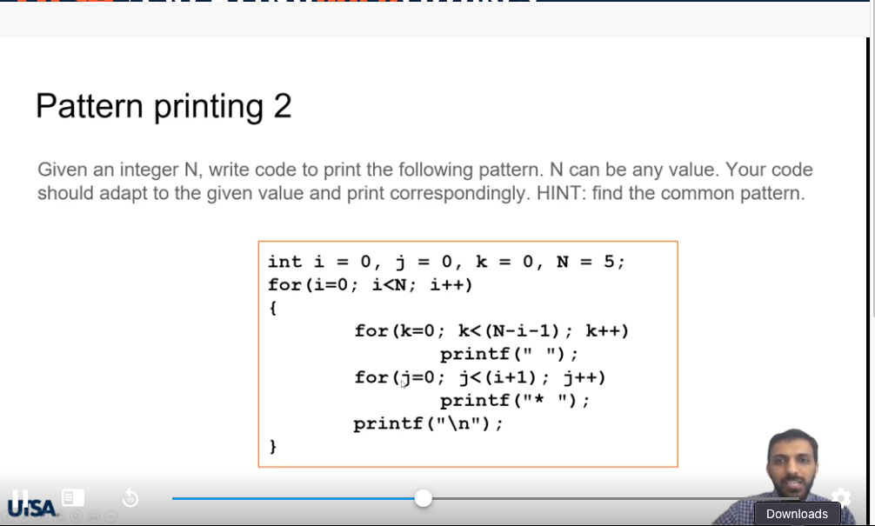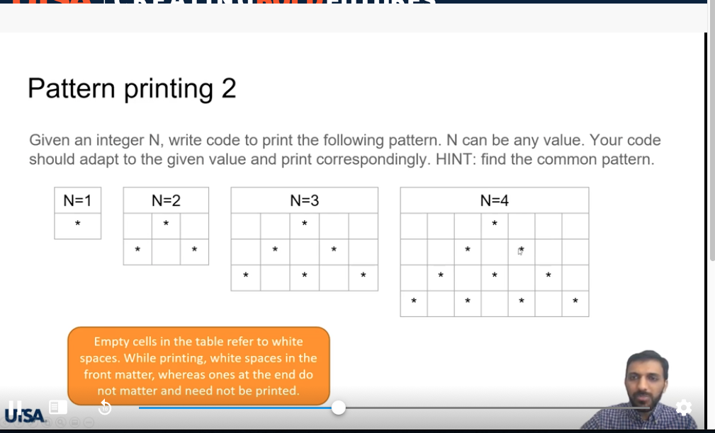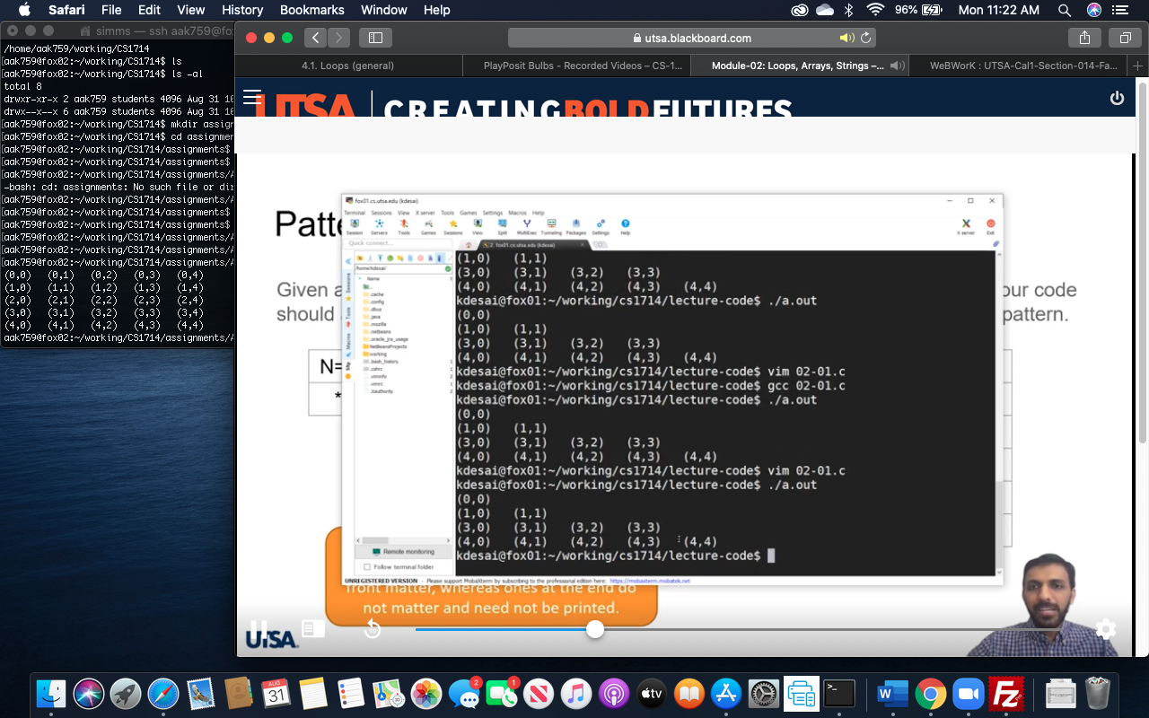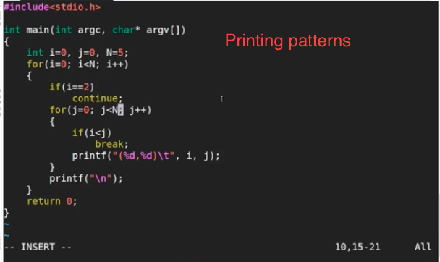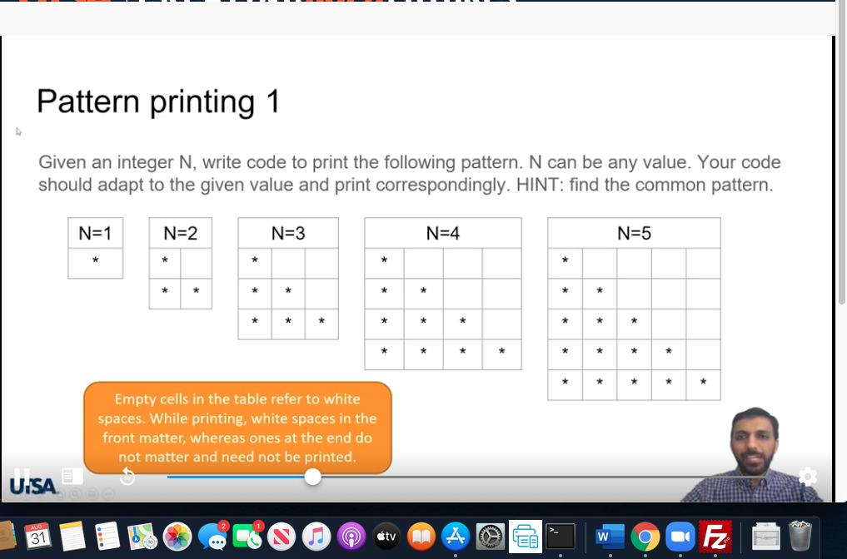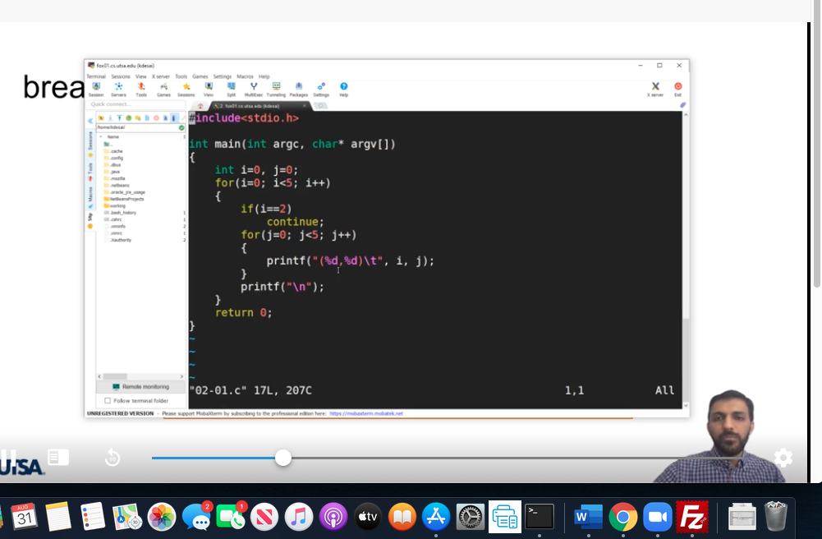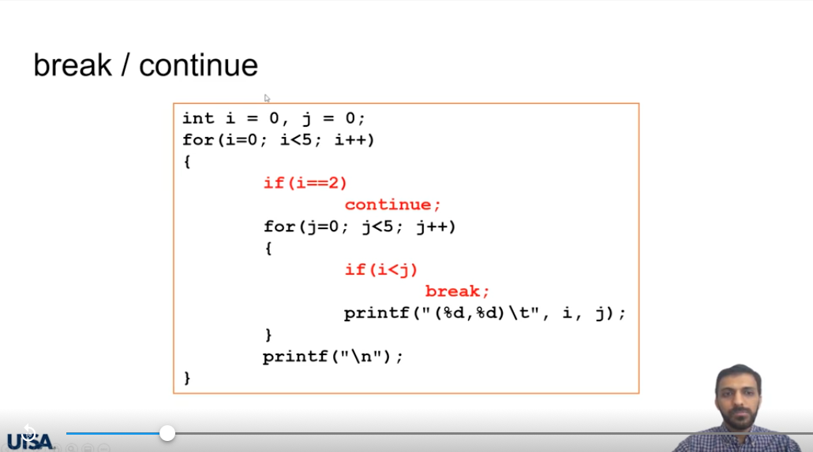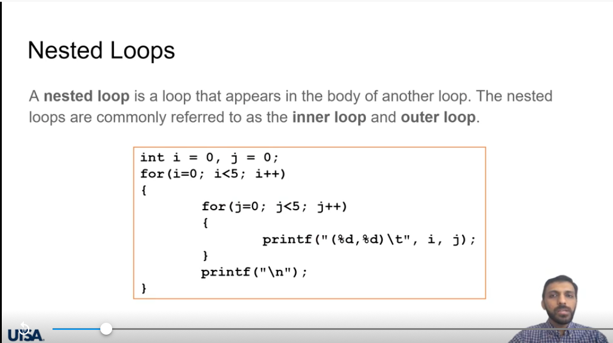



4.1 Loops (general)

**Loop concept**

People who have children may be familiar with looping around the block until a baby falls asleep.

**PARTICIPATIONACTIVITY**

4.1.1: Loop concept: Driving a baby around the block.

123

2x speed













Awake?

3rd check

2nd check

1st check

False

True

Baby in car

After second loop, baby is asleep, so parents head home for a peaceful evening.

Captions

keyboard_arrow_up

1. Parents may be familiar with this scenario: Driving home, baby is awake. Parents circle the block, hoping the baby will fall asleep.
2. After first loop, baby is still awake, so parents loop again.
3. After second loop, baby is asleep, so parents head home for a peaceful evening.

Feedback?

**PARTICIPATIONACTIVITY**

4.1.2: Loop concept.

Consider the example above.

1)

When the parents first checked, was the baby awake?

Yes

**Correct**

The baby was awake, so the parents looped around the block.

2)

After the first loop, was the baby awake?

Yes

**Correct**

The baby was getting drowsy, but still awake, so the parents looped around the block again.

3)

After the second loop, was the baby awake?

No

**Correct**

The baby was asleep, so the parents did not loop around the block again, but instead went home.

4)

How many loops around the block did the parents make?

2

**Correct**

For the first and second checks, the baby was awake so the parents looped. But on the third check, the baby was asleep, so a third loop was not made.

5)

Where was the decision point for whether to loop: At the top of the street or bottom?

Top

**Correct**

The decision whether to loop around the block was made at the top of the street, where the entrance to the looping street exists.

Feedback?

**Loop basics**

A ***loop*** is a program construct that repeatedly executes the loop's statements (known as the ***loop body***) while the loop's expression is true; when false, execution proceeds past the loop. Each time through a loop's statements is called an ***iteration***.

**PARTICIPATIONACTIVITY**

4.1.3: A simple loop: Summing the input values.

12345

2x speed

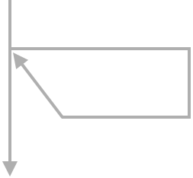

Put sum to output

sum = sum + val

val = Get next input

While val > -1

val = Get next input

sum = 0

Output

Input

sum:

0

2

6

7

2

4

1

-1

2

4

1

-1

7

Loop

The next input is -1. This time, -1 > -1 is false, so the loop is not entered. Instead, execution proceeds past the loop, where a statement puts sum, which is 7, to the output.

Captions

keyboard_arrow_up

1. A loop is like a branch, but jumping back to the expression when done. Thus, the loop's statements may execute multiple times, before execution proceeds past the loop.
2. This program gets an input value. If the value > -1, the program adds the value to a sum, gets another input, and repeats. val is 2, so the loop's statements execute, making sum 2.
3. The loop statement's ended by getting the next input, which is 4. The loop's expression 4 > -1 is true, so the loop's statements execute again, making sum 2 + 4 or 6.
4. The loop's statements got the next input of 1. The loop's expression 1 > -1 is true, so the loop's statements execute a third time, making sum 6 + 1 or 7.
5. The next input is -1. This time, -1 > -1 is false, so the loop is not entered. Instead, execution proceeds past the loop, where a statement puts sum, which is 7, to the output.

Feedback?

**Loop example: Computing an average**

A loop can be used to compute the average of a list of numbers.

**PARTICIPATIONACTIVITY**

4.1.4: Loop example: Computing an average.

1234

2x speed

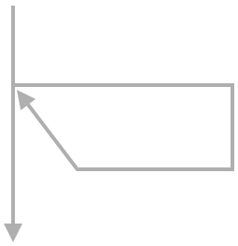

Put avg to output

avg = sum / num

sum = sum + val

num = num + 1

val = Get next input

While val > -1

val = Get next input

num = 0

sum = 0

Output

2

4

9

-1

2

4

9

-1

Input

3

2

1

0

num:

15

6

2

0

sum:

15

3

/

5

The next input is -1, so the loop is not entered. 15 / 3 or 5 is output.

Captions

keyboard_arrow_up

1. The program computes an average of a list of numbers (a negative ends the list). The first input is 2, so the loop is entered. Sum becomes 2, and num is incremented to 1.
2. The next input is 4. The loop is entered, so sum becomes 2 + 4 or 6, and num is incremented to 2.
3. The next input is 9, so the loop is entered. Sum becomes 6 + 9 or 15, and num is incremented to 3.
4. The next input is -1, so the loop is not entered. 15 / 3 or 5 is output.

Feedback?

**PARTICIPATIONACTIVITY**

4.1.5: Loop example: Average.

Consider the computing an average example above.

1)

In the example above, the first value gotten from input was 2. That caused the loop body to be _____.

executed

**Correct**

2 > -1 is true, so the loop body is executed.

2)

At the end of the loop body, the _____.

next input is gotten

**Correct**

The loop should keep getting input values until a negative value is seen, so the last statement gets the next input value.

3)

With what value was sum initialized?

0

**Correct**

The loop body accumulates input values in the sum variable. Thus, before any input values are gotten, sum is assigned with 0.

4)

Each time through the loop, the sum variable is increased by _____.

the current input value

**Correct**

Variable sum accumulates all the input values.

5)

What was variable num's value after the loop was done iterating?

3

**Correct**

Each time a non-negative value was gotten from input, the loop body executed, which incremented num. Because three non-negative values were gotten, num was incremented 3 times. Having started with 0, num was incremented to 1, then 2, then 3.

6)

Before the loop, the first input value is gotten. If that input was negative (unlike the data in the example above), the loop's body would _____.

not be executed

**Correct**

val is negative, so val > -1 would be false. When the loop's expression is false, execution jumps past the loop, and does not enter the loop body.

Feedback?

**Example: Counting specific values in a list**

Programs execute one statement at a time. Thus, using a loop to examine a list of values one value at a time and updating variables along the way, as in the above examples, is a common programming task.

Below is a task to help a person get accustomed to examining a list of values one value at a time. The task asks a person to count the number of negative values, incrementing a variable to keep count.

**PARTICIPATIONACTIVITY**

4.1.6: Counting negative values in a list of values.

Click "Increment" if a negative value is seen.

|  |
| --- |
| Reset |
| |  |  | | --- | --- | |  | **Counter** | | |  |  |  |  |  |  |  | | --- | --- | --- | --- | --- | --- | --- | | 11 | 11 | -48 | -10 | -46 | -12 | 27 | | 0 | | Next value | Increment | |  |  | | Time 3Best time -Clear best |  | |  |  | |

Feedback?

**PARTICIPATIONACTIVITY**

4.1.7: Counting negative values.

Complete the program such that variable count ends having the number of negative values in an input list of values (the list ends with 0). So if the input is -1 -5 9 3 0, then count should end with 2.

count = 0

val = Get next input

While val is not 0

If __(A)__

__(B)__

val = Get next input

1)

What should expression (A) be?

val < 0

**Correct**

The program should count negative values. The expression detects a negative value.

2)

What should statement (B) be?

count = count + 1

**Correct**

Variable count should be incremented each time a negative input value is seen. The final loop is:

count = 0

val = Get next input

While val is not 0

If val < 0

count = count + 1

val = Get next input

3)

If the input value is 0, does the loop body execute?

No

**Correct**

As long as the input value is not 0 (such as -1, -5, 9, or 3), the loop body will execute. But when the value IS 0, the loop's expression is false and thus the loop body is not executed.

Feedback?

**Example: Finding the max value**

Examining items one at a time and updating a variable can achieve some interesting computations. The task below is to find the maximum value in a list of positive values. A variable stores the max value seen so far. Each input value is compared with that max, and if greater, that value replaces that max. The max value is initialized with -1 so that such comparison works even for the first input value.

**PARTICIPATIONACTIVITY**

4.1.8: Find the maximum value in the list of values.

Click "Store value" if a new maximum value is seen.

|  |
| --- |
| Reset |
| |  |  | | --- | --- | |  | **Stored value** | | |  |  |  |  |  |  |  | | --- | --- | --- | --- | --- | --- | --- | | 37 | 39 | 33 | 42 | 16 | 93 | 81 | | -1 | | Next value | Store value | |  |  | | Time 2Best time -Clear best |  | |  |  | |

Feedback?

**PARTICIPATIONACTIVITY**

4.1.9: Determining the max value.

Complete the program such that variable max ends up having the maximum value in an input list of positive values (the list ends with 0). So if the input is 22 5 99 3 0, then max should end as 99.

max = -1

val = Get next input

While val is not 0

If __(A)__

__(B)__

val = Get next input

1)

What should expression (A) be?

val > max

**Correct**

If the current value is greater than the max value seen so far, then the max value needs to be updated.

2)

What should statement (B) be?

max = val

**Correct**

If the current value is greater than the max seen so far, then this statement updates max to the current value, which is now the max seen so far. The program is:

max = -1

val = Get next input

While val is not 0

If val > max

max = val

val = Get next input

3)

Does the final value of max depend on the order of inputs? In particular, would max be different for inputs 22 5 99 3 0 versus inputs 99 3 5 22 0?

No

**Correct**

99 is the max, regardless of the order. For the first order, max will be -1, then 22, then 99. For the second order, max will be -1, then 99.

4)

For inputs 5 10 7 20 8 0, with what values will max be assigned?

-1, 5, 10, 20

**Correct**

The first value, 5, is > -1, so max gets 5. Then 10 > 5, so max gets 10. Then 7 > 10 is false, so max does not get 7. Then 20 > 10, so max gets 20. Finally, 8 > 20 is false, so max does not get 8. max thus correctly ends with 20.

4.2 While loops

**While loop: Basics**

A ***while loop*** is a program construct that repeatedly executes a list of sub-statements (known as the ***loop body***) while the loop's expression evaluates to true. Each execution of the loop body is called an ***iteration***. Once entering the loop body, execution continues to the body's end, even if the expression would become false midway through.

Construct 4.2.1: While loop.

**while** (expression) { // Loop expression

// Loop body: Executes if expression evaluated to true

// After body, execution jumps back to the "while"

}

// Statements that execute after the expression evaluates to false

Feedback?

**PARTICIPATIONACTIVITY**

4.2.1: While loop.

12345

2x speed

#include <stdio.h>

**int** main(**void**) {

**int** currPower;

**char** userChar;

currPower = 2;

userChar = 'y';

**while** (userChar == 'y') {

printf("%d\n", currPower);

currPower = currPower * 2;

scanf("%c", &userChar);

}

printf("Done\n");

**return** 0;

}

y y n

Input

Done

8

4

2

Output

userChar is now 'n', so userChar == 'y' is false. Thus, execution jumps to after the loop, which outputs "Done".

Captions

keyboard_arrow_up

1. When encountered, a while loop's expression is evaluated. If true, the loop's body is entered. Here, userChar was initialized with 'y', so userChar == 'y' is true.
2. Thus, the loop body is executed, which outputs currPower's current value of 2, doubles currPower, and gets the next input.
3. Execution jumps back to the while part. userChar is 'y' (the first input), so userChar == 'y' is true, and the loop body executes (again), outputting 4.
4. userChar is 'y' (the second user input), so userChar == 'y' is true, and the loop body executes (a third time), outputting 8.
5. userChar is now 'n', so userChar == 'y' is false. Thus, execution jumps to after the loop, which outputs "Done".

Feedback?

**PARTICIPATIONACTIVITY**

4.2.2: While loops: Number of iterations.

For the following code, indicate how many times the loop body will execute for the indicated input values.

userNum = 3;

**while** (userNum > 0) {

// Do something

// Get userNum from input

}

1)

Input: 5   -1

CheckShow answer

**Correct**

2

The loop's expression will be encountered as follows:   
First time: 3 > 0 (userNum was initialized with 3). True, so loop body executes.   
Second time: 5 > 0 (5 was gotten from input). True, so loop body executes.   
Third time: -1 > 0 (-1 was gotten from input). False, so loop body does NOT execute.  
Thus, the loop body was executed twice.

2)

Input: 2   1   0

CheckShow answer

**Correct**

3

The loop's expression will see:   
3 > 0: Body executes  
2 > 0: Body executes  
1 > 0: Body executes  
0 > 0: False, so body does not execute  
So the body executes 3 times.

3)

Input: -1   5   4

CheckShow answer

**Correct**

1

3 > 0: Loop body executes  
-1 > 0: False, so body does not execute  
The additional inputs are not relevant; the -1 ends the looping.

Feedback?

**Basic while loop example**

The following Celsius to Fahrenheit example shows the common pattern of getting user input at the end of each loop iteration to determine whether to continue looping.

Figure 4.2.1: While loop example: Celsius to Fahrenheit.

|  |  |
| --- | --- |
| #include <stdio.h>  **int** main(**void**) {  **double** celsiusValue;  **double** fahrenheitValue;  **char** userChar;  celsiusValue = 0.0;  userChar = 'y';    **while** (userChar == 'y') {  fahrenheitValue = (celsiusValue * 9.0 / 5.0) + 32.0;  printf("%lf C is ", celsiusValue);  printf("%lf F\n", fahrenheitValue);  printf("Type y to continue, any other to quit: ");  scanf(" %c", &userChar);  celsiusValue = celsiusValue + 5;  printf("\n");  }  printf("Goodbye.\n");  **return** 0;  } | 0.000000 C is 32.000000 F  Type y to continue, any other to quit: y  5.000000 C is 41.000000 F  Type y to continue, any other to quit: y  10.000000 C is 50.000000 F  Type y to continue, any other to quit: y  15.000000 C is 59.000000 F  Type y to continue, any other to quit: y  20.000000 C is 68.000000 F  Type y to continue, any other to quit: y  25.000000 C is 77.000000 F  Type y to continue, any other to quit: y  30.000000 C is 86.000000 F  Type y to continue, any other to quit: y  35.000000 C is 95.000000 F  Type y to continue, any other to quit: y  40.000000 C is 104.000000 F  Type y to continue, any other to quit: q  Goodbye. |

Feedback?

Notice the space before the %c in the scanf(" %c", &userChar) statement above. The space causes scanf to first read and discard any whitespace characters, including spaces (' '), tabs ('\t'), and newline ('\n') characters, in the user input before reading and storing the character indicated by the %c format specifier.

Above, if the user presses key 'a' followed by pressing enter, the system sends two characters to the program: 'a' and then a newline character '\n' (some systems send both '\n' plus '\r'). If the statement was instead scanf("%c", &userChar) without the space before %c, the scanf would read the '\n' into userChar and quit the program.

A common error is to forget to insert a blank space at the beginning of a scanf statement, causing whitespace and newlines to not be skipped, usually resulting in odd program behavior.

**PARTICIPATIONACTIVITY**

4.2.3: While loop example: Celsius to Fahrenheit.

Consider the example above.

1)

The loop will always iterate at least once.

True

**Correct**

userChar is initialized with 'y' and then the loop expression userChar == 'y' is checked. So for that first check, the expression is always true and the loop will iterate at least that first time.

2)

For the user inputs shown, how many times did the loop iterate?

9

**Correct**

Each iteration outputs C and F values. 9 such outputs occur (0 C is 32 F, 5 C is 41 F, ..., 40 C is 104 F), so the loop must have iterated 9 times.

3)

Each iteration adds _____ to celsiusValue.

5

**Correct**

The loop body includes the statement: celsiusValue = celsiusValue + 5;

This pattern of updating a value in each iteration is commonplace.

4)

If the user's first input is 'n', how many times will the loop iterate?

1

**Correct**

After the first iteration, the user's input of 'n' is gotten into userChar, and execution jumps back to the while part. userChar == 'y' is thus false, and a second iteration will not occur. The only output would be "0 C is 32 F".

Feedback?

**Getting input before a loop**

The above examples got user input into a variable only at the end of the loop body. The examples assigned that variable an initial value that always caused the loop body to execute the first time. Another common pattern gets that initial value from user input as well, thus getting input in two places: before the loop, and at the loop body's end.

Figure 4.2.2: Common pattern: Getting input before and at end of loop.

// Get input into userChar

**while** (userChar == 'y') {

// Do something ...

// Get input into userChar

}

Feedback?

**PARTICIPATIONACTIVITY**

4.2.4: While loops: Number of iterations, with input gotten before the loop.

For the following code, indicate how many times the loop body will execute for the indicated input values.

// Get userNum from input

**while** (userNum > 0) {

// Do something ...

// Get userNum from input

}

1)

Input: 5   -1

CheckShow answer

**Correct**

1

The loop's expression will see:   
5 > 0: Body executes   
-1 > 0: False, body does not execute  
  
Thus, the loop body was executed once.

2)

Input: 2   1   0

CheckShow answer

**Correct**

2

The loop's expression will see:   
2 > 0: Body executes  
1 > 0: Body executes  
0 > 0: False, so body does not execute  
  
So the body executes 2 times.

3)

Input: -1   5   4

CheckShow answer

**Correct**

0

The loop's expression will see:   
-1 > 0: False, so body does not execute  
  
The additional inputs are not relevant; the -1 ends the looping.

Feedback?

**Loop expressions**

Various kinds of expressions are found in while loop expressions. For example, sometimes a loop is executed as long as a value is greater than another value, or less than another value. Sometimes a loop is executed as long as a value is NOT equal to another value.

Below is an example with a relational operator in the loop expression.

**PARTICIPATIONACTIVITY**

4.2.5: While loop using a relational operator in the loop expression.

1234

2x speed

#include <stdio.h>

**int** main(**void**) {

**int** userNum;

scanf("%d", &userNum);

**while** (userNum > 0) {

printf("%d\n", userNum % 10);

userNum = userNum / 10;

}

**return** 0;

}

Iteration

userNum

Output

3

2

1

902

902

90

90

9

9

0

2

0

9

The body assigned userNum = userNum / 10, so 9 becomes 0. The loop jumps back, and since 0 > 0 is false, execution proceeds past the loop.

Captions

keyboard_arrow_up

1. Some loop expressions use a relational operator like userNum > 0. If the input is 902, the first iteration executes (902 > 0), so outputs 902 % 10, or 2.
2. The body assigned userNum = userNum / 10, so 902 becomes 90. The loop jumps back, and since 90 > 0, the loop iterates again, outputting 90 % 10 or 0.
3. The body assigned userNum = userNum / 10, so 90 becomes 9. The loop jumps back, and since 9 > 0, the loop iterates again, outputting 9 % 10 or 9.
4. The body assigned userNum = userNum / 10, so 9 becomes 0. The loop jumps back, and since 0 > 0 is false, execution proceeds past the loop.

Feedback?

**PARTICIPATIONACTIVITY**

4.2.6: Loop expressions.

Use a *single operator* in each loop expression, and the most straightforward translation of the stated goal into an expression.

**while** ( _____ ) {

// Loop body

}

1)

Iterate while x is less than 100.

CheckShow answer

**Correct**

x < 100

100 > x is also correct, but is not a straightforward translation of the stated goal (and slightly non-intuitive).

2)

Iterate while x is greater than or equal to 0.

CheckShow answer

**Correct**

x >= 0

Note that x => 0 is not OK because => is not an operator.

3)

Iterate while c equals 'g'.

CheckShow answer

**Correct**

c == 'g'

As long as c is 'g', the loop executes. Note that = is NOT the equality operator, but rather is the assignment operator. A common error is to use = rather than ==.

4)

Iterate while c is not equal to 'x'.

CheckShow answer

**Correct**

c != 'x'

As long as c is not equal to 'x', the loop executes. When c equals 'x', the loop finishes.

5)

Iterate *until* c equals 'z' (tricky; think carefully).

CheckShow answer

**Correct**

c != 'z'

c == 'z' is incorrect. Note the word "until", meaning to loop while c does *not* equal 'z'. Thus, the "not equal" is needed here.

Feedback?

**Example: Ancestors**

Below is another loop example. The program asks the user to enter a year, and then outputs the approximate number of a person's ancestors who were alive for each generation leading back to that year, with the loop computing powers of 2 along the way.

Figure 4.2.3: While loop example: Ancestors printing program.

#include <stdio.h>

**int** main(**void**) {

**const** **int** YEARS_PER_GEN = 20; // Approx. years per generation

**int** userYear; // User input

**int** consYear; // Year being considered

**int** numAnc; // Approx. ancestors in considered year

consYear = 2020;

numAnc = 2;

printf("Enter a past year (neg. for B.C.): ");

scanf("%d", &userYear);

**while** (consYear >= userYear) {

printf("Ancestors in %d: %d\n", consYear, numAnc);

numAnc = 2 * numAnc; // Each ancestor had two parents

consYear = consYear - YEARS_PER_GEN; // Go back 1 generation

}

**return** 0;

}

Enter a past year (neg. for B.C.): 1900

Ancestors in 2020: 2

Ancestors in 2000: 4

Ancestors in 1980: 8

Ancestors in 1960: 16

Ancestors in 1940: 32

Ancestors in 1920: 64

Ancestors in 1900: 128

...

Enter a past year (neg. for B.C.): 1600

Ancestors in 2020: 2

Ancestors in 2000: 4

Ancestors in 1980: 8

Ancestors in 1960: 16

Ancestors in 1940: 32

Ancestors in 1920: 64

Ancestors in 1900: 128

Ancestors in 1880: 256

Ancestors in 1860: 512

Ancestors in 1840: 1024

Ancestors in 1820: 2048

Ancestors in 1800: 4096

Ancestors in 1780: 8192

Ancestors in 1760: 16384

Ancestors in 1740: 32768

Ancestors in 1720: 65536

Ancestors in 1700: 131072

Ancestors in 1680: 262144

Ancestors in 1660: 524288

Ancestors in 1640: 1048576

Ancestors in 1620: 2097152

Ancestors in 1600: 4194304

Feedback?

Each iteration prints a line with the year and the ancestors in that year. (Note: the numbers are large due to not considering breeding among distant relatives, but nevertheless a person has many ancestors).

**PARTICIPATIONACTIVITY**

4.2.7: Ancestors example.

Consider the example above.

1)

The loop expression involves a relational operator.

True

**Correct**

As long as the considered year is greater than the user year, the loop iterates.

2)

The loop body updates the considered year consYear.

True

**Correct**

consYear was initialized with 2020. Each loop iteration decreased consYear by YEARS_PER_GEN, which is 20.

3)

The user is asked to enter a value at the end of each loop iteration.

False

**Correct**

The user only enters one value, before the loop begins. Then the loop executes until userYear > consYear.

4)

Each loop iteration outputs the current number of ancestors (numAnc), and then doubles numAnc in preparation for the next iteration.

True

**Correct**

Updating a value in each iteration is a common pattern.

Feedback?

**Common errors**

A common error is to use the opposite loop expression than desired, like using x == 0 rather than x != 0. Programmers should remember that the expression describes when the loop *should* iterate, not when the loop should terminate.

An ***infinite loop*** is a loop that never stops iterating.  A common error is to accidentally create an infinite loop, often by forgetting to update a variable in the body, or by creating a loop expression whose evaluation to false isn't always reachable.

**PARTICIPATIONACTIVITY**

4.2.8: Infinite loops.

12345

2x speed

// Get userVal from input

**while** (userVal != 0) {

// Put userVal to output

// userVal = userVal - 2;

}

*Oops, loop expression always*

*evaluates to true*

...

-5

-3

-1

1

3

*OK, loop terminates after 3 iterations*

0

2

4

6

numKids = 2;

// Get userChar from input

**while** (userChar == 'y') {

// Put numKids to output

// numKids = numKids * 2;

}

*Oops, forgot to get userChar*

*from input again*

... But if userVal is 3, the loop iterates infinitely, for 3, 1, -1, -3, and so on.

Captions

keyboard_arrow_up

1. This while loop gets userChar from input, iterating if userChar is 'y'. If the first input is 'y', the loop body executes a first time.
2. The loop body outputs numKids and updates numKids. But, the programmer forgot to get userChar from the input at the end of the loop body.
3. Thus, userChar is still 'y', and the loop body is executed again, and again, and again, with no way out. The loop is an "infinite loop".
4. Another cause is a bad loop expression. If userVal is 6, this loop iterates 3 times, for 6, 4, and 2.
5. ... But if userVal is 3, the loop iterates infinitely, for 3, 1, -1, -3, and so on.

Feedback?

For the above left, programmers must get in the habit of remembering to update needed variables at the loop body's end.

For the above right, good practice is to include greater than or less than along with equality in a loop expression whenever possible, such as userVal >= 0 rather than userVal != 0. Note that the earlier ancestors program used >=, not just >.

A program with an infinite loop may print excessively, or just seem to stall. On some systems, the user can halt execution by pressing Control-C on the command prompt, or by selecting Stop (or Pause) from within an IDE.

Another common error is to use the assignment operator = rather than the equality operator == in a loop expression, usually causing an unintended infinite loop.

**PARTICIPATIONACTIVITY**

4.2.9: While loop iterations.

What will the following code output? For an infinite loop, type "IL" (without the quotes).

1)

x = 0;

**while** (x > 0) {

printf("%d ", x);

x = x - 1;

}

printf("Bye");

CheckShow answer

**Correct**

Bye

x = 0 so the loop is never entered.

2)

x = 5;

y = 18;

**while** (y >= x) {

printf("%d ", y);

y = y - x;

}

CheckShow answer

**Correct**

18 13 8

As long as y is greater than or equal to 5, y's value will be printed, then decremented by 5. Note that there is a space after each number, including after the last number.

3)

(Assume the user always enters 'q')

z = 0;

c = 'y';

**while** (c = 'y') {

printf("%d ", z);

scanf(" %c", &c);

z = z + 1;

}

CheckShow answer

**Correct**

IL

(Infinite loop) Because the expression is c = 'y' rather than c == 'y', the expression always evaluates to true. If == were used, and the user entered 'q' as input, then the output would be 0 followed by a space.

4)

x = 10;

**while** (x != 3) {

printf("%d ", x);

x = x / 2;

}

CheckShow answer

**Correct**

IL

(Infinite loop) No matter how many times 10 is divided by 2, the result will never equal 3. The programmer perhaps should have used x >= 3.

5)

x = 0;

**while** (x <= 5) {

printf("%d ", x);

}

CheckShow answer

**Correct**

IL

(Infinite loop) Because x is not updated within the loop, x is always less than 5. Not updating is a common cause of an infinite loop.

Feedback?

**CHALLENGEACTIVITY**

4.2.1: Enter the output of the while loop.

Jump to level 1

Type the program's output

|  |  |
| --- | --- |
| #include <stdio.h>  **int** main**(void)** {  **int** g;    g = 4;  **while** (g <= 6) {  printf("%d", g);  g = g + 1;  }  **return** 0;  } |  |

1

2

3

4

**5**

Check

Next

**Done**. Click any level to practice more. Completion is preserved.



|  |  |
| --- | --- |
| Yours | 456 |
| Expected | 456 |

1

2

3

4

5

Feedback?

**CHALLENGEACTIVITY**

4.2.2: Basic while loop with user input.

Write an expression that executes the loop while the user enters a number greater than or equal to 0.   
  
  
Note: These activities may test code with different test values. This activity will perform three tests, with user input of 9, 5, 2, -1, then with user input of 0, -17, then with user input of -1. See ["How to Use zyBooks"](https://learn.zybooks.com/zybook/HowToUseZyBooks2/chapter/1/section/3).   
  
Also note: If the submitted code has an infinite loop, the system will stop running the code after a few seconds, and report "Program end never reached." The system doesn't print the test case that caused the reported message.

#include <stdio.h>

int main(void) {

int userNum;

scanf("%d", &userNum);

while (userNum >= 0) {

printf("Body\n");

scanf("%d", &userNum);

}

printf("Done.\n");

return 0;

}

**CHALLENGEACTIVITY**

4.2.3: Basic while loop expression.

Write a while loop that prints userNum divided by 2 (integer division) until reaching 1. Follow each number by a space. Example output for userNum = 40: 

20 10 5 2 1

Note: These activities may test code with different test values. This activity will perform four tests, with userNum = 40, then with userNum = 2, then with userNum = 0, then with userNum = -1. See ["How to Use zyBooks"](https://learn.zybooks.com/zybook/HowToUseZyBooks2/chapter/1/section/3).   
  
Also note: If the submitted code has an infinite loop, the system will stop running the code after a few seconds, and report "Program end never reached." The system doesn't print the test case that caused the reported message.

#include <stdio.h>

int main(void) {

int userNum;

scanf("%d", &userNum);

while (userNum > 1){

userNum = userNum / 2;

printf("%d ",userNum);

}

printf("\n");

return 0;

}

# 4.3 More while examples

info

This section has been set as optional by your instructor.

### Example: GCD

The following is an example of using a loop to compute a mathematical quantity. The program computes the greatest common divisor (GCD) among two user-entered integers numA and numB, using Euclid's algorithm: If numA > numB, set numA to numA - numB, else set numB to numB - numA. These steps are repeated until numA equals numB, at which point numA and numB each equal the GCD.

Figure 4.3.1: While loop example: GCD (greatest common divisor) program.

|  |  |
| --- | --- |
| #include <stdio.h>  // Output GCD of user-input numA and numB  **int** main(**void**) {  **int** numA; // User input  **int** numB; // User input    printf("Enter first positive integer: ");  scanf("%d", &numA);    printf("Enter second positive integer: ");  scanf("%d", &numB);    **while** (numA != numB) { // Euclid's algorithm  **if** (numB > numA) {  numB = numB - numA;  }  **else** {  numA = numA - numB;  }  }    printf("GCD is: %d\n", numA);    **return** 0;  } | Enter first positive integer: 9  Enter second positive integer: 7  GCD is: 1  ...  Enter first positive integer: 15  Enter second positive integer: 10  GCD is: 5  ...  Enter first positive integer: 99  Enter second positive integer: 33  GCD is: 33  ...  Enter first positive integer: 500  Enter second positive integer: 500  GCD is: 500 |

Feedback?

**PARTICIPATIONACTIVITY**

4.3.1: GCD program.

Refer to the GCD code above. Assume user input of numA = 15 and numB = 10.

1)

For the GCD program, what is the value of numA *before* the first loop iteration?

CheckShow answer

**Correct**

15

numA is 15, the original value assigned by the user. Because we have yet to perform a loop iteration, numA's value is still 15.

2)

What is the value of numB *after* the first iteration of the while loop?

CheckShow answer

**Correct**

10

Because (10 > 15) is false, the else branch executes numA = numA - numB. numA is assigned with 15 - 10 or 5. numB remains unchanged.

3)

What is numB after the second iteration of the while loop?

CheckShow answer

**Correct**

5

Because (10 > 5) is true, the if branch executes numB = numB - numA, thus assigning numB with 10 - 5 or 5.

4)

How many loop iterations will the algorithm execute?

CheckShow answer

**Correct**

2

After the first iteration, numA is 5 and numB is 10. After the second iteration, numA is 5 and numB is 5. The loop does not execute a third iteration because (numA != numB) is false.

Feedback?

### Example: Conversation

Below is a program that has a "conversation" with the user, asking the user to type something and then (randomly) printing one of four possible responses until the user enters "Goodbye".

Figure 4.3.2: While loop example: Conversation program.

#include <stdio.h>

#include <string.h>

/* Program that has a conversation with the user.

Uses a if-else statements and a random number (sort of)

to mix up the program's responses. */

**int** main(**void**) {

**const** **int** TEXT_LIMIT = 1000; // Size limit for user input

**char** userText[TEXT_LIMIT]; // User input

**int** rand0_3; // Random number 0 - 3

printf("Tell me something about yourself.\n");

printf("You can type \"Goodbye\" at anytime to quit.\n\n> ");

fgets(userText, TEXT_LIMIT, stdin); // Reads a full line of text

userText[strlen(userText) - 1] = '\0'; // Replaces the newline character

**while** (strcmp(userText, "Goodbye") != 0) {

rand0_3 = strlen(userText) % 4; // "Random" num. %4 ensures 0-3

**if** (rand0_3 == 0) {

printf("\nPlease explain further.\n\n> ");

}

**else** **if** (rand0_3 == 1) {

printf("\nWhy do you say: \"%s\"?\n\n> ", userText);

}

**else** **if** (rand0_3 == 2) {

printf("\nI don't think that's right.\n\n> ");

}

**else** **if** (rand0_3 == 3) {

printf("\nWhat else can you share?\n\n> ");

}

**else** {

printf("\nUh-oh, something went wrong. Try again.\n\n");

}

fgets(userText, TEXT_LIMIT, stdin);

userText[strlen(userText)-1] = '\0';

}

printf("\nIt was nice talking with you. Goodbye.\n\n");

**return** 0;

}

Tell me something about yourself.

You can type "Goodbye" at anytime to quit.

> I'm 26 years old.

Why do you say: "I'm 26 years old."?

> Well, I was born 26 years ago.

I don't think that's right.

> I am sure it is correct.

Please explain further.

> Goodbye

It was nice talking with you. Goodbye.

Feedback?

The loop checks whether userText is "Goodbye"; if not, the loop body executes. The loop body generates a "random" number between 0 and 3, by getting the length of the user's text (which is sort of random) and mod'ing by 4. The loop body then prints one of four messages, using an if-else statement.

If you haven't covered fgets, just know that fgets reads an entire line of text. In contrast, scanf would just read a word (stopping when reaching a space).

**PARTICIPATIONACTIVITY**

4.3.2: Conversation program.

1)

What will be printed if the user types "Ouch"?

CheckShow answer

**Correct**

Please explain further.

"Ouch" is four characters long. 4 % 4 is 0. The if statement executes because (randNum0_3 == 0) evaluates to true.

2)

What will be printed if the user types "Bye"?

CheckShow answer

**Correct**

What else can you share?

"Bye" is three characters long and 3 % 4 is 3, so (randNum0_3 == 3) evaluates to true.

3)

Which if-else branch will execute if the user types "Goodbye"?   
Valid answers are branch 0, 1, 2, 3, or none.

CheckShow answer

**Correct**

none

The while loop condition checks if the user typed "Goodbye". If so, the loop body will NOT be executed, and instead the "It was nice talking ..." message gets printed.

4)

How many loop iterations will execute if the user plans to type "I'm hungry", "You are weird", "Goodbye", and "I like you".

CheckShow answer

**Correct**

2

After the second iteration, the user typed "Goodbye". The while loop condition will be false, and so the third iteration will not execute. The additional inputs are not relevant.

Feedback?

### Example: Getting input until a sentinel is seen

Loops are commonly used to process an input list of values. A ***sentinel value*** is a special value indicating the end of a list, such as a list of positive integers ending with 0, as in 10 1 6 3 0. The example below computes the average of an input list of positive integers, ending with 0. The 0 is not included in the average.

Figure 4.3.3: Computing average of a list with a sentinel.

#include <stdio.h>

// Outputs average of list of positive integers

// List ends with 0 (sentinel)

// Ex: 10 1 6 3 0 yields (10 + 1 + 6 + 3) / 4, or 5

**int** main(**void**) {

**int** currValue;

**int** valuesSum;

**int** numValues;

valuesSum = 0;

numValues = 0;

scanf("%d", &currValue);

**while** (currValue > 0) { // Get values until 0 (or less)

valuesSum = valuesSum + currValue;

numValues = numValues + 1;

scanf("%d", &currValue);

}

printf("Average: %d\n", valuesSum / numValues);

**return** 0;

}

10 1 6 3 0

Average: 5

...

90 70 30 10 99 1 0

Average: 50

Feedback?

**PARTICIPATIONACTIVITY**

4.3.3: Average example with a sentinel.

Consider the example above.

1)

How many actual (non-sentinel) values are given in the first input sequence?

4

**Correct**

The first four values are 10, 1, 6, and 3.

2)

For the first input sequence, what is the final value of numValues?

4

**Correct**

numValues is initialized with 0, and then incremented in each loop iteration:   
   10: numValues is 1  
   1: numValues is 2  
   6: numValues is 3  
   3: numValues is 4  
   0: Loop body not entered.   
  
Thus, numValues ends with 4, which is the correct number of non-sentinel values.

3)

Suppose the first input was 0. Would valuesSum / numValues be 0?

No

**Correct**

numValues would still have its initial value of 0. Dividing by 0 is an error. This program generates an error in this case.

4)

What would happen if this list was input: 10 1 6 3 -1

Output would be 5

**Correct**

The loop expression checks for > 0, rather than == 0. Thus, any negative value also acts as a sentinel, ending the loop.

Feedback?

**CHALLENGEACTIVITY**

4.3.1: While loop with sentinel.

Jump to level 1

Type the program's output

|  |  |
| --- | --- |
| #include <stdio.h>  #include <stdlib.h>  **int** main**(void)** {  **int** currAge;  scanf("%d", &currAge);  **while** (currAge < 18 || currAge > 40) {  **if** (currAge < 18) {  printf("Too young\n");  }  **else** {  printf("Already adult\n");  }  scanf("%d", &currAge);  }  printf("Perfect fit");  **return** 0;  } | Input  8 42 19  Output |

1

2

**3**

Check

Next

**Done**. Click any level to practice more. Completion is preserved.



currAge is assigned with the first input. The while loop iterates while currAge is less than 18 or currAge is greater than 40. In each iteration, if currAge is less than 18, then "Too young" is output. Otherwise, "Already adult" is output. At the loop body's end, currAge is assigned with the next input. After the loop exits, "Perfect fit" is output.

|  |  |
| --- | --- |
| Yours | Too young  Already adult  Perfect fit |
| Expected | Too young  Already adult  Perfect fit |

1

2

3

Feedback?

**CHALLENGEACTIVITY**

4.3.2: Bidding example.

Write an expression that continues to bid until the user enters 'n'.

#include <stdio.h>

int main(void) {

char keepGoing;

int nextBid;

nextBid = 0;

keepGoing = 'y';

while (keepGoing != 'n') {

nextBid = nextBid + 3;

printf("I'll bid $%d!\n", nextBid);

printf("Continue bidding? (y/n) ");

scanf(" %c ", &keepGoing);

}

printf("\n");

return 0;

}

**CHALLENGEACTIVITY**

4.3.3: While loop: Insect growth.

Given positive integer numInsects, write a while loop that prints that number doubled without reaching 100. Follow each number with a space. After the loop, print a newline. Ex: If numInsects = 8, print:

8 16 32 64

#include <stdio.h>

int main(void) {

int numInsects;

scanf("%d", &numInsects); // Must be >= 1

while ((numInsects < 100) && (numInsects > 0)){ //num doubled without reaching 100

printf("%d ", numInsects);//follow with a space

numInsects = numInsects * 2;

}

printf("\n");//follow with a newline

return 0;

}

4.4 Do-while loops

A ***do-while loop*** is a loop construct that first executes the loop body's statements, then checks the loop condition.

Construct 4.4.1: Do-while loop.

**do** {

// Loop body

} **while** (loopExpression);

Feedback?

Versus a while loop, a do-while loop is useful when the loop should iterate at least once.

**PARTICIPATIONACTIVITY**

4.4.1: Do-while loop.

123

2x speed

#include <stdio.h>

**int** main(**void**) {

**char** fill;

fill = '*';

**do** {

printf("%c%c%c\n", fill, fill, fill);

printf("%c%c%c\n", fill, fill, fill);

printf("%c%c%c\n", fill, fill, fill);

printf("Enter char (q to quit): ");

scanf(" %c", &fill);

printf("\n");

} **while** (fill != 'q');

**return** 0;

}

(false)

(true)

!= 'q'

q

q

Enter char (q to quit):

xxx

xxx

xxx

x

x

Enter char (q to quit):

***

***

***

Because q != 'q' evaluates to false, execution proceeds past the loop.

Captions

keyboard_arrow_up

1. The loop body's statements first, then checks the loop condition.
2. Because x != 'q' evaluates to true, a second iteration will occur.
3. Because q != 'q' evaluates to false, execution proceeds past the loop.

Feedback?

**PARTICIPATIONACTIVITY**

4.4.2: Do-while loop.

Consider the following loop:

count = 0;

num = 6;

**do** {

num = num - 1;

count = count + 1;

} **while** (num > 4);

1)

What is the value of count after the loop?

2

**Correct**

The first iteration decrements num to 5 and increments count to 1. The second iteration decrements num to 4 and increments count to 2.

2)

What initial value of num would prevent count from being incremented?

No such value.

**Correct**

By design, the do-while loop iterates at least once, thus incrementing count at least once.

Feedback?

**CHALLENGEACTIVITY**

4.4.1: Basic do-while loop with user input.

Complete the do-while loop to output from 0 to the value of countLimit using printVal. Assume the user will only input a positive number.  
For example, if countLimit is 5 the output will be

0 1 2 3 4 5

#include <stdio.h>

int main(void) {

int countLimit;

int printVal;

// Get user input

scanf("%d", &countLimit);

printVal = 0;

do {

printf("%d ", printVal);

printVal = printVal + 1;

} while (printVal < (countLimit + 1) );

printf("\n");

return 0;

}

**CHALLENGEACTIVITY**

4.4.2: Do-while loop to prompt user input.

Write a do-while loop that continues to prompt a user to enter a number less than 100, until the entered number is actually less than 100. End each prompt with newline. Ex: For the user input 123, 395, 25, the expected output is:

Enter a number (<100):

Enter a number (<100):

Enter a number (<100):

Your number < 100 is: 25

#include <stdio.h>

int main(void) {

int userInput;

//do/while

do{

printf("Enter a number (<100):\n");

scanf("%d", &userInput);//get user int input

}while (userInput >= 100);

//scanf("%d", &userInput);

printf("Your number < 100 is: %d\n", userInput);

return 0;

}

4.5 For loops

**Basics**

A loop commonly must iterate a specific number of times, such as 10 times. Though achievable with a while loop, that situation is so common that a special kind of loop exists. A ***for loop*** is a loop with three parts at the top: a loop variable initialization, a loop expression, and a loop variable update. A for loop describes iterating a specific number of times more naturally than a while loop.

Construct 4.5.1: For loop.

**for** (initialExpression; conditionExpression; updateExpression) {

// Loop body

}

// Statements after the loop

Feedback?

**PARTICIPATIONACTIVITY**

4.5.1: For loops.

123

2x speed

}

// Loop body

) {

i = i + 1

i < 5;

i = 0;

for (

int i;

}

i = i + 1;

// Loop body

) {

i < 5

while (

i = 0;

int i;

i:

0 (Iterates)

1 (Iterates)

2 (Iterates)

3 (Iterates)

4 (Iterates)

5 (Does not iterate)

*5 iteratons*

Note that semicolons separate the three parts. No semicolon is needed at the end.

Captions

keyboard_arrow_up

1. This while loop pattern with i = 0 before, loop expression i < 5, and loop body ending with i = i + 1, iterates 5 times: when i = 0, 1, 2, 3, and 4.
2. The pattern is so common that a special construct, a for loop, exists to collect the three parts in one place at the loop's top, improving readability and reducing errors.
3. Note that semicolons separate the three parts. No semicolon is needed at the end.

Feedback?

The statement i = i + 1 is so common that the language supports the shorthand ***++i***, with ++ known as the ***increment operator***. (Likewise,  ***--*** is the ***decrement operator***, --i means i = i - 1). As such, a standard way to loop N times is shown below.

Figure 4.5.1: A standard way to loop N times, using a for loop.

**int** i;

...

**for** (i = 0; i < N; ++i) {

...

}

Feedback?

**PARTICIPATIONACTIVITY**

4.5.2: For loops.

1)

What are the values of i for each iteration of:

**for** (i = 0; i < 6; ++i) {

...

}

0, 1, 2, 3, 4, 5

**Correct**

i starts with 0. When i reaches 6, the loop body will not be entered because 6 < 6 is false.

2)

How many times will this loop iterate?

**for** (i = 0; i < 8; ++i) {

...

}

8 times

**Correct**

The iterations will be for i of 0, 1, 2, 3, 4, 5, 6, and 7; counting those yields 8 iterations.

3)

Goal: Loop 10 times

**for** (i = 0; _____; ++i) {

...

}

i < 10

**Correct**

The 10 iterations will have i of 0, 1, 2, 3, 4, 5, 6, 7, 8, and 9. (Because counting started at 0, iterating with i = 10 would yield 11 iterations.).

4)

Goal: Loop 99 times

**for** (i = 0; _____; ++i) {

...

}

i < 99

**Correct**

The iterations will have i of 0, 1, ..., 97, 98.

5)

Goal: Loop 20 times

**for** (____; i < 20; ++i) {

...

}

i = 0

**Correct**

Because the comparison is i < 20, then i should start with 0. (If the comparison was i <= 20, then i should start with 1).

6)

Goal: Loop numYears times (numYears is an int variable).

**for** (i = 0; _____; ++i) {

...

}

i < numYears

**Correct**

The desired number of iterations is commonly in a variable like numYears. If numYears is currently 5, then the loop will iterate with i as 0, 1, 2, 3, and 4 (so 5 iterations).

Feedback?

**PARTICIPATIONACTIVITY**

4.5.3: For loops.

Write for loops using the following form:

for (i = 0; i < 10; ++i) {

Note: Using i = 1, <=, i++ / i = i + 1, or a variable other than i, are not accepted by this activity.

1)

Complete the for loop to iterate 5 times. (Don't forget the semicolon).

for (i = 0; ++i) {

...

}

CheckShow answer

**Correct**

i < 5;

The loop will iterate with i of 0, 1, 2, 3, and 4, so 5 iterations.

2)

Complete the for loop to iterate 7 times.

for ( ++i) {

...

}

CheckShow answer

**Correct**

i = 0; i < 7;

The loop will iterate with i of 0, 1, 2, 3, 4, 5, and 6, so 7 iterations.

3)

Complete the for loop to iterate 500 times. (Don't forget the parentheses).

for {

...

}

CheckShow answer

**Correct**

(i = 0; i < 500; ++i)

The loop will iterate with i of 0, 1, ..., 488, and 499, which is 500 iterations.

4)

Complete the for loop to iterate numDogs times. numDogs is an int variable.

for (i = 0; ++i) {

...

}

CheckShow answer

**Correct**

i < numDogs;

The loop will iterate with i of 0, 1, ..., numDogs-1. So if numDogs is 5, the loop will iterate with i as 0, 1, 2, 3, and 4 (so 5 times).

Feedback?

*Note: Actually two increment operators exist: ++i (****pre-increment****) and i++ (****post-increment****). ++i increments before evaluating to a value, while i++ increments after. Ex: If i is 5, outputting ++i outputs 6, while outputting i++ outputs 5 (and then i becomes 6). This material primarily uses ++i for simplicity and safety, although many programmers use i++, especially in for loops.*

**Example: Savings with interest**

The following program outputs the amount of a savings account each year for 10 years, given an input initial amount and interest rate. A for loop iterates 10 times, such that each iteration represents one year, outputting that year's savings amount.

Figure 4.5.2: For loop: Savings interest program.

|  |  |
| --- | --- |
| #include <stdio.h>  **int** main(**void**) {  **double** initialSavings; // User-entered initial savings  **double** interestRate; // Interest rate  **double** currSavings; // Current savings with interest  **int** i; // Loop variable  printf("Enter initial savings: ");  scanf("%lf", &initialSavings);  printf("Enter interest rate: ");  scanf("%lf", &interestRate);  printf("\nAnnual savings for 10 years: \n");  currSavings = initialSavings;  **for** (i = 0; i < 10; ++i) {  printf("$%lf\n", currSavings);  currSavings = currSavings + (currSavings * interestRate);  }  **return** 0;  } | Enter initial savings: 10000  Enter interest rate: 0.05  Annual savings for 10 years:  $10000.000000  $10500.000000  $11025.000000  $11576.250000  $12155.062500  $12762.815625  $13400.956406  $14071.004227  $14774.554438  $15513.282160 |

Feedback?

**PARTICIPATIONACTIVITY**

4.5.4: Savings interest program.

Consider the example above.

1)

How many times does the for loop iterate?

10

**Correct**

The loop is:

**for** (i = 0; i < 10; ++i) {

...

}

Those values cause 10 iterations.

2)

During each iteration, the loop body's statements output the current savings amount, and then _____.

update currSavings

**Correct**

The loop body is:

printf("$%lf\n", currSavings);

currSavings = currSavings + (currSavings * interestRate);

The second statement updates currSavings for the next year, by adding the interest amount. Note that ++i is in the loop header; that update implicitly occurs after the loop body.

3)

Can the input values change the number of loop iterations?

No

**Correct**

For this loop, the number of iterations is fixed at 10. In other programs, the number of iterations may depend on input values.

Feedback?

**Example: Computing the average of a list of input values**

The example below computes the average of an input list of integer values. The first input indicates the number of values in the subsequent list. That number controls how many times the subsequent for loop iterates.

Figure 4.5.3: Computing an average, with first value indicating list size.

|  |  |
| --- | --- |
| #include <stdio.h>  // Outputs average of list of integers  // First value indicates list size  // Ex: 4 10 1 6 3 yields (10 + 1 + 6 + 3) / 4, or 5  **int** main(**void**) {  **int** currValue;  **int** valuesSum;  **int** numValues;  **int** i;  scanf("%d", &numValues); // Gets number of values in list  valuesSum = 0;  **for** (i = 0; i < numValues; ++i) {  scanf("%d", &currValue); // Gets next value in list  valuesSum += currValue;  }  printf("Average: %d\n", (valuesSum / numValues));  **return** 0;  } | 4 10 1 6 3  Average: 5  ...  5 -75 -50 30 60 80  Average: 9 |

Feedback?

**PARTICIPATIONACTIVITY**

4.5.5: Computing the average.

Consider the example above, with input 4 10 1 6 3. Note: The first input indicates the number of values in the subsequent list.

1)

Before the loop is entered, what is valuesSum?

CheckShow answer

**Correct**

0

valuesSum = 0; appears just before the for loop. The sum of the values seen so far is 0, because no values have been seen so far. Such initialization just before a loop is common.

2)

What is valuesSum after the first iteration?

CheckShow answer

**Correct**

10

valuesSum was initially 0. The first iteration gets currValue (10) from input, and executes valuesSum += currValue, thus assigning valuesSum with 0 + 10 or 10.

3)

What is valuesSum after the second iteration?

CheckShow answer

**Correct**

11

After the first iteration, valuesSum was 10. The second iteration adds 1, yielding 11. valuesSum will be 11 + 6 or 17 after the third iteration, and 17 + 3 or 20 after the fourth.

4)

valuesSum is 20 after the fourth iteration. What is numValues?

CheckShow answer

**Correct**

4

The first input was 4, which was gotten from input before the loop. That value did not change during the loop iterations.

5)

For the following input, how many times will the for loop iterate?  
7 -1 -3 -5 -14 -15 -20 -40

CheckShow answer

**Correct**

7

The first input value (7) is put into numValues. The for loop then iterates numValues time, getting each value from the list one at a time, summing those values, then dividing the sum by numValues to compute the average.

Feedback?

**Choosing among for and while loops**

Generally, a programmer uses a for loop when the number of iterations is known (like loop 5 times, or loop numItems times), and a while loop otherwise.

Table 4.5.1: Choosing between while and for loops: General guidelines (not strict rules though).

|  |  |
| --- | --- |
| *for* | Number of iterations is computable before the loop, like iterating N times. |
| *while* | Number of iterations is not (easily) computable before the loop, like iterating until the input is 'q'. |

Feedback?

**PARTICIPATIONACTIVITY**

4.5.6: While loops and for loops.

Choose the most appropriate loop type.

1)

Iterate as long as user-entered char c is not 'q'.

while

**Correct**

The iterations are not known before the loop, so use: while (c != 'q').

2)

Iterate until the values of x and y are equal, where x and y are changed in the loop body.

while

**Correct**

The iterations are not known before the loop, so use: while (x != y).

3)

Iterate 100 times.

for

**Correct**

The iterations are known before the loop, so use: for ( i = 0 ; i < 100; ++i).

Feedback?

**CHALLENGEACTIVITY**

4.5.1: Enter the for loop's output.

Jump to level 1

Type the program's output

|  |  |
| --- | --- |
| #include <stdio.h>  **int** main**(void)** {  **int** i;    **for** (i = 0; i > -2; --i) {  printf("%d", i);  }  **return** 0;  } |  |

1

2

**3**

Check

Next

**Done**. Click any level to practice more. Completion is preserved.



i starts with 0. Each iteration outputs the value of i then decrements i by 1. When i reaches -2, the loop body will not be entered because -2 > -2 is false.

|  |  |
| --- | --- |
| Yours | 0-1 |
| Expected | 0-1 |

1

2

3

# 4.6 More for loop examples

info

This section has been set as optional by your instructor.

### Example: Finding the max

Analyzing data is a common programming task. A common data analysis task is to find the maximum value in a list of values. A loop can achieve that task by updating a max-seen-so-far variable on each iteration.

Figure 4.6.1: Finding the max in a list.

|  |  |
| --- | --- |
| #include <stdio.h>  /* Outputs max of list of integers  First value indicates list size  Ex: 4 -1 9 0 3 yields 9  */  **int** main(**void**) {  **int** maxSoFar;  **int** currValue;  **int** numValues;  **int** i;  scanf("%d", &numValues);  **for** (i = 0; i < numValues; ++i) {  scanf("%d", &currValue);  **if** (i == 0) { // First iteration  maxSoFar = currValue;  }  **else** **if** (currValue > maxSoFar) {  maxSoFar = currValue;  }  }  **if** (numValues > 0) {  printf("Max: %d\n", maxSoFar);  }  **return** 0;  } | 4 -1 9 0 3  Max: 9  ...  5 -15 -90 -2 -60 -30  Max: -2 |

Feedback?

**PARTICIPATIONACTIVITY**

4.6.1: Finding the max.

Consider the example above.

1)

Before entering the loop, what is the maximum value seen so far from the list of integers?

0

-1

No such value

**Correct**

Before the loop, no list item has been input yet, so no max value has been seen.

2)

The loop's first iteration gets the list's first integer into variable currValue. Is that the maximum value seen so far?

Yes

No

**Correct**

The first value is the max value seen so far, as well as being the min value seen so far. The if-else statement's i == 0 branch detects that this iteration is the first, and simply assigns maxSoFar = currValue.

3)

For each iteration after the first iteration, the comparison _____ is checked.

maxSoFar > currValue

currValue > maxSoFar

currValue == maxSoFar

**Correct**

After the first iteration, i == 0 will be false, so the else if expression is checked. If the current value is greater than the max seen so far, then that current value is the new max seen so far, so the else if branch executes maxSoFar = currValue.

Feedback?

### Beyond iterating N times

The three parts of a for loop may be adjusted to do more than just iterate N times. For example, a for loop can output various sequences. The following outputs multiples of 5 from 10 to 50.

Figure 4.6.2: Outputting multiples of 5 from 10 to 50.

|  |  |
| --- | --- |
| #include <stdio.h>  // Outputs 10 15 20 25 30 35 40 45 50  **int** main(**void**) {  **int** i;  **for** (i = 10; i <= 50; i = i + 5) {  printf("%d ", i);  }  printf("\n");  **return** 0;  } | 10 15 20 25 30 35 40 45 50 |

Feedback?

**PARTICIPATIONACTIVITY**

4.6.2: For loops beyond iterating N times.

Type the output of the for loop. Whitespace matters, including after the last item.

Example:

for (i = 1; i <= 5; ++i) {

(Put i to output, followed by a space)

}

Outputs:   
1 2 3 4 5

1)

for (i = 0; i < 5; ++i) {

(Put i to output, followed by a space)

}

CheckShow answer

**Correct**

0 1 2 3 4

This loop is the standard counting for loop that happens to output the loop variable's value.

2)

for (i = 1; i <= 5; ++i) {

(Put i to output, followed by a space)

}

CheckShow answer

**Correct**

1 2 3 4 5

The loop starts with 1 due to i = 1. The loop ends with 5 rather than 4, due to <= 5 rather than < 5.

3)

for (i = 0; i < 10; i = i + 2) {

(Put i to output, followed by a space)

}

CheckShow answer

**Correct**

0 2 4 6 8

The update expression is i = i + 2 rather than ++i. Thus each iteration increases i by 2, not 1. Also, 8 is the last value output, because 10 < 10 is false.

4)

for (i = -3; i <= 3; ++i) {

(Put i to output, followed by a space)

}

CheckShow answer

**Correct**

-3 -2 -1 0 1 2 3

A for loop can start with a negative value.

5)

for (i = 5; i >= 0; --i) {

(Put i to output, followed by a space)

}

CheckShow answer

**Correct**

5 4 3 2 1 0

A for loop can count down rather than up. Notice the use of --i rather than ++i.

6)

for (i = 0; i < 5; ++i) {

(Put 2 * i to output, followed by a space)

}

CheckShow answer

**Correct**

0 2 4 6 8

Notice that the output is of 2 * i, not just of i. A for loop may iterate N times and use N in calculations.

Feedback?

### Example: Outputting a table of temperatures

Programs are sometimes used to auto-generate data tables. The following program generates a table of Celsius and Fahrenheit temperature values, in increments of 5 C. The for loop counts from -10 to 40 in increments of 5, and names the loop variable currC rather than i to be more descriptive.

Figure 4.6.3: Auto-generate a data table: Celsius to Fahrenheit.

|  |  |
| --- | --- |
| #include <stdio.h>  **int** main(**void**) {  **int** currC;  **double** equivalentF;    **for** (currC = -10; currC <= 40; currC += 5) {  equivalentF = (currC * 9.0 / 5.0) + 32.0;    printf("%d C is ", currC);  printf("%lf F\n", equivalentF);  }    **return** 0;  } | -10 C is 14.000000 F  -5 C is 23.000000 F  0 C is 32.000000 F  5 C is 41.000000 F  10 C is 50.000000 F  15 C is 59.000000 F  20 C is 68.000000 F  25 C is 77.000000 F  30 C is 86.000000 F  35 C is 95.000000 F  40 C is 104.000000 F |

Feedback?

**PARTICIPATIONACTIVITY**

4.6.3: For loop generating a table of temperature values.

Consider the example above.

1)

What is the loop variable's name?

CheckShow answer

**Correct**

currC

While the loop variable could have been named i, the name currC (current Celsius) is more descriptive, helping a reader better understand the program.

2)

What are the values of currC for the first four iterations?   
Type as: 1 9 2 6

CheckShow answer

**Correct**

-10 -5 0 5

currC is initialized with -10. The update amount is + 5. Thus, the first four iterations are -10, -10+5 or -5, -5+5 or 0, and 0+5 or 5.

3)

What is the loop expression? (The expression checked for whether to enter the loop body).

CheckShow answer

**Correct**

currC <= 40

The loop will iterate with currC of 40, but not with 45. The programmer could have written currC < 45 (or 41), but the <= 40 approach is more explicit, making clear that the last value considered is 40. (Note that this expression differs from the standard approach when merely looping N times, which starts with i = 0 and has expression i < N).

Feedback?

### Loop style issues

#### Starting with 0

Programmers in C, C++, Java, and other languages have generally standardized on looping N times by starting with i = 0 and checking for i < N, rather than by using i = 1 and i <= N. One reason is due to other constructs (arrays / vectors), often used with loops, start with 0. Another is simply that a choice was made.

#### The ++ operators

The ++ operator can appear as ++i (***prefix form***) or as i++ (***postfix form***). ++i increments i first and then evaluates the result, while i++ evaluates the result first and then increments i. The distinction is relevant in a statement like x = ++i vs. x = i++; if i is 5, the first yields x = 6, the second x = 5.

Some consider ++i safer for beginners in case they type i = ++i, which typically works as expected (whereas i = i++ does not), so this material uses ++i throughout. The -- operator also has prefix and postfix versions. Incidentally, the C++ programming language gets its name from the ++ operator, suggesting C++ is an increment or improvement over its C language predecessor.

#### In-loop declaration of i

Variables can be declared throughout code, so many programmers use: for (int i = 0; i < N; ++i). But, the teaching experience of this material's authors suggests such declarations may confuse learners who may declare variables within loops, repeatedly re-declaring variables, etc. This material avoids the in-loop declaration approach. The authors hope to make the learning less error-prone, and have confidence that programmers can easily pick up on the common in-loop declaration approach later.

**PARTICIPATIONACTIVITY**

4.6.4: Miscellaneous for loop and ++ topics.

1)

Do these loops iterate the same number of times?

**for** (i = 0; i < 5; ++i) {

...

}

**for** (i = 1; i <= 5; ++i) {

...

}

Yes

No

**Correct**

The first iterates with i as 0, 1, 2, 3, and 4. The second iterates with i as 1, 2, 3, 4, and 5. Both iterate 5 times. Starting with 0 is simply the more standard approach.

2)

Does this for loop iterate 5 times?

**for** (i = 0; i < 5; i++) {

...

}

Yes

No

**Correct**

The update expression can be either ++i or i++. In this case, no difference occurs. But this material uses ++i, which some teachers consider to be safer for learners.

3)

Is the following valid code?

**for** (**int** i = 0; i < 5; i++) {

...

}

Yes

No

**Correct**

The int i = 0; part declares a variable i and initializes i with 0. That form is common in practice. However, for learners, this material declares all variables first, rather than throughout the code, and thus this material avoids such in-loop declaration.

Feedback?

### Common errors / good practice

A common error is to also have a ++i; statement in the loop body, causing the loop variable to be updated twice per iteration.

Figure 4.6.4: Common error: loop variable updated twice.

// Loop variable updated twice per iteration

**for** (i = 0; i < 5; ++i) {

// Loop body

++i; // Oops

}

Feedback?

While the initialization and update parts of a for loop can include multiple statements separated by a comma, good practice is to use a single statement for each part. Good practicealso is to use a for loop's parts to count the necessary loop iterations, with nothing added or omitted. The following loop examples should be avoided, if possible.

Figure 4.6.5: Avoid these for loop variations.

// initialExpression not related to counting iterations; move r = rand() before loop

**for** (i = 0, r = rand(); i < 5; ++i) {

// Loop body

}

// updateExpression not related to counting iterations; move r = r + 2 into loop body

**for** (i = 0; i < 5; ++i, r = r + 2) {

// Loop body

}

Feedback?

**PARTICIPATIONACTIVITY**

4.6.5: For loop: Common errors / good practice.

1)

Putting ++i at the end of a for loop body, in addition to in the updateExpression part, yields a syntax error.

True

False

**Correct**

The code is valid. The ++i in the loop body will execute, and then the ++i from the updateExpression part will also execute, thus incrementing i twice.

2)

The above two for loop variations each yield a syntax error.

True

False

**Correct**

Each is valid code, but generally the for loop's three parts should be restricted to counting. Knowing that the initialExpression executes before the loop doesn't justify pulling code down into that part. Knowing that the updateExpression part executes after the loop body doesn't justify pulling code up into that part.

**CHALLENGEACTIVITY**

4.6.1: For loops.

Jump to level 1

Write a for loop that prints: 1 2 ... lastNumber  
Ex: lastNumber = 4 prints:

1 2 3 4

#include <stdio.h>

int main(void) {

int lastNumber;

int i;

scanf("%d", &lastNumber);

for(i = 1; i <= lastNumber; ++i) {

printf("%d ", i);

}

return 0;

}

Write code that prints: numVal ... 2 1  
Print a newline after each number. Ex: numVal = 3 outputs:

3

2

1

#include <stdio.h>

int main(void) {

int numVal;

int i;

scanf("%d", &numVal);

for(i = numVal; i > 0; --i) {

printf("%d\n", i);

}

return 0;

}

Write code that prints: Ready! firstNumber ... 2 1 Go!  
Your code should contain a for loop. Print a newline after each number and after each line of text Ex: firstNumber = 3 outputs:

Ready!

3

2

1

Go!

#include <stdio.h>

int main(void) {

int firstNumber;

int i;

scanf("%d", &firstNumber);

printf("Ready!\n");

for (i = firstNumber; i > 0; --i){

printf("%d\n", i);

}

printf("Go!\n");

return 0;

}

Write a for loop that prints countNum ... -1 0. Ex: countNum = -3 outputs:

-3 -2 -1 0

#include <stdio.h>

int main(void) {

int countNum;

int i;

scanf("%d", &countNum);

for(i = countNum; i <= 0; ++i) {

printf("%d ", i);

}

return 0;

}

Write a for loop that prints from startNumber to finalNumber. Ex: startNumber = -3 and finalNumber = 1 outputs:

-3 -2 -1 0 1

#include <stdio.h>

int main(void) {

int startNumber;

int finalNumber;

int i;

scanf("%d", &startNumber);

scanf("%d", &finalNumber);

for(i = startNumber; i <= finalNumber; i++) {

printf("%d ", i);

}

return 0;

}

# 4.7 Nested loops

A ***nested loop*** is a loop that appears in the body of another loop. The nested loops are commonly referred to as the ***inner loop*** and ***outer loop***.

Nested loops have various uses. One use is to generate all combinations of some items. For example, the following program generates all two-letter .com Internet domain names.

Figure 4.7.1: Nested loops example: Two-letter domain name printing program.

|  |  |
| --- | --- |
| #include <stdio.h>  /* Output all two-letter .com Internet domain names */  **int** main(**void**) {  **char** letter1;  **char** letter2;    printf("Two-letter domain names:\n");    letter1 = 'a';  **while** (letter1 <= 'z') {  letter2 = 'a';  **while** (letter2 <= 'z') {  printf("%c%c.com\n", letter1, letter2);  ++letter2;  }  ++letter1;  }    **return** 0;  } | Two-letter domain names:  aa.com  ab.com  ac.com  ad.com  ae.com  af.com  ag.com  ah.com  ai.com  aj.com  ak.com  al.com  am.com  an.com  ao.com  ap.com  aq.com  ar.com  as.com  at.com  au.com  av.com  aw.com  ax.com  ay.com  az.com  ba.com  bb.com  bc.com  bd.com  be.com  ...  zw.com  zx.com  zy.com  zz.com |

Feedback?

Note that the program makes use of ascending characters being encoded as ascending numbers, e.g., 'a' is 97, 'b' is 98, etc., so assigning 'a' to letter1 and then incrementing yields 'b'.

(Forget about buying a two-letter domain name: They are all taken, and each sells for several hundred thousand or millions of dollars. Source: dnjournal.com, 2012).

zyDE 4.7.1: Two character dotcom domain names.

Modify the program to include two-character .com names where the second character can be a letter or a number, as in a2.com. Hint: Add a second loop, following the while (letter2 <= 'z') loop, to handle numbers.

char letter2;

printf("Two-letter domain names:\n");

letter1 = 'a';

while (letter1 <= 'z') {

letter2 = 'a';

while (letter2 <= 'z') {

printf("%c%c.com\n", letter1, letter2);

++letter2;

}

++letter1;

}

return 0;

}

Run

Feedback?

Below is a nested loop example that graphically depicts an integer's magnitude by using asterisks, creating a "histogram." The inner loop is a for loop that handles the printing of the asterisks. The outer loop is a while loop that handles executing until a negative number is entered.

Figure 4.7.2: Nested loop example: Histogram.

|  |  |
| --- | --- |
| #include <stdio.h>  **int** main(**void**) {  **int** numAsterisk; // Number of asterisks to print  **int** i; // Loop counter    numAsterisk = 0;  **while** (numAsterisk >= 0) {  printf("Enter an integer (negative to quit): ");  scanf("%d", &numAsterisk);    **if** (numAsterisk >= 0) {  printf("Depicted graphically:\n");  **for** (i = 1; i <= numAsterisk; ++i) {  printf("*");  }  printf("\n\n");  }  }    printf("Goodbye.\n");  **return** 0;  } | Enter an integer (negative to quit): 9  Depicted graphically:  *********  Enter an integer (negative to quit): 23  Depicted graphically:  ***********************  Enter an integer (negative to quit): 25  Depicted graphically:  *************************  Enter an integer (negative to quit): -1  Goodbye. |

Feedback?

**PARTICIPATIONACTIVITY**

4.7.1: Nested loops: Inner loop execution.

1)

Given the following code, how many times will the inner loop body execute?

**int** row;

**int** col;

**for**(row = 0; row < 2; row = row + 1) {

**for**(col = 0; col < 3; col = col + 1) {

// Inner loop body

}

}

CheckShow answer

**Correct**

6

The outer loop executes 2 times (row is 0, then 1). The inner loop executes 3 times (col is 0, 1, 2) for every outer loop execution. 2 * 3 is 6.

2)

Given the following code, how many times will the inner loop body execute?

**char** letter1;

**char** letter2;

letter1 = 'a';

**while** (letter1 <= 'f') {

letter2 = 'c';

**while** (letter2 <= 'f') {

// Inner loop body

++letter2;

}

++letter1;

}

CheckShow answer

**Correct**

24

The outer loop iterates 6 times (letter1 is a, b, c, d, e, f). The inner loop iterates 4 times (letter2 is c, d, e, f) for each outer loop execution. 6 * 4 is 24.

Feedback?

**PARTICIPATIONACTIVITY**

4.7.2: Nested loops: What is the output.

1)

What is output by the following code?

**int** row;

**int** col;

**for**(row = 2; row <= 3; row = row + 1) {

**for**(col = 0; col <= 1; col = col + 1) {

printf("%d%d ", row, col);

}

}

CheckShow answer

**Correct**

20 21 30 31

The outer loop ranges from 2 to 3, and the inner loop ranges from 0 to 1. The first outer loop iteration outputs 20 and 21. The second outer loop iteration outputs 30 and 31.

2)

What is output by the following code?

**char** letter1;

**char** letter2;

letter1 = 'y';

**while** (letter1 <= 'z') {

letter2 = 'a';

**while** (letter2 <= 'c') {

printf("%c%c ", letter1, letter2);

++letter2;

}

++letter1;

}

CheckShow answer

**Correct**

ya yb yc za zb zc

The outer loop ranges from y to z, and the inner loop ranges from a to c. First outer loop iteration prints ya yb yc. Second prints za zb zc.

Feedback?

**CHALLENGEACTIVITY**

4.7.1: Nested loops: Indent text.

Print numbers 0, 1, 2, ..., userNum as shown, with each number indented by that number of spaces. For each printed line, print the leading spaces, then the number, and then a newline. Hint: Use i and j as loop variables (initialize i and j explicitly). Note: Avoid any other spaces like spaces after the printed number. Ex: userNum = 3 prints:

0

1

2

3

#include <stdio.h>

int main(void) {

int userNum;

int i;

int j;

scanf("%d", &userNum);

i = 0;

j = 0;

for (i = 0; i <= userNum; ++i){

for (j = 1; j <= i; ++j){

printf(" ");

}

printf("%d\n", i);

}

return 0;

}

**CHALLENGEACTIVITY**

4.7.2: Nested loops: Print seats.

Given numRows and numColumns, print a list of all seats in a theater. Rows are numbered, columns lettered, as in 1A or 3E. Print a space after each seat, including after the last. Ex: numRows = 2 and numColumns = 3 prints:

1A 1B 1C 2A 2B 2C

#include <stdio.h>

int main(void) {

int numRows;

int numColumns;

int currentRow;

int currentColumn;

char currentColumnLetter;

scanf("%d", &numRows);

scanf("%d", &numColumns);

currentColumnLetter = 'A';

for (currentRow = 1; currentRow <= numRows; currentRow++){

for (currentColumn = 1; currentColumn <= numColumns; currentColumn++){

printf("%d%c ", currentRow, currentColumnLetter++);

}

currentColumnLetter = 'A';//reset var to A outside of inner loop

}

printf("\n");

return 0;

}

# 4.8 Break and continue

info

This section has been set as optional by your instructor.

A ***break statement*** in a loop causes an immediate exit of the loop. A break statement can sometimes yield a loop that is easier to understand.

Figure 4.8.1: Break statement: Meal finder program.

#include <stdio.h>

**int** main(**void**) {

**const** **int** EMPANADA_COST = 3;

**const** **int** TACO_COST = 4;

**int** userMoney;

**int** numTacos;

**int** numEmpanadas;

**int** mealCost;

**int** maxEmpanadas;

**int** maxTacos;

mealCost = 0;

printf("Enter money for meal: ");

scanf("%d", &userMoney);

maxEmpanadas = userMoney / EMPANADA_COST;

maxTacos = userMoney / TACO_COST;

**for** (numTacos = 0; numTacos <= maxTacos; ++numTacos) {

**for** (numEmpanadas = 0; numEmpanadas <= maxEmpanadas; ++numEmpanadas) {

mealCost = (numEmpanadas * EMPANADA_COST) + (numTacos * TACO_COST);

// Find first meal option that exactly matches user money

**if** (mealCost == userMoney) {

**break**;

}

}

// If meal option exactly matching user money is found,

// break from outer loop as well

**if** (mealCost == userMoney) {

**break**;

}

}

**if** (mealCost == userMoney) {

printf("$%d buys %d empanadas and %d tacos without change.\n",

mealCost, numEmpanadas, numTacos);

}

**else** {

printf("You cannot buy a meal without having change left over.\n");

}

**return** 0;

}

Enter money for meal: 20

$20 buys 4 empanadas and 2 tacos without change.

...

Enter money for meal: 31

$31 buys 9 empanadas and 1 tacos without change.

Feedback?

The nested for loops generate all possible meal options for the number of empanadas and tacos that can be purchased. The inner loop body calculates the cost of the current meal option. If equal to the user's money, the search is over, so the break statement immediately exits the inner loop. The outer loop body also checks if equal, and if so that break statement exits the outer loop.

The program could be written without break statements, but the loops' condition expressions would be more complex and the program would require additional code, perhaps being harder to understand.

**PARTICIPATIONACTIVITY**

4.8.1: Break statements.

Given the following while loop, what is the value assigned to variable z for the given values of variables a, b and c?

mult = 0;

**while** (a < 10) {

mult = b * a;

**if** (mult > c) {

**break**;

}

a = a + 1;

}

z = a;

1)

a = 1, b = 1, c = 0

CheckShow answer

**Correct**

1

In the first iteration, a and b will be 1. mult is assigned 1. Because 1 > 0, the if branch executes, so the break exits the loop. Thus, a's value of 1 is assigned to z.

2)

a = 4, b = 5, c = 20

CheckShow answer

**Correct**

5

In the first iteration, a is 4, so mult is assigned 20 (4*5). 20 > 20 is false, so a is incremented by 1. In the second iteration, a is 5, so mult is assigned 25 (5*5). 25 > 20, so the if branch executes, causing a break from the loop. Thus, a's value of 5 is assigned to z.

Feedback?

A ***continue statement*** in a loop causes an immediate jump to the loop condition check. A continue statement can sometimes improve the readability of a loop. The example below extends the previous meal finder program to find meal options for which the total number of items purchased is evenly divisible by the number of diners. The program also outputs all possible meal options, instead of just reporting the first meal option found.

Figure 4.8.2: Continue statement: Meal finder program that ensures items purchased is evenly divisible by the number of diners.

#include <stdio.h>

**int** main(**void**) {

**const** **int** EMPANADA_COST = 3;

**const** **int** TACO_COST = 4;

**int** userMoney;

**int** numTacos;

**int** numEmpanadas;

**int** mealCost;

**int** maxEmpanadas;

**int** maxTacos;

**int** numOptions;

**int** numDiners;

mealCost = 0;

numOptions = 0;

printf("Enter money for meal: ");

scanf("%d", &userMoney);

printf("How many people are eating: ");

scanf("%d", &numDiners);

maxEmpanadas = userMoney / EMPANADA_COST;

maxTacos = userMoney / TACO_COST;

numOptions = 0;

**for** (numTacos = 0; numTacos <= maxTacos; ++numTacos) {

**for** (numEmpanadas = 0; numEmpanadas <= maxEmpanadas; ++numEmpanadas) {

// Total items purchased must be equally

// divisible by number of diners

**if** ( ((numTacos + numEmpanadas) % numDiners) != 0) {

**continue**;

}

mealCost = (numEmpanadas * EMPANADA_COST) + (numTacos * TACO_COST);

**if** (mealCost == userMoney) {

printf("$%d buys %d empanadas and %d tacos without change.\n",

mealCost, numEmpanadas, numTacos);

numOptions = numOptions + 1;

}

}

}

**if** (numOptions == 0) {

printf("You cannot buy a meal without having change left over.\n");

}

**return** 0;

}

Enter money for meal: 60

How many people are eating: 3

$60 buys 12 empanadas and 6 tacos without change.

$60 buys 0 empanadas and 15 tacos without change.

...

Enter money for meal: 54

How many people are eating: 2

$54 buys 18 empanadas and 0 tacos without change.

$54 buys 10 empanadas and 6 tacos without change.

$54 buys 2 empanadas and 12 tacos without change.

Feedback?

The nested loops generate all possible combinations of tacos and empanadas. If the total number of tacos and empanadas is not exactly divisible by the number of diners (e.g., ((numTacos + numEmpanadas) % numDiners) != 0), the continue statement proceeds to the next iteration, thus causing incrementing of numEmpanadas and checking of the loop condition.

Break and continue statements can avoid excessive indenting/nesting within a loop. But they could be easily overlooked, and should be used sparingly, when their use is clear to the reader.

**PARTICIPATIONACTIVITY**

4.8.2: Continue.

Given:

**for** (i = 0; i < 5; ++i) {

**if** (i < 10) {

**continue**;

}

// Put i to output

}

1)

The loop will print at least some output.

True

False

**Correct**

In each iteration, i is less than 10, so the continue statement executes.

2)

The loop will iterate only once.

True

False

**Correct**

The loop will iterate 5 times. Continue jumps to the next iteration, thus preventing each iteration from printing anything, but it doesn't break out of the loop.

Feedback?

**CHALLENGEACTIVITY**

4.8.1: Simon says.

"Simon Says" is a memory game where "Simon" outputs a sequence of 10 characters (R, G, B, Y) and the user must repeat the sequence. Create a for loop that compares the two strings starting from index 0. For each match, add one point to userScore. Upon a mismatch, exit the loop using a break statement. Assume simonPattern and userPattern are always the same length. Ex: The following patterns yield a userScore of 4:

simonPattern: RRGBRYYBGY

userPattern: RRGBBRYBGY

#include <stdio.h>

#include <string.h>

int main(void) {

char simonPattern[50];

char userPattern[50];

int userScore;

int i;

userScore = 0;

scanf("%s", simonPattern);

scanf("%s", userPattern);

/* Your solution goes here */

printf("userScore: %d\n", userScore);

return 0;

}

4.9 Variable name scope

**Scope of names**

A declared name is only valid within a region of code known as the name's ***scope***. Ex: A variable userNum declared in main() is only valid within main(), from the declaration to main()'s end.

Most of this material declares variables at the top of main() (and if the reader has studied functions, at the top of other functions). However, a variable may be declared within other blocks too. A ***block*** is a brace-enclosed {...} sequence of statements, such as found with an if-else, for loop, or while loop. A variable name's scope extends from the declaration to the closing brace }.

**PARTICIPATIONACTIVITY**

4.9.1: Variable name scope extend to the end of the declaration's block.

123

2x speed

#include <stdio.h>

**int** main(**void**) {

// int val1 = userNum; // ERROR

**int** userNum = 2; // Name valid to main's "}"

**int** newNum = userNum + 1;

**int** i;

**for** (i = 0; i < newNum; ++i) {

**int** valSquared; // Name valid to for's "}"

valSquared = userNum * userNum;

printf("%d squared: %d\n", i, valSquared);

}

// printf("Last value: %d\n", valSquared); // ERROR

**return** 0;

}

valSquared is not valid outside that block.

Captions

keyboard_arrow_up

1. userNum's scope is from the declaration to main's closing brace. Using userNum before the declaration would yield an "Undeclared name" compiler error.
2. A declaration can appear within any block (statements in braces {...}). valSquared is valid from the declaration to the closing brace.
3. valSquared is not valid outside that block.

Feedback?

**PARTICIPATIONACTIVITY**

4.9.2: Variable name scope.

Refer to the animation above.

1)

userNum can be used in newNum's declaration.

True

**Correct**

userNum is declared above newNum's declaration, so can be used.

2)

If uncommented, userNum can be used in val1's declaration.

False

**Correct**

val1 is declared above userNum, so userNum is not known yet. A compiler would generate an error like "Unknown name: userNum".

3)

userNum can be used within the for loop's block of statements.

True

**Correct**

userNum's scope extends into blocks.

4)

valSquared can be used within the for loop's block.

True

**Correct**

valSquared's scope extends from the declaration to the for loop's closing brace.

5)

valSquared can be used in the for loop's loop variable update, such as replacing ++i by i = i + valSquared.

False

**Correct**

valSquared's scope starts at valSquared's declaration, which comes after the for loop's loop variable update.

6)

valSquared can be used just before main's return statement

False

**Correct**

That return statement is outside the for loop's closing brace, but valSquared's scope ends at the for loop's closing brace.

Feedback?

**For loop index**

Programmers commonly declare a for loop's index variable in the for loop's initialization statement. That index variable's scope covers the other parts of the for loop, up to the for loop's closing brace. The reason is clear from the for loop's equivalent while loop code shown below, noting the braces around the equivalent code.

Table 4.9.1: Index variable declared in a for loop's initialization statement.

|  |  |
| --- | --- |
| for loop | Equivalent while loop |
| **for** (**int** i = 0; i < 5; ++i) {  x = x + i;  }  // x = x + i; // ERROR | {  **int** i = 0;  **while** (i < 5) {  x = x + i;  ++i;  }  }  // x = x + i; // ERROR |

Feedback?

The approach of declaring a for loop's index variable in the for loop's initialization statement makes clear that the variable's sole purpose is to serve as that loop's index.

This material avoids declaring index variables in for loops

*This material's authors have found that declaring all variables first, then using those variables in the rest of the code, can simplify learning for students. Thus, this material avoids late declarations of variables, including declaring index variables in for loops. With that said, declaring index variables in for loops is extremely common and considered good practice by many programmers, and thus is something to consider, if one can do so without confusion.*

**PARTICIPATIONACTIVITY**

4.9.3: For loop index declared in loop's initialization statement.

Given the following for loop, use the above equivalent while-loop to determine whether index i's scope includes the indicated region.

(a)

**for** (**int** i = 0; (b); (c) ) {

(d)

}

(e)

1)

(a)

No

**Correct**

i is not valid before i's declaration.

2)

(b)

Yes

**Correct**

The loop's condition statement comes after the initialization statement where i is declared, so i can be used. An example use is: i < 99.

3)

(c)

Yes

**Correct**

The loop's update statement comes after the initialization statement where i is declared, and comes before the while loop's closing brace, so i is valid there. An example use is: ++i.

4)

(d)

Yes

**Correct**

The for loop's statements are within the while loop's braces, so i is valid there. An example use is: x = x + i;

5)

(e)

No

**Correct**

The while loop is surrounded by braces, forming a block. Variable i's scope ends at the closing brace of that block. Part (e) is outside that block, so i is not valid there.

6)

Suppose the above for loop is followed by a second for loop also with int i = 0 in the initialization statement. Will the compiler generate an error due to two declarations of i?

No

**Correct**

The while-loop equivalent is surrounded by braces. Thus, the first loop's scope of i ends at the closing surround brace. i's declaration in the first loop is thus completely hidden outside those braces. The second loop can thus declare i again.

Feedback?

**Common error**

A common error is to declare a variable inside a loop whose value should persist across iterations. Below, the programmer expects the output to be 0, 1 (0+1), 3 (0+1+2), 6 (0+1+2+3), and 10 (0+1+2+3+4), but instead the output is just 0, 1, 2, 3, 4.

Figure 4.9.1: Common error: A variable declared within a loop block is (unexpectedly) re-initialized every iteration.

|  |  |
| --- | --- |
| #include <stdio.h>  **int** main(**void**) {  **int** i = 0;    **while** (i < 5) {  **int** tmpSum = 0;  tmpSum = tmpSum + i; // Logic error: Sum is always just i  printf("tmpSum: %d\n", tmpSum);  i = i + 1;  }    **return** 0;  } | tmpSum: 0  tmpSum: 1  tmpSum: 2  tmpSum: 3  tmpSum: 4 |

Feedback?

**PARTICIPATIONACTIVITY**

4.9.4: Common error of a variable declared within a loop block being reinitialized every iteration.

Given the following code, indicate j's value at the specified point.

**for** (**int** i = 0; i < 5; ++i) {

**int** j = 0;

j = j * i;

}

1)

At the end of iteration i = 0.

CheckShow answer

**Correct**

0

j is initialized to 0 at the iteration's start. i is 0. So j = 0 * 0 = 0.

2)

At the end of iteration i = 1.

CheckShow answer

**Correct**

0

At the start of iteration i = 1, j is declared and initialized to 0. Thus, j = 0 * 1 = 0.

3)

At the end of iteration i = 2.

CheckShow answer

**Correct**

0

At the start of iteration i = 2, j is declared and initialized to 0. Thus, j = 0 * 2 = 0. The programmer probably should have declared j before the loop, not within the loop.

4)

After the loop terminates, can j be output? Type yes or no.

CheckShow answer

**Correct**

No

In addition to the common error of re-initializing a variable on every iteration, new programmers sometimes try to access such a variable outside a loop. New programmers may be wise to declare all variables at the top of main() (or other function), with the possible exception of the loop index variable, for convenience.

4.10 C example: Salary calculation with loops

zyDE 4.10.1: Calculate adjusted salary and tax with deductions: Using loops.

A program may execute the same computations repeatedly.

The program below repeatedly asks the user to enter an annual salary, stopping when the user enters 0 or less. For each annual salary, the program determines the tax rate and computes the tax to pay.

1. Run the program below with annual salaries of 40000, 90000, and then 0.
2. Modify the program to use a while loop inside the given while loop. The new inner loop should repeatedly ask the user to enter a salary deduction, stopping when the user enters a 0 or less. The deductions are summed and then subtracted from the annual income, giving an adjusted gross income. The tax rate is then calculated from the adjusted gross income.
3. Run the program with the following input: 40000, 7000, 2000, 0, and 0. Note that the 7000 and 2000 are deductions. 20

#include <stdio.h>

int main(void) {

const char SALARY_PROMPT[] = "\nEnter annual salary (0 to exit): ";

int annualSalary;

int deduction;

int totalDeductions;

double taxRate;

int taxToPay;

printf("%s", SALARY_PROMPT);

scanf("%d", &annualSalary);

while (annualSalary > 0) {

// FIXME: Add a while loop to gather deductions. Use the variables

// deduction and totalDeduction for deduction handling.

// End the inner while loop when a deduction <= 0 is entered.

// Determine the tax rate from the annual salary

if (annualSalary <= 20000) {

Run

Enter annual salary (0 to exit): Annual salary: 40000

Tax rate: 0.200000

Tax to pay: 8000

Enter annual salary (0 to exit):

Annual salary: 90000

Tax rate: 0.300000

Tax to pay: 27000

Enter annual salary (0 to exit):

Feedback?

A solution to the above problem follows. The input consists of three sets of annual salaries and deductions.

zyDE 4.10.2: Calculate adjusted salary and tax with deductions: Using loops (solution).

#include <stdio.h>

int main(void) {

const char SALARY_PROMPT[] = "\nEnter annual salary (0 to exit): ";

const char PROMPT_DEDUCTION[] = "Enter a deduction (0 to end deductions): ";

int annualSalary;

int oneDeduction;

int adjustedSalary;

int totalDeductions;

double taxRate;

int taxToPay;

printf("%s\n", SALARY_PROMPT);

scanf("%d", &annualSalary);

while (annualSalary > 0) {

totalDeductions = 0; // Start with 0 for each annual salary

printf("%s\n", PROMPT_DEDUCTION);

scanf("%d", &oneDeduction);

Run

Enter annual salary (0 to exit):

Enter a deduction (0 to end deductions):

Enter a deduction (0 to end deductions):

Enter a deduction (0 to end deductions):

Annual salary: 40000

Deductions: 9000

Adjusted salary after deductions: 31000

Tax rate: 0.200000

Tax to pay: 6200

Enter annual salary (0 to exit):

Enter a deduction (0 to end deductions):

Enter a deduction (0 to end deductions):

Annual salary: 90000

Deductions: 5000

Adjusted salary after deductions: 85000

Tax rate: 0.300000

Tax to pay: 25500

Enter annual salary (0 to exit):

Enter a deduction (0 to end deductions):

Enter a deduction (0 to end deductions):

Enter a deduction (0 to end deductions):

Enter a deduction (0 to end deductions):

Annual salary: 60000

Deductions: 4450

Adjusted salary after deductions: 55550

Tax rate: 0.300000

Tax to pay: 16665

Enter annual salary (0 to exit):

Feedback?

zyDE 4.10.3: Create an annual income and tax table.

A tax table shows three columns: an annual salary, the tax rate, and the tax amount to pay. The program below shows most of the code needed to calculate a tax table.

1. Run the program below and note the results.
2. Alter the program to use a for loop to print a tax table of annual income, tax rate, and tax to pay. Use starting and ending annual salaries of 40000 and 60000, respectively, and a salary increment of 5000.
3. Run the program again and note the results. You should have five rows in the tax table.
4. Alter the program to add user prompts and read the starting and ending annual incomes from user input.
5. Run the program again using 40000 and 60000, respectively, and the same salary increment of 5000. You should have the same results as before.
6. Alter the program to ask the user for the increment to use in addition to the starting and ending annual salaries.
7. Run the program again using an increment of 2500. Are the entries for 40000, 45000, 50000, 55000 and 60000 the same as before

#include <stdio.h>

int main(void) {

int annualSalary;

double taxRate;

int taxToPay;

int startingAnnualSalary;

int endingAnnualSalary;

annualSalary = 0;

startingAnnualSalary = 0; // FIXME: Change the starting salary to 40000

endingAnnualSalary = 0; // FIXME: Change the ending salary to 60000

// FIXME: Use a for loop to calculate the tax for each entry in the table.

// Hint: the initialization clause is annualSalary = startingAnnualSalary

// Determine the tax rate from the annual salary

if (annualSalary <= 0) {

taxRate = 0.0;

}

Run

Annual salary: 0 Tax rate: 0.000000 Tax to pay: 0

Feedback?

A solution to the above problem follows.

zyDE 4.10.4: Create an annual income and tax table (solution).

#include <stdio.h>

int main(void) {

int annualSalary;

double taxRate;

int taxToPay;

int startingAnnualSalary;

int endingAnnualSalary;

int incomeIncrement;

printf("Enter first annual salary for the table: \n");

scanf("%d", &startingAnnualSalary);

printf("Enter last annual salary for the table: \n");

scanf("%d", &endingAnnualSalary);

printf("Enter the increment for the table: \n");

scanf("%d", &incomeIncrement);

for (annualSalary = startingAnnualSalary; annualSalary <= endingAnnualSalary;

annualSalary += incomeIncrement) {

Run

Enter first annual salary for the table:

Enter last annual salary for the table:

Enter the increment for the table:

Annual salary: 40000 Tax rate: 0.200000 Tax to pay: 8000

Annual salary: 42500 Tax rate: 0.200000 Tax to pay: 8500

Annual salary: 45000 Tax rate: 0.200000 Tax to pay: 9000

Annual salary: 47500 Tax rate: 0.200000 Tax to pay: 9500

Annual salary: 50000 Tax rate: 0.200000 Tax to pay: 10000

Annual salary: 52500 Tax rate: 0.300000 Tax to pay: 15750

Annual salary: 55000 Tax rate: 0.300000 Tax to pay: 16500

Annual salary: 57500 Tax rate: 0.300000 Tax to pay: 17250

Annual salary: 60000 Tax rate: 0.300000 Tax to pay: 18000

Feedback?

4.11 C example: Domain name validation with loops

zyDE 4.11.1: Validate domain names.

A ***top-level domain*** (TLD) name is the last part of an Internet domain name like .com in example.com. A ***core generic top-level domain*** (core gTLD) is a TLD that is either .com, .net, .org, or .info. A ***second-level domain*** is a single name that precedes a TLD as in apple in apple.com

The following program uses a loop to repeatedly prompt for a domain name, and indicates whether that domain name consists of a second-level domain followed by a core gTLD. An example of a valid domain name for this program is apple.com. An invalid domain name for this program is support.apple.com because the name contains two periods. The program ends when the user presses just the Enter key in response to a prompt.

1. Run the program and enter domain names to validate. Note that even valid input is flagged as invalid.
2. Change the program to validate a domain name. A valid domain name for this program has a second-level domain followed by a core gTLD. Run the program again.

Load default template...

1

2

3

4

5

6

7

8

9

10

11

12

13

14

15

16

17

18

19

20

#include <stdio.h>

#include <string.h>

#include <stdbool.h>

#include <ctype.h>

int main(void) {

char coreGtld1[50];

char coreGtld2[50];

char coreGtld3[50];

char coreGtld4[50];

char inputName[50];

char searchName[50];

char theTld[50];

bool isCoreGtld;

// FIXME: Add variable periodCounter to count periods in a domain name

int periodPosition; // Position of the period in the domain name

int j;

strcpy(coreGtld1, ".com");

strcpy(coreGtld2, ".net");

Run

Enter the next domain name (<Enter> to exit):

"apple.com" is not a second-level domain followed by a core gTLD.

Enter the next domain name (or <Enter> to exit):

"APPLE.COM" is not a second-level domain followed by a core gTLD.

Enter the next domain name (or <Enter> to exit):

"apple.comm" is not a second-level domain followed by a core gTLD.

Enter the next domain name (or <Enter> to exit):

"www.apple.info" is not a second-level domain followed by a core gTLD.

Enter the next domain name (or <Enter> to exit):

Feedback?

A solution for the above problem follows.

zyDE 4.11.2: Validate domain names (solution).

Load default template...

1

2

3

4

5

6

7

8

9

10

11

12

13

14

15

16

17

18

19

20

#include <stdio.h>

#include <string.h>

#include <stdbool.h>

#include <ctype.h>

int main(void) {

char coreGtld1[50];

char coreGtld2[50];

char coreGtld3[50];

char coreGtld4[50];

char inputName[50];

char searchName[50];

char theTld[50];

bool isCoreGtld;

int periodCounter;

int periodPosition;

int j;

int i;

strcpy(coreGtld1, ".com");

Run

Enter the next domain name (<Enter> to exit):

"apple.com" is a second-level domain followed by a core gTLD ".com".

Enter the next domain name (or <Enter> to exit):

"APPLE.COM" is a second-level domain followed by a core gTLD ".com".

Enter the next domain name (or <Enter> to exit):

"apple.comm" is not a second-level domain followed by a core gTLD.

Enter the next domain name (or <Enter> to exit):

"www.apple.info" is not a second-level domain followed by a core gTLD.

Enter the next domain name (or <Enter> to exit):

Feedback?

# 4.12 LAB: Convert to binary

Write a program that takes in a positive integer as input, and outputs a string of 1's and 0's representing the integer in binary. For an integer x, the algorithm is:

As long as x is greater than 0

Output x % 2 (remainder is either 0 or 1)

x = x / 2

Note: The above algorithm outputs the 0's and 1's in reverse order.

Ex: If the input is:

6

the output is:

011

6 in binary is 110; the algorithm outputs the bits in reverse.

**LABACTIVITY**

4.12.1: LAB: Convert to binary

# #include <stdio.h>

# int main(void) {

# int x;//declare userinput var

# scanf("%d",&x);//rec'v user input

# int output;

# 

# //loop conditions

# while (x > 0){

# printf("%d", x % 2);

# x = x / 2;

# }

# printf("\n");

# return 0;

# strlen, strcat, snprintf

# NOTE: To Reverse the first part… the easiest way that came to mind i was about to say is you could create a char[] that you are fairly sure has enough space for the binary and then as you’re walking though it in reverse you just have to start not only from the strlen, but also decrement until you actually reach where the last number was. This is easy because you dont need pointers at all. More elegantly though, what you would want to do is dynamically allocate a char* after you’ve scanned the input and perhaps use strcat or snprintf to build a string that you could use the way you originally intended

# NOTE: the main trick is that its problematic in C when you dont know what size a variable will need to be until runtime, though this can be overcome of course

# }4.13 LAB: Varied amount of input data

Statistics are often calculated with varying amounts of input data. Write a program that takes any number of non-negative integers as input, and outputs the average and max. A negative integer ends the input and is not included in the statistics.

Ex: If the input is:

15 20 0 5 -1

the output is:

10 20

You can assume that at least one non-negative integer is input.

**LABACTIVITY**

4.13.1: LAB: Varied amount of input data

#include <stdio.h>

int main(void) {

int userInt;//user ints from input

int sum = 0;//add ints

//int avg = 0;// sum/counter

int max = 0;// largest int

int counter = 0; //track how many ints are given for division later

do{

scanf("%d", &userInt);//get from input

if (userInt >= 0){//ADDED CONDITION TO CHECK BEFORE LOOP

sum += userInt;

counter++;

//printf("%d ",userInt);//VERIFY DATA input values are correct

if (userInt > max){

max = userInt;//set max to first input > 0 then compare to all following inputs

}

}

}

while (userInt >= 0);//all above conditions for positive ints only

//printf("\n");

printf("%d %d", sum/counter, max);//VERIFY DATA counter SHOULD BE 4 max SHOULD BE 20

printf("\n");

//printf("%d", sum);//VERIFY DATA sum amount SHOULD BE 40

return 0;

}

5.1 Array concept (general)

A typical variable stores one data item, like the number 59 or the character 'a'. Instead, sometimes a  *list* of data items should be stored. Ex: A program recording points scored in each quarter of a basketball game needs a list of 4 numbers. Requiring a programmer to declare 4 variables is annoying; 200 variables would be ridiculous. An ***array*** is a special variable having one name, but storing a list of data items, with each item being directly accessible. Some languages use a construct similar to an array called a ***vector***. Each item in an array is known as an ***element***.

**PARTICIPATIONACTIVITY**

5.1.1: Sometimes a variable should store a list, or array, of data items.

123

2x speed

numPlayers

pointsPerQuarter

0

1

2

3

22

19

12

28

12

How many points in 4th quarter?

pointsPerQuarter[3] is 28

28

Each element is accessible, like the element numbered 3.

Captions

keyboard_arrow_up

1. A variable usually stores just one data item.
2. Some variables should store a list of data items, like variable pointsPerQuarter that stores 4 items.
3. Each element is accessible, like the element numbered 3.

Feedback?

You might think of a normal variable as a truck, and an array variable as a train. A truck has just one car for carrying "data", but a train has many cars, each of which can carry data.

Figure 5.1.1: A normal variable is like a truck, whereas an array variable is like a train.

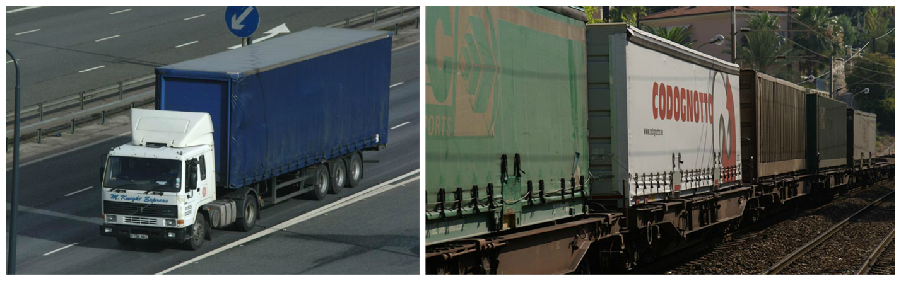Source: Truck ([Ian Britton](http://www.freefoto.com/preview/21-26-37/Truck)/[freefoto.com](http://www.freefoto.com/browse/99-05-0/Free-Use-Rules)), train ([Ian Britton](http://www.freefoto.com/preview/807-36-1892/Euro-Cargo-Rail-Intermodal-train)/[freefoto.com](http://www.freefoto.com/browse/99-05-0/Free-Use-Rules))

Feedback?

In an array, each element's location number is called the ***index***, myArray[2] has index 2. An array's key feature is that the index enables direct access to any element, as in myArray[2]; different languages may use different syntax, like myArray(3) or myVector.at(3). In many languages, indices start with 0 rather than 1, so an array with 4 elements has indices 0, 1, 2, and 3.

**PARTICIPATIONACTIVITY**

5.1.2: Update the array's data values.

Jump to level 1

|  |  |
| --- | --- |
| Update myItems with myItems[2] = myItems[2] + 6 |  |
| |  |  | | --- | --- | |  | myItems | | 0 | **24** | | 1 | **48** | | 2 | **93** | | 3 | **82** | | 4 | **27** | | 5 | **17** | | 6 | **84** | | |  |  | | --- | --- | |  |  | |  |  | |  |  | |  |  | |  |  | |  |  | |  |  | |  |  | |

1

2

3

4

5

**6**

Check

Next

**Done**.

 Correct.

Feedback?

**PARTICIPATIONACTIVITY**

5.1.3: Array basics.

Array peoplePerDay has 365 elements, one for each day of the year. Valid accesses are peoplePerDay[0], [1], ..., [364].

1)

Which assigns element 0 with the value 250?

peoplePerDay[250] = 0

peoplePerDay[0] = 250

peoplePerDay = 250

**Correct**

Assigns element 0 with 250.

2)

Which assigns element 1 with the value 99?

peoplePerDay[1] = 99

**Correct**

Assigns element 1 with 99.

3)

What is the value of peoplePerDay[8]?

peoplePerDay[9] = 5;

peoplePerDay[8] = peoplePerDay[9] - 3;

2

**Correct**

peoplePerDay[9] is 5. So peoplePerDay[9] - 3 is 5 - 3, which is 2.

4)

Assume N is initially 1. What is the value of peoplePerDay[2]?

peoplePerDay[N] = 15;

N = N + 1;

peoplePerDay[N] = peoplePerDay[N - 1] * 3;

45

**Correct**

peoplePerDay[1] is assigned with 15. Then, peoplePerDay[2] is assigned with peoplePerDay[1] * 3, which is 15 * 3, so 45.

Feedback?

**PARTICIPATIONACTIVITY**

5.1.4: Arrays with element numbering starting with 0.

Array scoresList has 10 elements with indices 0 to 9, accessed as scoresList[0] to scoresList[9].

1)

Assign the first element in scoresList with 77.

CheckShow answer

**Correct**

scoresList[0] = 77;

scoresList[0] refers to element number 0, which is the first element.

2)

Assign the second element in scoresList with 77.

CheckShow answer

**Correct**

scoresList[1] = 77;

When indices start at 0, the second element is at index 1.

3)

Assign the last element with 77.

CheckShow answer

**Correct**

scoresList[9] = 77;

When indices start at 0, an N-element array's last element has index N - 1. With 10 elements, the last index is 9.

4)

If that array instead has 100 elements, what is the last element's index?

CheckShow answer

**Correct**

99

The last index is at N - 1, where N is the number of elements, because the first element has index 0.

5)

If the array's last index was 499, how many elements does the array have?

CheckShow answer

**Correct**

500

Because numbering starts at 0, the last index is N - 1, where N is the number of elements.

5.2 Arrays

**Array declarations and accessing elements**

A programmer commonly needs to maintain a list of items, just as people often maintain lists of items like a grocery list or a course roster. An ***array*** is an ordered list of items of a given data type. Each item in an array is called an ***element***.

Construct 5.2.1: Array declaration.

dataType arrayName[numElements];

Feedback?

This statement declares an array having the specified number of elements in memory, each element of the specified data type. The desired number of elements are specified in [ ] symbols.

Terminology note: [ ] are ***brackets***. { } are ***braces***. In an array access, the number in brackets is called the ***index*** of the corresponding element. The first array element is at index 0.

**PARTICIPATIONACTIVITY**

5.2.1: An array declaration creates multiple variables in memory, each accessible using [ ].

12

2x speed

#include <stdio.h>

**int** main(**void**) {

**int** itemCounts[3];

itemCounts[0] = 122;

itemCounts[1] = 119;

itemCounts[2] = 117;

printf("%d", itemCounts[1]);

**return** 0;

}

96

97

98

99

itemCounts[0]

itemCounts[1]

itemCounts[2]

itemCounts

122

119

117

119

An element is accessed with brackets. The number in brackets is called the index of the corresponding element.

Captions

keyboard_arrow_up

1. An array named itemCounts is declared. The array consists of 3 elements, each of data type int.
2. An element is accessed with brackets. The number in brackets is called the index of the corresponding element.

Feedback?

**PARTICIPATIONACTIVITY**

5.2.2: Select the index shown.

Jump to level 1

Select the elements at indexes [3] and [2].

|  |  |  |  |  |
| --- | --- | --- | --- | --- |
|  |  |  |  |  |

1

2

3

4

5

**6**

Check

Next

**Done**.

 Correct.

Feedback?

**PARTICIPATIONACTIVITY**

5.2.3: Array basics.

Given:

**int** yearsArr[4];

yearsArr[0] = 1999;

yearsArr[1] = 2012;

yearsArr[2] = 2025;

1)

How many elements in memory does the array declaration create?

4

**Correct**

The declaration creates array yearsArr with 4 elements. The elements' indices will be 0, 1, 2, and 3.

2)

What value is stored in yearsArr[1]?

2012

**Correct**

The element yearsArr[1] is like an int variable. That element was assigned 2012.

3)

With what value does  currYear = yearsArr[2]  assign currYear?

2025

**Correct**

The element yearsArr[2] is like an int variable. 2025 was earlier assigned to that element.

4)

With what value does  currYear = yearsArr[3]  assign currYear?

Unknown

**Correct**

Element yearsArr[3] was never assigned, so its value is unknown, just like any uninitialized variable.

5)

Recall that the array declaration was int yearsArr[4]. Is currYear = yearsArr[4] a valid assignment?

No, yearsArr[4] does not exist.

**Correct**

The valid indices start at 0, so the four elements are 0, 1, 2, and 3. Accessing yearsArr[4] will cause an error.

6)

What is the proper way to access the *first*  element in array yearsArr?

yearsArr[0]

**Correct**

Array elements are indexed starting with 0. That idea can be hard for new programmers to remember.

7)

What are the contents of the array if the above code is followed by the statement: yearsArr[0] = yearsArr[2]?

2025, 2012, 2025, ?

**Correct**

Each element is its own variable, and can be read and assigned just like any other variable. yearsArr[3] was never assigned so its value is unknown (represented by ?).

8)

What is the index of the *last*  element for the following array:  int pricesArr[100];

99

**Correct**

The 100 elements will have indices 0..99.

Feedback?

**Using an expression for an array index**

A powerful aspect of arrays is that the index is an expression. Ex: userNums[i] uses the value held in the int variable i as the index. As such, an array is useful to easily lookup the Nth item in a list.

An array's index must be an integer type. The array index cannot be a floating-point type, even if the value is 0.0, 1.0, etc.

The program below allows a user to print the age of the Nth oldest known person to have ever lived. The program quickly accesses the Nth oldest person's age using oldestPeople[nthPerson - 1]. Note that the index is nthPerson - 1 rather than just nthPerson because an array's indices start at 0, so the 1st age is at index 0, the 2nd at index 1, etc.

Figure 5.2.1: Array's nth element can be directly accessed using [n]: Oldest people program.

|  |  |
| --- | --- |
| #include <stdio.h>  **int** main(**void**) {  **int** oldestPeople[5];  **int** nthPerson; // User input, Nth oldest person    oldestPeople[0] = 122; // Died 1997 in France  oldestPeople[1] = 119; // Died 1999 in U.S.  oldestPeople[2] = 117; // Died 1993 in U.S.  oldestPeople[3] = 117; // Died 1998 in Canada  oldestPeople[4] = 116; // Died 2006 in Ecuador    printf("Enter N (1-5): ");  scanf("%d", &nthPerson);    **if** ((nthPerson >= 1) && (nthPerson <= 5)) {  printf("The %dth oldest person lived ", nthPerson);  printf("%d years.\n", oldestPeople[nthPerson-1]);  }    **return** 0;  } | Enter N (1-5): 1  The 1th oldest person lived 122 years.  ...  Enter N (1-5): 4  The 4th oldest person lived 117 years.  ...  Enter N (1-5): 9  ...  Enter N (1-5): 0  ...  Enter N (1-5): 5  The 5th oldest person lived 116 years. |

Feedback?

**PARTICIPATIONACTIVITY**

5.2.4: Nth oldest person program.

1)

In the program above, what is the purpose of this if statement:

**if** ((nthPerson >= 1) && (nthPerson <= 5)) {

...

}

To ensure only valid array elements are accessed because the array oldestPeople only has 5 elements.

**Correct**

The user enters 1..5, which is converted to 0..4 when accessing the vector's 5 elements.

Feedback?

**PARTICIPATIONACTIVITY**

5.2.5: Array declaration and accesses.

1)

Declare an array named myVals that stores 10 items of type int.

CheckShow answer

**Correct**

int myVals[10];

The value inside the [] declares 10 integer values are stored in an array called myVals.

2)

Assign variable x with the value stored at index 8 of array myVals.

CheckShow answer

**Correct**

x = myVals[8];

Any element in an array can be accessed by the [] operator, as long as the element is in the array's scope.

3)

Assign the second element of array myVals with the value 555.

CheckShow answer

**Correct**

myVals[1] = 555;

Note that myVals' first element is myVals[0], so the second element is myVals[1] rather than myVals[2].

4)

Assign myVals array element at the index held in currIndex with the value 777.

CheckShow answer

**Correct**

myVals[currIndex] = 777;

The value held in currIndex is used as the array index. An array index may be any expression that evaluates to an integer value.

5)

Assign tempVal with the myVals array element at the index one after the value held in variable i.

CheckShow answer

**Correct**

tempVal = myVals[i + 1];

The expression i + 1 is evaluated, and the result is used as the array index.

Feedback?

**Loops and arrays**

A key advantage of arrays becomes evident when used in conjunction with loops. The program below uses a loop to allow a user to enter 8 integer values, storing those values in an array, and then printing those 8 values.

Figure 5.2.2: Arrays combined with loops are powerful together: User-entered numbers.

|  |  |
| --- | --- |
| #include <stdio.h>  **int** main(**void**) {  **const** **int** NUM_ELEMENTS = 8; // Number of elements in array  **int** userVals[NUM_ELEMENTS]; // User numbers  **int** i; // Loop index    printf("Enter %d integer values...\n", NUM_ELEMENTS);  **for** (i = 0; i < NUM_ELEMENTS; ++i) {  printf("Value: ");  scanf("%d", &(userVals[i]));  }    printf("You entered: ");  **for** (i = 0; i < NUM_ELEMENTS; ++i) {  printf("%d ", userVals[i]);  }  printf("\n");    **return** 0;  } | Enter 8 integer values...  Value: 5  Value: 99  Value: -1  Value: -44  Value: 8  Value: 555555  Value: 0  Value: 2  You entered: 5 99 -1 -44 8 555555 0 2 |

Feedback?

**PARTICIPATIONACTIVITY**

5.2.6: Array with loops.

Refer to the program above.

1)

How many times does each for loop iterate?

8

**Correct**

NUM_ELEMENTS is a const variable initialized to 8, which is used to declare an array of 8 elements. The for loop uses NUM_ELEMENTS to iterate through the 8 array elements.

2)

Which one line of code can be changed to allow the user to enter 100 elements?

const int NUM_ELEMENTS = 8;

**Correct**

Using arrays and loops, only the constant literal 8 would be changed.

Feedback?

**Array initialization**

An array's elements are not automatically initialized during the variable declaration and should be initialized before being read. A programmer may initialize an array's elements in an array variable declaration by specifying the initial values in braces {} separated by commas. Ex: int myArray[3] = {5, 7, 11}; initializes element at index 0 with 5, element at index 1 with 7, and element at index 2 with 11. For larger arrays, a loop may be used for initialization.

Like other variables, the keyword ***const***may be prepended to an array variable declaration to prevent changes to the array. Thus, const int YEARS[3] = {1865, 1920, 1964}; followed by YEARS[0] = 2000; yields a compiler error.

**PARTICIPATIONACTIVITY**

5.2.7: Array initialization.

1)

Declare an array of ints named myVals with 4 elements each initialized to 10. The array declaration and initialization should be done in a single statement.

CheckShow answer

**Correct**

int myVals[4] = {10, 10, 10, 10};

The number of elements within the {} must never be greater than the size of an array.

2)

Given: int maxScores[4] = {20, 20, 100, 50};. What is maxScores[3]?

CheckShow answer

**Correct**

50

maxScores' elements are initialized with 20, 20, 100, and 50. So, the value at index 3 is 50.

Feedback?

**CHALLENGEACTIVITY**

5.2.1: Enter the output for the array.

Jump to level 1

Type the program's output

|  |  |
| --- | --- |
| #include <stdio.h>  **int** main**(void)** {  **const** **int** NUM_ELEMENTS = 3;  **int** userVals[NUM_ELEMENTS];  **int** i;    userVals[0] = 2;  userVals[1] = 6;  userVals[2] = 9;  userVals[0] = userVals[2];  userVals[2] = userVals[1];    **for** (i = 0; i < NUM_ELEMENTS; ++i) {  printf("%d\n", userVals[i]);  }    **return** 0;  } |  |

1

2

3

4

**5**

Check

Next

**Done**. Click any level to practice more. Completion is preserved.



|  |  |
| --- | --- |
| Yours | 9  6  6 |
| Expected | 9  6  6 |

1

2

3

4

5

Feedback?

**CHALLENGEACTIVITY**

5.2.2: Printing array elements.

Write three statements to print the first three elements of array runTimes. Follow each statement with a newline. Ex: If runTimes[5] = {800, 775, 790, 805, 808}, print:

800

775

790

Note: These activities will test the code with different test values. This activity will perform two tests, both with a 5-element array (int runTimes[5]). See ["How to Use zyBooks".](https://learn.zybooks.com/zybook/HowToUseZyBooks2/chapter/1/section/3)  
  
Also note: If the submitted code tries to access an invalid array element, such as runTimes[9] for a 5-element array, the test may generate strange results. Or the test may crash and report "Program end never reached", in which case the system doesn't print the test case that caused the reported message.

#include <stdio.h>

int main(void) {

const int NUM_ELEMENTS = 5;

int runTimes[NUM_ELEMENTS];

int i;

for (i = 0; i < NUM_ELEMENTS; ++i) {

scanf("%d", &(runTimes[i]));

}

printf("%d\n", runTimes[0]);

printf("%d\n", runTimes[1]);

printf("%d\n", runTimes[2]);

return 0;

}

**CHALLENGEACTIVITY**

5.2.3: Printing array elements with a for loop.

Write a for loop to print all elements in courseGrades, following each element with a space (including the last). Print forwards, then backwards. End each loop with a newline. Ex: If courseGrades = {7, 9, 11, 10}, print:

7 9 11 10

10 11 9 7

Hint: Use two for loops. Second loop starts with i = NUM_VALS - 1. [(Notes)](https://www.zybooks.com/coding-ca-notes/#PrintArray)  
  
  
Note: These activities may test code with different test values. This activity will perform two tests, both with a 4-element array (int courseGrades[4]). See ["How to Use zyBooks".](https://learn.zybooks.com/zybook/HowToUseZyBooks2/chapter/1/section/3)  
  
Also note: If the submitted code tries to access an invalid array element, such as courseGrades[9] for a 4-element array, the test may generate strange results. Or the test may crash and report "Program end never reached", in which case the system doesn't print the test case that caused the reported message.

#include <stdio.h>

int main(void) {

const int NUM_VALS = 4;

int courseGrades[NUM_VALS];

int i;

for (i = 0; i < NUM_VALS; ++i) {

scanf("%d", &(courseGrades[i]));

}

for (i = 0; i <= NUM_VALS-1;i++){

printf("%d ", courseGrades[i]);

}

printf("\n");

for (i = NUM_VALS-1; i >= 0;--i){

printf("%d ", courseGrades[i]);

}

printf("\n");

return 0;

}

5.3 Iterating through arrays

**Iterating through an array using loops**

Iterating through arrays using loops is commonplace and is an important programming skill to master.

Because array indices are numbered 0 to N - 1 rather than 1 to N, programmers commonly use this for loop structure:

Figure 5.3.1: Common for loop structure for iterating through an array.

// Iterating through myArray

**for** (i = 0; i < numElements; ++i) {

// Loop body accessing myArray[i]

}

Feedback?

Note that index variable i is initialized to 0, and the loop expression is i < N rather than i <= N. If N were 5, the loop's iterations would set i to 0, 1, 2, 3, and 4, for a total of 5 iterations. The benefit of the loop structure is that each array element is accessed as myArray[i] rather than the more complex myArray[i - 1].

**PARTICIPATIONACTIVITY**

5.3.1: Iterating through an array.

1)

Complete the code to print all items for the given array, using the above common loop structure.

**int** daysList[365];

...

**for** (i = 0; ; ++i) {

printf("%d\n", daysList[i]);

}

CheckShow answer

**Correct**

i < 365

Valid elements are 0..364. When i reaches 365, the loop body does not execute.

2)

Given that this loop iterates over all items of the array, how many items are in the array?

**for** (i = 0; i < 99; ++i) {

printf("%d\n", someArray[i]);

}

CheckShow answer

**Correct**

99

The loop iterates from 0 to 98, so the array has elements at indices 0 to 98. That's 99 items (the 0'th item counts as an item).

Feedback?

**Determining a quantity about an array's items**

Iterating through an array for various purposes is an important programming skill to master. The program below computes the sum of an array's element values. For computing the sum, the program initializes a variable sum to 0, then simply adds the current iteration's array element value to that sum.

Figure 5.3.2: Iterating through an array example: Program that computes the sum of an array's elements.

|  |  |
| --- | --- |
| #include <stdio.h>  **int** main(**void**) {  **const** **int** NUM_ELEMENTS = 8; // Number of elements  **int** userVals[NUM_ELEMENTS]; // User numbers  **int** i; // Loop index  **int** sumVal; // For computing sum    // Prompt user to populate array  printf("Enter %d integer values...\n", NUM_ELEMENTS);    **for** (i = 0; i < NUM_ELEMENTS; ++i) {  printf("Value: ");  scanf("%d", &(userVals[i]));  }    // Determine sum  sumVal = 0;  **for** (i = 0; i < NUM_ELEMENTS; ++i) {  sumVal = sumVal + userVals[i];  }    printf("Sum: %d\n", sumVal);    **return** 0;  } | Enter 8 integer values...  Value: 3  Value: 5  Value: 234  Value: 346  Value: 234  Value: 73  Value: 26  Value: -1  Sum: 920  ...  Enter 8 integer values...  Value: 3  Value: 5  Value: 234  Value: 346  Value: 234  Value: 73  Value: 26  Value: 1  Sum: 922 |

Feedback?

**Finding the maximum value in an array**

Programs commonly iterate through arrays to determine some quantity about the array's items. The program below determines the maximum value in a user-entered list. If the user enters numbers 7, -9, 55, 44, 20, -400, 0, 2, then the program will output "max: 55". The program uses the variable maxVal to store the largest value seen "so far" as the program iterates through the array. During each iteration, if the array's current element value is larger than the max seen so far, the program assigns maxVal with the array element.

Before entering the loop, maxVal must be initialized to some value because max will be compared with each array element's value. A logical error would be to initialize maxVal to 0, because 0 is not in fact the largest value seen so far, and would result in incorrect output (of 0) if the user entered all negative numbers. Instead, the program peeks at an array element (using the first element, though any element could have been used) and initializes maxVal to that element's value.

Figure 5.3.3: Iterating through an array example: Program that finds the max item.

|  |  |
| --- | --- |
| #include <stdio.h>  **int** main(**void**) {  **const** **int** NUM_ELEMENTS = 8; // Number of elements  **int** userVals[NUM_ELEMENTS]; // Array of user numbers  **int** i; // Loop index  **int** maxVal; // Computed max    // Prompt user to populate array  printf("Enter %d integer values...\n", NUM_ELEMENTS);    **for** (i = 0; i < NUM_ELEMENTS; ++i) {  printf("Value: ");  scanf("%d", &(userVals[i]));  }    // Determine largest (max) number  maxVal = userVals[0]; // Largest so far    **for** (i = 0; i < NUM_ELEMENTS; ++i) {  **if** (userVals[i] > maxVal) {  maxVal = userVals[i];  }  }  printf("Max: %d\n", maxVal);    **return** 0;  } | Enter 8 integer values...  Value: 3  Value: 5  Value: 23  Value: -1  Value: 456  Value: 1  Value: 6  Value: 83  Max: 456  ...  Enter 8 integer values...  Value: -5  Value: -10  Value: -44  Value: -2  Value: -27  Value: -9  Value: -27  Value: -9  Max: -2 |

Feedback?

**PARTICIPATIONACTIVITY**

5.3.2: Array iteration.

Given an integer array myVals of size N_SIZE (i.e. int myVals[N_SIZE] ), complete the code to achieve the stated goal.

1)

Determine the minimum number in the array, using the same initialization as the maximum number example above.

minVal = ;

**for** (i = 0; i < N_SIZE; ++i) {

**if** (myVals[i] < minVal) {

minVal = myVals[i];

}

}

CheckShow answer

**Correct**

myVals[0]

minVal must be initialized to an element in the array. Using the 0'th element ensures the code works for any size array.

2)

Count how many negative numbers exist in the array.

cntNeg = 0;

**for** (i = 0; i < N_SIZE; ++i) {

**if** ( ) {

++cntNeg;

}

}

CheckShow answer

**Correct**

myVals[i] < 0 or myVals[i] <= -1

Each iteration of the for loop checks if the element's value is negative, which can be accomplished by either myVals[i] < 0 or myVals[i] <= -1.

3)

Count how many odd numbers exist in the array.

cntOdd = 0;

**for** (i = 0; i < N_SIZE; ++i) {

**if** ( (myVals[i] % 2) == 1 ) {

;

}

}

CheckShow answer

**Correct**

++cntOdd

For each odd value found, cntOdd is incremented.

Feedback?

zyDE 5.3.1: Print the sum and average of an array's elements.

Modify the program to print the average (mean) as well as the sum. Hint: You don't actually have to change the loop, but rather change what you print.

for (i = 0; i < NUM_ELEMENTS; ++i) {

printf("Value: \n");

scanf("%d", &(userVals[i]));

}

// Determine sum

sumVal = 0;

for (i = 0; i < NUM_ELEMENTS; ++i) {

sumVal = sumVal + userVals[i];

}

printf("Sum: %d\n", sumVal);

return 0;

}

Run

Enter 8 integer values...

Value:

Value:

Value:

Value:

Value:

Value:

Value:

Value:

Sum: 920

Feedback?

zyDE 5.3.2: Print selected elements of an array.

Modify the program to instead just print each number that is greater than 21.

for (i = 0; i < NUM_ELEMENTS; ++i) {

printf("Value: \n");

scanf("%d", &(userVals[i]));

}

// Determine sum

sumVal = 0;

for (i = 0; i < NUM_ELEMENTS; ++i) {

sumVal = sumVal + userVals[i];

}

printf("Sum: %d\n", sumVal);

return 0;

}

Run

Feedback?

**Common error: Accessing out of range array element**

A common error is to try to access an array with an index that is out of the array's index range. Ex: Trying to access highScores[8] when highScores's valid indices are 0-7. Care should be taken whenever a user enters a number that is then used as an array index, and when using a loop index as an array index also, to ensure the index is within the array's valid index range. Checking whether an array index is in range is very important. Trying to access an array with an out-of-range index is not only a very common error, but is also one of the hardest errors to debug. The following animation shows what happens when a program writes to an out-of-range index using an array.

**PARTICIPATIONACTIVITY**

5.3.3: Writing to an out-of-range index using an array.

123

2x speed

**int** userWeights[3];

**int** userAge;

userAge = 44;

userWeights[0] = 122;

userWeights[1] = 119;

userWeights[2] = 117;

userWeights[3] = 199; // (Problematic)

// Print userAge

96

97

98

99

44

100

userAge

userWeights[2]

userWeights[1]

userWeights[0]

userWeights

122

119

117

199

199

3 is out of userWeights's index range, and results in overwriting userAge's value.

Captions

keyboard_arrow_up

1. Variable userAge is allocated a location in memory immediately after the array userWeights. userAge is assigned with 44.
2. Each element of array userWeights is assigned a value.
3. 3 is out of userWeights's index range, and results in overwriting userAge's value.

Feedback?

A write to an array with an out-of-range index may simply write to a memory location of a different variable X residing next to the array in memory. Later, when the program tries to read X, the program encounters incorrect data. For example, a program may write X with the number 44, but when reading X later in the program X may be 2533, with X never (intentionally) written by any program statement in between.

**PARTICIPATIONACTIVITY**

5.3.4: Iterating through an array.

Given the following code:

**const** **int** NUM_ELEMENTS = 5;

**int** myArray[NUM_ELEMENTS];

**int** i;

1)

The normal for loop structure iterates as long as:  
i <= NUM_ELEMENTS

True

False

**Correct**

The normal structure uses <, not <=. The <= causes the loop to iterate outside of the array's valid index range.

2)

To compute the sum of elements, a reasonable statement preceding the for loop is: sumVal = 0;

True

False

**Correct**

sumVal starts at 0, then as the for loop iterates through each element, that element's value gets added to sum.

3)

To find the maximum element value, a reasonable statement preceding the for loop is: maxVal = 0;

True

False

**Correct**

0 would yield a wrong final maxVal if all element values were negative. A better statement would be: maxVal = myArray[0].

Feedback?

**CHALLENGEACTIVITY**

5.3.1: Enter the output for the array.

Jump to level 1

Type the program's output

|  |  |
| --- | --- |
| #include <stdio.h>  **int** main**(void)** {  **const** **int** NUM_ELEMENTS = 4;  **int** userVals[NUM_ELEMENTS];  **int** i;    userVals[0] = -1;  userVals[1] = 4;  userVals[2] = -6;  userVals[3] = 7;    **for** (i = 0; i < NUM_ELEMENTS; ++i) {  **if** (userVals[i] < 0) {  userVals[i] = -1 * userVals[i];  }  printf("%d\n", userVals[i]);  }    **return** 0;  } |  |

Check

Next

**Done**. Click any level to practice more. Completion is preserved.



|  |  |
| --- | --- |
| Yours | 1  4  6  7 |
| Expected | 1  4  6  7 |

1

2

3

4

5

6

Feedback?

**CHALLENGEACTIVITY**

5.3.2: Finding values in arrays.

Assign numMatches with the number of elements in userValues that equal matchValue. userValues has NUM_VALS elements. Ex: If userValues is {2, 1, 2, 2} and matchValue is 2 , then numMatches should be 3.   
  
Your code will be tested with the following values:   
matchValue: 2, userValues: {2, 1, 2, 2} (as in the example program above)   
matchValue: 0, userValues: {0, 0, 0, 0}   
matchValue: 10, userValues: {20, 50, 70, 100}   
[(Notes)](https://www.zybooks.com/coding-ca-notes/#FindArrayValues)

#include <stdio.h>

int main(void) {

const int NUM_VALS = 4;

int userValues[NUM_VALS];

int i;

int matchValue;

int numMatches = -99; // Assign numMatches with 0 before your for loop

scanf("%d", &matchValue);

for (i = 0; i < NUM_VALS; ++i) {

scanf("%d", &(userValues[i]));

}

numMatches = 0;// Assign numMatches with 0 before your for loop

for (i = 0; i < NUM_VALS; i++){ //userValues has NUM_VALS elements.

if (userValues[i] == matchValue){//Assign numMatches with # of [elements] in userValues == matchValue

++numMatches;// then numMatches should be 3.

}

}

printf("matchValue: %d, numMatches: %d\n", matchValue, numMatches);

return 0;

}

**CHALLENGEACTIVITY**

5.3.3: Populating an array with a for loop.

Write a for loop to populate array userGuesses with NUM_GUESSES integers. Read integers using scanf. Ex: If NUM_GUESSES is 3 and user enters 9 5 2, then userGuesses is {9, 5, 2}.

#include <stdio.h>

int main(void) {

const int NUM_GUESSES = 3;

int userGuesses[NUM_GUESSES];

int i;

for (i = 0; i < NUM_GUESSES; i++ ){//populate array userGuesses with NUM_GUESSES integers

scanf("%d", &userGuesses[i]);//Read integers using scanf.

}

for (i = 0; i < NUM_GUESSES; ++i) {

printf("%d ", userGuesses[i]);

}

return 0;

}

**CHALLENGEACTIVITY**

5.3.4: Array iteration: Sum of excess.

Array testGrades contains NUM_VALS test scores. Write a for loop that sets sumExtra to the total extra credit received. Full credit is 100, so anything over 100 is extra credit. Ex: If testGrades = {101, 83, 107, 90}, then sumExtra = 8, because 1 + 0 + 7 + 0 is 8.

#include <stdio.h>

int main(void) {

const int NUM_VALS = 4;

int testGrades[NUM_VALS];

int i;

int sumExtra = -9999; // Assign sumExtra with 0 before your for loop

for (i = 0; i < NUM_VALS; ++i) {

scanf("%d", &(testGrades[i]));

}

//line 5: Array testGrades contains NUM_VALS test scores.

sumExtra = 0;//Assign sumExtra with 0 before your for loop

for (i = 0; i < NUM_VALS; i++){//for loop that sets sumExtra to the total extra credit received

if (testGrades[i] > 100){

sumExtra += (testGrades[i] % 100);//anything over 100 is extra credit

}

}

printf("sumExtra: %d\n", sumExtra);

return 0;

}

**CHALLENGEACTIVITY**

5.3.5: Printing array elements separated by commas.

Write a for loop to print all NUM_VALS elements of array hourlyTemp. Separate elements with a comma and space. Ex: If hourlyTemp = {90, 92, 94, 95}, print:

90, 92, 94, 95

Your code's output should end with the last element, without a subsequent comma, space, or newline.

#include <stdio.h>

int main(void) {

const int NUM_VALS = 4;

int hourlyTemp[NUM_VALS];

int i;

for (i = 0; i < NUM_VALS; ++i) {

scanf("%d", &(hourlyTemp[i]));

}

for (i = 0; i < NUM_VALS; i++){

if (i == NUM_VALS-1){

printf("%d", hourlyTemp[i]);

}

else{

printf("%d, ", hourlyTemp[i]);

}

}

printf("\n");

return 0;

}

5.4 Multiple arrays

Programmers commonly use multiple same-sized arrays to store related lists. The program below maintains a list of letter weights in ounces, and another list indicating the corresponding postage cost for first class mail (usps.com).

The if (userLetterWeight <= letterWeights[i]) statement compares the user-entered letter weight with the current element in the letterWeights array. If the entered weight is less than or equal to the current element in the letterWeights array, the program prints the element in postageCosts at the same index.

The loop's expression (i < NUM_ELEMENTS) && (!foundWeight) depends on the value of the variable foundWeight. This expression prevents the loop from iterating through the entire array once the correct letter weight has been found. Omitting the check for found from the loop expression would result in an incorrect output; the program would incorrectly print the postage cost for all letter weights greater than the user's letter weight.

Figure 5.4.1: Multiple array example: Letter postage cost program.

#include <stdio.h>

#include <stdbool.h>

**int** main (**void**) {

**const** **int** NUM_ELEMENTS = 14;

// Weights in ounces

**double** letterWeights[14] = {1.0, 2.0, 3.0, 3.5, 4.0, 5.0, 6.0,

7.0, 8.0, 9.0, 10.0, 11.0, 12.0, 13.0};

// Costs in cents (usps.com 2017)

**int** postageCosts[14] = {49, 70, 91, 112, 161, 182, 203,

224, 245, 266, 287, 308, 329, 350};

**double** userLetterWeight;

bool foundWeight;

**int** i;

// Prompt user to enter letter weight

printf("Enter letter weight (in ounces): ");

scanf("%lf", &userLetterWeight);

// Postage costs is based on smallest letter weight greater than

// or equal to mailing letter weight

foundWeight = false;

**for** (i = 0; (i < NUM_ELEMENTS) && (!foundWeight); ++i) {

**if**( userLetterWeight <= letterWeights[i] ) {

foundWeight = true;

printf("Postage for USPS first class mail is %d cents\n",

postageCosts[i]);

}

}

**if**( !foundWeight ) {

printf("Letter is too heavy for USPS first class mail.\n");

}

**return** 0;

}

Enter letter weight (in ounces): 3

Postage for USPS first class mail is 91 cents

...

Enter letter weight (in ounces): 9.5

Postage for USPS first class mail is 287 cents

...

Enter letter weight (in ounces): 15

Letter is too heavy for USPS first class mail.

Feedback?

**PARTICIPATIONACTIVITY**

5.4.1: Multiple arrays in the above postage cost program.

1)

letterWeights[0] is 1, meaning element 0 of letterWeights and postageCosts correspond to a weight of 1 ounce.

True

False

**Correct**

The first weight for which the USPS defines a cost is 1 ounce.

2)

postageCosts[2] represents the cost for a weight of 2 ounces.

True

False

**Correct**

The index is merely used to access the lists in increasing order of weight. letterWeights[2] is 3, meaning postageCosts[2] corresponds to 3 ounces.

3)

The program fails to provide a cost for a weight of 7.5.

True

False

**Correct**

The program will visit letterWeights[7] which is 7. Because 7.5 is not <= 7, the program will visit letterWeights[8] which is 8. Because 7.5 <= 8, the program will print postageCosts[i] which is 245.

Feedback?

zyDE 5.4.1: Postage calculation with negative weight error message.

Improve the program by also outputting "The next higher weight is ___ with a cost of ___ cents".

Load default template...

14

15

16

17

18

19

20

21

22

23

24

25

26

27

28

29

30

31

32

33

34

int i;

// Prompt user to enter letter weight

printf("Enter letter weight (in ounces): ");

scanf("%lf", &userLetterWeight);

// Postage costs is based on smallest letter weight greater than

// or equal to mailing letter weight

foundWeight = false;

for (i = 0; (i < NUM_ELEMENTS) && (!foundWeight); ++i) {

if( userLetterWeight <= letterWeights[i] ) {

foundWeight = true;

printf("Postage for USPS first class mail is %d cents\n",

postageCosts[i]);

}

}

if( !foundWeight ) {

Run

Enter letter weight (in ounces): Postage for USPS first class mail is 91 cents

Feedback?

**PARTICIPATIONACTIVITY**

5.4.2: Multiple arrays.

1)

Using two separate statements, declare two related integer arrays named seatPosition and testScore (in that order) each with 130 elements.

CheckShow answer

**Correct**

int seatPosition[130]; int testScore[130];

While the arrays are related, they should be declared separately. int seatPosition[130]; declares an integer array named seatPostion that stores 130 elements, while int testScore[130]; declares an integer array named testScore that stores 130 elements.

2)

How many total elements are stored within the two arrays int familyAges[50] and double familyHeights[50]?

CheckShow answer

**Correct**

100

Each array stores 50 elements. Thus, 50 + 50 is 100.

Feedback?

**CHALLENGEACTIVITY**

5.4.1: Multiple arrays.

Jump to level 1

Add each element in origList with the corresponding value in offsetAmount. Print each sum followed by a semicolon (no spaces).   
Ex: If the input is:

4 5 10 12

2 4 7 3

the output is:

6;9;17;15;

#include <stdio.h>

int main(void) {

const int NUM_VALS = 4;

int origList[NUM_VALS];

int offsetAmount[NUM_VALS];

int i;

scanf("%d", &origList[0]);

scanf("%d", &origList[1]);

scanf("%d", &origList[2]);

scanf("%d", &origList[3]);

scanf("%d", &offsetAmount[0]);

scanf("%d", &offsetAmount[1]);

scanf("%d", &offsetAmount[2]);

scanf("%d", &offsetAmount[3]);

for (i = 0; i <= NUM_VALS-1;i++){

printf("%d;", origList[i]+ offsetAmount[i]);

}

printf("\n");

return 0;

}

For any element in keysList with a value greater than 60, print the corresponding value in itemsList, followed by a semicolon (no spaces).   
Ex: If the input is:

32 105 101 35

10 20 30 40

the output is:

20;30;

#include <stdio.h>

int main(void) {

const int SIZE_LIST = 4;

int keysList[SIZE_LIST];

int itemsList[SIZE_LIST];

int i;

scanf("%d", &keysList[0]);

scanf("%d", &keysList[1]);

scanf("%d", &keysList[2]);

scanf("%d", &keysList[3]);

scanf("%d", &itemsList[0]);

scanf("%d", &itemsList[1]);

scanf("%d", &itemsList[2]);

scanf("%d", &itemsList[3]);

for (i = 0; i <= SIZE_LIST;i++){

if (keysList[i] > 60){

printf("%d;", itemsList[i]);

}

}

printf("\n");

return 0;

}

5.5 Two-dimensional arrays

An array can be declared with two dimensions.  int myArray[R][C] represents a table of int variables with R rows and C columns, so R*C elements total. For example, int myArray[2][3] creates a table with 2 rows and 3 columns, for 6 int variables total. Example accesses are myArray[0][0] = 33; or num = myArray[1][2].

**PARTICIPATIONACTIVITY**

5.5.1: Two-dimensional array.

12

2x speed

// Define array with size [2][3]

// Write to some elements

myArray[0][0] = 55;

myArray[1][1] = 77;

myArray[1][2] = 99;

90

91

92

93

95

94

55

77

99

0

1

0 1 2

55

77

99

[0][0] [0][1] [0][2]

[1][0] [1][1] [1][2]

Columns [3]

Rows [2]

myArray[ ][ ]

myArray[ ][ ]

myArray[ ][ ]

myArray[ ][ ]

myArray[ ][ ]

myArray[ ][ ]

Row 0 Row 1

- - - - - - - - - - - - -

*Implementation in memory*

0 0

0 1

0 2

1 0

1 1

1 2

A two-dimensional array is implemented in a one-dimensional memory by placing each row following the previous row.

Captions

keyboard_arrow_up

1. Conceptually, a two-dimensional array is a table with rows and columns.
2. A two-dimensional array is implemented in a one-dimensional memory by placing each row following the previous row.

Feedback?

Conceptually, a two-dimensional array is a table with rows and columns. The compiler maps two-dimensional array elements to one-dimensional memory, each row following the previous row, known as ***row-major order***.

Figure 5.5.1: Using a two-dimensional array: A driving distance between cities example.

|  |  |
| --- | --- |
| #include <stdio.h>  /* Direct driving distances between cities, in miles */  /* 0: Boston 1: Chicago 2: Los Angeles */  **int** main(**void**) {  **int** cityA; // Starting city  **int** cityB; // Destination city  **int** drivingDistances[3][3]; // Driving distances  // Initialize distances array  drivingDistances[0][0] = 0;  drivingDistances[0][1] = 960; // Boston-Chicago  drivingDistances[0][2] = 2960; // Boston-Los Angeles  drivingDistances[1][0] = 960; // Chicago-Boston  drivingDistances[1][1] = 0;  drivingDistances[1][2] = 2011; // Chicago-Los Angeles  drivingDistances[2][0] = 2960; // Los Angeles-Boston  drivingDistances[2][1] = 2011; // Los Angeles-Chicago  drivingDistances[2][2] = 0;  printf("0: Boston 1: Chicago 2: Los Angeles\n");  printf("Enter city pair (Ex: 1 2) -- ");  scanf("%d %d", &cityA, &cityB);  **if** ((cityA >= 0) && (cityA <= 2) && (cityB >= 0) && (cityB <= 2)) {  printf("Distance: %d miles\n", drivingDistances[cityA][cityB]);  }  **return** 0;  } | 0: Boston 1: Chicago 2: Los Angeles  Enter city pair (Ex: 1 2) -- 1 2  Distance: 2011 miles  ...  0: Boston 1: Chicago 2: Los Angeles  Enter city pair (Ex: 1 2) -- 2 0  Distance: 2960 miles  ...  0: Boston 1: Chicago 2: Los Angeles  Enter city pair (Ex: 1 2) -- 1 1  Distance: 0 miles |

Feedback?

A programmer can initialize a two-dimensional array's elements during declaration using nested braces, as below. Multiple lines make the rows and columns more visible.

Construct 5.5.1: Initializing a two-dimensional array during declaration.

// Initializing a 2D array

**int** numVals[2][3] = { {22, 44, 66}, {97, 98, 99} };

// Use multiple lines to make rows more visible

**int** numVals[2][3] = {

{22, 44, 66}, // Row 0

{97, 98, 99} // Row 1

};

Feedback?

Arrays of three or more dimensions can also be declared, as in int myArray[2][3][5], which declares a total of 2*3*5 or 30 elements. Note the rapid growth in size -- an array declared as int myArray[100][100][5][3] would have 100*100*5*3 or 150,000 elements. A programmer should make sure not to unnecessarily occupy available memory with a large array.

**PARTICIPATIONACTIVITY**

5.5.2: Two-dimensional arrays.

1)

Declare a two dimensional array of integers named dataVals with 4 rows and 7 columns.

CheckShow answer

**Correct**

int dataVals[4][7];

The value inside the first [] defines the number of rows, and the value inside the second [] defines the number of columns.

2)

How many total elements are in an array with 4 rows and 7 columns?

CheckShow answer

**Correct**

28

4 rows * 7 columns = 28 elements

3)

How many elements are in the array declared as: char streetNames[20][50];

CheckShow answer

**Correct**

1000

20 rows * 50 columns or 1000 elements; each element being 1 character.

4)

Write a statement that assigns 99 into the fifth row, third column of array numVals. Note: the first row/column is at index 0, not 1.

CheckShow answer

**Correct**

numVals[4][2] = 99;

New programmers commonly forget that the first row, first column is at [0][0] rather than at [1][1].

Feedback?

**CHALLENGEACTIVITY**

5.5.1: Find 2D array max and min.

Find the maximum value and minimum value in milesTracker. Assign the maximum value to maxMiles, and the minimum value to minMiles. Sample output for the given program:

Min miles: -10

Max miles: 40

[(Notes)](https://www.zybooks.com/coding-ca-notes/#2DArrays)

#include <stdio.h>

int main(void) {

const int NUM_ROWS = 2;

const int NUM_COLS = 2;

int milesTracker[NUM_ROWS][NUM_COLS];

int i;

int j;

int maxMiles = 0; // Assign with first element in milesTracker before loop

int minMiles = 0; // Assign with first element in milesTracker before loop

for (i = 0; i < NUM_ROWS; i++){

for (j = 0; j < NUM_COLS; j++){

scanf("%d", &(milesTracker[i][j]));

}

}

maxMiles = milesTracker[0][0];

minMiles = milesTracker[0][0];

for (i = 0; i < NUM_ROWS; i++){

for (j = 0; j < NUM_COLS; j++){

if (milesTracker[i][j] > maxMiles){

maxMiles = milesTracker[i][j];

}

if (milesTracker[i][j] < minMiles){

minMiles = milesTracker[i][j];

}

}

}

printf("Min miles: %d\n", minMiles);

printf("Max miles: %d\n", maxMiles);

return 0;

}

# 5.6 LAB: Elements in a range

Write a program that first gets a list of integers from input. The input begins with an integer indicating the number of integers that follow. Assume that the list will always contain less than 20 integers.

That list is followed by two more integers representing lower and upper bounds of a range. Your program should output all integers from the list that are within that range (inclusive of the bounds). For coding simplicity, follow each output integer by a space, even the last one. The output ends with a newline.

Ex: If the input is:

5 25 51 0 200 33

0 50

then the output is:

25 0 33

(the bounds are 0-50, so 51 and 200 are out of range and thus not output).

To achieve the above, first read the list of integers into an array.

**LABACTIVITY**

5.6.1: LAB: Elements in a range

# 5.7 LAB: Adjust list by normalizing

When analyzing data sets, such as data for human heights or for human weights, a common step is to adjust the data. This can be done by normalizing to values between 0 and 1, or throwing away outliers.

For this program, adjust the values by subtracting the smallest value from all the values. The input begins with an integer indicating the number of integers that follow. Assume that the list will always contain less than 20 integers.

Ex: If the input is:

5 30 50 10 70 65

the output is:

20 40 0 60 55

The 5 indicates that there are five values in the list, namely 30, 50, 10, 70, and 65. 10 is the smallest value in the list, so is subtracted from each value in the list.

For coding simplicity, follow every output value by a space, including the last one.

**LABACTIVITY**

5.7.1: LAB: Adjust list by normalizing

# 6.1 Char arrays / C strings

A programmer can use an array to store a sequence of characters, known as a ***string***. An example is: char movieTitle[20] = "Star Wars";. Because a string can be shorter than the character array, a string in a char array must end with a special character known as a  ***null character***, written as '\0'. Given a string literal like "Star Wars", the compiler automatically appends a null character.

**PARTICIPATIONACTIVITY**

6.1.1: A char array declaration and initialization with null-terminated string.

2x speed

**char** name[4] = "Amy";

80

79

78

77

76

75

k

\0

y

m

A

...

name

3

2

1

0

otherVar

strlen(): 3

4th element for \0

The character array must be large enough to include the null character. The compiler automatically inserts the null character to indicate the end of a string.

##### Captions

keyboard_arrow_up

1. The character array must be large enough to include the null character. The compiler automatically inserts the null character to indicate the end of a string.

Feedback?

A char array of size 20 can store strings of lengths 0 to 19. The longest string is 19, not 20, since the null character must be stored.

If a char array is initialized when declared, then the char array's size may be omitted, as in char userName[] = "Hellen"; . The compiler determines the size from the string literal, in this case 6 + 1 (for the null character), or 7.

An array of characters ending with a null character is known as a ***null-terminated string***.

printf() automatically handle null-terminated strings, printing each character until reaching the null character that ends the string.

Figure 6.1.1: Printing stops when reaching the null character at each string's end.

|  |  |
| --- | --- |
| #include <stdio.h>  **int** main(**void**) {  **char** cityName[20] = "Forest Lake"; // Compiler appends null char  // In each printf(), printing stops when reaching null char  printf("%s\n", "City:"); // Compiler appends null char to "City:"  printf("%s\n", cityName);  **return** 0;  } | City:  Forest Lake |

Feedback?

**PARTICIPATIONACTIVITY**

6.1.2: Char array strings.

Indicate whether the array declaration and initialization are appropriate.

1)

**char** firstName[10] = "Henry";

True

False

**Correct**

The string literal has 5 regular characters, plus the compiler-appended null character, for 6 characters total, which fits in the 10-character array.

2)

**char** lastName[10] = "Michelson";

True

False

**Correct**

The string literal has 9 regular characters, plus the compiler-appended null character, for 10 characters total, which fits in the 10-character array.

3)

**char** favoriteMuseum[10] = "Smithsonian";

True

False

**Correct**

The string literal has 11 regular characters, plus the compiler-appended null character, for 12 characters total, which does not fit in the 10-character array.

4)

Printing catBreed will print 19 characters.

**char** catBreed[20] = "Persian";

True

False

**Correct**

The compiler appends a null character after the 7 characters of "Persian". Printing stops at the null character, so only those 7 characters will be printed.

Feedback?

After a string is declared, a programmer may not later assign the string as in movieTitle = "Indiana Jones";. That statement tries to assign a value to the char array variable itself, rather than copying each character from the string on the right into the array on the left. Functions exist to *copy* strings, such as strcpy(), discussed elsewhere.

A programmer can traverse a string using a loop that stops when reaching the null character.

A common error is to loop for the string's array size rather than stopping at the null character. Such looping visits unused array elements beyond the null character. An even worse common error is to loop beyond the last valid element, which visits memory locations that are not part of the array. These errors are illustrated below. Notice the strange characters that are output as the contents of other memory locations are printed out; the program may also crash.

Figure 6.1.2: Traversing a C string.

|  |  |
| --- | --- |
| #include <stdio.h>  **int** main(**void**) {  **char** userStr[20] = "1234567890123456789"; // Input string  **int** i;    // Prompt user for string input  printf("Enter string (<20 chars): ");  scanf("%s", userStr);    // Print string  printf("\n%s\n", userStr);    // Look for '@'  **for** (i = 0; userStr[i] != '\0'; ++i) {  **if** (userStr[i] == '@') {  printf("Found '@'.\n");  }  }      // The following is an ERROR.  // May print chars it shouldn't.  // Problem: doesn't stop at null char.  printf("\n\""); // Print opening "  **for** (i = 0; i < 20; ++i) { // Print each char  printf("%c", userStr[i]);  }  printf("\"\n"); // Print closing "      // The following is an even WORSE ERROR.  // Accesses beyond valid index range.  // Program may crash.  printf("\""); // Print opening "  **for** (i = 0; i < 30; ++i) {  printf("%c", userStr[i]); // Print each char  }  printf("\"\n"); // Print closing "    **return** 0;  } | Enter string (<20 chars): test@gmail.com  test@gmail.com  Found '@'.  "test@gmail.com6789"  "test@gmail.com6789$\305\366;\226\333" |

Feedback?

The above output is machine and compiler dependent. Also, some values aren't printable so don't appear in the output.

**PARTICIPATIONACTIVITY**

6.1.3: C string errors.

Given the following char array declaration, which of the following code snippets are bad?

**char** userText[10] = "Car";

1)

**for** (i = 0; userText != '\0'; ++i) {

// Print userText[i]

}

OK

Bad

**Correct**

Need to compare with userText[i], not just userText.

2)

**for** (i = 0; userText[i] != '\0'; ++i) {

// Print userText[i]

}

OK

Bad

**Correct**

The loop iterates until reaching the null character, meaning the string end was reached.

3)

**for** (i = 0; i < 10; ++i) {

// Print userText[i]

}

OK

Bad

**Correct**

When a char array holds a null-terminated string, looping should stop at the null character. For this string, element 0 is C, 1 is a, 2 is r, and 3 is the null character. Elements 4-9 contain unknown values and should not be printed.

4)

**for** (i = 0; i < 4; ++i) {

// Print userText[i]

}

OK

Bad

**Correct**

While the loop won't print elements 4-9 (whose values are unknown), that is a bad way to print the string. Instead, the loop should iterate until reaching the null character.

5)

userText = "Bus";

OK

Bad

**Correct**

A C string cannot be assigned that way. Functions exist to copy one string's characters to another.

Feedback?

Yet another common error with C strings is for the program user to enter a string larger than the character array. That may cause the input statement to write to memory locations outside the array's locations, which may corrupt other parts of program or data, and typically causes the program to crash.

zyDE 6.1.1: Reading in a string too large for a C string.

Run the program, which simply reads an input string and prints it one character at a time. Then, lengthen the input string beyond 10 characters, and run again. The program *might*work, if the extra memory locations being assigned don't matter. Try larger and larger strings, and see if the program fails (be sure to scroll to the bottom of the output to look for erroneous output or an error message).

int main(void) {

char userStr[10]; // Input string

int i;

// Prompt user for string input

printf("Enter string (<10 chars): ");

scanf("%s", userStr);

// Print 1 char at a time

printf("\n");

for (i=0; userStr[i] != '\0'; ++i) {

printf("%c\n", userStr[i]);

}

return 0;

}

Run

Enter string (<10 chars):

H

e

l

l

o

Feedback?

The following program is for illustration, showing how a string is made up of individual character elements followed by a null character. Normally a programmer would not create a string that way.

Figure 6.1.3: A C string is an array of characters, ending with the null character.

#include <stdio.h>

**int** main(**void**) {

**char** nameArr[9];

nameArr[0] = 'A';

nameArr[1] = 'l';

nameArr[2] = 'a';

nameArr[3] = 'n';

nameArr[4] = '\0'; // Null character

printf("%s\n", nameArr);

nameArr[4] = '!'; // Oops, overwrote null char

printf("%s\n", nameArr); // *Might* still work

**return** 0;

}

Alan

Alan!

Feedback?

When printing a string stored within a character array, each character within the array will be printed until the null character is reached. If the null character is omitted, the program would print whatever values are found in memory after the array, until a null character happens to be encountered. Omitting the null character is a serious logical error.

It just so happens that the null character '\0' has an ASCII encoding of 0. Many compilers initialize memory to 0s. As such, omitting the '\0' in the above program would not always cause erroneous execution. Like a nail in the road, that bug in your code is just waiting to wreak havoc.

**PARTICIPATIONACTIVITY**

6.1.4: C string without null character.

Given:

**char** userText[10];

userText[0] = 'C';

userText[1] = 'a';

userText[2] = 'r';

userText[3] = '\0';

...

userText[3] = 's';

1)

The first four characters in userText are now: Cars.

True

False

**Correct**

userText[0] is 'C', 1 is 'a', 2 is 'r', and 3 was the null character but is now 's'.

2)

The compiler generates an error, because element 3 is the null character and can't be overwritten.

True

False

**Correct**

The null character is just another value, and can certainly be overwritten by a new value.

3)

Printing userText should work fine because the new string is 4 characters, which is still much less than the array size of 10.

True

False

**Correct**

The string no longer has an ending null character, so printing may continue printing elements 4, 5, 6, and so on, until reaching a null character. That might even mean printed hundreds, or thousands, of values. Who knows when the next null character will exist in memory?

# 6.2 Loops and strings

### Iterating through a string with a for loop

A programmer commonly iterates through a string, examining each character. The following example counts the number of letters in a string, not counting digits, symbols, etc.

Figure 6.2.1: Iterating through a string: Counting letters.

|  |  |
| --- | --- |
| #include <stdio.h>  #include <string.h>  #include <ctype.h>  **int** main(**void**) {  **char** inputWord[21];  **int** numLetters;  **int** i;  printf("Enter a word (<= 20 char): ");  scanf("%s", inputWord);  numLetters = 0;  **for** (i = 0; i < strlen(inputWord); ++i) {  **if** (isalpha(inputWord[i])) {  numLetters += 1;  }  }  printf("Number of letters: %d\n", numLetters);  **return** 0;  } | Enter a word (<= 20 char): Hey!!  Number of letters: 3  ...  Enter a word (<= 20 char): 123abc...xyz  Number of letters: 6 |

Feedback?

**PARTICIPATIONACTIVITY**

6.2.1: Iterating through a string.

1)

To visit every character in a string, a for loop should iterate over indices _____.

0 to length-1

**Correct**

The last index is at length-1. Ex: For "Hey", length is 3, with H at 0, e at 1, and y at 2.

2)

If a for loop iterates through a string s using variable i, the loop body can access the current character as:   
s[ _____ ]

i

**Correct**

i will vary from 0 to length-1, and is used to index the current character in the string.

Feedback?

### Iterating until done with a while loop

The example below appends input words to a string, separating words by spaces, until the word "DONE" is gotten. Because the number of words is unknown beforehand, a while loop is used.

Figure 6.2.2: Iterating until done: Appending words into a sentence.

|  |  |
| --- | --- |
| #include <stdio.h>  #include <string.h>  **int** main(**void**) {  **char** sentenceText[81];  **char** currWord[81];  **int** numChars;  printf("Enter words. End with DONE. Max 80 chars.\n");  strcpy(sentenceText, ""); // Initially empty  numChars = 0; // Can't exceed 80  scanf("%s", currWord); // Get first word  **while** (strcmp(currWord, "DONE") != 0) {  // Must be <= 79 (plus space is 80) to fit in string  **if** ( (strlen(sentenceText) + strlen(currWord)) > 79) {  printf("Max sentence length reached.\n");  strcpy(currWord, "DONE"); // Force done  }  **else** {  strcat(sentenceText, " "); // Append a space  strcat(sentenceText, currWord); // Append the word  scanf("%s", currWord); // Get next word  }  }  printf("Sentence: %s\n", sentenceText);  **return** 0;  } | Enter words. End with DONE. Max 80 chars.  I would like to swim. DONE  Sentence: I would like to swim.  ...  Enter words. End with DONE. Max 80 chars.  Will you  join me?  DONE  Sentence: Will you join me? |

Feedback?

**PARTICIPATIONACTIVITY**

6.2.2: Iterating until done.

1)

The number of loop iterations is known before entering the loop.

False

**Correct**

The user decides how many words to enter before entering DONE. Because the number of words is not known beforehand, a while loop is used.

2)

Based on user input, the loop possibly might not be entered at all.

True

**Correct**

If the user initially enters DONE, the loop expression will be false the first time the expression is evaluated, and thus the loop won't be entered. The output sentence will simply be an empty string, because sentenceText was initialized with "".

3)

If the call to strcmp returns 0, the loop will be entered.

False

**Correct**

0 means the user's word is DONE, so the loop should not be entered. For any other user word, strcmp will return something other than 0, meaning != 0 will yield true, so the loop will be entered.

4)

In the loop, the user's word is appended to the sentence string, after which the sentence string's length is checked for exceeding 79 characters.

False

**Correct**

*Before* appending the user's word to the sentence string, the program checks that the word (plus a space) will fit. Programmers should always be careful not to write to elements beyond the end of a string.

5)

The user's sentence will begin with a blank space.

True

**Correct**

For simplicity, the program appends a space and then the user's word. An improvement would be to not append a space for the first word, which could be done by checking if sentenceText equals "".

[6.2 Loops and strings](https://learn.zybooks.com/zybook/UTSACS1714Fall2020/chapter/6/section/2)

# 6.3 String library functions

C provides common functions for working with C strings, presented in the ***string.h*** library. To use those functions, the programmer starts with:  #include <string.h>.

Some C string functions for *modifying* strings are summarized below.

Table 6.3.1: Some C string modification functions.

Given:

**char** orgName[100] = "United Nations";

**char** userText[20] = "UNICEF";

**char** targetText[10];

|  |  |  |
| --- | --- | --- |
| ***strcpy()*** | strcpy(destStr, sourceStr)  Copies sourceStr (up to and including null character) to destStr. | strcpy(targetText, userText); // Copies "UNICEF" + null char  // to targetText  strcpy(targetText, orgName); // Error: "United Nations"  // has > 10 chars  targetText = orgName; // Error: Strings can't be  // copied this way |
| ***strncpy()*** | strncpy(destStr, sourceStr, numChars)  Copies up to numChars characters. | strncpy(orgName, userText, 6); // orgName is "UNICEF Nations" |
| ***strcat()*** | strcat(destStr, sourceStr)   Copies sourceStr (up to and including null character) to *end* of destStr (starting at destStr's null character). | strcat(orgName, userText); // orgName is "United NationsUNICEF" |
| ***strncat()*** | strncat(destStr, sourceStr, numChars)  Copies up to numChars characters to destStr's end, then appends null character. | strcpy(targetText, "abc"); // targetText is "abc"  strncat(targetText, "123456789", 3); // targetText is "abc123" |

For strcpy(), a common error is to copy a source string that is too large, causing an out-of-range access in the destination string. Another common error is to call strcpy with the source string first rather than the destination string, which copies in the wrong direction.

Note that string assignment, as in targetText = orgName, does not copy the string and should not be used. The exception is during initialization, as in char userText[20] = "UNICEF";, for which the compiler copies the string literal's characters into the array.

**PARTICIPATIONACTIVITY**

6.3.1: String modification functions.

Given: char userStr[5];   
Do not type quotes in your answers.   
If the function call is incorrect, causes an out-of-range access, or the resulting string does not end with a null character, type Error.

1)

What is userStr after: strcpy(userStr, "Bye");

CheckShow answer

**Correct**

Bye

strcpy() simply copies the source string "Bye" into the destination string.

2)

If userStr is initially "Hi", what is userStr after: strcpy(userStr, "Bye");

CheckShow answer

**Correct**

Bye

The initial contents of userStr are irrelevant; strcpy() overwrites them.

3)

What is userStr after: strcpy(userStr, "Goodbye");

CheckShow answer

**Correct**

Error

userStr is size 5, but "Goodbye" is longer. strcpy will write to memory locations beyond the end of userStr's allocated memory. That's a serious error.

4)

If userStr is initially "Hi!!", what is userStr after: strncpy(userStr, "Bye", 3);

CheckShow answer

**Correct**

Bye!

strncpy(..., ..., 3) copies 3 characters from the second string into the first string. "Bye" is copied to the userStr, replacing the first three characters "Hi!". The last character in the string is not changed. So the resulting string is "Bye!".

5)

What is userStr after: strncpy(userStr, "Goodbye", 4);

CheckShow answer

**Correct**

Error

strncpy(..., ..., 4) only copies 4 characters from the second string into the first string, and does not append a null character. So, the resulting string does not end in a null character.

6)

If userStr is initially "Hi", what is userStr after: strcat(userStr, '!');

CheckShow answer

**Correct**

Error

strcat()'s second parameter must be a string, not a single character.

7)

If userStr is initially "Hi", what is userStr after: strcat(userStr, "!");

CheckShow answer

**Correct**

Hi!

userStr's characters are initially 'H', 'i', null. strcat() changes them to 'H', 'i', '!', null.

8)

If userStr is initially "Hi", what is userStr after: strncat(userStr, "?!$#@%", 2);

CheckShow answer

**Correct**

Hi?!

strncat(...,...,2) only appends 2 characters of the second string onto the first string.

Feedback?

Several C string functions that get *information* about strings are summarized below.

Table 6.3.2: Some C string information functions.

Given:

**char** orgName[100] = "United Nations";

**char** userText[20] = "UNICEF";

**char** targetText[10];

|  |  |  |
| --- | --- | --- |
| ***strchr()*** | strchr(sourceStr, searchChar)  Returns NULL if searchChar does not exist in sourceStr. (Else, returns address of first occurrence, discussed elsewhere).  NULL is defined in the string.h library. | **if** (strchr(orgName, 'U') != NULL) { // 'U' exists in orgName?  ... // 'U' exists in "United Nations", branch taken  }  **if** (strchr(orgName, 'u') != NULL) { // 'u' exists in orgName?  ... // 'u' doesn't exist (case matters), branch not taken  } |
| ***strlen()*** | size_t strlen(sourceStr)   Returns number of characters in sourceStr up to, but not including, first null character. size_t is integer type. | x = strlen(orgName); // Assigns 14 to x  x = strlen(userText); // Assigns 6 to x  x = strlen(targetText); // Error: targetText may lack null char |
| ***strcmp()*** | int strcmp(str1, str2)   Returns 0 if str1 and str2 are equal, non-zero if they differ. | **if** (strcmp(orgName, "United Nations") == 0) {  ... // Equal, branch taken  }  **if** (strcmp(orgName, userText) == 0) {  ... // Not equal, branch not taken  } |

strcmp() is usually used to compare for equality, returning 0 if the strings are the same length and have identical characters. A common error is to use == when comparing C strings, which does not work. str1 == str2 compares the strings' addresses, not their contents. Because those addresses will usually be different, str1 == str2 will evaluate to 0. This is not a syntax error, but clearly a logic error. Another common error is to forget to compare the result of strcmp with 0, as in if (strcmp(str1, str2)) {...}. The code is not a syntax error, but is a logic error because the if condition will be false (0) when the strings are equal. The correct condition would instead be if (strcmp(str1, str2) == 0) {...}. Although strcmp returns 0, a good practice is to avoid using if (!strcmp(str1,str2)) {...}because that 0 does not represent "false" but rather is encoding a particular situation.

strcmp(str1, str2) returns a negative number if str1 is less than str2, and a positive number if str1 is greater than str2. Evaluation first compares the character pair at element 0, then at element 1, etc., returning as soon as a pair differs.

**PARTICIPATIONACTIVITY**

6.3.2: String comparison.

123

2x speed

K a y , _ J

K a y , _ A

m y

student_name

teacher_name

student_name > teacher_name

'J' is greater than 'A', so student_name is greater than teacher_name.

1. Each comparison uses ASCII values.
2. Values at indexes 0-4 are the same for both student_name and teacher_name.
3. 'J' is greater than 'A', so student_name is greater than teacher_name.

Feedback?

strlen is often used to iterate through each string character in a loop.

Figure 6.3.1: Iterating through a C string using strlen.

|  |  |
| --- | --- |
| #include <stdio.h>  #include <string.h>  **int** main(**void**) {  **char** userName[15] = "Alan Turing";  **int** i;    printf("Before: %s\n", userName);    **for** (i = 0; i < strlen(userName); ++i) {  **if** (userName[i] == ' ') {  userName[i] = '_';  }  }  printf("After: %s\n", userName);    **return** 0;  } | Before: Alan Turing  After: Alan_Turing |

Feedback?

**PARTICIPATIONACTIVITY**

6.3.3: Some C string library functions.

1234

2x speed

strlen(str1)

strcpy(str1, str2)

strcat(str1, str2)

strchr(str1, 'w')

count:

str1

1

2

3

done

Returns 3

...

N

e

w

\0

...

...

N

e

w

\0

...

str1

str2

Y

o

r

k

\0

...

Y

o

r

k

\0

done

str1

str2

...

...

N

e

w

\0

...

...

...

Y

o

r

k

\0

Y

o

r

k

\0

done

...

str1

...

N

e

w

\0

Searching for: w

x

x

Returns 97

The strchr() function returns the address of the first occurrence of 'w' in str1. If 'w' does not exist in str1, then the strchr() function returns NULL.

1. The strlen() function returns the number of characters in str1 up to, but not including, the first null character.
2. The strcpy() function copies str2 to str1, up to and including str2's null character.
3. The strcat() function starts at str1's null character, then copies str2 to str1, up to and including str2's null character.
4. The strchr() function returns the address of the first occurrence of 'w' in str1. If 'w' does not exist in str1, then the strchr() function returns NULL.

Feedback?

**PARTICIPATIONACTIVITY**

6.3.4: String information functions.

Given:

**char** str1[10] = "Earth";

**char** str2[20] = "Earthlings";

**char** str3[15] = "Mars";

Answer the following questions. If appropriate, type: Error

1)

What does strlen(str3) return?

CheckShow answer

**Correct**

4

strlen() returns the number of characters up to but not including the first null character.

2)

Is the branch taken? (Yes/No/Error)

**if** (strchr(str1, '@') != NULL) {

// Print "Found @"

}

CheckShow answer

**Correct**

No

This is a common way to branch if a character exists in a string. '@' does NOT exist, so strchr returns NULL. NULL != NULL is false, so the branch is NOT taken.

3)

Is the branch taken? (Yes/No/Error)

**if** (strchr(str1, 'E') != NULL) {

// Print "Found E"

}

CheckShow answer

**Correct**

Yes

'E' is found in str1, so strchr returns a non-NULL value. non-NULL != NULL is true, so the branch is taken.

4)

Is the branch taken? (Yes/No/Error)

**if** (strchr(str2, "Earth") != NULL) {

// Print "Found Earth"

}

CheckShow answer

**Correct**

Error

strchr() looks for a single character. The second parameter can't be an entire string.

5)

Is the branch taken? (Yes/No/Error)

**if** (strcmp(str1, str2) == 0) {

// Print "strings are equal"

}

CheckShow answer

**Correct**

No

strcmp returns a non-zero number because Earth does not equal Earthlings. So the branch expression will be false.

6)

Is the branch taken? (Yes/No/Error)

**if** (str1 == str3) {

// Print "strings are equal"

}

CheckShow answer

**Correct**

ErrororNo

Strings should not be compared using ==, as that compares their variable addresses, not character pairs in the strings. So this is a programming error. The error may not be reported, so because the variables have different addresses, the branch will not execute.

7)

Finish the code to take the branch if str1 and str3 are equal.

**if** (strcmp(str1, str3) ) {

// Strings are equal

}

CheckShow answer

**Correct**

== 0

This is the standard way to compare two strings for equality.

Feedback?

***scanf() and fgets() in stdio.h***

stdio.h has several functions to support C strings. ***scanf*** can be used to read a string from the user input. For example, scanf("%s", myString) reads a string from the user input into myString, where a string is a sequence of characters excluding spaces, tabs, or newline. If a user types "John Smith<enter>", then myString will just be "John" because the string ends at the space after the 'n'.

Allowing spaces in a user's string input can be accomplished using the ***fgets*** function. fgets(str, num, stdin) reads one line of characters from user input, ending with a newline, and writes those characters into the C string str. The read characters may include spaces and tabs. If a newline character is read from the user input before num characters are read, the newline character itself is also written into str, after which the function appends a null character. num is the maximum number of characters to be written into str. If num is 10 and the input line exceeds 10 characters, only the first 9 characters will be written into str, followed by the null character; the remaining input characters will not be read and will remain in user input.

The following example asks the user to enter a name, and then creates and modifies a string involving that name and other text.

Figure 6.3.2: C string modification example.

|  |  |
| --- | --- |
| #include <stdio.h>  #include <string.h>  **int** main(**void**) {  **char** nameArr[10]; // User specified name  **char** greetingArr[17]; // Output greeting and name    // Prompt user to enter a name  printf("Enter name: ");  fgets(nameArr, 10, stdin);    // Eliminate end-of-line char  **if** (nameArr[strlen(nameArr) - 1] == '\n') {  nameArr[strlen(nameArr)-1] = '\0';  }    // Modify string, hello + user specified name  strcpy(greetingArr, "Hello ");  strcat(greetingArr, nameArr);  strcat(greetingArr, ".");    // Output greeting and name  printf("%s\n", greetingArr);    **return** 0;  } | Enter name: Al Smith  Hello Al Smith.  ...  Enter name: Mary Johnson  Hello Mary John. |

Feedback?

**PARTICIPATIONACTIVITY**

6.3.5: fgets and scanf.

1)

scanf() reads an entire line of text, including spaces.

False

**Correct**

That's what fgets does. scanf just reads up to the first whitespace.

2)

fgets' first parameter is the string that will be filled with the line of text.

True

**Correct**

That string will be filled with the line of text, including the newline character.

3)

fgets' second parameter is the number of characters to be written into the string parameter.

True

**Correct**

That parameter prevents the input characters from exceeding the maximum size of the string.

4)

If a user types "Hi there" and presses enter, after fgets(inputStr, 10, stdin) is executed, inputStr will contain the string "Hi there" ending with a null character.

False

**Correct**

Almost. The string would contain "Hi there" followed by a newline character, and then the null character. The newline character is typically removed by another statement, as in the above example.

# 6.4 String comparisons

### String comparison: Equality

Two strings are commonly compared for equality. Equal strings have the same number of characters, and each corresponding character is identical.

**PARTICIPATIONACTIVITY**

6.4.1: Equal strings.

Which strings are equal?

1)

"Apple", "Apple"

Equal

**Correct**

Same length, same corresponding characters.

2)

"Apple", "Apples"

Unequal

**Correct**

Different lengths.

3)

"Apple pie!!", "Apple pie!!"

Equal

**Correct**

Spaces and special symbols are compared just like other characters.

4)

"Apple", "apple"

Unequal

**Correct**

'A' and 'a' differ. Case matters.

A programmer can compare two strings using: strcmp(str1, str2) == 0. The ***strcmp***function returns 0 if the strings are equal, and some non-zero value otherwise. The programmer must add  #include <string.h> to use strcmp. A common error is to omit the == 0 from strcmp(str1, str2) == 0 when comparing for equality. Another common error is to compare two strings using str1 == str2, which behaves differently than expected.

Figure 6.4.1: String equality example: Censoring.

|  |  |
| --- | --- |
| #include <stdio.h>  #include <string.h>  **int** main() {  **char** userWord[50];    printf("Enter a word: ");  scanf("%s", userWord);    **if** (strcmp(userWord, "Voldemort") == 0) {  printf("He who must not be named\n");  }  **else** {  printf("%s\n", userWord);  }    **return** 0;  } | Enter a word: Sally  Sally  ...  Enter a word: Voldemort  He who must not be named  ...  Enter a word: voldemort  voldemort |

Feedback?

**PARTICIPATIONACTIVITY**

6.4.2: Comparing strings for equality.

To what does each expression evaluate? Assume str1 is "Apples" and str2 is "apples".

1)

strcmp(str1, "Apples") == 0

True

**Correct**

Same length, same corresponding characters, so equal. strcmp returns 0 when equal, so 0 == 0 yields true.

2)

strcmp(str1, str2) == 0

False

**Correct**

'A' and 'a' differ, so strcmp returns some non-zero value, suppose 1. Then 1 == 0 is false.

3)

strcmp(str2, "oranges") != 0

True

**Correct**

apples does not equal oranges, so strcmp returns a non-zero value, suppose 1. Then 1 != 0 is true.

4)

A good way to compare strings is: str1 == str2

False

**Correct**

That actually compares the strings' starting addresses, rather than the strings' contents. That's a common error.

5)

The following evaluates to true if the strings are equal: strcmp(str3, str4).

False

**Correct**

strcmp returns 0 if equal. == 0 is needed to evaluate to true when equal, as in: strcmp(str3, str4) == 0. Forgetting the == 0 is a common error.

Feedback?

### String comparison: Relational

Strings are sometimes compared relationally (less than, greater than), as when sorting words alphabetically. A comparison begins at index 0 and compares each character until the evaluation results in false, or the end of a string is reached. 'A' is 65, 'B' is 66, etc., while 'a' is 97, 'b' is 98, etc. So "Apples" is less than "apples" because 65 is less than 97.

**PARTICIPATIONACTIVITY**

6.4.3: String comparison.

12

2x speed

K a y , _ J

K a y , _ A

m y

o

0

1

2

3

4

5

6

7

studentName

teacherName

75

75

=

97

97

=

121

121

=

44

44

32

32

=

=

74

65

>

'J' is greater than 'A', so studentName is greater than teacherName.

##### Captions

keyboard_arrow_up

1. A string comparison compares each character. The first five characters of studentName and teacherName are the same.
2. 'J' is greater than 'A', so studentName is greater than teacherName.

Feedback?

**PARTICIPATIONACTIVITY**

6.4.4: Case matters in string comparisons.

Indicate the result of comparing the first string with the second string.

1)

"Apples", "Oranges"

less than

**Correct**

'A' is less than 'O'

2)

"merry", "Merry"

greater than

**Correct**

The coded value for 'm' is greater than the coded value for 'M'

3)

"banana", "bananarama"

less than

**Correct**

If existing characters are equal, the shorter string is less than.

Feedback?

To support relational comparisons, strcmp returns negative or positive values too, as follows.

Table 6.4.1: strcmp(str1, str2) return values.

|  |  |  |
| --- | --- | --- |
| Relation | Returns | Expression to detect |
| str1 less than str2 | Negative number | strcmp(str1, str2) < 0 |
| str1 equal to str2 | 0 | strcmp(str1, str2) == 0 |
| str1 greater than str2 | Positive number | strcmp(str1, str2) > 0 |

Feedback?

A common error is to forget that case matters in a string comparison. A programmer can compare strings while ignoring case by first converting both strings to lowercase before comparing (discussed elsewhere).

**PARTICIPATIONACTIVITY**

6.4.5: Relational string comparison.

1)

Write an expression that evaluates to true if myName is greater than yourName.

**if** ( strcmp(myName, yourName) 0) {

...

}

CheckShow answer

**Correct**

>

strcmp returns a positive number if myName is greater than yourName.

2)

Write an expression that evaluates to true if authorName1 is less than authorName2.

**if** ( ) {

...

}

CheckShow answer

**Correct**

strcmp(authorName1, authorName2) < 0

strcmp returns a negative number if authorName1 is less than authorName2.

**CHALLENGEACTIVITY**

6.4.1: String comparison: Detect word.

Write an if-else statement that prints "Goodbye" if userString is "Quit", else prints "Hello". End with newline.

#include <stdio.h>

#include <string.h>

int main(void) {

char userString[50];

scanf("%s", userString);

if (strcmp(userString, "Quit") == 0){

printf(strcpy(userString,"Goodbye\n"));

}

else {

printf(strcpy(userString,"Hello\n"));

}

return 0;

}

**CHALLENGEACTIVITY**

6.4.2: Print two strings in alphabetical order.

Print the two strings, firstString and secondString, in alphabetical order. Assume the strings are lowercase. End with newline. Sample output:

capes rabbits

#include <stdio.h>

#include <string.h>

int main(void) {

char firstString[50];

char secondString[50];

scanf("%s", firstString);

scanf("%s", secondString);

if (strcmp(firstString, secondString) < 0){

printf("%s %s\n", firstString, secondString);

}

else{

printf("%s %s\n", secondString, firstString);

}

return 0;

}

# 6.5 Char library functions: ctype

C provides common functions for working with characters, presented in the ctype.h library, short for "character type". To use those functions, the programmer adds the following at the top of a file: #include <ctype.h>.

Commonly-used ctype.h functions are summarized below; a complete reference is found at <http://www.cplusplus.com/reference/cctype/> (applies to C).

### Character checking functions

The following functions check whether a character is of a given category, returning either false (0) or true (non-zero).

Table 6.5.1: Functions that check whether a character is of a given category.

The examples below assume the following string declaration.

**char** myString[30] = "Hey9! Go";

|  |  |
| --- | --- |
| ***isalpha(c)*** -- Returns true if c is alphabetic: a-z or A-Z. | isalpha('A'); // Returns true  isalpha(myString[0]); // Returns true because 'H' is alphabetic  isalpha(myString[3]); // Returns false because '9' is not alphabetic |
| ***isdigit(c)*** -- Returns true if c is a numeric digit: 0-9. | isdigit(myString[3]); // Returns true because '9' is numeric  isdigit(myString[4]); // Returns false because ! is not numeric |
| ***isalnum(c)*** -- Returns true if c is alphabetic or a numeric digit. Thus, returns true if either isalpha or isdigit would return true. | isalnum('A'); // Returns true  isalnum(myString[3]); // Returns true because '9' is numeric |
| ***isspace(c)*** -- Returns true if character c is a whitespace. | isspace(myString[5]); // Returns true because that character is a space ' '.  isspace(myString[0]); // Returns false because 'H' is not whitespace. |
| ***islower(c)*** -- Returns true if character c is a lowercase letter a-z. | islower(myString[0]); // Returns false because 'H' is not lowercase.  islower(myString[1]); // Returns true because 'e' is lowercase.  islower(myString[3]); // Returns false because '9' is not a lowercase letter. |
| ***isupper(c)*** -- Returns true if character c is an uppercase letter A-Z. | isupper(myString[0]); // Returns true because 'H' is uppercase.  isupper(myString[1]); // Returns false because 'e' is not uppercase.  isupper(myString[3]); // Returns false because '9' is not an uppercase letter. |
| ***isblank(c)*** -- Returns true if character c is a blank character. Blank characters include spaces and tabs. | isblank(myString[5]); // Returns true because that character is a space ' '.  isblank(myString[0]); // Returns false because 'H' is not blank. |
| ***isxdigit(c)*** -- Returns true if c is a hexadecimal digit: 0-9, a-f, A-F. | isxdigit(myString[3]); // Returns true because '9' is a hexadecimal digit.  isxdigit(myString[1]); // Returns true because 'e' is a hexadecimal digit.  isxdigit(myString[6]); // Returns false because 'G' is not a hexadecimal digit. |
| ***ispunct(c)*** -- Returns true if c is a punctuation character. Punctuation characters include: !"#$%&'()*+,-./:;<=>?@[\]^_`{|}~ | ispunct(myString[4]); // Returns true because '!' is a punctuation character.  ispunct(myString[6]); // Returns false because 'G' is not a punctuation character. |
| ***isprint(c)*** -- Returns true if c is a printable character. Printable characters include alphanumeric, punctuation, and space characters. | isprint(myString[0]); // Returns true because 'H' is a alphabetic.  isprint(myString[4]); // Returns true because '!' is punctuation.  isprint(myString[5]); // Returns true because that character is a space ' '.  isprint('\0'); // Returns false because the null character is not printable |
| ***iscntrl(c)*** -- Returns true if c is a control character. Control characters are all characters that are not printable. | iscntrl(myString[0]); // Returns false because 'H' is a not a control character  iscntrl(myString[5]); // Returns false because space is a not a control character  iscntrl('\0'); // Returns true because the null character is a control character |

Feedback?

### Character conversion functions

The following functions return a character representing a converted version of the input character.

Table 6.5.2: Functions that convert a character is of a given category.

The examples below assume the following string declaration.

**char** myString[30] = "Hey9! Go";

|  |  |
| --- | --- |
| ***toupper(c)*** -- If c is a lowercase alphabetic character (a-z), returns the uppercase version (A-Z). If c is not a lowercase alphabetic character, just returns c. | toupper(myString[0]); // Returns 'H' (no change)  toupper(myString[1]); // Returns 'E' ('e' converted to 'E')  toupper(myString[3]); // Returns '9' (no change)  toupper(myString[5]); // Returns ' ' (no change) |
| ***tolower(c)*** -- If c is an uppercase alphabetic character (A-Z), returns the lowercase version (a-z). If c is not an uppercase alphabetic character, just returns c. | tolower(myString[0]); // Returns 'h' ('H' converted to 'h')  tolower(myString[1]); // Returns 'e' (no change)  tolower(myString[3]); // Returns '9' (no change)  tolower(myString[5]); // Returns ' ' (no change) |

Feedback?

The following example illustrates some of the ctype.h functions.

Figure 6.5.1: Use of some functions in ctype.h.

|  |  |
| --- | --- |
| #include <stdio.h>  #include <ctype.h>  **int** main(**void**) {  **const** **int** MAX_LEN = 30; // Max string length  **char** userStr[MAX_LEN]; // User defined string  **int** i;    // Prompt user to enter string  printf("Enter string (<%d chars): ", MAX_LEN);  scanf("%s", userStr);    printf("Original: %s\n", userStr);    printf("isalpha: ");  **for** (i = 0; userStr[i] != '\0'; ++i) {  printf("%d", isalpha(userStr[i]));  }  printf("\n");    printf("isdigit: ");  **for** (i = 0; userStr[i] != '\0'; ++i) {  printf("%d", isdigit(userStr[i]));  }  printf("\n");    printf("isupper: ");  **for** (i = 0; userStr[i] != '\0'; ++i) {  printf("%d", isupper(userStr[i]));  }  printf("\n");    **for** (i = 0; userStr[i] != '\0'; ++i) {  userStr[i] = toupper(userStr[i]);  }  printf("After toupper: %s\n", userStr);    **return** 0;  } | Enter string (<30 chars): ABC123$%&def  Original: ABC123$%&def  isalpha: 111000000111  isdigit: 000111000000  isupper: 111000000000  After toupper: ABC123$%&DEF |

Feedback?

To compare two strings without paying attention to case, one technique is to first convert (a copy of) each string to lowercase (using a loop, discussed elsewhere) and then comparing.

**PARTICIPATIONACTIVITY**

6.5.1: Character type functions.

Enter the value to which each function evaluates. If a function evaluates to true or false, type 1 or 0, respectively.   
Assume str is "Hi 321!".

1)

isalpha(str[0])

CheckShow answer

**Correct**

1

H is alphabetic.

2)

isdigit(str[4])

CheckShow answer

**Correct**

1

2 is a numeric digit

3)

isalnum(str[2])

CheckShow answer

**Correct**

0

A space is neither alphabetic nor a numeric digit.

4)

isspace(str[2])

CheckShow answer

**Correct**

1

A space is whitespace.

5)

islower(str[6])

CheckShow answer

**Correct**

0

! is not a letter, so ! cannot be a lowercase letter.

6)

tolower(str[0])

CheckShow answer

**Correct**

h

The lowercase version of H is h.

7)

tolower(str[1])

CheckShow answer

**Correct**

i

If the input character is not an uppercase letter, the function just returns the same character.

# 6.6 Arrays and strings

Because C strings are stored using arrays of characters, an array of strings can be created using a two-dimensional char array. For example, char studentNames[5][30]; creates an array of 5 strings, in which each string contains up to 30 characters. Strings within the array are accessed using only the first array index, e.g., studentNames[0] will access the first string in the array. The following example illustrates the use of an array of strings.

Figure 6.6.1: Array of strings example: Top 10 countries for most TV watched daily.

#include <stdio.h>

#include <string.h>

// Source: www.statista.com, 2011

**int** main(**void**) {

**const** **int** NUM_COUNTRY = 10; // Number of countries supported

**const** **int** MAX_COUNTRY_NAME_LENGTH = 50; // Max length for names

**char** ctryNames[NUM_COUNTRY][MAX_COUNTRY_NAME_LENGTH]; // 2D array of country tv stats

**int** arrPosition = 0; // User specified position

// Populate array

strcpy(ctryNames[0], "U.S.A.");

strcpy(ctryNames[1], "Italy");

strcpy(ctryNames[2], "Poland");

strcpy(ctryNames[3], "U.K.");

strcpy(ctryNames[4], "Canada");

strcpy(ctryNames[5], "Spain");

strcpy(ctryNames[6], "France");

strcpy(ctryNames[7], "Germany");

strcpy(ctryNames[8], "Brazil");

strcpy(ctryNames[9], "Russia");

// Prompt user to enter desired position

printf("Enter desired position (1-10): ");

scanf("%d", &arrPosition);

// Print results

printf("People in %s watch the %d", ctryNames[arrPosition-1], arrPosition);

**if**( arrPosition == 1 ) {

printf("st");

}

**else** **if**( arrPosition == 2 ) {

printf("nd");

}

**else** **if**( arrPosition == 3 ) {

printf("rd");

}

**else** {

printf("th");

}

printf(" most TV per day.\n");

**return** 0;

}

Enter desired position (1-10): 1

People in U.S.A. watch the 1st most TV per day.

...

Enter desired position (1-10): 3

People in Poland watch the 3rd most TV per day.

...

Enter desired position (1-10): 10

People in Russia watch the 10th most TV per day.

Feedback?

Note that the initialization of the array uses strcpy() (e.g., strcpy(ctryNames[i], "U.S.A.");) to copy the string literal for the country names to the corresponding string within the array ctryNames.

**PARTICIPATIONACTIVITY**

6.6.1: Arrays of strings.

1)

Declare an array named favoriteBooks that stores 20 strings each with a maximum of 75 characters.

CheckShow answer

**Answer**

char favoriteBooks[20][75];

The size of the array's first dimension (e.g., 20) defines the number of strings in the array, the size of the array's second dimension (e.g., 75) defines the maximum length of each string.

2)

Using strcpy(), write a statement to copy the string "Hamlet" into the second string of the array favoriteBooks.

CheckShow answer

**Correct**

strcpy(favoriteBooks[1], "Hamlet");

strcpy() will copy the contents of the string "Hamlet" into the favoriteBooks[1], including a null character at the end of the string.

3)

Write a statement to print the last string in the array.

CheckShow answer

**Correct**

printf("%s", favoriteBooks[19]);

The last string in the array is located at element 19.

# 6.7 C example: Annual salary tax rate calculation with arrays

zyDE 6.7.1: Various tax rates.

Arrays are useful to process tabular information. Income taxes are based on annual salary, usually with a tiered approach. Below is an example of a simple tax table:

|  |  |
| --- | --- |
| Annual Salary | Tax Rate |
| 0 to 20000 | 10% |
| Above 20000 to 50000 | 20% |
| Above 50000 to 100000 | 30% |
| Above 100000 | 40% |

The below program uses an array salaryBase to hold the cutoffs for each salary level and a parallel array taxBase that has the corresponding tax rate.

1. Run the program and enter annual salaries of 40000 and 60000, then enter 0.
2. Modify the program to use two parallel arrays named annualSalaries and taxesToPay, each with 10 elements. Array annualSalaries holds up to 10 annual salaries entered; array taxesToPay holds up to 10 corresponding amounts of taxes to pay for those annual salaries. Print the total annual salaries and taxes to pay after all input has been processed.
3. Run the program again with the same annual salary numbers as above.
4. Challenge: Modify the program from the previous step to use a 2-dimensional array of 10 elements named salariesAndTaxes instead of two one-dimensional parallel arrays. The 2D array's first column will hold the salaries, the second the taxes to pay for each salary.

The following program calculates the tax rate and tax to pay based on annual income.

#include <stdbool.h>

int main(void) {

const int BASE_TABLE_ELEMENTS = 5;

const int MAX_ELEMENTS = 10;

int annualSalary;

double taxRate;

int taxToPay;

int numSalaries;

bool keepLooking;

int i;

int salaryBase[] = { 20000, 50000, 100000, 999999999 };

double taxBase[] = { .10, .20, .30, .40 };

// FIXME: Declare annualSalaries and taxesToPay arrays to hold 10 elements each.

// FIXME: Use the final constant MAX_ELEMENTS to declare the arrays

numSalaries = 0;

Run

Enter annual salary (0 to exit):

Annual salary: 40000 Tax rate: 0.200000 Tax to pay: 8000

Enter annual salary (0 to exit):

Annual salary: 60000 Tax rate: 0.300000 Tax to pay: 18000

Enter annual salary (0 to exit):

Feedback?

zyDE 6.7.2: Various tax rates (solution).

A solution to the problem follows.

#include <stdio.h>

#include <stdbool.h>

int main(void) {

const int BASE_TABLE_ELEMENTS = 5;

const int MAX_ELEMENTS = 10;

int annualSalary;

double taxRate;

int taxToPay;

int totalSalaries;

int totalTaxes;

int numSalaries;

bool keepLooking;

int i;

int salaryBase[] = { 20000, 50000, 100000, 999999999 };

double taxBase[] = { .10, .20, .30, .40 };

int annualSalaries[MAX_ELEMENTS];

int taxesToPay[MAX_ELEMENTS];

Run

Enter annual salary (0 to exit):

Annual salary: 40000 Tax rate: 0.200000 Tax to pay: 8000

Enter annual salary (0 to exit):

Annual salary: 60000 Tax rate: 0.300000 Tax to pay: 18000

Enter annual salary (0 to exit):

Total salaries: 100000 Total taxes: 26000

# 6.8 C example: Domain name validation with arrays

info

This section has been set as optional by your instructor.

zyDE 6.8.1: Validate domain names with arrays.

Arrays are useful to process lists.

A ***top-level domain*** (TLD) name is the last part of an Internet domain name like .com in example.com. A ***core generic top-level domain*** (core gTLD) is a TLD that is either .com, .net, .org, or .info. A ***restricted top-level domain*** is a TLD that is either .biz, .name, or .pro. A ***second-level domain*** is a single name that precedes a TLD as in apple in apple.com.

The following program repeatedly prompts for a domain name, and indicates whether that domain name consists of a second-level domain followed by a core gTLD. Valid core gTLD's are stored in an array. For this program, a valid domain name must contain only one period, such as apple.com, but not support.apple.com. The program ends when the user enters -1.

1. Run the program and enter domain names to validate.
2. Extend the program to also recognize restricted TLDs using an array, and statements to validate against that array. The program should also report whether the TLD is a core gTLD or a restricted gTLD. Run the program again.

#include <stdio.h>

#include <stdbool.h>

#include <string.h>

#include <ctype.h>

int main(void) {

// Define the list of valid core gTLDs

const int NUM_ELEMENTS_CORE = 4;

const int MAX_SIZE = 6;

char validCoreGtld[NUM_ELEMENTS_CORE][MAX_SIZE];

// FIXME: Declare an array named validRestrictedGtld that has the names

// of the restricted domains, .biz, .name, and .pro

char inputName[50];

char searchName[50];

char theGtld[50];

bool isValidDomainName;

bool isCoreGtld;

bool isRestrictedGtld;

Run

Feedback?

zyDE 6.8.2: Validate domain names with arrays (solution).

A solution to the problem follows.

printf("\"%s\" ", inputName);

if (isValidDomainName) {

printf("is a valid domain name and ");

if (isCoreGtld) {

printf("has a core gTLD of \"%s\".\n", theGtld);

}

else if (isRestrictedGtld) {

printf("has a restricted gTLD of \"%s\".\n", theGtld);

}

else {

printf("does not have a core or restricted gTLD.\n");

}

}

else {

printf("is not a valid domain name.\n");

}

printf("\nEnter the next domain name (-1 to exit): \n");

strcpy(inputName, "");

Run

# 6.9 LAB: Count input length without spaces, periods, or commas

Given a line of text as input, output the number of characters excluding spaces, periods, or commas. You may assume that the input string will not exceed 50 characters.

Ex: If the input is:

Listen, Mr. Jones, calm down.

the output is:

21

Note: Account for all characters that aren't spaces, periods, or commas (Ex: "r", "2", "!").

**LABACTIVITY**

6.9.1: LAB: Count input length without spaces, periods, or commas

#include <stdio.h>

#include <string.h>

int main(void) {

/* Type your code here. */

return 0;

}

# 6.10 LAB: Password modifier

Many user-created passwords are simple and easy to guess. Write a program that takes a simple password and makes it stronger by replacing characters using the key below, and by appending "q*s" to the end of the input string. You may assume that the string does not contain spaces and will always contain less than 50 characters.

* i becomes !
* a becomes @
* m becomes M
* B becomes 8
* o becomes .

Ex: If the input is:

mypassword

the output is:

Myp@ssw.rdq*s

**LABACTIVITY**

6.10.1: LAB: Password modifier

# 6.11 LAB: Print string in reverse

Write a program that takes in a line of text as input, and outputs that line of text in reverse. You may assume that each line of text will not exceed 50 characters.The program repeats, ending when the user enters "Quit", "quit", or "q" for the line of text.

Ex: If the input is:

Hello there

Hey

quit

then the output is:

ereht olleH

yeH

Hint: Use the fgets function to read a string with spaces from the user input. Recall that if a newline character is read from the user input before the specified number of characters are read, the newline character itself is also written into the string.

**LABACTIVITY**

6.11.1: LAB: Print string in reverse

#include <stdio.h>

#include <string.h>

#include <stdbool.h>

#define LENGTH 50

int main(void) {

//variables

char userString[LENGTH];//assume string will not exceed 50 chars

int length = 0;//will use to calc length

int i = 0;//initialize for use in loops

int quit;//check if quit command given

do{ //iterate until termination command

quit=0;//condition 1 to run

//may need loop to get initial input

//get user input one char at atime in loop MAY NOT NEED BCUZ fgets

if (i==0){//to keep from running without meeting condition

fgets(userString, sizeof(userString), stdin);//user input with spaces(full line of text)

i+=1;

}

length = strlen(userString);//calculate the string size using strlen()

for (i = LENGTH-1; i >= 0; i--){//traverse in reverse

printf("%c", userString[i]);//create str from array char input

}

printf("\n");//newline after loop

fgets(userString, sizeof(userString), stdin);//get again with spaces(full line of text) outside loop

/*

//if user input is either Quit or quit or q, then program exits

if(strncmp(userString, "Quit") == 0 || strncmp(userString, "quit") == 0 || strncmp(userString, "q") == 0){

quit = 1;

}*/

}

while(quit!=1);//condition 2 to stop

return 0;

}

LIVE LECTURE 2 SEPTEMBER

1 #include<stdio.h>

2 #define LENGTH 10//LENGTH BELOW REPLACE WITH 10 so no semicolon

3

4 int main(int argc, char* argv[]){

5

6 double arr[LENGTH];

7 int i;

8 for (i = 0; i < LENGTH; i++){

9 scanf("%0.2lf", &arr[i]);

10 //code

11 }

12 return 0;

13 }

14

15

16 //WILL WORK/*

17 double arr[10];

18 double arr[] = {0,0,0,0,0,0,0,0,0,0,0};

19 double arr[LENGTH];//LENGTH REPLACED WITH 10 for size of array

20 double a = LENGTH * 5;// double a = 10 * 5

21 for (i=LENGTH-1; i =0; i--){//print in reverse

22 for (i = 0; i < LENGTH; i++)//print in reverse

23 printf(%.2lf", arr[LENGTH -i-1]);//length minus 1 minus i

//WILL NOT WORK

27 /*double arr[];

28 int n = 10;

29 scanf)"%d", &n);

30 double arr[n];*/

NOTE: N = number of lines, (printf = ("+ ")),

EXAMPLE:

13 //***example

14 N=1

15 +

16 N=2

17 +

18 + +

19 N=3

20 +

21 + +

22 + + +

23 N=4

24 +

25 + +

26 + + +

27 + + + +

29 int i;

30 int j;

31 int N;

32 scanf…

33 for (i =0; i < N; i++){

34 for (k = 0; k < (N - i -1); k++){ //leading spaces N-i-1

35 for (j = 0; j <(i + 1); j++){//plusses

36 printf("+ ");

37 }

38 printf("\n");

39 }

40 return 0;

41 }